Lab no 3
Topic : to familiar with OLTP system query execution
Objectives: To learn query execution in OLTP databases
Create Tables:
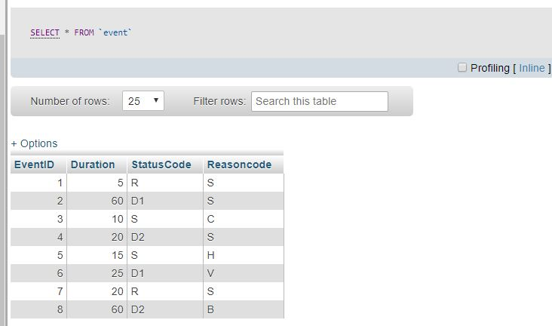
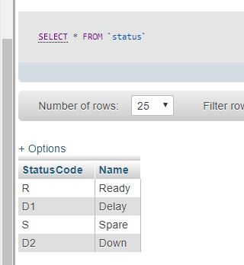
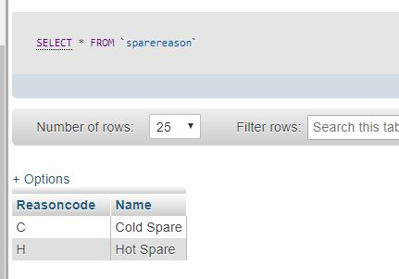
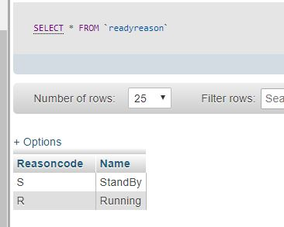
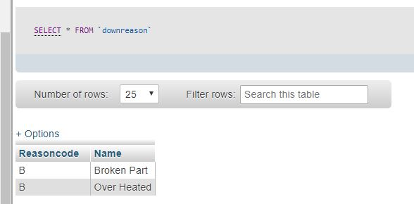
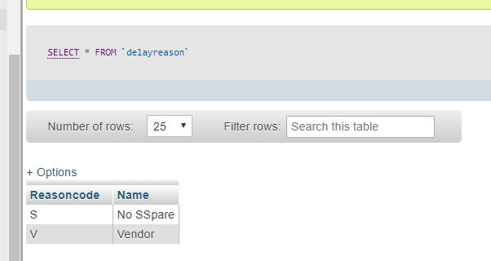
InnerJoin:
Inner join to return status name.
Query: SELECT EventID, Duration, S.Name FROM Event E INNER JOIN Status S ON E.StatusCode = S.StatusCode
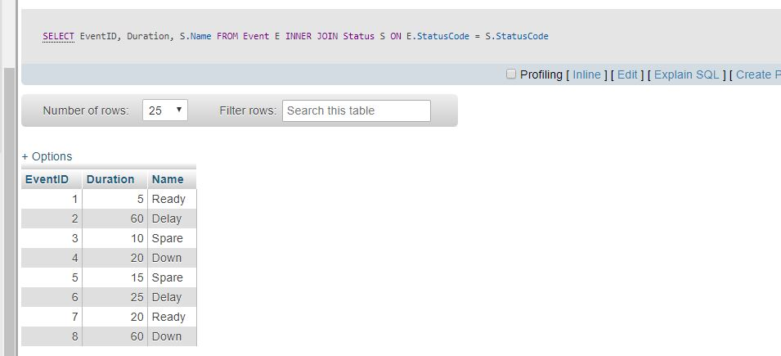

Union:
SELECT 'R', ReasonCode, Name FROM ReadyReason UNION SELECT 'D1', ReasonCode, Name FROM DelayReason UNION SELECT 'S', ReasonCode, Name FROM SpareReason UNIONSELECT 'D2', ReasonCode, Name FROM DownReason

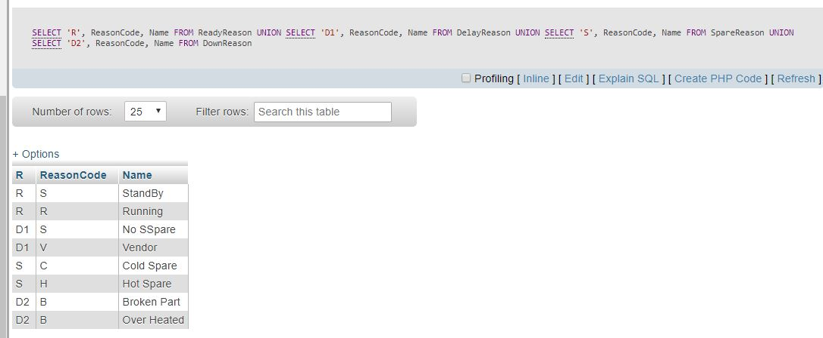

Query:
SELECT EventID, Duration,S.Name as [Status Name],
SR.ReasonName as [Rason Name]
FROM Event E
INNER JOIN Status S
ON E.StatusCode = S.StatusCode
INNER JOIN
(
SELECT 'R', ReasonCode, Name
FROM ReadyReason
UNION
SELECT 'D1', ReasonCode, Name
FROM DelayReason
UNION
SELECT 'S', ReasonCode, Name
FROM SpareReason
UNION
SELECT 'D2', ReasonCode, Name
FROM DownReason
) SR
ON E.StatusCode = SR.StatusCode AND
E.ReasonCode = SR.ReasonCode

