Alyssa

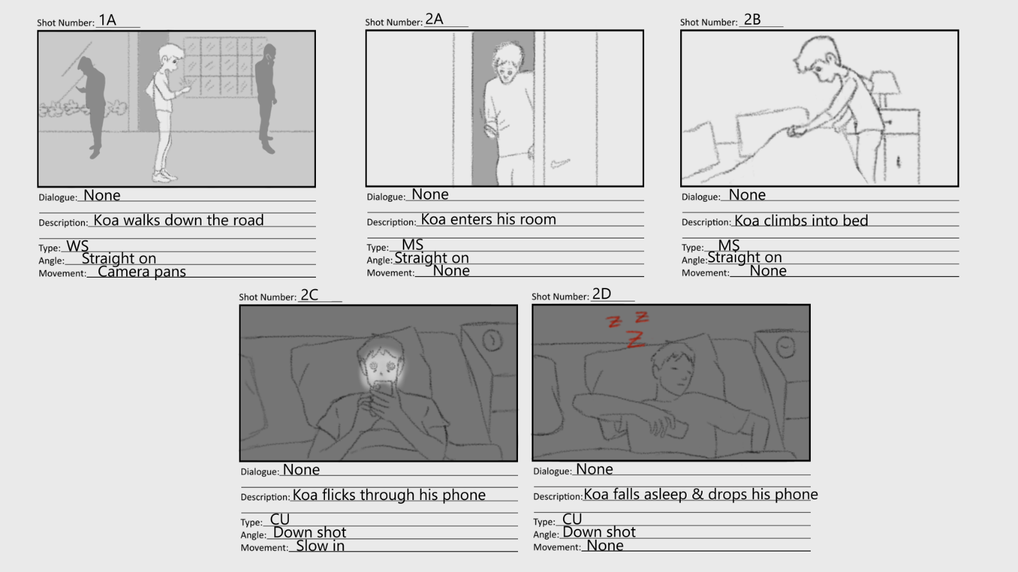



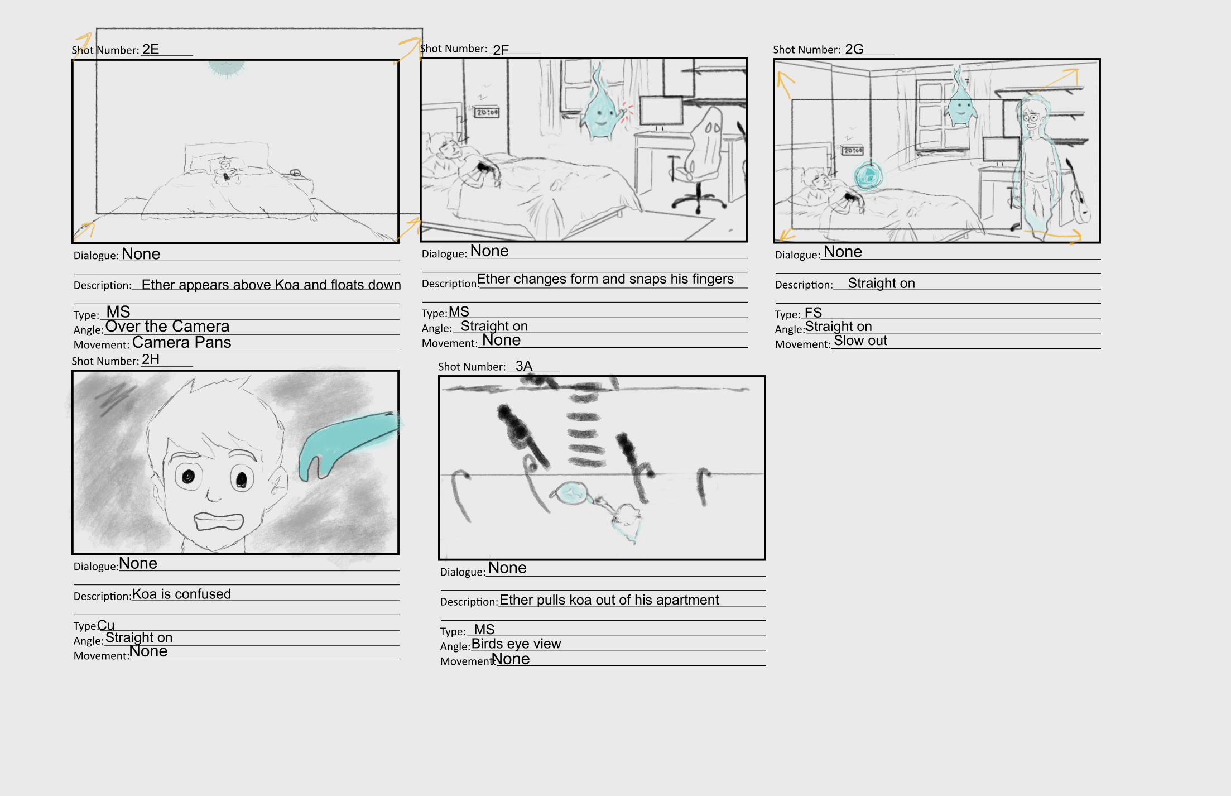

Mishalia



Alyssa



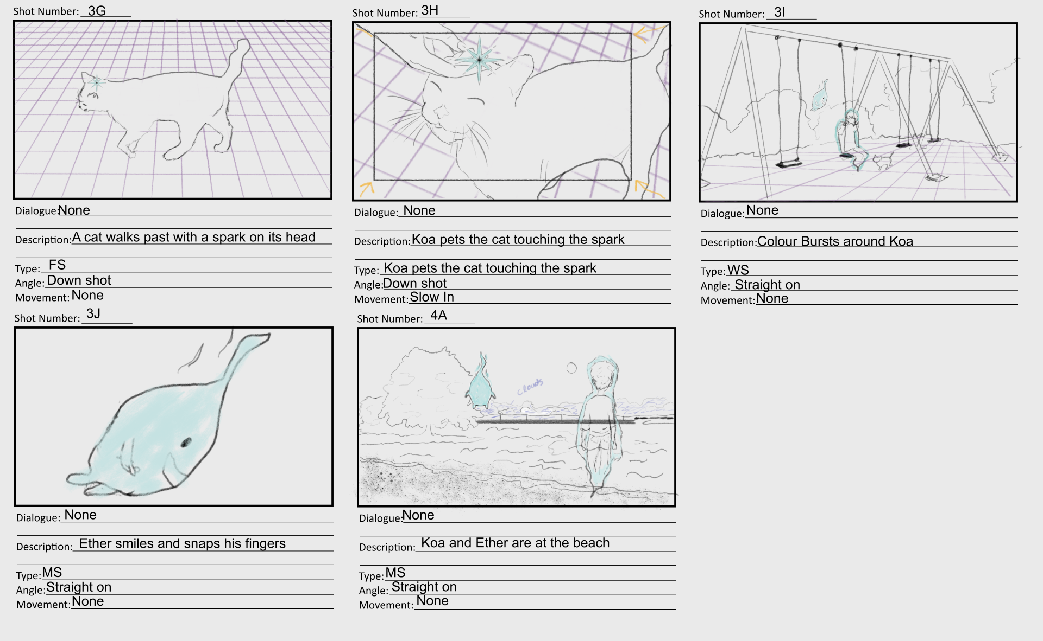

Mishalia



Alyssa



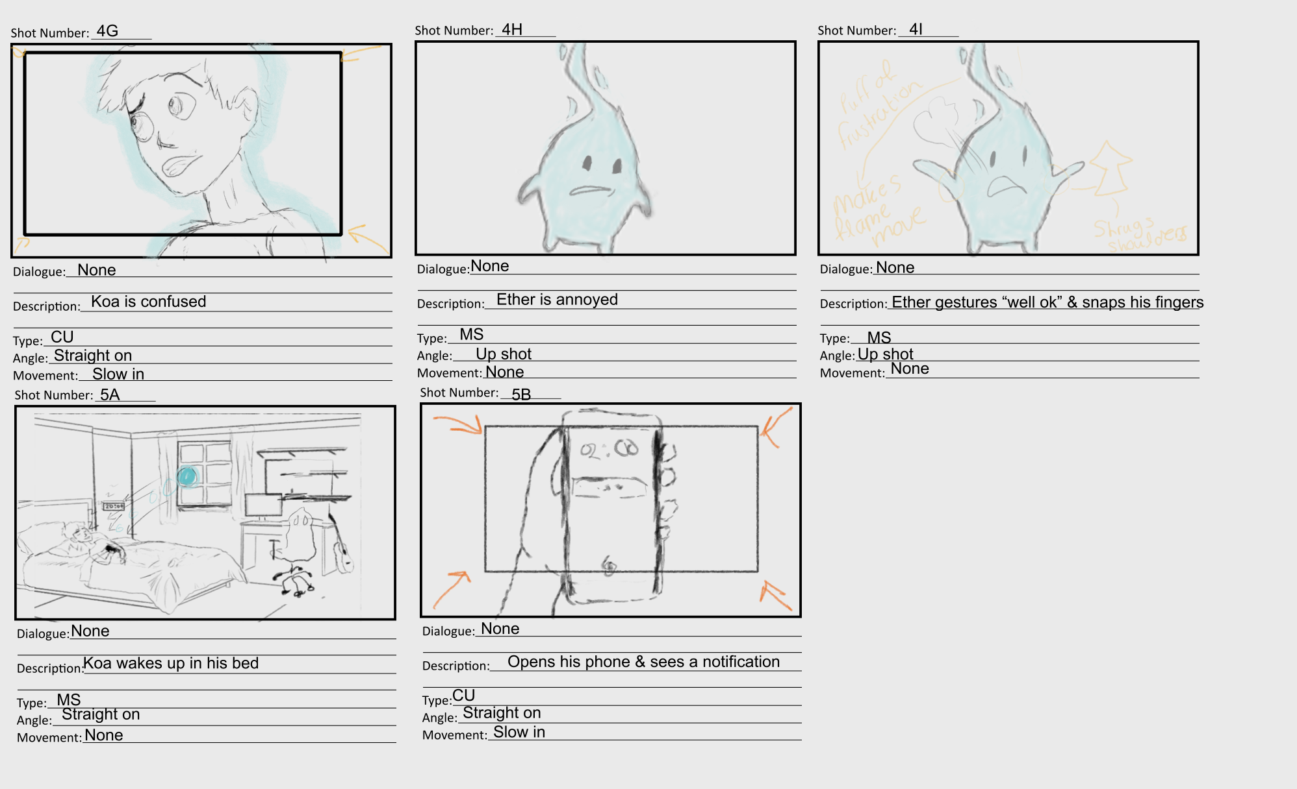

Mishalia

