Bangladesh University of Engineering and Technology
Department of Electrical and Electronic Engineering

EEE 416 (July–September 2026)
Microprocessor Interfacing and Embedded Systems Sessional
Final Project Report
Section: A2 Group: 08

Bangla Braille Learning and Testing Device: An ESP32-Based Haptic-Audio Tutor with On-Device Machine Learning

Course Instructors:
[To be filled in by the course office — not recorded in the project repository]

Signature of Instructor: ___________________________________________________

Academic Honesty Statement:
IMPORTANT! Please carefully read and sign the Academic Honesty Statement, below. Type the student ID and name, and put your signature. You will not receive credit for this project experiment unless this statement is signed in the presence of your lab instructor.
“In signing this statement, We hereby certify that the work on this project is our own and that we have not copied the work of any other students (past or present), and cited all relevant sources while completing this project. We understand that if we fail to honor this agreement, We will each receive a score of ZERO for this project and be subject to failure of this course.”
Signature: ____________________________  Full Name:  Student ID: 1806xyz | Signature: ____________________________  Full Name:  Student ID:
Signature: ____________________________  Full Name:  Student ID: | Signature: ____________________________  Full Name:  Student ID:

Student ID: 2106055 Name: Santu Nag Signature: ___________________
Student ID: 2106056 Name: Md. Adib Hasan Audhi Signature: ___________________
Student ID: 2106059 Name: Mishat Hasan Milon Signature: ___________________
Student ID: 2106065 Name: Khalid Mehebub Signature: ___________________

Table of Contents
1 Abstract 1
2 Introduction 1
3 Design 1
3.1 Problem Formulation (PO(b)) 1
3.1.1 Identification of Scope 1
3.1.2 Literature Review 1
3.1.3 Formulation of Problem 1
3.1.4 Analysis 1
3.2 Design Method (PO(a)) 1
3.3 Circuit Diagram 1
3.4 Simulation Model 2
3.5 CAD/Hardware Design 2
3.6 PCB Design 2
3.7 Full Source Code of Firmware 2
3.8 2
4 Implementation 2
4.1 Description 2
5 Design Analysis and Evaluation 3
5.1 Novelty 3
5.2 Design Considerations (PO(c)) 3
5.2.1 Considerations to public health and safety 3
5.2.2 Considerations to environment 3
5.2.3 Considerations to cultural and societal needs 3
5.3 Investigations (PO(d)) 3
5.3.1 Design of Experiment 3
5.3.2 Data Collection 3
5.3.3 Results and Analysis 3
5.3.4 Interpretation and Conclusions on Data 3
5.4 Limitations of Tools (PO(e)) 3
5.5 Impact Assessment (PO(f)) 3
5.5.1 Assessment of Societal and Cultural Issues 4
5.5.2 Assessment of Health and Safety Issues 4
5.5.3 Assessment of Legal Issues 4
5.6 Sustainability Evaluation (PO(g)) 4
5.7 Ethical Issues (PO(h)) 4
6 Reflection on Individual and Team work (PO(i)) 4
6.1 Individual Contribution of Each Member 4
6.2 Mode of TeamWork 4
6.3 Diversity Statement of Team 4
6.4 Log Book of Project Implementation 4
7 Communication to External Stakeholders (PO(j)) 5
7.1 Executive Summary 5
7.2 User Manual 5
7.3 Github Link 5
7.4 YouTube Link 5
8 Project Management and Cost Analysis (PO(k)) 5
8.1 Bill of Materials 5
8.2 Calculation of Per Unit Cost of Prototype 5
8.3 Calculation of Per Unit Cost of Mass-Produced Unit 5
8.4 Timeline of Project Implementation 5
9 Future Work (PO(l)) 5
10 References 5

Abstract
This project presents a dual-mode embedded tutor that teaches and assesses Bangla Braille literacy using synchronised haptic vibration, spoken audio, and an on-device machine-learning model, aimed at Bangla-speaking blind and visually-impaired learners, for whom no low-cost, offline-capable Braille trainer currently exists in Bangladesh. The device is built around an ESP32-WROOM-32 microcontroller driving six coin vibration motors through a ULN2803A driver and a DFPlayer Mini speaker module to present any of 50 Bangla Braille characters, and reads the learner's response through six tactile dot buttons and a submit button. Two independent, mutually exclusive firmware images were built: a fully offline mode that selects letters by inverse-mastery weighting and logs every attempt to a local microSD card, and a remote/teacher-controlled mode in which a teacher's web panel inserts commands into a Supabase (PostgreSQL) table that the ESP32 polls every 250 ms, with results posted back for the teacher to see live. Every attempt is scored two ways: by a hand-written deterministic rule engine and, independently, by a compact dual-head neural network (1,734 parameters, 8 live behavioural features, trained on 1,000 real attempts from four participants plus 1,242 calibrated synthetic rows) that predicts a teaching action (repeat / hint / normal practice) and a confidence state (confident / hesitant / guessing). The trained model reaches 98.56% agreement with the rule engine on teaching action and 91.37% on confidence state, evaluated on real data only. A single specification file generates the rule engine identically in JavaScript, C, and Python so the web app, firmware, and training pipeline cannot silently disagree. As of this report, 11 of 50 Braille cell patterns (all vowels) have been verified against photographed reference charts; the remaining 39 consonants still carry unverified placeholder patterns, and the physical hardware has been wired to the documented pin map but not yet exercised end-to-end with a live learner outside firmware test sketches.

Introduction
Bangla-speaking blind and visually-impaired learners in Bangladesh have very limited access to affordable, language-appropriate Braille literacy tools. Commercial Braille trainers are almost universally built for English/Latin Braille, are expensive to import, and give no adaptive feedback tailored to an individual learner's pace. This project builds a self-contained hardware and software system that teaches and tests the 50-character Bangla Braille alphabet through touch (vibration) and sound, works with or without an internet connection, and adapts its teaching behaviour to each learner's real performance history rather than following a fixed script.
The problem satisfies the criteria of a Complex Engineering Problem. It requires depth of knowledge across several disciplines that do not normally meet in one undergraduate project: embedded firmware and real-time haptic/audio actuation, cloud-backed REST communication between a microcontroller and a web application, and the training and on-device deployment of a machine-learning model under a few kilobytes of RAM. It has conflicting requirements rather than a single obvious design: full classroom autonomy (no internet, no dependency on a teacher's device) directly conflicts with live remote control and analytics (which need connectivity), and the project resolves this not by compromise but by shipping two mutually exclusive firmware images from one shared specification. There is no standard textbook solution to combine adaptive pedagogy with Bangla Braille specifically — the character-to-dot mapping itself (Bharati Braille) had to be digitised and partially re-verified against photographed reference charts rather than taken from an existing verified dataset. Finally, the problem has wide-ranging consequences and stakeholders: the learners themselves, the teachers who would operate the remote-control panel, and, because 39 of the 50 character mappings are still unverified guesses at the time of this report, the broader question of whether a digitised Braille standard can be trusted before it reaches a real classroom.

Design

Problem Formulation (PO(b))

Identification of Scope
The project scope is a single ESP32-class device that teaches and tests the 50 base characters of the Bangla Braille alphabet (11 vowels, 39 consonants/marks) defined in data/braille_map.json. Numerals, punctuation, and Braille contractions are explicitly out of scope. Two firmware images are in scope (offline, remote/teacher-controlled); running both simultaneously on one board is explicitly out of scope, since they share GPIO pins and network resources.

Literature Review
Bangla Braille follows the Bharati Braille convention used across several Indian and Bangladeshi languages, in which the standard 6-dot cell is reused across letters that need more glyphs than 63 non-empty dot combinations allow — for example, the vocalic vowel ্ৰ (োৰি, ri) and the consonant ত (ta) end up sharing the same dot pattern in some references, disambiguated in principle by a preceding dot-5 modifier cell, which this project implements in firmware as a two-stage teach sequence for the two characters known to collide this way. On the machine-learning side, published TinyML work has repeatedly shown that networks in the few-hundred to few-thousand-parameter range can run a full forward pass in well under a millisecond on a 240 MHz Cortex-class or Xtensa microcontroller with no dedicated neural accelerator, which is the same order of magnitude this project's own 1,734-parameter, 8-input dual-head network targets. No existing open-source project combining Bangla-specific Braille content with on-device adaptive teaching decisions was found during this project's development.

Formulation of Problem
The vague goal “build an assistive Braille-teaching device” was formulated into concrete, testable requirements: (1) for any of 50 characters, reproduce its correct audio prompt and haptic dot pattern within a fixed timing budget; (2) capture the learner's six-dot response and a submit action with software debouncing; (3) after each attempt, produce a teaching decision (repeat / hint / normal practice) and a confidence estimate (confident / hesitant / guessing) using both a deterministic rule engine and an independently-trained neural network, and log the comparison; (4) guarantee the rule engine used by the web app, the firmware, and the model-training pipeline can never numerically disagree, since they must all interpret the same historical data the same way; and (5) fit the entire on-device model and inference code inside the ESP32's flash/RAM budget with no external accelerator.

Analysis
Several design alternatives were analysed against these requirements. A single neural network with two output heads sharing one hidden trunk (as first prototyped, see Limitations) is more parameter-efficient, but couples the two prediction tasks through shared hidden features, so a revision was made to run two fully independent multilayer perceptrons (separate Dense(32)→Dense(16)→Dense(3) stacks per task) at roughly double the multiply-add cost — 1,734 parameters and well under a millisecond of theoretical inference time either way — which was judged an acceptable trade for cleaner, task-independent learning. For the ESP32–web communication link, a plain HTTPS REST poll against Supabase's PostgREST endpoint was chosen over MQTT or a persistent WebSocket: it reuses the same publishable-key authentication as every other read/write in the system, needs no additional broker, and a 250 ms poll interval is imperceptible against the multi-second human timescale of a teaching interaction. For feature normalisation, fixed minimum/maximum ranges taken directly from the specification file (rather than statistics computed from whichever dataset happens to be on hand) were chosen specifically so that retraining the model on a larger dataset later can never silently desynchronise the firmware's normalisation from the model that was actually trained.

Design Method (PO(a))
Mathematics, science, and engineering principles were applied throughout. Statistics: model evaluation is reported as real-data-only accuracy (98.56% teaching-action agreement, 91.37% confidence-state agreement) kept deliberately separate from any metric computed on the synthetic rows, to avoid a circular accuracy claim. Numerical methods: the mastery score is an asymmetric exponential moving average, M_n = M_{n-1} + α(x_n)·(x_n − M_{n-1}), with α=0.25 on a correct attempt and α=0.35 on a wrong one, chosen so recent performance is weighted more heavily than a simple lifetime ratio (accuracy) and forgets old mistakes and successes geometrically rather than arithmetically. Electrical engineering: the six vibration motors are inductive loads and are driven through a ULN2803A Darlington array specifically for its built-in flyback diodes, since driving an inductive motor from a bare GPIO or an unprotected transistor is documented as the most common way this class of circuit destroys a microcontroller pin; GPIO2 and GPIO15 (both ESP32 boot-strapping pins repurposed here as motor outputs) are given 10 kΩ pull-down resistors so they cannot corrupt the boot flash-voltage selection; a 1 kΩ series resistor protects the DFPlayer Mini's 3.3 V-logic RX input from the 5 V side. Power budgeting: six motors at roughly 80 mA peak each, plus the ESP32 at 80 mA with Wi-Fi active and the DFPlayer/speaker at 200 mA, sum to a worst-case peak of about 760–800 mA, which sized the supply at 5 V/2 A with a 1000 μF bulk capacitor across the motor rail to prevent motor-inrush brown-outs that would otherwise reboot the board mid-session and look like a firmware crash.

Circuit Diagram
Function | GPIO pin(s) | Note
Dot buttons 1–6 | 32, 33, 25, 26, 27, 14 | Internal pull-ups; avoids the input-only, no-pull-up pins 34/35/36/39
Submit button | 12 | Must read LOW at boot (flash-voltage strap); a switch to GND can only pull LOW, never HIGH, so it is boot-safe
Vibration motors 1–6 (via ULN2803A) | 21, 13, 22, 2, 15, 4 | GPIO2 and 15 are boot-strapping pins — fitted with 10 kΩ pull-downs
DFPlayer Mini (UART2) | 16 (RX), 17 (TX) | 1 kΩ series resistor on the DFPlayer RX line
microSD (VSPI) | 18 (CLK), 19 (MISO), 23 (MOSI), 5 (CS) | Offline-mode attempt logging
DS3231 RTC (I2C) | not yet wired (USE_RTC = 0) | Recommended but not fitted — see Limitations

The full hardware/firmware pin assignment is version-controlled in firmware/t11_ml_test/pins.h and mirrored across every firmware variant, so the same wiring serves both the offline and the remote/teacher-controlled images.

Simulation Model
Before any physical hardware existed, the exact same rule-engine logic the firmware would later run was exercised entirely in software through a browser-based data-collection application, so that the teaching logic, the feature/label scheme, and the Supabase schema could all be validated without waiting on hardware assembly.
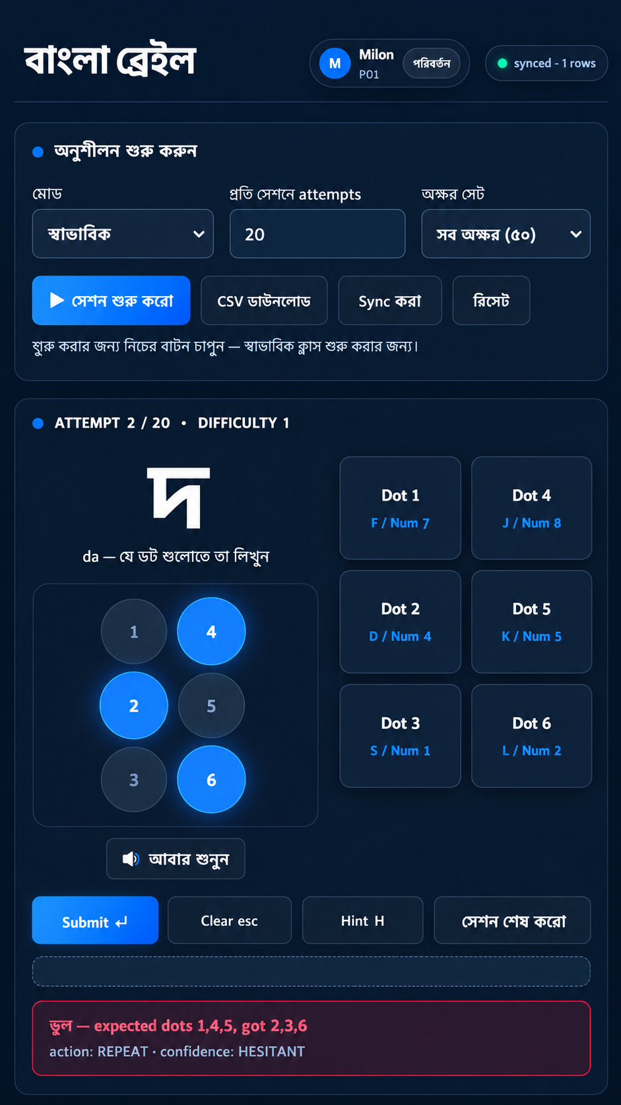
Figure: the browser-based data-collection application — the same rule engine and feature scheme later ported into firmware, used here to run real practice sessions and log attempts to Supabase before any physical device was wired.

CAD/Hardware Design
An enclosure was modelled to house the ESP32, the six coin vibration motors under a tactile top panel, the six dot buttons, submit button, and speaker.
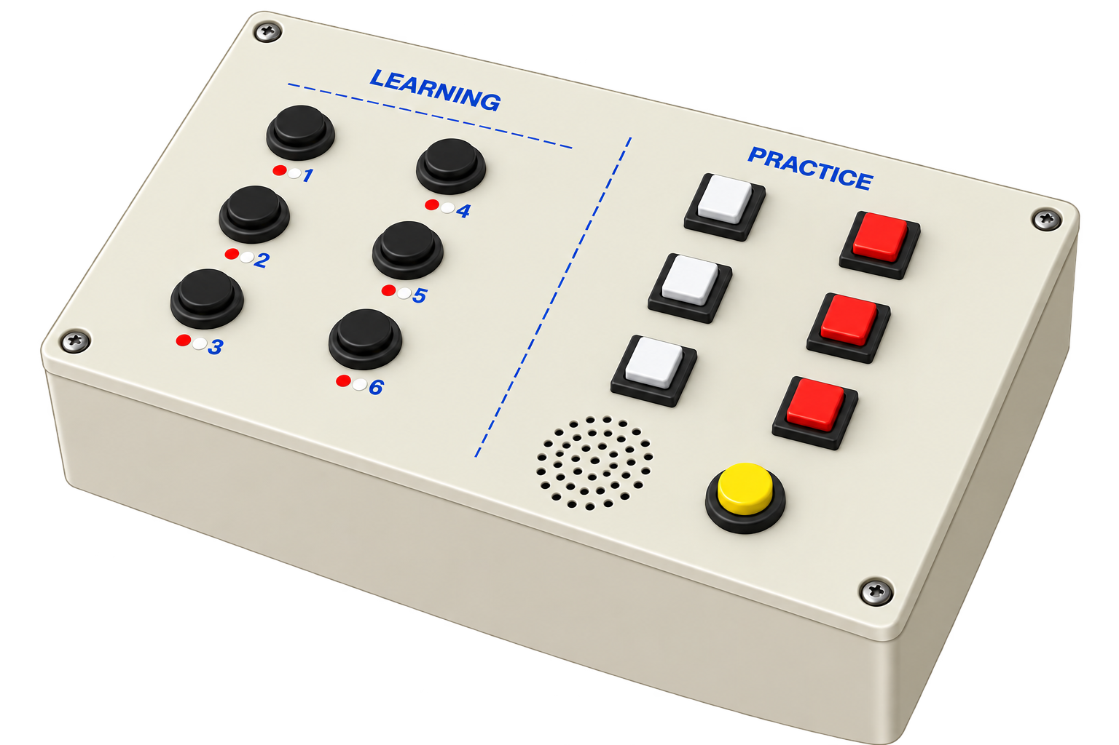
Figure: 3D-rendered concept of the enclosure housing the ESP32, motor array, and button panel.
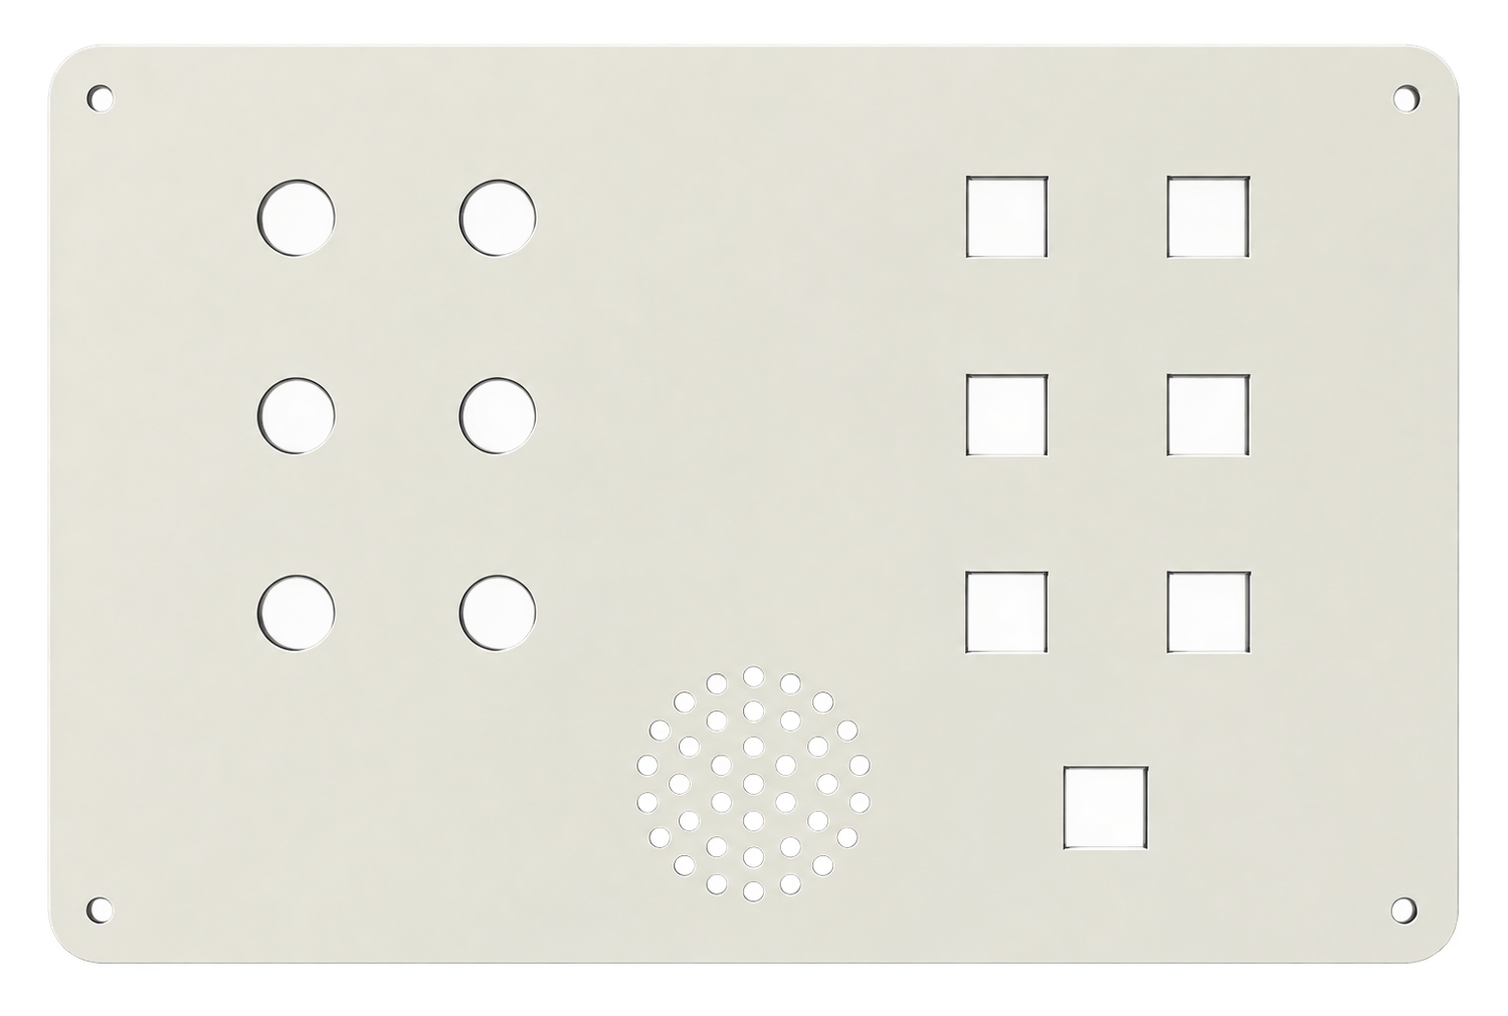
Figure: top panel layout showing the six tactile dot positions and submit button.

PCB Design
No custom PCB was fabricated for this iteration. The motors are switched through a breadboard-mounted ULN2803A Darlington-array module, and the buttons, DFPlayer Mini, and microSD module are wired directly to the ESP32-WROOM-32 dev board on a prototyping board. A custom PCB is listed under Future Work.

Full Source Code of Firmware
The complete firmware is organised as two mutually exclusive images that share the same generated rule engine and pin map: an offline image (firmware/braille_tutor/) that stores attempts to a local microSD card, and a remote/teacher-controlled family (firmware/t10_learning/, firmware/t11_ml_test/, firmware/t11_testing/) that communicates with the web application over Supabase's REST API. The complete, current source is maintained in the project's GitHub repository (see Communication to External Stakeholders); the excerpt below is the on-device forward pass that both firmware images call after every learner attempt.
// Run both prediction heads in one call (firmware/t11_ml_test/inference.h)
static inline void ml_infer(const Features *f, int *out_ta, int *out_cs) {
float norm[ML_FEATURE_COUNT];
normalize_features(f, norm);
float h0[ML_HIDDEN1], h1[ML_HIDDEN2], logits[ML_OUTPUT];

// Teaching-action head (its own Dense32 -> Dense16 -> Dense3)
_ml_dense_relu(ML_TA_W0, ML_TA_B0, norm, ML_FEATURE_COUNT, h0, ML_HIDDEN1);
_ml_dense_relu(ML_TA_W1, ML_TA_B1, h0, ML_HIDDEN1, h1, ML_HIDDEN2);
_ml_dense (ML_TA_W2, ML_TA_B2, h1, ML_HIDDEN2, logits, ML_OUTPUT);
*out_ta = _ml_argmax(logits, ML_OUTPUT);

// Confidence-state head (separate weights, not shared with TA head)
_ml_dense_relu(ML_CS_W0, ML_CS_B0, norm, ML_FEATURE_COUNT, h0, ML_HIDDEN1);
_ml_dense_relu(ML_CS_W1, ML_CS_B1, h0, ML_HIDDEN1, h1, ML_HIDDEN2);
_ml_dense (ML_CS_W2, ML_CS_B2, h1, ML_HIDDEN2, logits, ML_OUTPUT);
*out_cs = _ml_argmax(logits, ML_OUTPUT);
}

Table: Source code excerpt — on-device dual-head inference (firmware/t11_ml_test/inference.h)

Implementation

Description
In the remote/teacher-controlled mode, a teacher selects a letter on a Next.js web panel, which inserts a command row into Supabase's remote_commands table. The ESP32 polls that table every 250 ms, and on receiving a new letter, plays its audio prompt through the DFPlayer Mini and speaker, then vibrates the corresponding dot pattern sequentially across the six motors. The learner presses the dot buttons and the submit button; the firmware scores the attempt with both the rule engine and the neural network, and posts the result back to Supabase's attempts table, which the teacher panel polls every 200 ms to display live and to advance automatically to the next letter. In the offline mode, the same teach/test cycle runs with no network at all: the device itself selects the next letter by inverse-mastery weighting and appends every attempt to a local microSD card as CSV. Two characters, োৰি (ri) and ্ত (the consonant-conjunct t), are taught as a two-stage sequence — a dot-5 marker cell, then the shared base cell — because their Bharati Braille patterns collide with other letters.
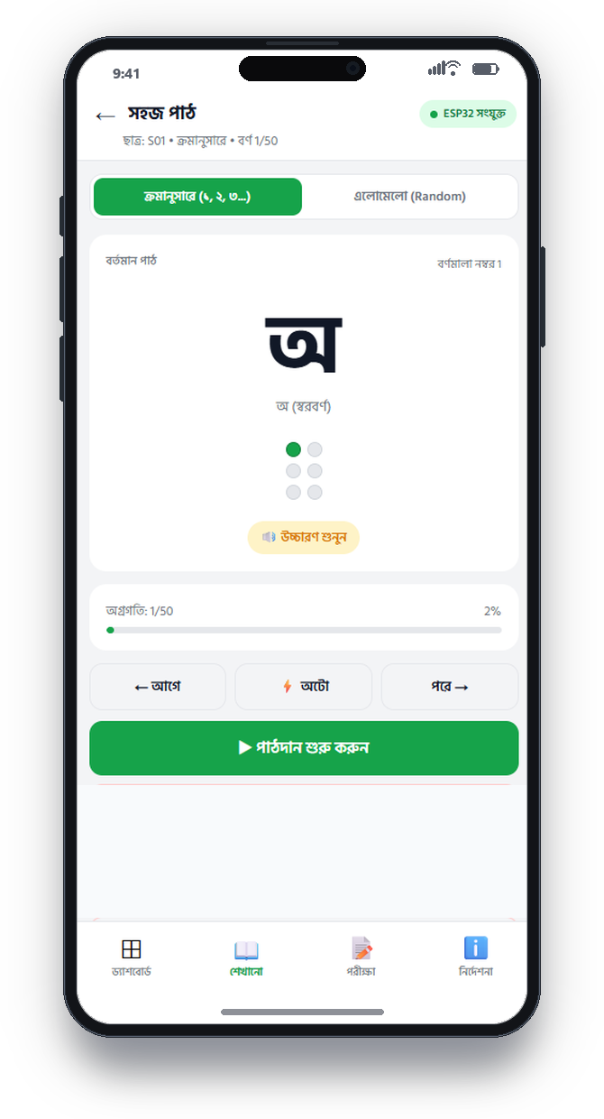
Figure: mobile-web mockup of the sequential-lesson screen shown to the learner/teacher during a teaching session (recreated to match the deployed web app's exact styling).
Note: this is a UI mockup, not a photograph of the assembled physical device — see Limitations of Tools regarding pending hardware bring-up photographs.

Design Analysis and Evaluation

Novelty
• A dual-mode firmware design generated from one shared specification file (spec/engine_spec.json), so an offline, SD-card-only classroom device and a live, teacher-controlled networked device are built from the same rule logic rather than two hand-maintained implementations that could drift apart.
• The rule engine that produces teaching decisions is transpiled into JavaScript, C, and Python from a single spec, so the web app, the ESP32 firmware, and the model-training pipeline are mathematically guaranteed to agree on every decision boundary, including edge cases sitting exactly on a threshold.
• A machine-learning model is run in parallel with the deterministic rule engine on every single attempt specifically so that the two can be compared, rather than trusting the model's output blindly — the project explicitly logs and studies where the model disagrees with the rule engine, rather than only reporting where they agree.

Design Considerations (PO(c))

Considerations to public health and safety
The entire circuit runs at 5 V/3.3 V logic levels, fully isolated from mains voltage. The six vibration motors are low-amplitude coin motors in direct skin contact by design (haptic feedback), which is inherently low-risk; the ULN2803A flyback diodes protect the driving electronics from inductive kick-back, removing the spark/overheat risk that an unprotected motor driver would carry.

Considerations to environment
The device draws well under 1 A at 5 V and has no consumables in normal operation. Its environmental cost is concentrated in end-of-life electronic waste from the ESP32 module, motors, and any battery pack; a formal recycling/disposal plan has not yet been written and is listed under Future Work.

Considerations to cultural and societal needs
The device speaks and vibrates Bangla-language content specifically, rather than adapting a generic English-Braille product, and targets a linguistic community (Bangla-speaking blind and visually-impaired learners in Bangladesh) that is not well served by imported assistive technology.

Investigations (PO(d))

Design of Experiment
Practice attempts were collected under participant codes (e.g. P01–P04) through the browser-based data-collection instrument and the ESP32 firmware's own logging path, following an explicit rule (documented for team testers in USER_MANUAL.md) that sessions for the same participant should be spread across at least two to three different days, since several model features (session_number, time_since_last_practice) only carry a meaningful signal across multiple sessions rather than within one sitting.

Data Collection
The deployed model (firmware/t11_ml_test/model_weights.h) was trained on 1,000 real attempt rows collected this way, combined with 1,242 synthetic rows generated by simulating the same learner state machine the web app itself runs (rather than sampling the 14 logged features independently, which would risk generating impossible combinations). Of the 14 logged behavioural fields per attempt, only 8 are actually fed to the model (response_time, press_duration, retry_count, prev_accuracy, prev_mastery, hint_count, current_streak, wrong_streak); the remaining 6 (char_id, session_number, difficulty_level, time_since_last_practice, prev_confidence, prev_mistakes) are recorded for analysis only.

Results and Analysis
Metric | Result
Model size | 1,734 parameters (two independent 8→32→16→3 heads), ≈ 6.8 KB as float32
Teaching-action agreement with rule engine (real data only) | 98.56%
Confidence-state agreement with rule engine (real data only) | 91.37%
Claimed inference time | ≈ 0.1 ms at 240 MHz (theoretical multiply-add estimate, not yet hardware-measured — see Limitations)

Interpretation and Conclusions on Data
The rule engine itself only ever looks at the current attempt (response time, retry count, this-round streaks) and has no memory of a learner's longer-term history; prev_accuracy and prev_mastery are fed only to the neural network, not to any hand-written rule, precisely so the model can resolve boundary cases the rule engine cannot see — for example, a fast, clean, first-try answer from a learner with a historically low mastery score on that character looks identical to the rule engine as the same answer from a learner who has mastered it for weeks, but the two carry very different pedagogical implications. The 1.44-percentage-point gap between the two agreement figures (98.56% vs 91.37%) is consistent with confidence-state boundary cases being the harder of the two classification problems, which matches the intent documented for these two features in the specification.

Limitations of Tools (PO(e))
• Only 11 of 50 Braille characters (all vowels) have been verified against photographed reference charts; the remaining 39 consonants still carry unverified Bharati-Braille placeholder patterns.
• The verified pattern for োৰি (ri) currently collides with the still-unverified placeholder pattern for ৰ (ra) — an unresolved conflict pending a reference image for ৰ.
• Five of the fourteen logged behavioural features are hardcoded placeholder constants on the ESP32 test firmware rather than measured values: press_duration (fixed 200.0), hint_count (fixed 0.0), session_number (fixed 1.0), difficulty_level (fixed 1.0), and time_since_last_practice (fixed 0.0). The hardware and code capability to measure press_duration for real already exists (buttons_mean_press_duration() in hardware.h) but is not yet called from the feature-building code.
• No real-time clock is fitted (USE_RTC = 0 in pins.h), so any time-since-last-practice feature cannot be trusted across power cycles.
• The ≈ 0.1 ms on-device inference time is a theoretical estimate from the code's own multiply-add count, not a benchmark actually measured on hardware with a timer.
• The physical hardware has been wired to the documented pin map and exercised through firmware bring-up test sketches, but has not yet been run end-to-end with a live learner in a real session.

Impact Assessment (PO(f))

Assessment of Societal and Cultural Issues
A working, affordable Bangla Braille tutor could widen access to Braille literacy instruction for learners outside specialist schools, in ordinary homes and mainstream classrooms.

Assessment of Health and Safety Issues
The device is low-voltage, battery/USB-powered, and has no parts capable of causing shock or burns in normal use; the one documented physical failure mode is an under-sized power supply causing motor-inrush brown-outs and an unexpected reboot, which is a nuisance rather than a safety hazard.

Assessment of Legal Issues
Learner attempt data is currently written to a shared Supabase table under a single hardcoded placeholder identity (“S01”) rather than a real, consented, per-student identity scheme. Before any deployment beyond the project team, a proper consent and data-privacy design for storing a minor's or a disabled learner's performance data would need to be put in place; no formal legal/regulatory review has been carried out at this stage.

Sustainability Evaluation (PO(g))
The device uses commodity, second-source-able components (a generic ESP32 dev module, generic coin vibration motors, a generic MP3 module) rather than a single proprietary part, which supports long-term repairability. Standby and active power draw are both low (well under 1 A at 5 V), and the model itself imposes a negligible flash/RAM cost (under 7 KB), so model size was never a resource constraint on this project compared to hardware assembly and data collection. A formal end-of-life recycling plan for the electronics has not yet been written.

Ethical Issues (PO(h))
An explicit honesty discipline was applied throughout this project's own internal documentation and is carried into this report: results are always described as “agreement with a hand-written rule engine” rather than “autonomous discovery of a teaching policy,” because that is what was actually measured. Every specific technical claim reused in this report (parameter counts, feature lists, accuracy numbers, pin assignments) was re-verified against the current source code rather than taken from the project's own earlier internal reports, several of which were found during drafting to describe an already-superseded, smaller version of the model. The remaining open ethical item is the placeholder single-identity data logging described above, which would need to be replaced by a real informed-consent and per-participant identity design before any data collection involving non-team-member learners.

Reflection on Individual and Team work (PO(i))

Individual Contribution of Each Member
The project's git history records commits at the GitHub-account level, not broken down per file or per feature by member, so an exact quantitative contribution split could not be reconstructed from the repository alone. The table below should be completed and signed off by the team.
Student ID | Name | Primary contribution area (to be completed by the team)
2106055 | Santu Nag
2106056 | Md. Adib Hasan Audhi
2106059 | Mishat Hasan Milon
2106065 | Khalid Mehebub

Mode of TeamWork
The team worked through a shared Git repository with a standard branch/commit workflow (64 commits recorded between 30 July 2026 and 19 September 2026), using AI-assisted pair programming (Claude Code) throughout implementation, with every AI-produced technical claim cross-checked against the actual source files before being relied upon or written into project documentation.

Diversity Statement of Team
The team consists of four students of the Department of Electrical and Electronic Engineering, BUET, assigned to the same section and group by departmental policy. [To be personalised by the team with any further diversity statement they wish to make.]

Log Book of Project Implementation
Date | Milestone achieved | Individual Role | Team Role | Comments
2026-07-30 | Project repository initialised; specification and rule engine drafted | — | All | First commit
2026-08–early Sept 2026 | Web data-collection app, Supabase schema, teacher panel, offline/remote firmware images, TinyML model training pipeline built and tested in software | — | All | Bulk of implementation
2026-09-16 to 09-19 | ESP32 pin map finalised; dual-head model retrained on 1,000 real + 1,242 synthetic rows (98.56% / 91.37% agreement); Next.js web app rebuilt | — | All | Most recent iteration verified against source in this report
2026-09-19 | Latest commit at time of this report (64 commits total) | — | All | Hardware wired to documented pin map; end-to-end physical test pending

Communication to External Stakeholders (PO(j))

Executive Summary
A BUET student team has built a low-cost teaching device that helps blind and visually-impaired Bangla speakers learn to read Braille. The device vibrates the correct finger positions and speaks each letter aloud in Bangla, then checks the learner's answer and decides whether to repeat, give a hint, or move on — using both a simple rule book and a small on-device AI model that learns from real practice sessions. It can run fully offline in a classroom with no internet, or be controlled live by a teacher through a web dashboard. The team has verified the vowel patterns against real Braille references and is now working to verify the remaining consonant patterns before wider testing.

User Manual
A Bengali-language user manual for team testers (USER_MANUAL.md) covers the following steps:
1. Open the web app in any browser (desktop or mobile) at the deployed URL.
2. Each Bangla Braille character shown on screen highlights the correct dot(s) in blue; select the matching dot buttons on screen (or via keyboard — Numpad 7/4/1 and 8/5/2 for the two columns of dots on a laptop, or the Perkins-style F/D/S and J/K/L layout), then press Submit (or Spacebar).
3. Enter a participant code (e.g. P01) and click “Start session.”
4. Practise each character shown, pressing Submit after each attempt; the session ends automatically after a fixed number of attempts.
5. Data auto-saves on every input; a temporary loss of internet connection is safe — the app queues attempts locally and syncs once connectivity returns.
6. Testers are asked to spread their own sessions across at least two to three different days, since some model features only carry meaningful signal across multiple sessions.

Github Link
https://github.com/Mishatmilon059/eee_416

YouTube Link
[Not yet recorded — no demonstration video link exists in the project repository at the time of this report.]

Project Management and Cost Analysis (PO(k))

Bill of Materials
The itemised costs below are reconstructed from the two cost figures actually documented in the project's internal notes (ESP32 module ≈ US$4; full prototype BOM total ≈ US$10.25) and the component list in the project README; per-component prices are therefore approximate engineering estimates, not itemised purchase receipts.
Component | Qty | Approx. unit cost (US$) | Approx. line cost (US$)
ESP32-WROOM-32 dev board | 1 | 4.00 | 4.00
Coin vibration motors | 6 | 0.35 | 2.10
ULN2803A Darlington driver | 1 | 0.60 | 0.60
DFPlayer Mini + small speaker | 1 | 1.80 | 1.80
Tactile push buttons (dots + submit) | 7 | 0.05 | 0.35
microSD module + card | 1 | 0.80 | 0.80
Resistors, capacitor, wiring, misc. | — | 0.60 | 0.60
Total (approx.) |  |  | 10.25

Calculation of Per Unit Cost of Prototype
Per-unit prototype material cost ≈ US$10.25 (table above). This figure excludes assembly labour, the enclosure, and any DS3231 RTC module (recommended, ≈ US$2, not yet fitted — see Future Work), none of which have been formally costed for this iteration.

Calculation of Per Unit Cost of Mass-Produced Unit
At volumes typical of small educational-hardware production runs, bulk pricing on the ESP32 module, motors, and passive components would be expected to reduce the per-unit bill-of-materials cost meaningfully below the ~US$10.25 prototype figure; replacing the breadboard/module-based assembly with a custom PCB (see PCB Design) would add a one-time non-recurring engineering cost but reduce per-unit assembly labour. No supplier quotations at volume have been obtained, so this remains a qualitative, not a quantified, estimate at this stage.

Timeline of Project Implementation
Phase | Approx. window | Work
Phase 0 – Specification | 30 Jul 2026 | Repository initialised; feature/rule specification (spec/engine_spec.json) drafted
Phase 1 – Software MVP | Aug 2026 | Web data-collection app, Supabase schema, teacher panel, rule engine code-generation pipeline
Phase 2 – Model & firmware | Late Aug – early Sep 2026 | TinyML model training pipeline, offline and remote/teacher-controlled firmware images, ESP32 pin map
Phase 3 – Verification & rebuild | 16–19 Sep 2026 | Model retrained on real + synthetic data (1,734 params, 98.56%/91.37% agreement); Next.js web app rebuilt; facts re-verified against source for this report
Phase 4 – Hardware bring-up (ongoing) | In progress | Physical wiring to documented pin map; end-to-end field test with a live learner pending

Future Work (PO(l))
• Obtain photographed reference images for the 39 still-unverified consonant characters and re-run the image-based Braille pattern verifier against them.
• Resolve the োৰি/ৰ pattern collision once a reference image for ৰ (ra) is supplied.
• Replace the five hardcoded placeholder features on the ESP32 test firmware (press_duration, hint_count, session_number, difficulty_level, time_since_last_practice) with genuinely measured values — the press-duration measurement code already exists and only needs to be wired in.
• Fit a DS3231 real-time clock and set USE_RTC = 1 so time-since-last-practice is trustworthy across power cycles.
• Run an actual on-device timer benchmark of ml_infer() rather than relying on the current theoretical multiply-add estimate.
• Complete end-to-end physical hardware bring-up and a real multi-day, multi-participant data-collection round beyond the four team members who have contributed data so far.
• Design a real per-student identity and informed-consent scheme before collecting data from any learner outside the project team.
• Design and fabricate a custom PCB and a manufacturable enclosure to replace the current breadboard/module assembly and 3D-rendered concept enclosure.

References
1. BUET Department of EEE, Programme Outcome (PO) statements, EEE 416 course page.
2. Bharati Braille Standard, as digitised in this project's data/braille_map.json and cross-checked against photographed reference charts for the 11 verified vowel characters.
3. Espressif Systems, ESP32-WROOM-32 Datasheet.
4. DFRobot, DFPlayer Mini MP3 Module Specification.
5. Texas Instruments, ULN2803A High-Voltage, High-Current Darlington Transistor Array Datasheet.
6. Supabase, PostgREST-based REST API Documentation.
7. TensorFlow/Keras Documentation, Dense layer and softmax activation reference (model-training pipeline).
8. Project source repository: https://github.com/Mishatmilon059/eee_416 (all firmware, web application, specification, and training-pipeline source code cited throughout this report).

