**LAB#01**

Object: To understand HTML basics for developing web applications

Key Concepts:

* Web Engineering is the application of systematic, disciplined and quantifiable approaches to development, operation, and maintenance of Web- based applications.
* Web development tends to break down into three main concentrations: front-end, back-end, and full stack.
* Front-end is LOOK. For that we start with very basic i.e. HTML
* HTML (Hyper Text Markup Language) defines the structure of your content.
* Markup language, a standardized set of notations used to annotate a plain-text document's content to give information regarding the structure of the text or instructions for how it is to be displayed
* Hypertext is text which is not constrained to be linear. Hypertext is text which contains links to other texts.
* HTML is Case insensitive language
* Html is translated by means of a web browser on the client side thus it is client side scripting language.
* No matter how much whitespace you use (which can include space characters, but also line breaks), the HTML parser reduces each one down to a single space when rendering the code.

Syntax:

<!DOCTYPE html>

<html>

<head>

<title></title>

</head>

<body>

</body>

</html>

Terminology:

* **HTML ELEMENTS/ TAGS/ MARKUPS:** Html elements or tags provide instructions for how information will be processed or displayed. Enclosed in <>
* **DELIMITERS ( <, >, /):** Delimiters surround the tag and inform the parser that it should read the enclosed information as an HTML element.
* **ATTRIBUTE:** Attributes contain extra information about the element that you don't want to appear in the actual content. The value for the attribute is enclosed in quotation marks.
* **TAG TYPES:**
* **Paired tags:** They require a starting and an ending tag e.g: <html></html>
* **Unpaired/Singular/Empty tags:** They require only a starting tag e.g.: <br/> <input/> or simply <br> <input>
* **HTML HEADINGS**: Heading elements allow you to specify that certain parts of your content are headings or subheadings. There are 6 heading levels.

Lab Tasks:

1. Create a simple webpage displaying your entire bio data including an image and an anchor tag for your email.

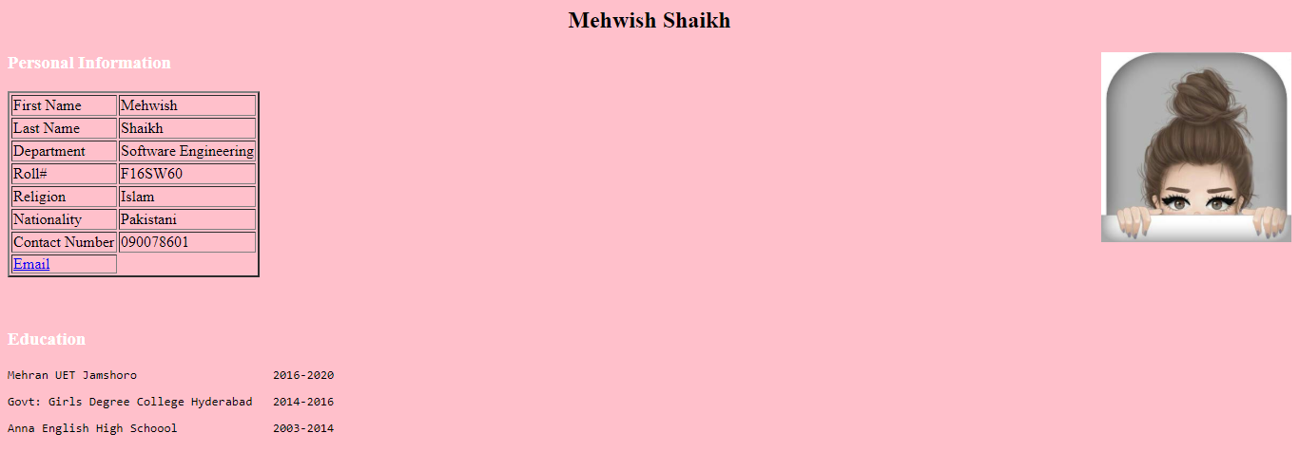

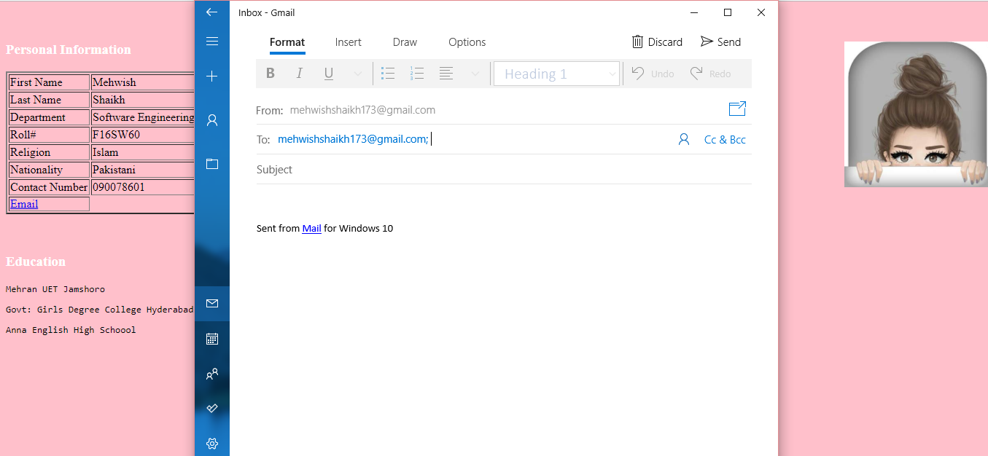

1. The sample image on next slide shows an example of what the letter might look like after being marked up. Create a simple webpage displaying this output (note: you can make variations like use your own content or give it a much better structure)

