**LAB#02**

OBJECT: To become familiar with HTML5 semantic and multimedia elements

HTML5 is a new version of the language HTML, with new elements, attributes, and behaviors, **and** a larger set of technologies that allows the building of more diverse and powerful Web sites and applications.

HTML5 technologies are classified into several groups based on their function.

* Semantics: allowing you to describe more precisely what your content is.

A look at the new outlining and sectioning elements in HTML5: [<section>](https://developer.mozilla.org/en-US/docs/Web/HTML/Element/section), [<article>](https://developer.mozilla.org/en-US/docs/Web/HTML/Element/article), [<nav>](https://developer.mozilla.org/en-US/docs/Web/HTML/Element/nav), [<header>](https://developer.mozilla.org/en-US/docs/Web/HTML/Element/header), [<footer>](https://developer.mozilla.org/en-US/docs/Web/HTML/Element/footer) and [<aside>](https://developer.mozilla.org/en-US/docs/Web/HTML/Element/aside).

* Connectivity: allowing you to communicate with the server in new and innovative ways.
* Offlineand storage: allowing webpages to store data on the client-side locally and operate offline more efficiently.

A look at the [constraint validation API](https://developer.mozilla.org/en-US/docs/Learn/HTML/Forms/Form_validation), several new attributes, new values for the [<input>](https://developer.mozilla.org/en-US/docs/Web/HTML/Element/input) attribute [type](https://developer.mozilla.org/en-US/docs/Web/HTML/Element/input#attr-type) and the new [<output>](https://developer.mozilla.org/en-US/docs/Web/HTML/Element/output) element.

* Multimedia: making video and audio first-class citizens in the Open Web.

The [<audio>](https://developer.mozilla.org/en-US/docs/Web/HTML/Element/audio) and [<video>](https://developer.mozilla.org/en-US/docs/Web/HTML/Element/video) elements embed and allow the manipulation of new multimedia content.

* 2D/3D graphics and effects: allowing a much more diverse range of presentation options.
* Performance and integration: providing greater speed optimization and better usage of computer hardware.
* Device access: allowing for the usage of various input and output devices.
* Styling: letting authors write more sophisticated themes.
* The most interesting new APIs in HTML5 are:
* HTML Geolocation
* HTML Drag and Drop
* HTML Local Storage
* HTML Application Cache
* HTML Web Workers
* HTML SSE

Task#1 Do as directed:

* 1. Save your audio and video files in a new directory on your computer.
  2. Create a new HTML file in the same directory, called index.html.
  3. Add <audio> and <video> elements to the page; make them display the default browser controls. Give both of them <source> elements so that browsers will find the audio format they support best and load it. These should include type attributes.
  4. Give the <video> element a poster that will be displayed before the video starts to be played.
  5. Play the video along with subtitles added to it

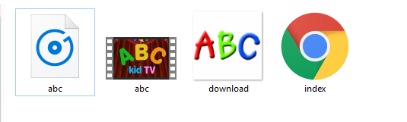

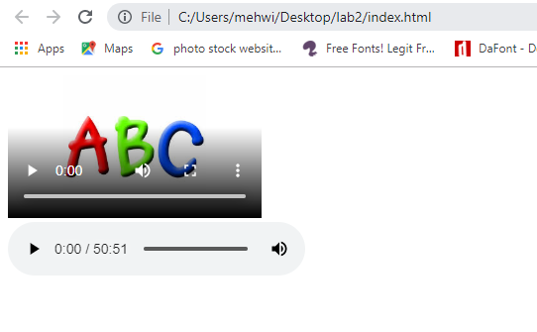

Task#2 Design the form.

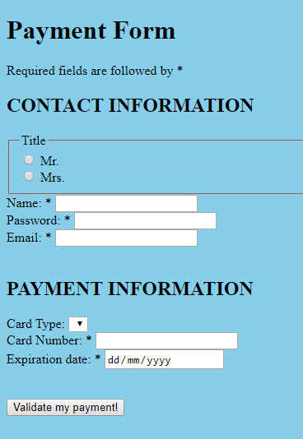

Task#3 Embed google maps into your page.

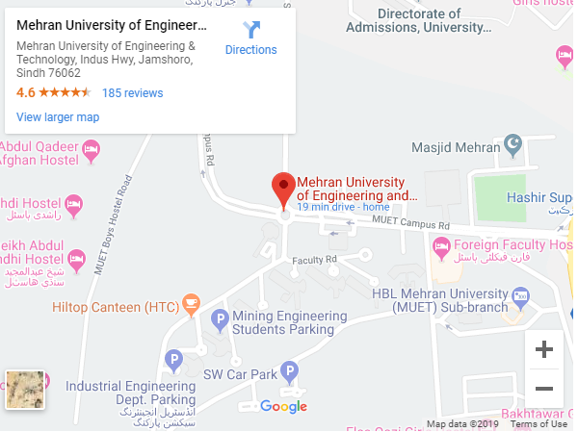

Task#4 Write a code to have header of page that displays the site name, then have a navigation bar which should contain links to home, about, services & contact (note this is a single page site)

* + add some content to home section related to your site
  + Add about the author section which should have image, name & designation
  + Add services section in the aside section which should display the services that your site provides
  + Add a contact form which should contain name, email and message

