LAB#03

Object: **CSS (Cascading Style Sheet)**

* CSS is a language for specifying how documents are presented to users — how they are styled, laid out, etc.
* CSS is a rule-based language — you define rules specifying groups of styles that should be applied to particular elements or groups of elements on your web page. For example "**I want the main heading on my page to be shown as red text**.

**h1 {**

color: red;

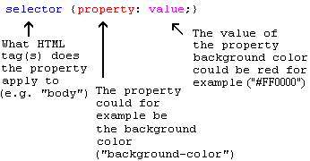}

**WAYS OF ADDING CSS**

* **In-line (the attribute style)**
* **Internal (the tag style)**
* **External style sheet**

**CSS SELECTORS**

CSS selectors are used to "find" (or select) the HTML elements you want to style.

We can divide CSS selectors into five categories:

* Simple selectors (select elements based on name, id, class)
* [Combinator selectors](https://www.w3schools.com/css/css_combinators.asp) (select elements based on a specific relationship between them)
* [Pseudo-class selectors](https://www.w3schools.com/css/css_pseudo_classes.asp) (select elements based on a certain state)
* [Pseudo-elements selectors](https://www.w3schools.com/css/css_pseudo_elements.asp) (select and style a part of an element)
* [Attribute selectors](https://www.w3schools.com/css/css_attribute_selectors.asp) (select elements based on an attribute or attribute value)

