LAB#08

Task 1:

* Write a PHP code for the following and print their outputs (where applicable) on the browser
  + To redirect a user to a different web page (for example: http://sw.muet.edu.pk).
  + To display the following strings:
  + Tomorrow I’ll learn something new.

This is a bad command: del c:\\*.\*\$.

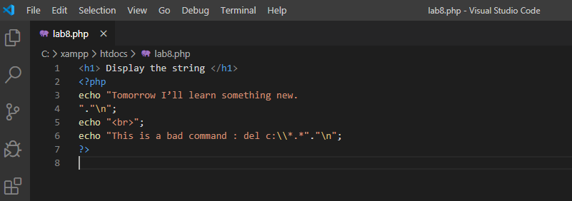

OUTPUT:

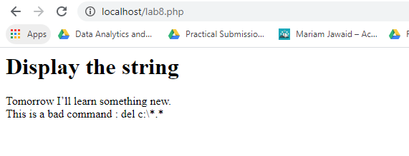

Task:2

To return the following components of any url stored in a variable such as:

* url: http://sw.muet.edu.pk/faculty/cvs/sample.pdf
* Scheme : http
* Host : www.sw.muet.edu.pk
* Path : /faculty/cvs/sample.pdf

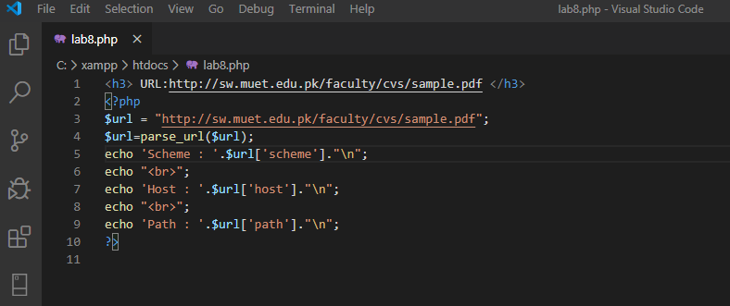

Output:

