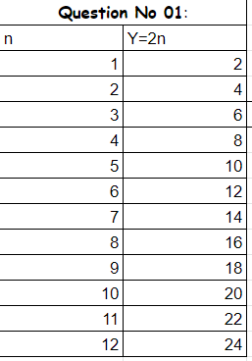

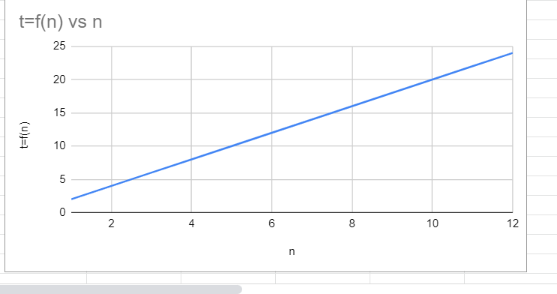

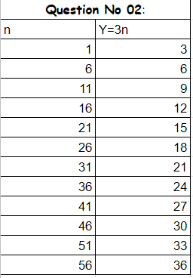

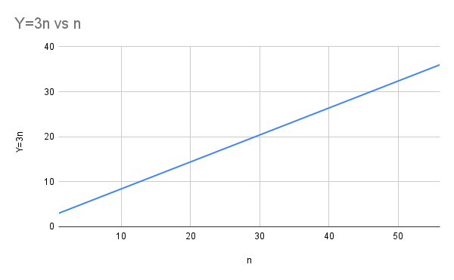

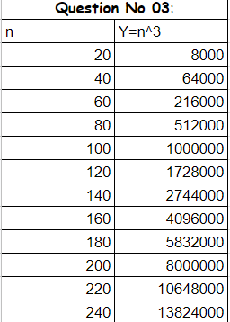

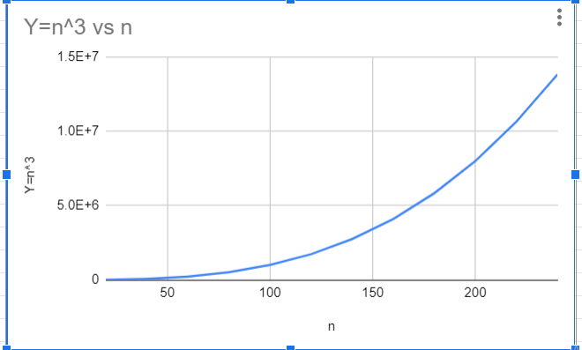

|  |  |
| --- | --- |
| **Question No:04** | |
| n | Y=Logn |
| 10 | 1 |
| 20 | 1.301029996 |
| 30 | 1.477121255 |
| 40 | 1.602059991 |
| 50 | 1.698970004 |
| 60 | 1.77815125 |
| 70 | 1.84509804 |
| 80 | 1.903089987 |
| 90 | 1.954242509 |
| 100 | 2 |
| 110 | 2.041392685 |
| 120 | 2.079181246 |
| 130 | 2.113943352 |
| 140 | 2.146128036 |
| 150 | 2.176091259 |
| 160 | 2.204119983 |

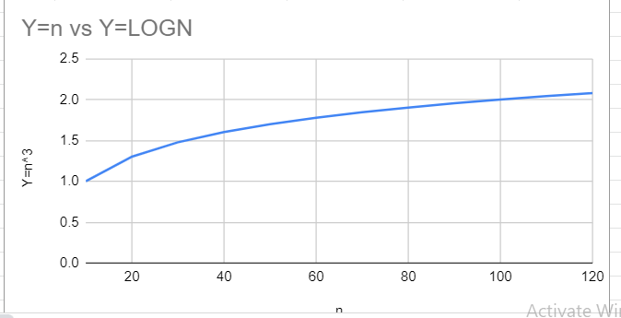

|  |  |
| --- | --- |
| **Question No:5** | |
| n | Y=2n^2+3n |
| 10 | 230 |
| 20 | 860 |
| 30 | 1890 |
| 40 | 3320 |
| 50 | 5150 |
| 60 | 7380 |
| 70 | 10010 |
| 80 | 13040 |
| 90 | 16470 |
| 100 | 20300 |
| 110 | 24530 |
| 120 | 29160 |
| 130 | 34190 |
| 140 | 39620 |
| 150 | 45450 |
| 160 | 51680 |

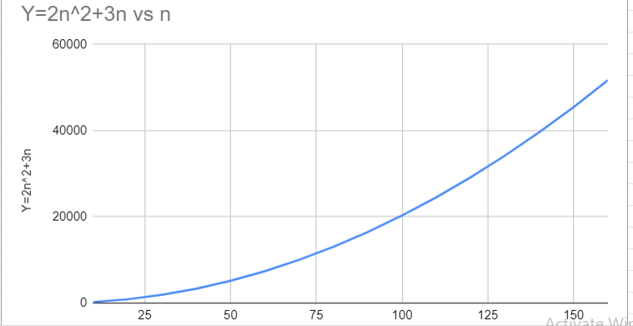

|  |  |
| --- | --- |
| **Question No:6** | |
| n | Y=3n+2 |
| 10 | 32 |
| 25 | 77 |
| 40 | 122 |
| 55 | 167 |
| 70 | 212 |
| 85 | 257 |
| 100 | 302 |
| 115 | 347 |
| 130 | 392 |
| 145 | 437 |
| 160 | 482 |
| 175 | 527 |

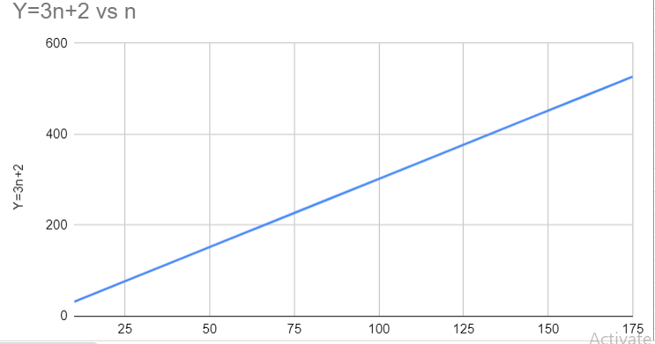

|  |  |  |
| --- | --- | --- |
| **Question No:7** | |  |
| n | Y=n^2 | Y=1000n |
| 100 | 10000 | 100000 |
| 200 | 40000 | 200000 |
| 300 | 90000 | 300000 |
| 400 | 160000 | 400000 |
| 500 | 250000 | 500000 |
| 600 | 360000 | 600000 |
| 700 | 490000 | 700000 |
| 800 | 640000 | 800000 |
| 900 | 810000 | 900000 |
| 1000 | 1000000 | 1000000 |
| 1100 | 1210000 | 1100000 |
| 1200 | 1440000 | 1200000 |
| 1300 | 1690000 | 1300000 |
| 1400 | 1960000 | 1400000 |
| 1500 | 2250000 | 1500000 |
| 1600 | 2560000 | 1600000 |
| 1700 | 2890000 | 1700000 |

