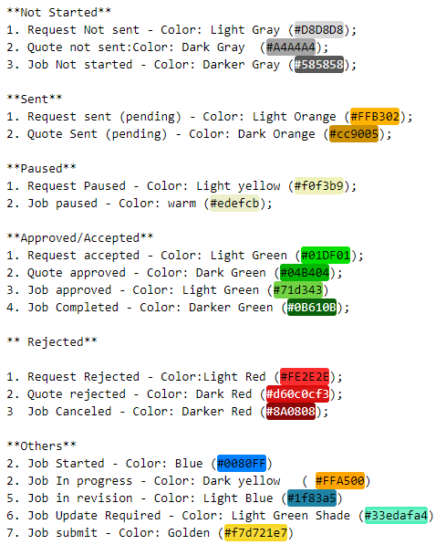

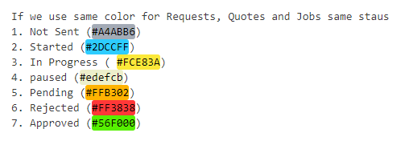

\*\*Not Started\*\*

1. Request not sent - Color: Light Gray (#D8D8D8);

2. Quote not sent: Color: Dark Gray (#A4A4A4);

3. Job Not started - Color: Darker Gray (#585858);

\*\*Sent\*\*

1. Request sent (pending) - Color: Light Orange (#FFB302);

2. Quote Sent (pending) - Color: Dark Orange (#cc9005);

\*\*Paused\*\*

1. Request Paused - Color: Light yellow (#f0f3b9);

2. Job paused - Color: warm (#edefcb);

\*\*Approved/Accepted\*\*

1. Request accepted - Color: Light Green (#01DF01);

2. Quote approved - Color: Dark Green (#04B404);

3. Job approved - Color: Light Green (#71d343)

4. Job Completed - Color: Darker Green (#0B610B);

\*\* Rejected\*\*

1. Request Rejected - Color: Light Red (#FE2E2E);

2. Quote rejected - Color: Dark Red (#d60c0cf3);

3. Job Canceled - Color: Darker Red (#8A0808);

\*\*Others\*\*

2. Job Started - Color: Blue (#0080FF)

2. Job In progress - Color: Dark yellow   (#FFA500)

5. Job in revision - Color: Light Blue (#1f83a5)

6. Job Update Required - Color: Light Green Shade (#33edafa4)

7. Job submit - Color: Golden (#f7d721e7)

Same for Milestones

If we use the same color for Requests, Quotes, and Jobs same status

1. Not Sent (#A4ABB6)

2. Started (#2DCCFF)

3. in Progress (#FCE83A)

4. paused (#edefcb)

5. Pending (#FFB302)

6. Rejected (#FF3838)

7. Approved (#56F000)