**TASK-1:**

TO CALCULATE THE TOTAL COST OF EACH PRODUCT

* CREATE TABLE STRUCTURE IN SNOWFLAKE BY CREATING YOUR OWN WAREHOUSE.
* INSERT SOME 10 ROWS USING INSERT COMMAND
* TRY DIFFERENT VALUES FOR ALL THE COLUMNS AND THEN CHECK USING SELECT *
* CREATE A TABLE CONSISTING OF THE PRODUCT NAME, NUMBER OF ITEMS BOUGHT AND PRICE OF A SINGLE ITEM.
* PRODUCTS MAY APPEAR MULTIPLE TIMES WITH DIFFERENT PRICES.
* WRITE AN SQL QUERY THAT RETURNS THE TOTAL AMOUNT OF MONEY SPENT ON EACH PRODUCT IN DESCENDING ALPHABETICAL ORDER BY PRODUCT

CREATE WAREHOUSE M_WAREHOUSE;

CREATE DATABASE M_DATABASE;

USE DATABASE M_DATABASE;

--TO CALCULATE THE TOTAL COST OF EACH PRODUCT

/*CREATE A TABLE CONSISTING OF THE PRODUCT NAME, NUMBER OF ITEMS BOUGHT AND PRICE OF A SINGLE ITEM. PRODUCTS MAY APPEAR MULTIPLE TIMES WITH DIFFERENT PRICES. */

CREATE TABLE M_Shopping_history(

PRODUCT VARCHAR NOT NULL,

QUANTITY INTEGER NOT NULL,

UNIT_PRICE INTEGER NOT NULL

);

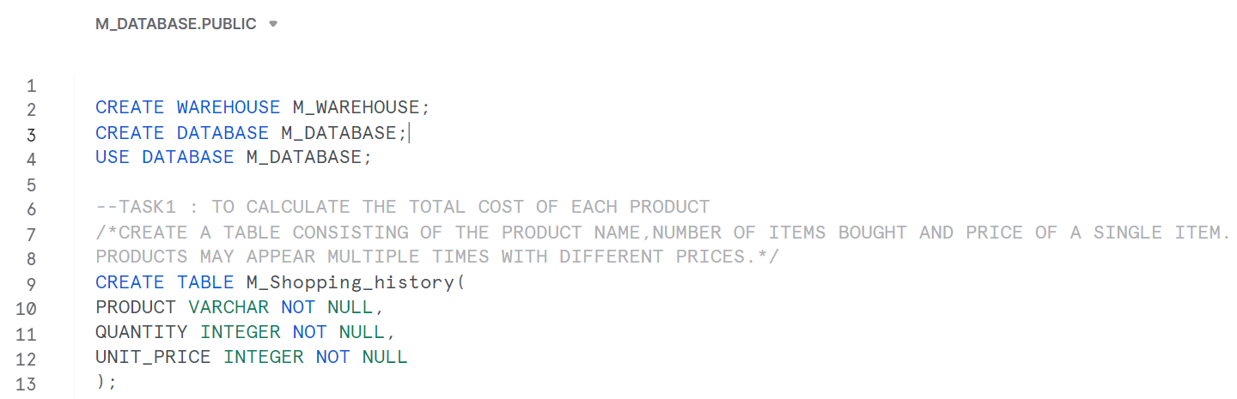

INSERT INTO M_Shopping_history VALUES('Milk',3,10);

INSERT INTO M_Shopping_history VALUES('Bread',7,3);

INSERT INTO M_Shopping_history VALUES('Bread',5,2);

INSERT INTO M_Shopping_history VALUES('Milk',6,12);

INSERT INTO M_Shopping_history VALUES('Cheese',3,8);

INSERT INTO M_Shopping_history VALUES('Milk',2,8);

INSERT INTO M_Shopping_history VALUES('Bread',1,5);

INSERT INTO M_Shopping_history VALUES('Cheese',2,3);

INSERT INTO M_Shopping_history VALUES('Butter',2,10);

INSERT INTO M_Shopping_history VALUES('Butter',1,6);

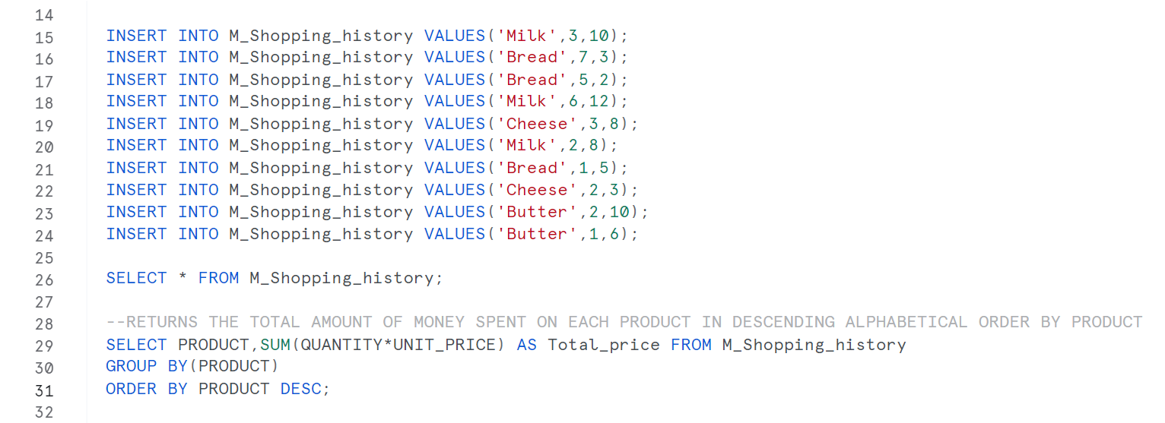

SELECT * FROM M_Shopping_history;



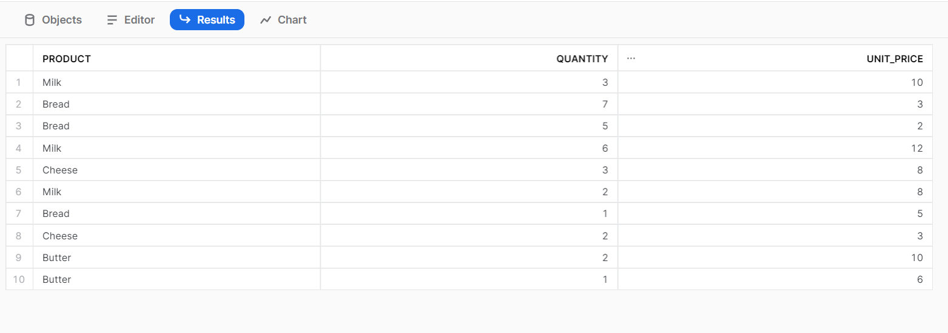

--RETURNS THE TOTAL AMOUNT OF MONEY SPENT ON EACH PRODUCT IN DESCENDING ALPHABETICAL ORDER BY PRODUCT

SELECT PRODUCT, SUM(QUANTITY*UNIT_PRICE) AS Total_price FROM M_Shopping_history group by(PRODUCT) ORDER BY PRODUCT DESC;





