**TASK-2:**

TO FIND NAME OF ALL THE CLIENTS WHO TALKED FOR ATLEAST 10 MINUTES IN TOTAL.

* CREATE A TABLE PHONES WHICH HAS THE INFORMATION ABOUT THE CLIENT’S NAME AND PHONE_NUMBER.
* EVERY CLIENT HAS ONLY ONE NUMBER.
* CREATE A TABLE CALLS WHERE ID HAS THE INFORMATION ABOUT SINGLE CALL, PHONE NUMBER OF THE CALLER, PHONE NUMBER OF THE CALLEE AND THE DURATION OF CALL.
* WRITE AN SQL QUERY THAT RETURNS THE NAMES OF ALL THE CLIENTS WHO TALKED FOR ATLEAST 10 MINUTES IN TOTAL

--CREATE A TABLE PHONES WHICH HAS THE INFORMATION ABOUT THE CLIENT’S NAME AND PHONE_NUMBER.

--EVERY CLIENT HAS ONLY ONE NUMBER

CREATE TABLE Phones(

NAME VARCHAR(20) NOT NULL UNIQUE,

PHONE_NUMBER INTEGER NOT NULL UNIQUE

);

--CREATE A TABLE CALLS WHERE ID HAS THE INFORMATION ABOUT SINGLE CALL,PHONE NUMBER OF THE CALLER ,PHONE NUMBER OF THE CALLEE AND THE DURATION OF CALL.

CREATE TABLE Calls(

ID INTEGER NOT NULL,

CALLER INTEGER NOT NULL,

CALLEE INTEGER NOT NULL,

DURATION INTEGER NOT NULL,

UNIQUE(ID)

);

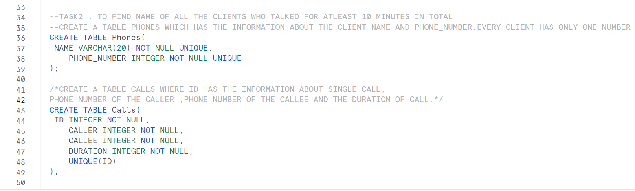

INSERT INTO Phones VALUES('Mishika',123456);

INSERT INTO Phones VALUES('XYZ',111111);

INSERT INTO Phones VALUES('ABC',222222);

INSERT INTO Phones VALUES('WWW',777777);

SELECT * FROM Phones;

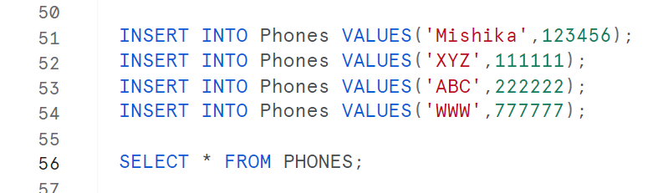

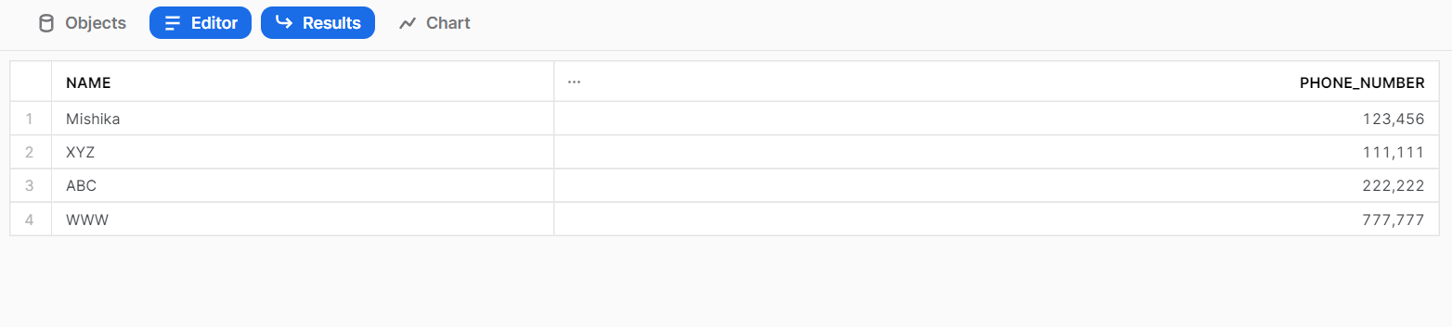

INSERT INTO Calls VALUES(1,123456,111111,8);

INSERT INTO Calls VALUES(2,222222,777777,3);

INSERT INTO Calls VALUES(3,123456,222222,1);

INSERT INTO Calls VALUES(4,111111,222222,1);

INSERT INTO Calls VALUES(5,777777,123456,7);

SELECT * FROM CALLS;

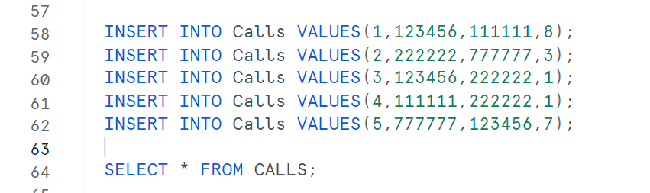

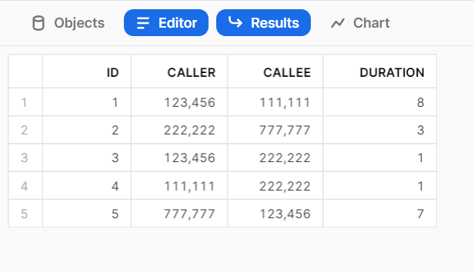

CREATE TABLE NEW AS SELECT NAME, PHONE_NUMBER, DURATION FROM PHONES JOIN CALLS ON PHONES.PHONE_NUMBER = CALLS.CALLER;

SELECT * FROM NEW;



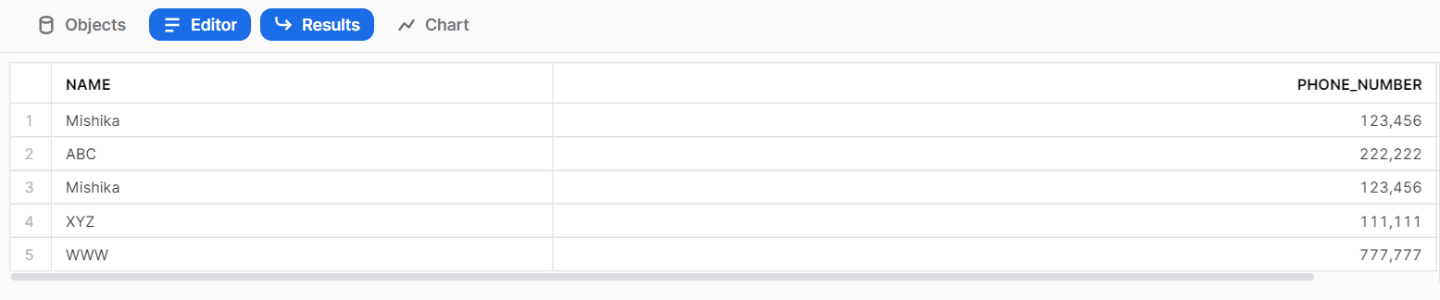

CREATE TABLE NEW1 AS SELECT NAME, PHONE_NUMBER, DURATION FROM PHONES JOIN CALLS ON PHONES.PHONE_NUMBER = CALLS.CALLEE;

SELECT * FROM NEW1;



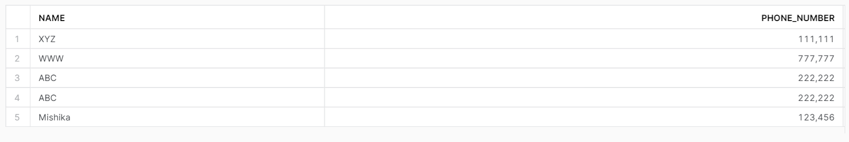

CREATE TABLE NEW2 AS SELECT NAME, PHONE_NUMBER, DURATION FROM NEW UNION SELECT NAME, PHONE_NUMBER, DURATION FROM NEW1;

SELECT * FROM NEW2;



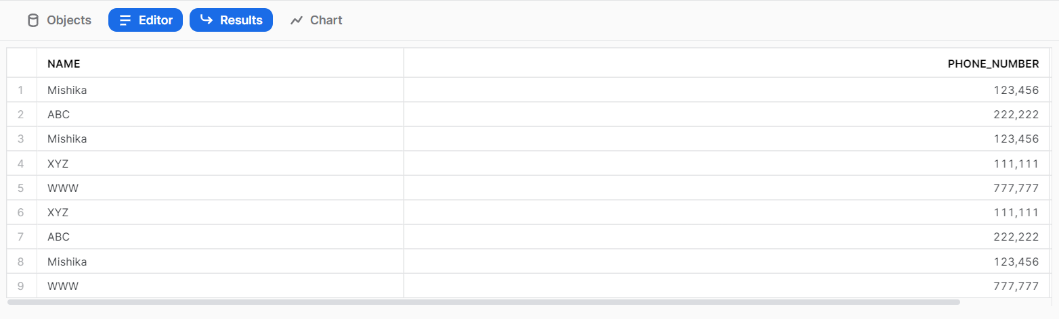

--IT RETURNS THE NAMES OF ALL THE CLIENTS WHO TALKED FOR AT LEAST 10 MINUTES IN TOTAL

SELECT NAME FROM NEW2 GROUP BY NAME HAVING SUM(DURATION)>=10;



