**TASK- 3** :

SQL QUERY THAT RETURNS A TABLE CONTAINING ONLY BALANCE COLUMN WHICH HAS THE TOTAL BALANCE OF YOUR ACCOUNT AT THE END OF THE YEAR INCLUDING ALL THE CREDIT CARD PAYMENTS, INCOMING TRANSFER AND THE FEE FOR HOLDING THE CARD

* THE CREDIT CARD COST CHARGED EACH MONTH IS 5.IT IS NOT CHARGED IF ATLEAST 3 CREDIT CARD PAYMENTS FOR TOTAL COST OF ATLEAST 100 IS DONE WIHTIN THAT MONTH.
* CREATE TABLE TRANSACTIONS WHICH HAS THE INFORMATION ABOUT THE SINGLE TRANSACTION CONTAINING THE AMOUNT OF MONEY AND THE DATE OF THE TRANSACTION
* IF THE AMOUNT IS NEGATIVE, IT IS THE CREDIT CARD PAYMENT
* THERE IS NO TRANSACTION WITH AN AMOUNT OF 0
* IT RETURNS BALANCE COLUMN WHICH CONTAINS THE TOTAL BALANCE OF THE ACCOUNT AT THE END OF THE YEAR.

--CREATE TABLE TRANSACTIONS WHICH HAS THE INFORMATION ABOUT THE SINGLE TRANSACTION CONTAINING THE AMOUNT OF MONEY AND THE DATE OF THE TRANSACTION

CREATE TABLE TRANSACTIONS(

AMOUNT INTEGER NOT NULL,

DATE DATE NOT NULL

);

--IF THE AMOUNT IS NEGATIVE, IT IS THE CREDIT CARD PAYMENT OTHERWISE AN INCOMING TRANSFER.

--THERE IS NO TRANSACTION WITH AN AMOUNT OF 0

INSERT INTO TRANSACTIONS VALUES(1000,'2020-01-06');

INSERT INTO TRANSACTIONS VALUES(-10,'2020-01-14');

INSERT INTO TRANSACTIONS VALUES(-75,'2020-01-20');

INSERT INTO TRANSACTIONS VALUES(-5,'2020-01-25');

INSERT INTO TRANSACTIONS VALUES(-4,'2020-01-29');

INSERT INTO TRANSACTIONS VALUES(2000,'2020-03-10');

INSERT INTO TRANSACTIONS VALUES(-75,'2020-03-12');

INSERT INTO TRANSACTIONS VALUES(-20,'2020-03-15');

INSERT INTO TRANSACTIONS VALUES(40,'2020-03-15');

INSERT INTO TRANSACTIONS VALUES(-50,'2020-03-17');

INSERT INTO TRANSACTIONS VALUES(200,'2020-10-10');

INSERT INTO TRANSACTIONS VALUES(-200,'2020-10-10');

SELECT * FROM TRANSACTIONS;

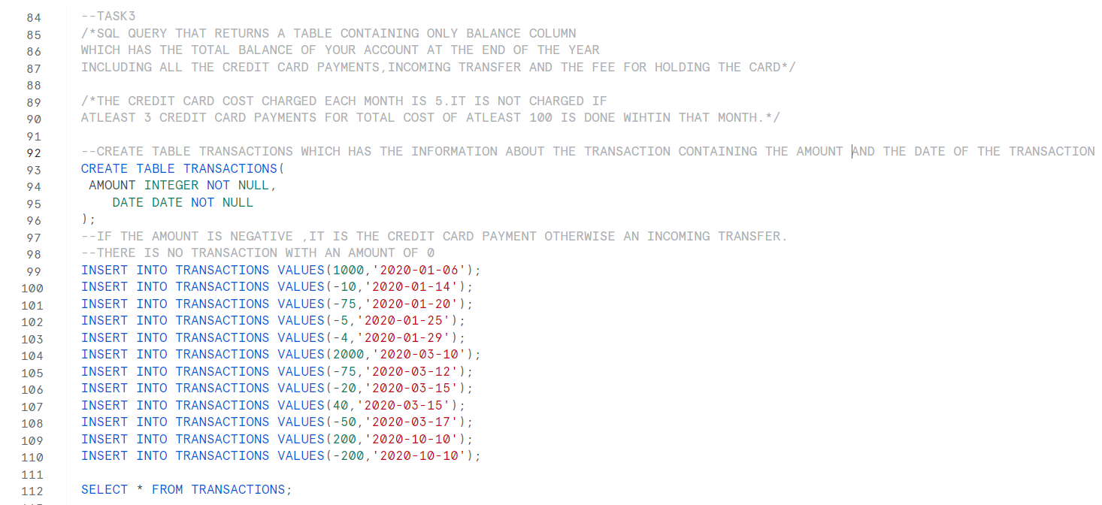

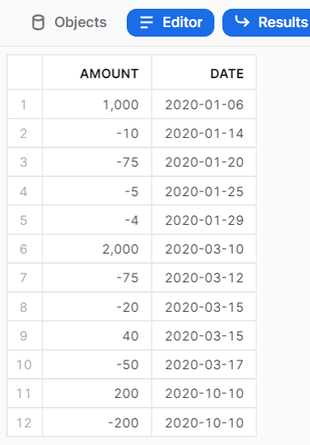

--TOTAL AMOUNT OF ALL THE TANSACTIONS

SELECT SUM(AMOUNT) AS AMT FROM TRANSACTIONS;

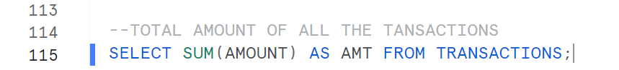

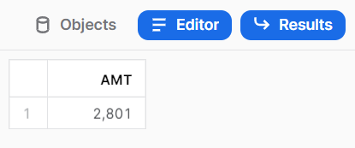

--CREATE A TABLE AS N_TRANSACTION WHICH HAS THE SUM(AMOUNT) COLUMN CONTAINING THE SUM OF CREDIT CARD PAYMENTS AND THE MONTH OF THE TRANSACTION WHERE ATLEAST 3 TRANSACTION OF ATLEAST 100 AMOUNT HAS BEEN MADE.

CREATE TABLE N_TRANSACTION AS

SELECT SUM(AMOUNT) AS N_SUM, DATE_PART('MONTH', DATE) AS MONTH FROM TRANSACTIONS WHERE AMOUNT<0 GROUP BY MONTH HAVING COUNT(-AMOUNT)>=3 AND SUM(-AMOUNT)>=100;

SELECT * FROM N_TRANSACTION;

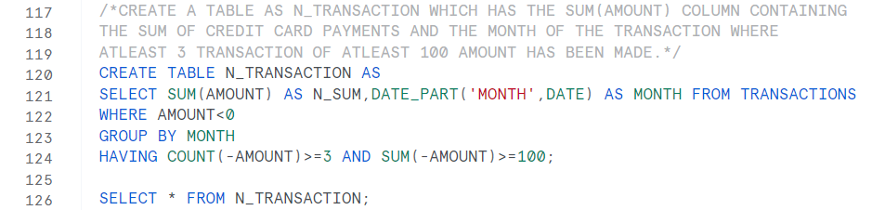

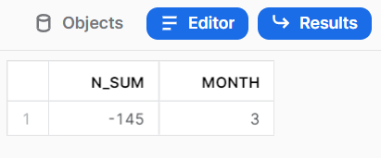

--IT RETURNS THE CREDIT CARD HOLDING CHARGE FOR THE MONTHS OF THE YEAR WHEN ATLEAST 3 TRANSACTIONS ARE NOT MADE OR THE TOTAL COST OF CREDIT CARD PAYMENT DOES NOT HAVE A MINIMUM AMOUNT OF 100.

SELECT 5*(12-COUNT(MONTH)) AS C_M FROM N_TRANSACTION;



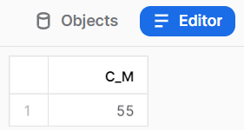

--IT RETURNS THE BALANCE COLUMN CONTAINING THE TOTAL AMOUNT OF ALL THE TRNSACTIONS AND THE CREDIT CARD HOLDING FEE.

CREATE TABLE N_NEW AS SELECT SUM(AMOUNT) AS BALANCE FROM TRANSACTIONS

UNION

SELECT 5*(12-COUNT(MONTH)) FROM N_TRANSACTION;

SELECT * FROM N_NEW;

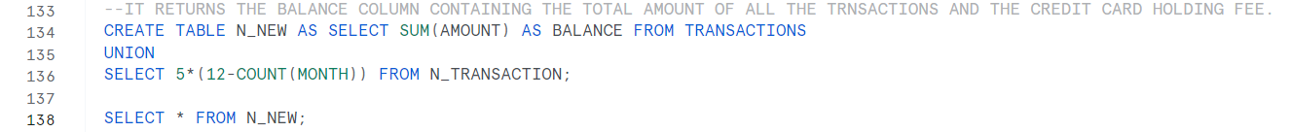

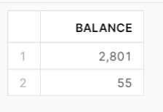

--IT RETURNS BALANCE COLUMN WHICH CONTAINS THE TOTAL BALANCE OF THE ACCOUNT AT THE END OF THE YEAR.

SELECT MAX(BALANCE) - MIN(BALANCE) AS BALANCE FROM N_NEW;



