Game Design Document

Fill up the following document

1. Write the title of your project.

Ans: SHE: The Saviour

1. What is the goal of the game?

Ans: The goal is to kill the terroists and collect the guns. The soldier needs to avoid the bombs placed by the terroists.

1. Write a brief story of your game.

Ans: The Indian Army has got an information from a secret spy that some Pakistani terroists are trying to enter India amidst the pandemic as there are not many soldiers on the border. The Indian Soldiers need to take action as quick as possible and need to start a mission. So, the soldier(player) has started campaigns and we need to kill the terroists and jump above the bombs. The score wil get updated when he kills all the terroists. As the time passes, the speed will increase making the game difficult. Once the soldier misses his target the game will end. The soldier will kill the terroist using his gun.

Which are the playing characters of this game?

* Playing characters are the ones who respond to the user based on the input from the user.
* Cars, monkeys, dinos, wizards, etc., are the playing characters in the game.

|  |  |  |
| --- | --- | --- |
| Number | Character Name | What can this character do? |
| 1 | Soldier | She will kill the terroist and save her country from the attack. |
| 2 |  |  |
| 3 |  |  |
| 4 |  |  |
| 5 |  |  |
| 6 |  |  |
| 7 |  |  |
| 8 |  |  |

1. Which are the Non-Playing Characters of this game?

* Non-Playing characters are the ones that don't have an action or behavior when the user interacts with the game.
* Hurdles, stones, bananas, coins, etc., are non-playing characters in the game.

|  |  |  |
| --- | --- | --- |
| Number | Character Name | What can this character do? |
| 1 | Bombs | They can kill the soldier |
| 2 | Terroist | They can kill the soldier |
| 3 | Guns | They will help the soldier to fight the war. |
| 4 |  |  |
| 5 |  |  |
| 6 |  |  |
| 7 |  |  |
| 8 |  |  |

Draw your imagination of this game. What does this game look like?

* Draw the game either on your computer or on paper.
* Add images of the game scenes to show each of the playing and non-playing characters at least once

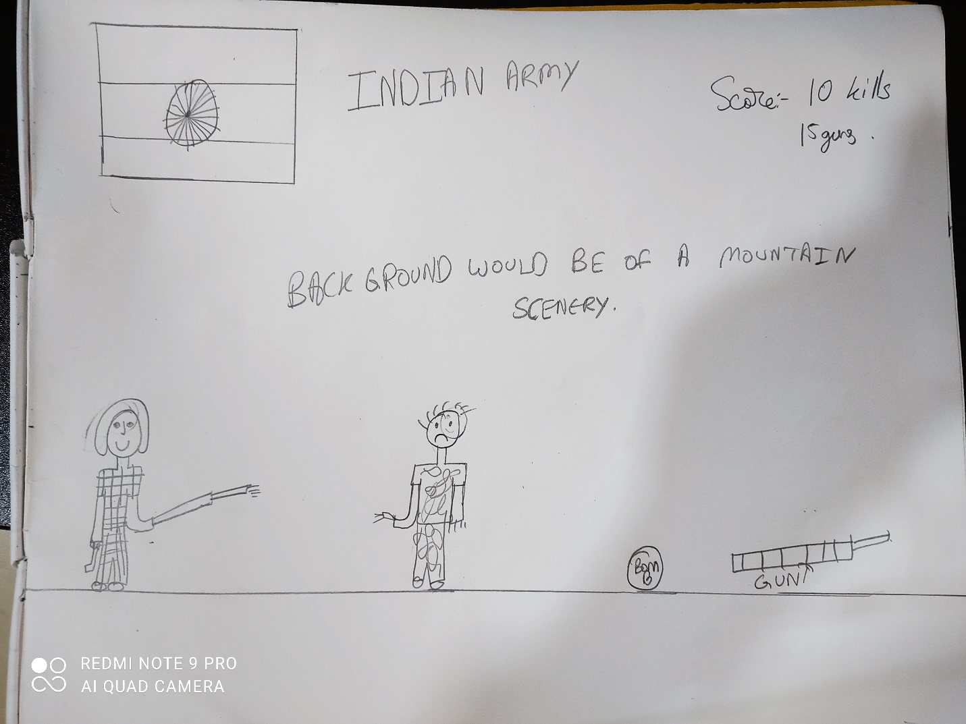

How do you plan to make your game engaging?

Ans: As there is a gun so it will work as a bonus and also when the gamer would kill the soldier there would be a sound of gun shooting. When the player would kill all the enemies, a clapping sound would be there. This game would really look like a war scene as in the game there is a hilly region of Jammu& Kashmir. The player needs to make a stratergy to kill as the speed would gradually increase.