Pac-Man Game
Aim To develop an interactive Pac-Man-style game using a joystick for directional control.
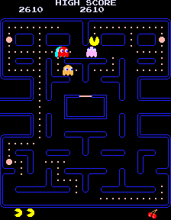

What is the project? An electronic game in which the player controls a character, navigates the game area, and follows the rules programmed into the ESP32.

How does it work?
- The HW-504 joystick detects movement along its horizontal and vertical axes.
- The joystick generates signals corresponding to the direction in which it is moved.
- The ESP32 reads these signals and determines the intended direction.
- The program updates the character's position and checks the game rules.
- The character and game elements are rendered on the display used in the project.
- The display is connected via a configured Bluetooth to the device used

Components used
· ESP32 microcontroller
· HW-504 joystick module
· Breadboard
· Jumper wires

Connections
Component / Pin | Typical connection
Joystick VCC | ESP32 5V
Joystick GND | ESP32 GND
Joystick VRx | ESP32 G34
Joystick VRy | ESP32 G35
Joystick SW | ESP32 G32

