Week 3 Day 3 Loops 17/5/23

# Loops in JavaScript

* Loops are a fundamental concept I programming.
* They allow programmers to perform some action or run some code a specific number of times, or if needed, forever.
* The main types of loops in JavaScript include:
  + For loop
  + While loop

# For loops

Let’s say we wanted to log to the con sole the numbers 1-5.

Without loops:

Violates the DRY principle (Don’t Repeat Yourself)

# Using a For loop

A for loop in JavaScript looks like this:



(initialExpression; conditionExpression; incrementExpression)

Arg1 Arg2 Arg3

We use the keyword “for” to start the for loop and then give it 3 arguments.

* Arg1: 
* This is our initial statement which is executed once before loop begins. We are defining a variable i(short for index) and setting its value to 0.
* Arg2: 
* This is our conditional statement. The loop will continue to run as long asthe condition evaluates to true, and in our case: as long as iis less than 5.
* Arg3: 
* this is our incrementing statement. The ++operator increments our “i” variable (adds 1 to the value of i) at the end of each loop. i++ is the same as writing i = i + 1.

# For loops continued…

Let’s say we wanted to log to the console the numbers 1 –5.

Without loops:

With loops:

# Exercise 1

* Try running a loop that logs to the console the numbers 1-10

# Exercise 2

* Try running a loop that logs to the console the numbers 10 –1 on each console line (so in reverse this time).

# Exercise 3

* We know that if we have a string we can use to get the first letter, to get the second A picture containing text, font, screenshot, clock

  Description automatically generatedletter etc.
* Use a loop to log to the console the each letter of “Responsiveness”

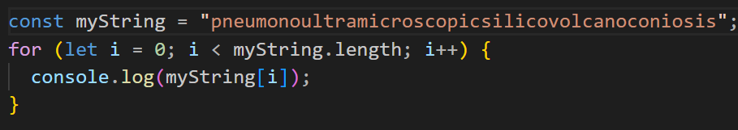

# Exercise 4&5

1. Loop through the following foods object using the for loop. Log to the console each element of this Array



1. Challenge: Within the loop, log each element to the console inside a string which says "I like…”



# Iterating over elements of an array

* The for...of loop iterates over the elements of an array.

# While loops

* Another loop we could use is called a while loop. It works in a similar way to the for loop but allows more freedom over the loop.
* Syntax:

* The condition can be any condition that evaluates to either true or false, similar to the for loop.
* If the condition is true, the block of code will keep running, when the condition becomes false, the code will stop running.

# While loop example

* Let’s take a look at an example of how we can use a while loop.

* We are declaring guess but not defining it.
* We then start our loop and tell it to keep running as long as guess is not equal to 3.
* Inside our loop we are defining guess with whatever the user inputs into a
* prompt()
* As long as the user doesn't type 3 into the prompt()prompt(), the loop continues
* When the user enters 3 into the prompt()prompt(), the loop ends

# Exercise 6

* Create a while loop that logs to the console the user's guess. But add some conditional logic where if the user types in the correct number, it logs some kind of success message to the console.

# Prompts in JavaScript

 instructs the browser to display a dialog prompting the user to input some text, and to wait until the user either submits the text or cancels the dialog.



* Message is an optional message which is displayed to the used.
* Default string is the default value of the input box.

Prompt returns a string, even if you enter a number or Boolean.

To return a number, add  or 

# Different ways to use the prompt method

# Prompt Exercise

1. Using prompt() ask for the age of user
2. Using an if… else statement to determine if the user is legally allowed to drink beer.

* Attention before using if…else:
* What’s the data type we got from prompt()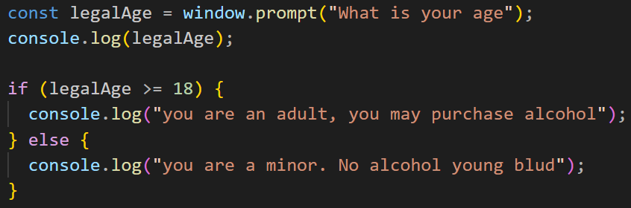

# My Prompt Exercise

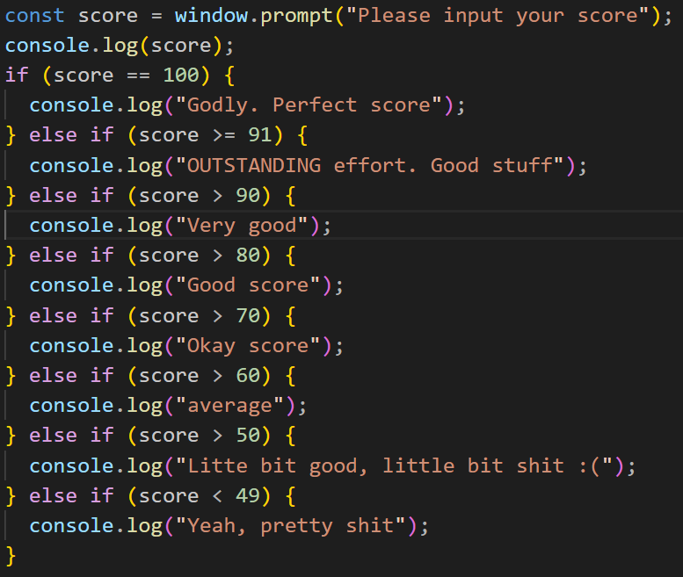

# Breaks and Continues

* When we are in a loop there may be times where we want to skip an iteration of the loop or stop the loop completely based on some condition.
* We can do this with break and continue
* To use a break or a continue all we need to do is add the key word into our loop

# Breaks in while loops

* At times we may not know exactly how many loops we want to go through but we may have an end goal in mind.
* Let’s look at this example

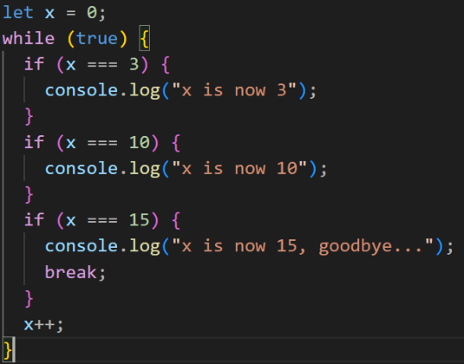In this example, we want the value of x to be 15 but we want to hit some milestones along the way and log a message for them.

We can set the condition of the while statement to true, this allows it to run on a loop forever.

But when we get to our goal of 15 we can set a break and stop the loop.

# Exercise 7

* Use a for loop to loop through a string: "Hell@ the#e".
* If you find a symbol in the string i.e. !, @, #, $ then log to the console an error message and break the loop

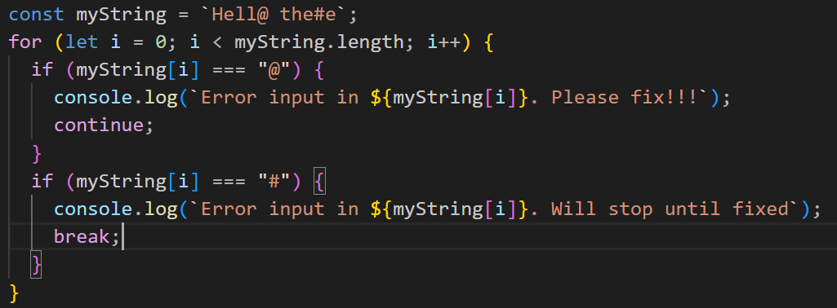

# Iterating over properties of an object

* The for…in loop iterates over the properties of an object.

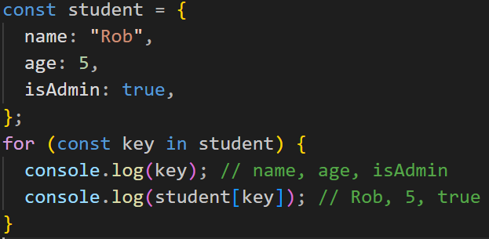

# Exercise 8

1. Loop through the following user object using the for..in loop.
2. Within the loop, log the value of the key age.

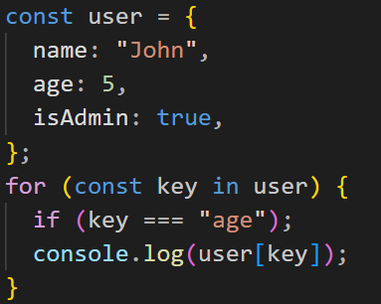

# Bonus: Exercise 9

1. Create an object myFavNumbers with three of your favourite numbers as values (any names for keys).
2. Loop through the object using for..in and find the sum of the numbers.
3. Log the sum to the console.

