Syztem Directory Based Object System

So you are here at the end of the internet and probably another beginning. This program should (if it would work) allow you to create your own military base, economy center, or whatever could create another cyber war. In this world you fight to survive. You may ask why you actually need to fight, while never had to. The answer is obvious: we will open some ports on your device and anyone using SDBOS will be able to take your computer on it’s own. More questions coming up: Then why I’ve downloaded that piece of sh*t? To conquest galaxy! Ehm, sry. Steal some data from your friend’s PC, get more disk space, trade your genius tanks you’ve created or just for fun.
It’s now time to stop that crazy piece of shi+ and introduce You into your new living environment! Yeah, that’s true. You will never need Winshit again! (You will probably encounter many errors in code so nevermind)

What do I need? .
Completely nothing! You don’t even need an operating system! Smash your mouse and jump out of the window! Oh sorry, my mistake. You don’t have money for mouse.
So you’ll need Python 3.4 or newer, obviously. I was using 3.4 writing code and I am sure that 2.7 won’t work.
A good text editor, you could use MS Word but I would rather prefer Notepad++. In Word simple “Hello world!” program would look like this:
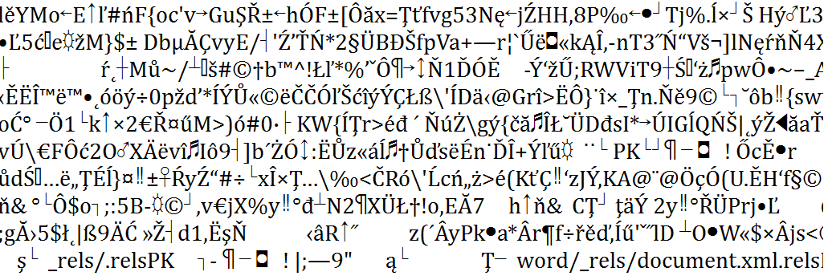
So you could try do something there but it’s not preferred…
You’ll need Winshit Freaking System ‘cause it was easier to me to write it for this poor platform. Most of games are developed for Windows and it would be pain switching os from linux to Windows again and again. Linux version will be soon.
You could also need admin permissions.

Basic overview .
Nope. We won’t code in Basic. Before we start you need appropriate operating system. It can be pirated or legal. Hmmm.. how it was? Windows? Yeah. Pirate windows are sometimes small and could not be opened mostly. Then you should buy yourself a legal window. You need only one. Now look! What a beautiful landscape! Smash the window and jump!
You’ve probably located where is \HELP directory. If not then get used to the first five lines of this chapter. They are really helpful!

