Introduction of Unit
Node.js is a powerful runtime environment that has redefined how server-side applications are built. It bridges the gap between client-side and server-side programming by enabling JavaScript to run outside the browser. This unit introduces Node.js, exploring its features, advantages, and the industries that rely on it for building modern, scalable, and efficient applications.

Introduction to Node.js
Node.js is an open-source, cross-platform runtime environment built on Google Chrome's V8 JavaScript engine. It allows developers to execute JavaScript code server-side, making it possible to build dynamic, real-time, and scalable applications efficiently. Introduced by Ryan Dahl in 2009, Node.js is particularly suited for applications requiring non-blocking, event-driven architectures, such as chat applications, streaming platforms, and APIs.
- Key Characteristics:
  - Uses JavaScript as its programming language.
  - Implements a non-blocking, event-driven I/O model.
  - Designed for high-performance, scalable network applications.

Features of Node.js
Node.js boasts several features that make it a preferred choice for modern application development:
- Asynchronous and Event-Driven:
  - Node.js processes requests without waiting for responses, enabling faster handling of multiple requests concurrently.
- Single-Threaded but Scalable:
  - It uses a single-threaded architecture with an event loop, capable of handling thousands of simultaneous connections without overwhelming server resources.
- High Performance:
  - Powered by the V8 JavaScript engine, Node.js compiles JavaScript directly to machine code, resulting in faster execution.
- Built-in NPM (Node Package Manager):
  - Provides access to a vast repository of over one million libraries, simplifying and accelerating development.
- Cross-Platform Compatibility:
  - Runs on Windows, macOS, and Linux, making it versatile and widely applicable.
- Real-Time Applications:
  - Ideal for applications requiring real-time interaction, such as chat platforms, gaming servers, and live-streaming services.
- Rich API Support:
  - Offers APIs to build a wide range of applications, from web servers to networking tools.

Who Uses Node.js?
Node.js is trusted by several prominent organizations and industries for its reliability and scalability. Here are some examples:
- Netflix:
  - Uses Node.js to reduce startup times and handle high traffic for its streaming services.
- LinkedIn:
  - Transitioned to Node.js for its backend to handle large-scale real-time data efficiently.
- PayPal:
  - Enhanced performance and reduced response times by adopting Node.js for its web applications.
- Uber:
  - Relies on Node.js to process millions of data requests in real time.
- Walmart:
  - Uses Node.js to manage high-traffic e-commerce transactions.
- Other Notable Users:
  - eBay, Trello, NASA, and GoDaddy.

Advantages of Node.js
- Speed:
  - The V8 engine compiles JavaScript to native machine code, ensuring high performance.
- Scalability:
  - The event-driven, non-blocking architecture allows applications to handle a large number of simultaneous connections with minimal resources.
- Single Programming Language:
  - JavaScript can be used for both frontend and backend, reducing the need to learn multiple languages and frameworks.
- Active Community and Ecosystem:
  - A vibrant community supports Node.js, contributing to a rich ecosystem of modules and packages via NPM.
- Asynchronous Programming:
  - Promotes non-blocking operations, enabling efficient execution of multiple tasks.
- Cross-Platform Development:
  - Tools like pkg allow Node.js applications to be compiled into executable files for various operating systems.
- Cost-Efficiency:
  - Lower memory and resource usage reduces server costs for organizations.
- Real-Time Capability:
  - Enables the creation of real-time web applications, such as collaborative tools and instant messaging platforms.

Conclusion
Node.js represents a significant shift in server-side programming by leveraging JavaScript's capabilities beyond the browser. Its asynchronous, non-blocking architecture and single-threaded event loop make it ideal for high-performance, scalable, and real-time applications. With a rich ecosystem and strong community support, Node.js is a powerful tool for modern developers, making it a must-learn technology in the era of full-stack development.

Traditional Web Server Model
Introduction
The traditional web server model is the foundation upon which many early web applications were built. It involves a request-response architecture where each incoming client request is handled by creating a separate thread or process on the server. This model, while straightforward, has inherent limitations in terms of scalability and efficiency, especially under heavy load.

How the Traditional Web Server Model Works
- Request-Response Cycle:
  - A client (usually a web browser) sends a request to the server.
  - The server processes the request, performs necessary operations (like querying a database), and sends a response back to the client.
- Thread/Process for Each Request:
  - For each incoming request, the server spawns a new thread or process to handle the request independently.
- Blocking I/O Operations:
  - Each thread waits (or blocks) until its I/O operations, such as file reading or database queries, are completed.
- Resource Allocation:
  - Each thread requires system resources (memory and CPU). As the number of threads increases, resource consumption grows significantly.

Key Characteristics of the Traditional Model
- Blocking Architecture:
  - Operations are executed sequentially, and a thread waits for one task to complete before moving to the next.
- Heavy Resource Usage:
  - Each thread consumes a considerable amount of memory and CPU, limiting the number of concurrent requests the server can handle.
- Limited Scalability:
  - As the number of clients grows, the server's performance degrades due to the overhead of managing multiple threads.
- Predictable Execution:
  - Because tasks are executed in order, the model is simpler to understand and debug.

Challenges with the Traditional Web Server Model
- Scalability Issues:
  - Creating a new thread or process for each request leads to significant resource consumption, making the model unsuitable for handling high traffic.
- Concurrency Bottleneck:
  - The blocking nature of the model limits its ability to handle concurrent requests efficiently.
- High Latency:
  - Requests that involve slow I/O operations can cause delays for other requests waiting in the queue.
- Inefficiency in Real-Time Applications:
  - Real-time applications, like chat apps or live updates, require faster response times and cannot afford the delays introduced by the traditional model.

Example of a Traditional Web Server
A common example is the Apache HTTP Server, which:
- Uses a thread-per-request architecture.
- Relies on multi-threading to handle multiple client connections.
Workflow:
- A client sends a request to the Apache server.
- The server spawns a thread to handle the request.
- The thread processes the request (e.g., fetches data from a database).
- The thread sends the response back to the client and terminates.

Comparison with Modern Models (e.g., Node.js)
Aspect | Traditional Web Server Model | Modern Models (e.g., Node.js)
Concurrency | Uses threads; limited by system resources. | Event-driven, non-blocking; highly scalable.
Scalability | Limited by thread management. | Can handle thousands of concurrent requests.
Resource Usage | High due to thread overhead. | Low due to single-threaded architecture.
I/O Operations | Blocking. | Non-blocking.
Performance | Degrades with high traffic. | Optimized for real-time and high-traffic apps.

Conclusion
The traditional web server model laid the groundwork for web application development but struggles to meet the demands of modern, high-performance applications. Its thread-based, blocking architecture is resource-intensive and less efficient for handling concurrent requests. Modern server models like Node.js, with their non-blocking, event-driven design, address these limitations and are better suited for today's real-time, scalable applications.

Node.js Process Model
Introduction
The Node.js process model is a fundamental concept that defines how Node.js handles multiple client requests efficiently. Unlike traditional web server models that use a thread-per-request approach, Node.js employs an event-driven, non-blocking I/O model, allowing it to handle thousands of concurrent connections with minimal resource usage.

Key Components of the Node.js Process Model
- Single-Threaded Architecture:
  - Node.js operates on a single thread to handle all incoming requests.
  - This thread does not wait for a task to complete and moves on to handle the next task.
- Event Loop:
  - The event loop is the core mechanism of Node.js, which listens for incoming requests and executes callbacks when operations are completed.
  - It ensures non-blocking execution by delegating time-consuming tasks to worker threads or the operating system.
- Non-Blocking I/O:
  - Input/Output operations (e.g., reading files, querying databases) do not block the main thread.
  - These operations are delegated, and a callback is invoked upon completion.
- Callback Functions:
  - Functions passed as arguments to asynchronous operations, executed after the completion of the task.
  - These enable Node.js to handle multiple tasks concurrently.
- Worker Threads (for Heavy Tasks):
  - For CPU-intensive tasks, Node.js uses worker threads from the libuv thread pool to avoid blocking the main thread.
  - Examples include file system operations or cryptographic computations.

How the Process Model Works
- Receiving a Request:
  - The event loop accepts an incoming client request.
- Delegating the Task:
  - For I/O-intensive tasks, the request is passed to a worker thread or the OS.
  - For lightweight operations, it is executed directly in the main thread.
- Callback Execution:
  - Once the operation is complete, the callback function is queued and executed in the event loop.
- Response:
  - The processed data is sent back to the client without blocking other tasks.

Advantages of Node.js Process Model
- Efficient Resource Utilization:
  - Uses fewer threads and consumes less memory compared to traditional models.
- High Scalability:
  - Handles thousands of concurrent requests efficiently.
- Real-Time Applications:
  - Ideal for real-time scenarios like chat applications, gaming servers, and live updates.
- Improved Performance:
  - Non-blocking I/O and event-driven architecture minimize latency.

Traditional Web Server Model
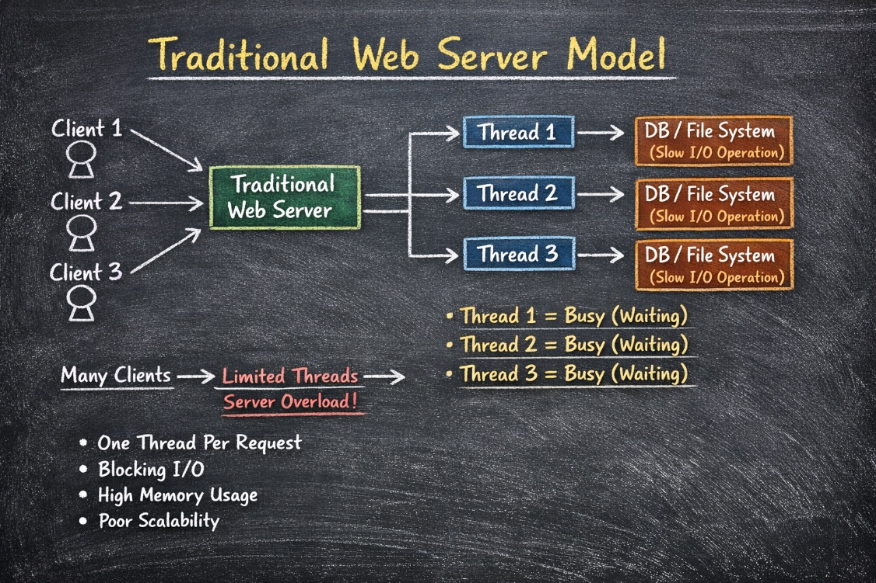
In the traditional web server model, each request is handled by a dedicated thread from the thread pool. If no thread is available in the thread pool at any point of time then the request waits till the next available thread. Dedicated thread executes a particular request and does not return to thread pool until it completes the execution and returns a response.

Node.js Process Model
Node.js processes user requests differently when compared to a traditional web server model. Node.js runs in a single process and the application code runs in a single thread and thereby needs less resources than other platforms. All the user requests to your web application will be handled by a single thread and all the I/O work or long running job is performed asynchronously for a particular request. So, this single thread doesn't have to wait for the request to complete and is free to handle the next request. When asynchronous I/O work completes then it processes the request further and sends the response.
An event loop is constantly watching for the events to be raised for an asynchronous job and executing callback function when the job completes. Internally, Node.js uses libev for the event loop which in turn uses internal C++ thread pool to provide asynchronous I/O.
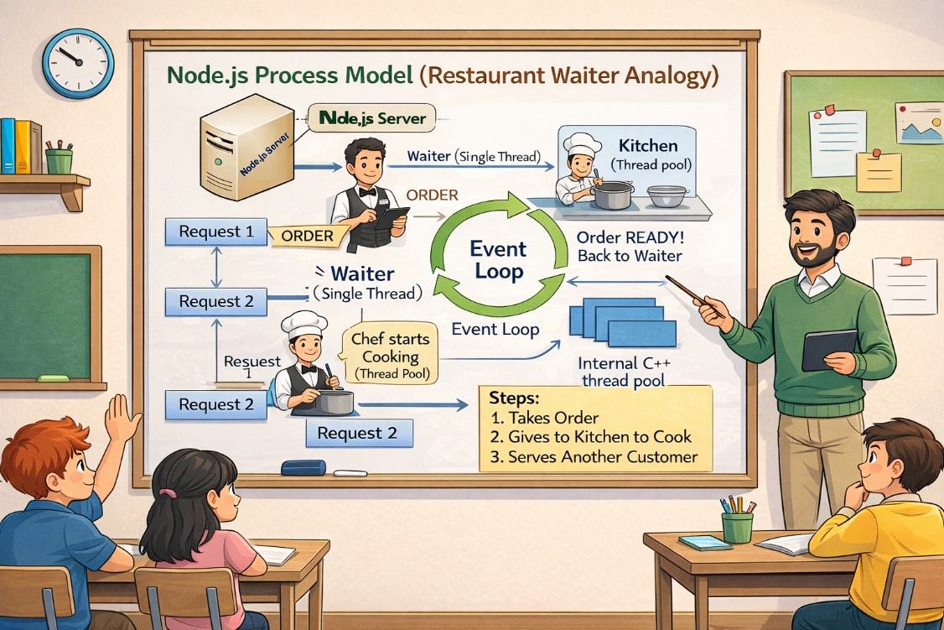
The following figure illustrates asynchronous web server model using Node.js.

Node.js process model increases the performance and scalability with a few caveats. Node.js is not fit for an application which performs CPU-intensive operations like image processing or other heavy computation work because it takes time to process a request and thereby blocks the single thread.
Example Workflow
Suppose multiple users send requests to a Node.js server:
- User A requests data from a database.
- User B sends an API request for computation.
- User C requests a static file.
  - The event loop handles all three requests simultaneously.
  - Database query and file I/O are delegated to worker threads.
  - Computation for User B is completed in the main thread.
  - When database and file operations are done, their respective callbacks are executed, and responses are sent.
Conclusion of Unit
Node.js introduces a transformative approach to server-side programming with its non-blocking, event-driven process model. By leveraging a single-threaded architecture with asynchronous I/O, Node.js delivers exceptional scalability and performance, especially for real-time and data-intensive applications. Its process model addresses the inefficiencies of traditional web servers, making it a powerful choice for modern developers. Mastering Node.js equips developers with the tools to build fast, scalable, and efficient web applications, meeting the demands of contemporary technology trends.

