Objective
Implement the following UI, layout, and content updates on the Batch Details page to improve user experience and align the page with the latest design requirements.

1. Full-Width Contact Section
Requirement
Redesign the Call Us and Enquiry / Get Details section.
Changes
- Make the section span the entire page width.
- Use a prominent call-to-action design.
- Place two large buttons/cards:
  - 📞 Call Us
  - 📝 Enquiry / Get Details
- Ensure both buttons are highly visible and mobile responsive.

2. Calling Hours
Display office timings clearly below the Call Us button.
Office Timings
Day | Timing
Monday – Friday | 10:30 AM – 6:30 PM
Saturday | 10:30 AM – 2:00 PM
Sunday | Closed
UI
- Display timings in a clean card or information box.
- Include relevant icons for better readability.

3. Move "Buy Now" Section
Requirement
Relocate the Buy Now / Choose Your Plan section.
Changes
- Move the complete Buy Now section to the bottom of the Batch Details page.
- Ensure it appears after all informational sections, including trainers, placements, comparison table, FAQs, etc.
- Keep the design consistent with the rest of the portal.

4. Trainer Section Title & Hierarchy
Requirement
Replace the current section title:
Current
- Learn from Industry Veterans
New
- Learn from the Best Trainers
Trainer Display
Instead of a simple card layout, display trainers in a hierarchical tree structure.
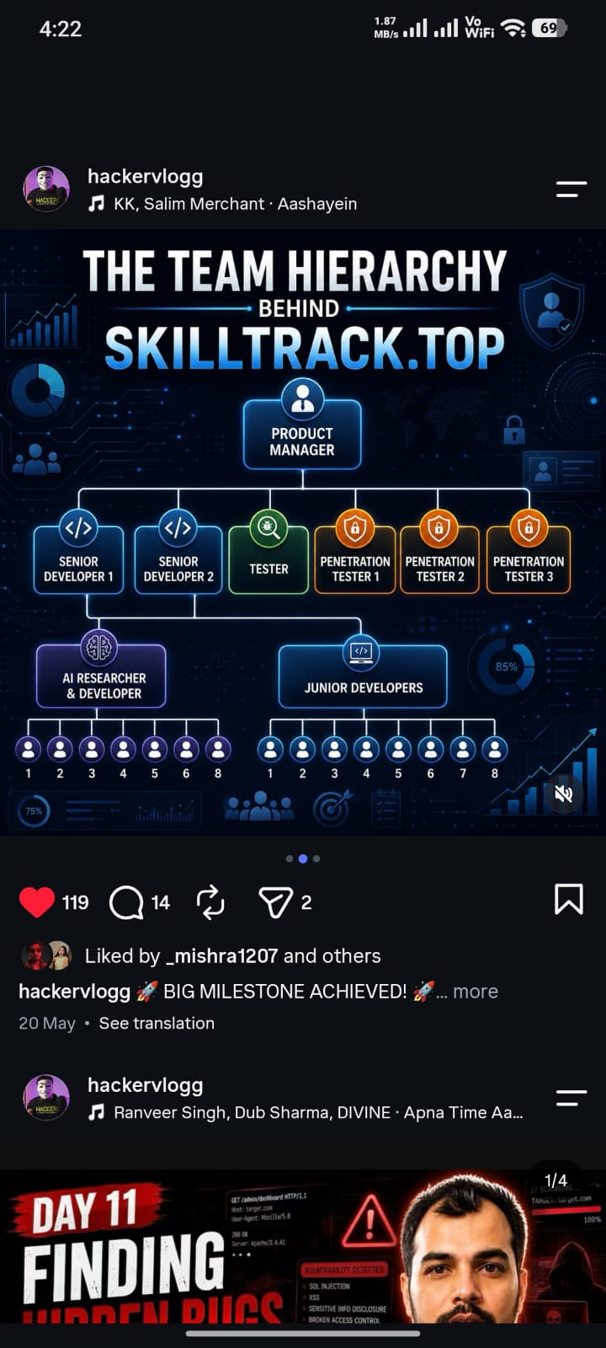
Each trainer node should include:
- Trainer Photo
- Trainer Name
- Designation
- Department/Domain
- Reporting or mentor hierarchy (where applicable)
Requirements
- Use a tree/organizational hierarchy layout.
- Responsive on all screen sizes.
- Expandable/collapsible hierarchy if needed.

5. Welcome Letter Update
Requirement
Update the Welcome Letter content.
Changes
- Replace the old year with the current year wherever applicable.
- Verify all references to academic sessions and dates.
- Ensure consistency across all Welcome Letter templates.

6. UI & Responsiveness
- Maintain ASD Academy Portal branding.
- Fully responsive layout.
- Proper spacing and alignment.
- Smooth animations where applicable.
- Ensure accessibility and readability on desktop, tablet, and mobile.

Deliverables
- Full-width Call Us & Enquiry section.
- Office timings displayed with proper formatting.
- Buy Now section moved to the bottom of the page.
- Trainer section updated to "Learn from the Best Trainers" with hierarchical tree layout.
- Welcome Letter updated with the current year.
- Fully responsive implementation with clean UI.

Priority
Medium
Expected Outcome
The Batch Details page should provide a stronger call-to-action, clearer contact information, improved trainer presentation, and an updated, well-structured layout that enhances the overall user experience.

