
2025-26
Acropolis Institute of Technology and Research, Indore

Submitted To:

Prof. Rishi Acharya

Department of CSE
(Artificial Intelligence & Machine Learning)

Database Management System (AL-502)

Submitted By:

Nehal Mishra
0827AL231081 ALT - 1/ 3rd / 5th

[Lab Assignment dbms (AL-502)]

Department of CSE (Artificial Intelligence & Machine Learning)

CERTIFICATE

This is to certify that the experimental work entered in this journal as per the B. TECH. III year syllabus prescribed by the RGPV was done by Ms. Nehal Mishra B. TECH III year V semester in the Database Management System of this institute during the academic year 2025- 2026.

Signature of the Faculty

ABOUT THE LABORATORY

- In this lab, students will be able to learn and practice Database Management System (AL-502) concepts. Students can expand their skill set by getting hands-on experience on various Operating System concepts. Experimenting on process scheduling and other operating system tasks. The concepts & hands-on experience discussed in this lab focuses on Operating System concepts and it’s commercial.
The outcome of this lab is to make students familiarizing with Linux system calls for process management and inter-process communication.

GENERAL INSTRUCTIONS FOR LABORATORY CLASSES

- DO’S

  - Without Prior permission do not enter into the Laboratory.

  - While entering into the LAB students should wear their ID cards.

  - The students should come with proper uniform.

  - Students should sign in the LOGIN REGISTER before entering into the
laboratory.

  - Students should come with observation and record note book to the laboratory.

  - Students should maintain silence inside the laboratory.

  - After completing the laboratory exercise, make sure to shut down the
system properly.

- DONT’S

  - Students bringing the bags inside the laboratory.

  - Students using the computers in an improper way.

  - Students scribbling on the desk and mishandling the chairs.

  - Students using mobile phones inside the laboratory.

HARDWARE AND SOFTWARE REQUIREMENTS:

S.  No. | Name of Item | Specification
1 | Computer System | Hard Disk min 5 GB RAM: 4 GB / 8 GB  Processor: Intel i3 or above

S.  No. | Name of Item | Specification
1 | Operating system | Windows X
2 | Software and Editor | Oracle g13, Oracle Online Editor

Program Outcome (PO)

The engineering graduate of this institute will demonstrate:
- Apply knowledge of mathematics, science, computing and engineering fundamentals to computer science engineering problems.
- Able to identify, formulate, and demonstrate with excellent programming, and problem solving skills.
- Design solutions for engineering problems including design of experiment and processes to meet desired needs within reasonable constraints of manufacturability, sustainability, ecological, intellectual and health and safety considerations.
- Propose and develop effective investigational solution of complex problems using research methodology; including design of experiment, analysis and interpretation of data, and combination of information to provide suitable conclusion. synthesis
- Ability to create, select and use the modern techniques and various tools to solve engineering problems and to evaluate solutions with an understanding of the limitations.
- Ability to acquire knowledge of contemporary issues to assess societal, health and safety, legal and cultural issues.
- Ability to evaluate the impact of engineering solutions on individual as well as organization in a societal and environmental context, and recognize sustainable development, and will be aware of emerging technologies and current professional issues.
- Capability to possess leadership and managerial skills, and understand and commit to professional
ethics and responsibilities.
- Ability to demonstrate the team work and function effectively as an individual, with an ability to design, develop, test and debug the project, and will be able to work with a multi-disciplinary team.
- Ability to communicate effectively on engineering problems with the community, such as being able to write effective reports and design documentation.
- Flexibility to feel the recognition of the need for, and have the ability to engage in independent and life- long learning by professional development and quality enhancement programs in context of technological change.
- A practice of engineering and management principles and apply these to one’s own work, as a member and leader in a team, to manage projects and entrepreneurship

Table of contents

s. no | Name of the experiment | Date of the experiment | Remarks
 | Introduction to database management and basic DDL and DML commands.
Implementation of DDL and DML queries
  - Write a query for create command
  - Write a query for insert and display it using select command
  - Write a query for delete and update command
  - Write a query for rename and alter command
  - Write a query for drop command
Implementation of where and ordered by clauses:
  - Write a query for select command using where clause
  - Write a query for select command using ordered by clause
Implementation of operators in oracle
  - Write a query using like operator
  - Write a query using IN operator
  - Write a query using BETWEEN operator
 | Write a query for pseudo columns
Implementation of advanced SQL plus commands
  - Write a query for referential integrity
  - Write a query for table alias
  - Write a query for column alias
Implementation of join operations in dbms
  - Write a query for Equi and non – Equi join commands
  - Write a query for self-join command
  - Write a query for natural join command
  - Write a query for cross join command
  - Write a query for outer join commands (left, full and right)
Implementation of functions and columns functions in dbms
  - Write a query for column function command
  - Write a query for character function
  - Write queries for date functions
Implementation of buffer and edit commands
  - Write a query for performing buffer command
  - Write a query for performing edit command in oracle
Implementation of checking constraints
10.1 Write a query by using IN and NOTIN operators
10.2 Write a query by using not null constraint.
10.3 Write a query by using unique constraint.
10.4 Write a query by using check constraint.
10.5 Write a query by using primary and foreign key constraint.
Implementation of clauses in SQL:

11.1. Write a query for implementing order by clause in ascending and descending order.
11.2. Write a query for implementing group by clause in SQL.
11.3. Write a query for implementing having clause in SQL.
Implementing of various types of subqueries.
12.1 Write a subquery for the particular query.
12.2 Write a query for union and union all commands.
12.3 Write a query for intersect and also for minus commands.
12.4 Write a subquery along with set operators.
Implementation of views in SQL.
13.1 Write a query for showing limited fields in views.
13.2 Write a query for updating or replacing the views.
13.3 Write a query for showing only single view.
Implementation of store procedure in SQL:
14.1 Write a query for input variables in SQL.
14.2 Write a query for define and bind variables
14.3 Write a query for if / else statements in SQL
14.4 Write a query for loop structures in SQL.
Implementation of pl commands:
15.1 Implementation of cursor command in different ways.
15.2 Implementation of trigger command in different ways.

Experiment: 1
Aim: Introduction to database management and basic DDL and DML commands.
Introduction:
A database management system (or DBMS) is essentially nothing more than a computerized data-keeping system. Users of the system are given facilities to perform several kinds of operations on such a system for either manipulation of the data in the database or the management of the database structure itself.
SQL commands which stand for structured query language. SQL commands are instructions. It is used to communicate with the database. It is also used to perform specific tasks, functions, and queries of data
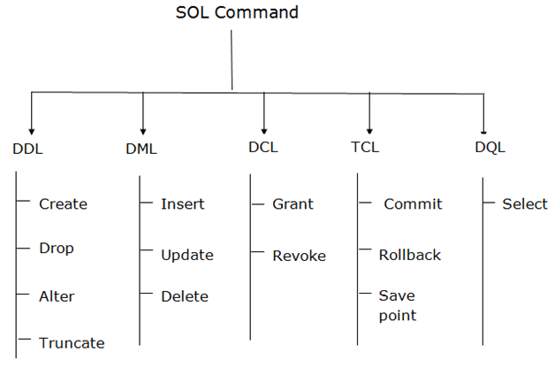
There are five types of SQL commands are : DML, DDL, DQL, TCL, DCL

- Data Definition Language (DDL) commands:
- CREATE to create a new table or database.
- ALTER for alteration.
- Truncate to delete data from the table.
- DROP to drop a table.
- RENAME to rename a table.
- Data Manipulation Language (DML) commands:
- INSERT to insert a new row.
- UPDATE to update an existing row.
- DELETE to delete a row.
- MERGE for merging two rows or two tables.
- Data Control Language (DCL) commands:
- COMMIT to permanently save.
- ROLLBACK to undo the change.
- SAVEPOINT to save temporarily.

Experiment: 2
Aim: Implementation of DDL and DML queries.
  - Write a query for create command.
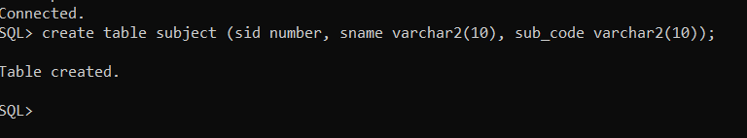

  - Write a query for insert command and display it using select .

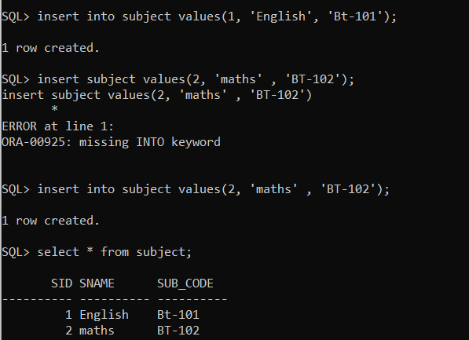

  - Write a query for delete and update command.

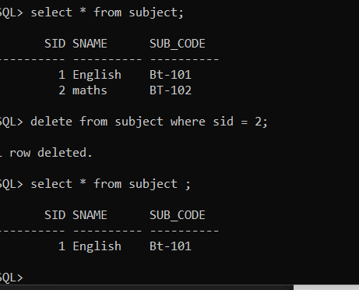

  - Write a query for rename and alter command.

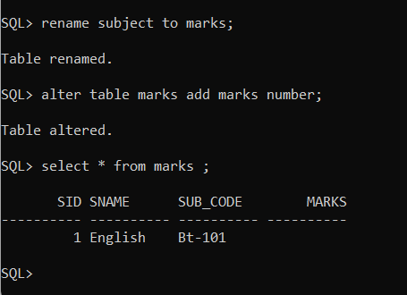

  - Write a query for drop command.
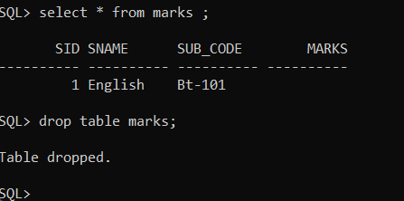

Experiment: 3
Aim: Implementation of where and ordered by clauses.

  - Write a query for select command using where clause.
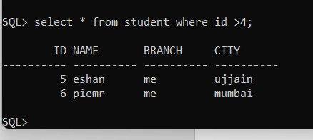

  - Write a query for select command using order by clause.

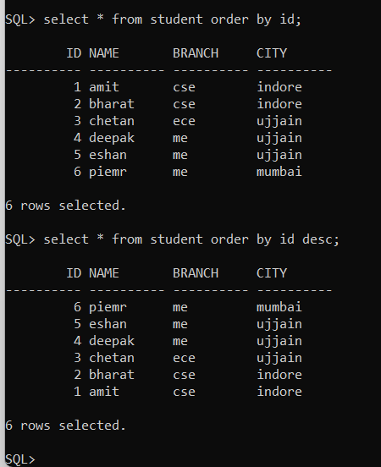

Experiment: 4

Aim: Implementation of operators in oracle.
- Write a query using like operator.

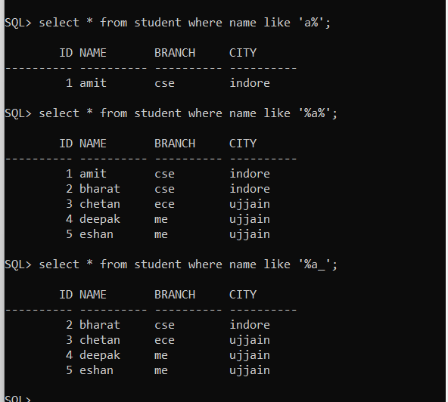

- Write a query using in operator.

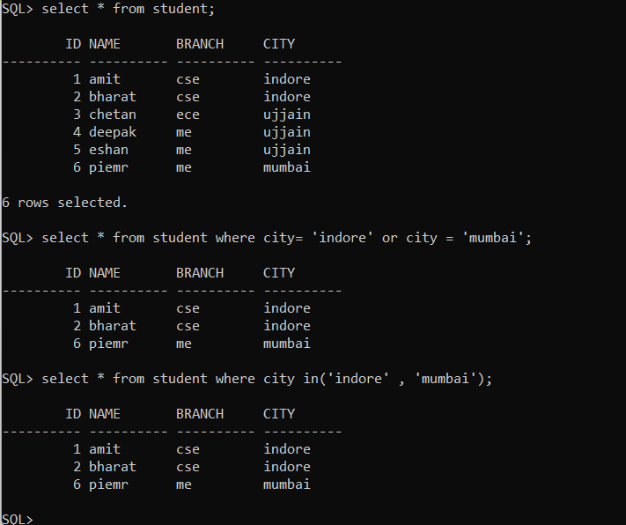

- Write a query using BETWEEN operator.

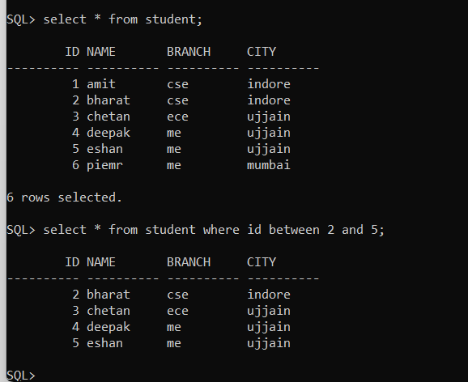

Experiment: 5

Aim: Write a query for pseudo columns.
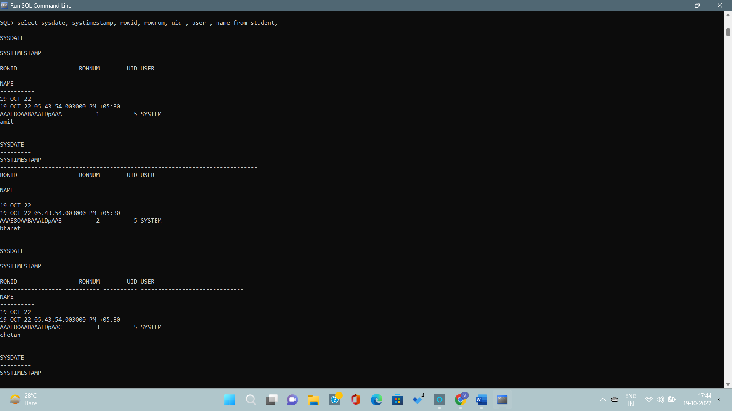

Experiment: 6
Aim: Implementation of advanced SQL queries.
- Write a query for referential integrity.
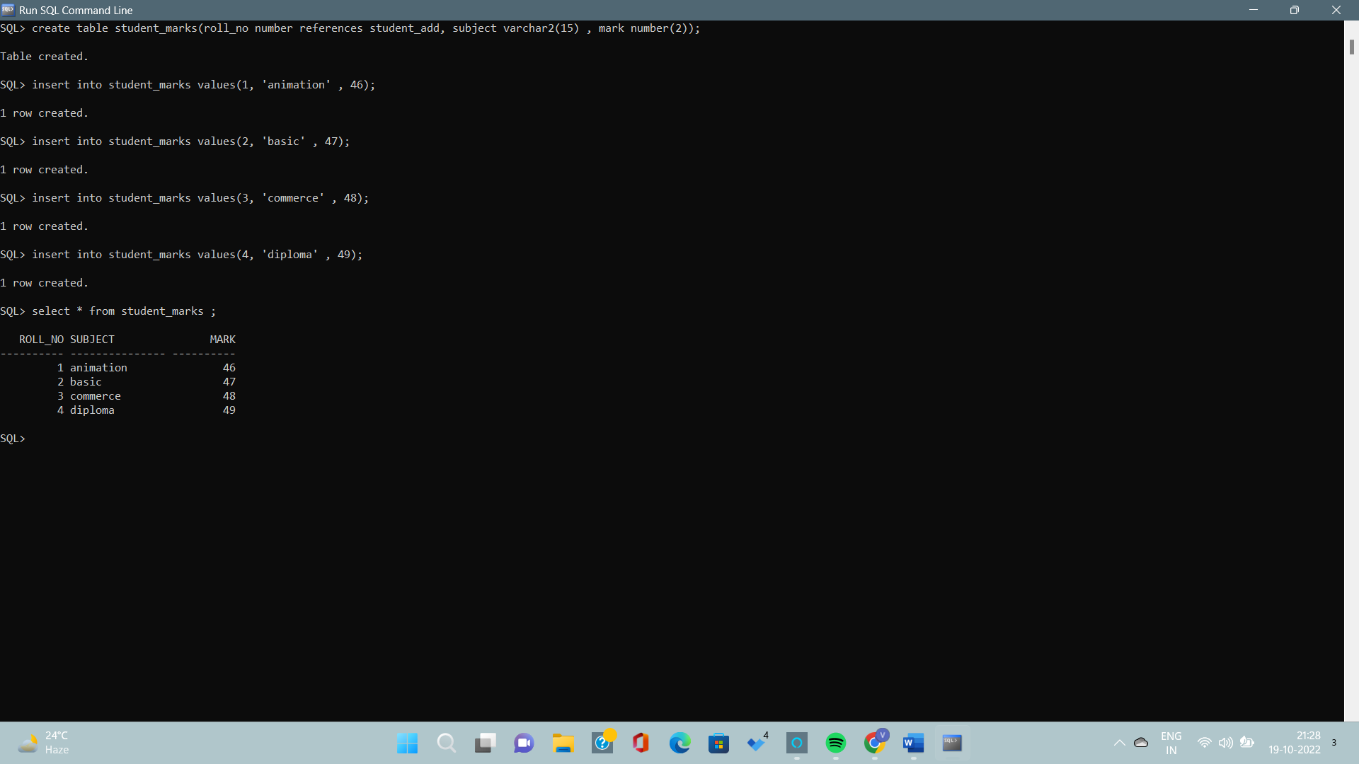

- Write a query for table alias
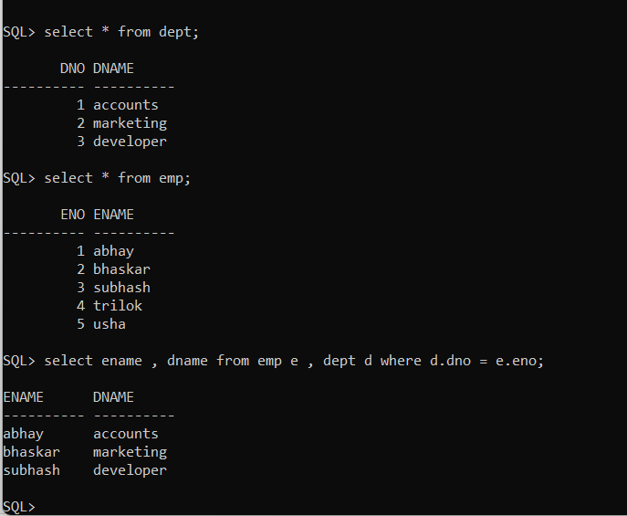
- Write a query for column alias
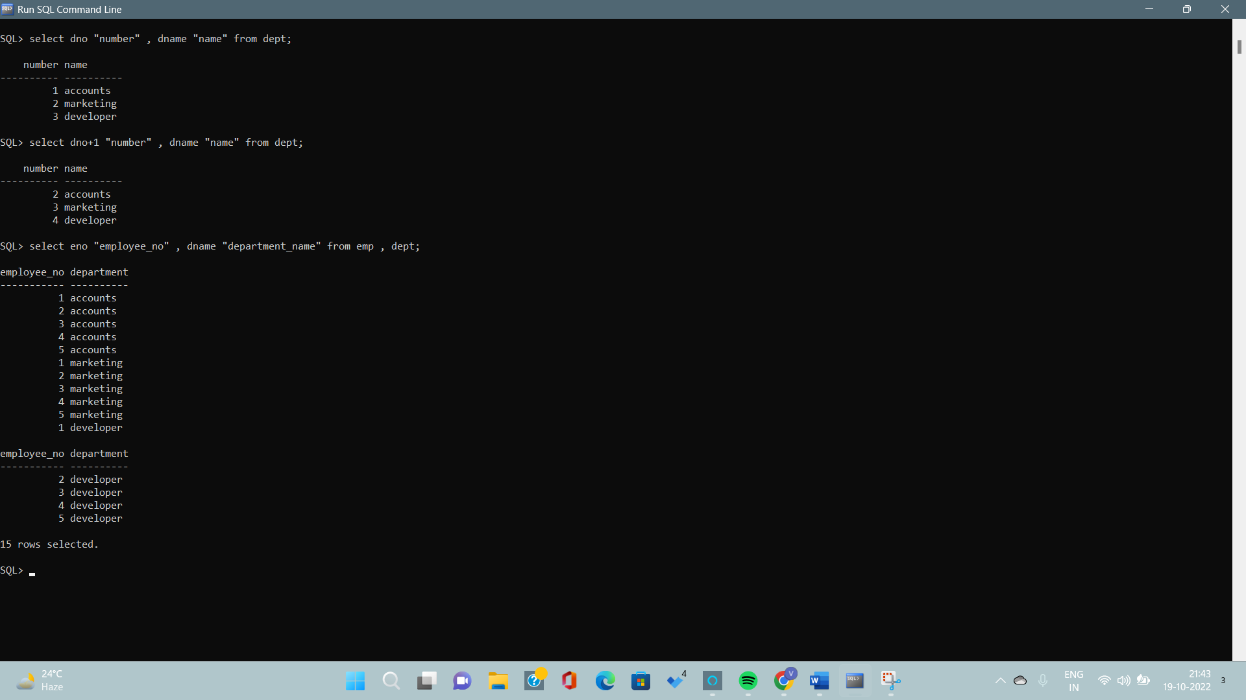

Experiment: 7
Aim: Implementation of join operations in dbms
  - Write a query for equi and non – equi join commands.
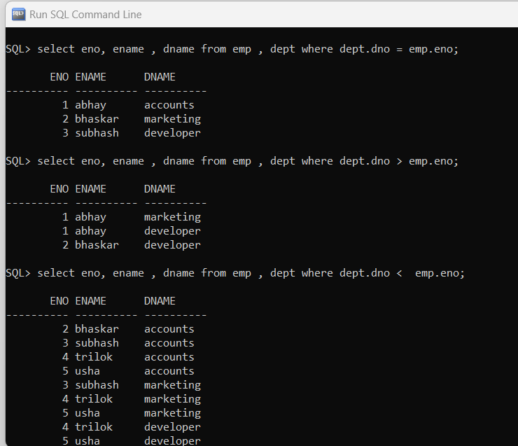

  - Write a query for self join commands.
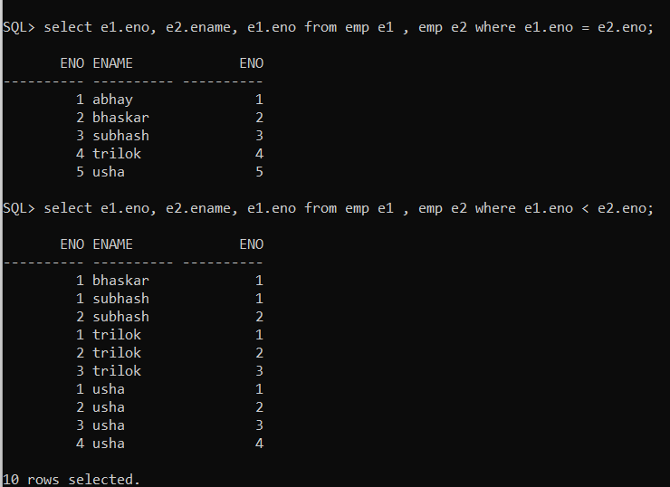
  - Write a query for natural join command
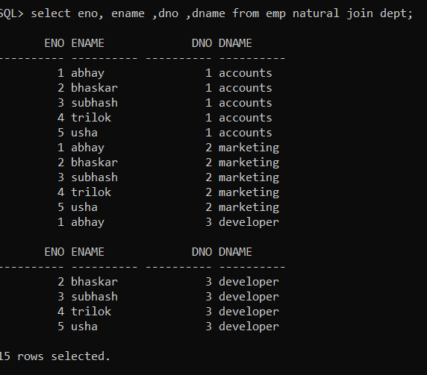

  - Write a query for cross join command
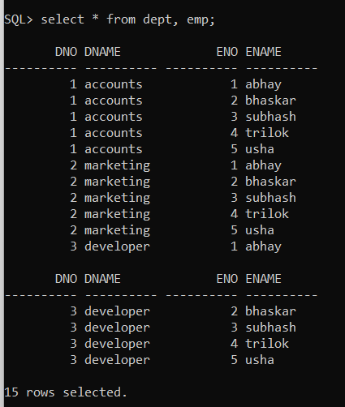

  - Write a query for outer join commands (left , full and right)

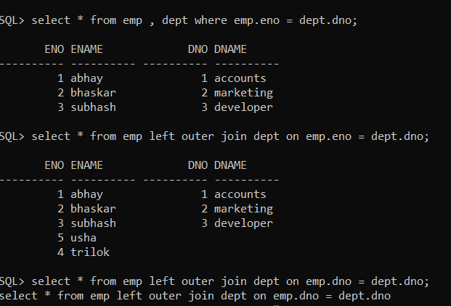

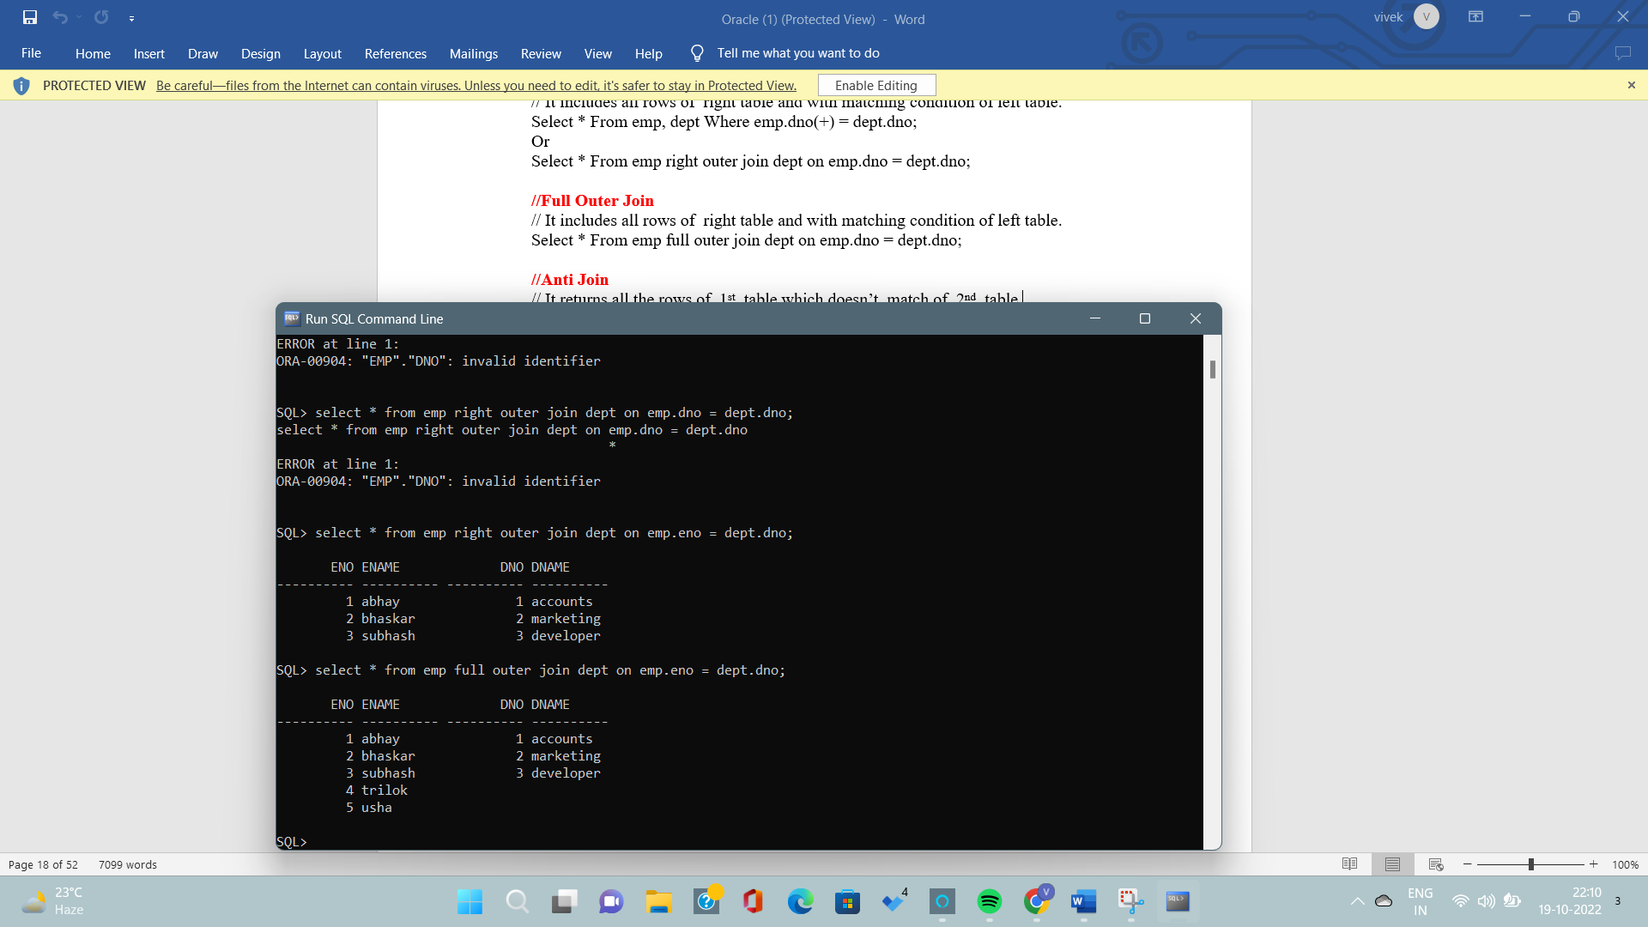

Experiment: 8
Aim: Implementation of functions and columns functions]in dbms
  - Write a query for column functions command.

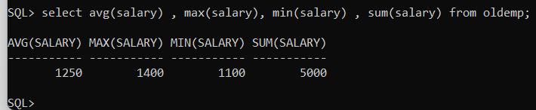

  - Write a query for character function.
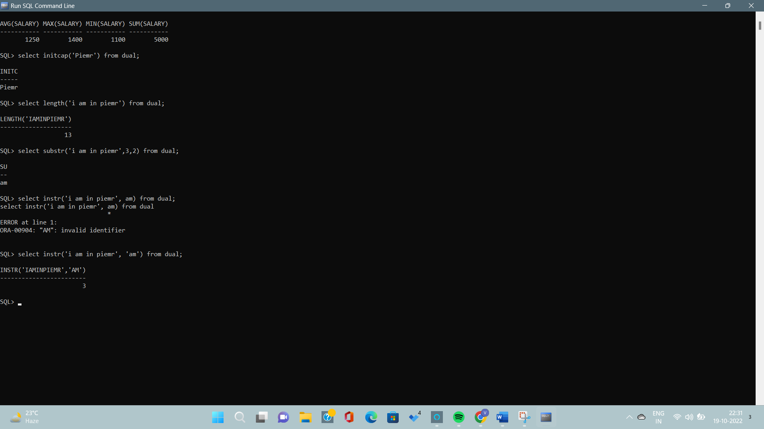

  - Write queries for date function.

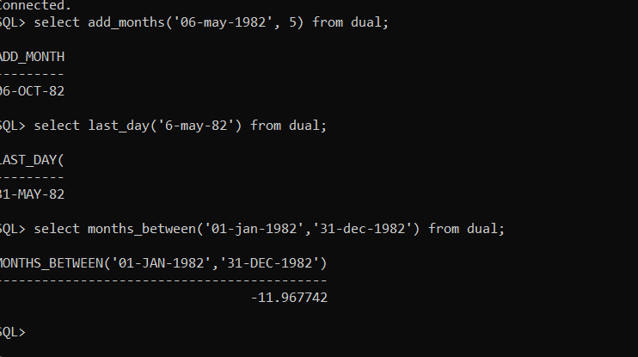

Experiment: 9
aim: Implementation of buffer and edit commands
  - Write a query for performing buffer command.
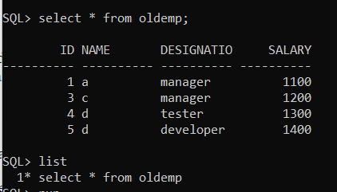

- Write a query for performing edit command in oracle.
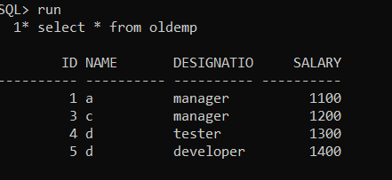

Experiment : 10
Aim: Implementation of checking constraints
  - Write a query by using IN and NOTIN operators
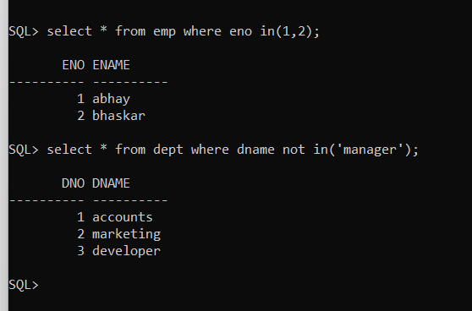

  - Write a query by using not null constraint.
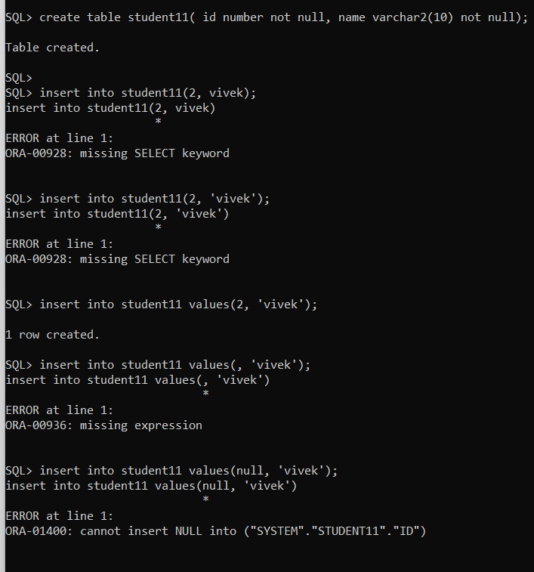

  - Write a query by using unique constraint.
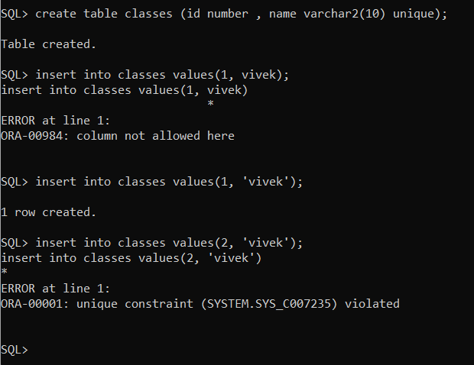

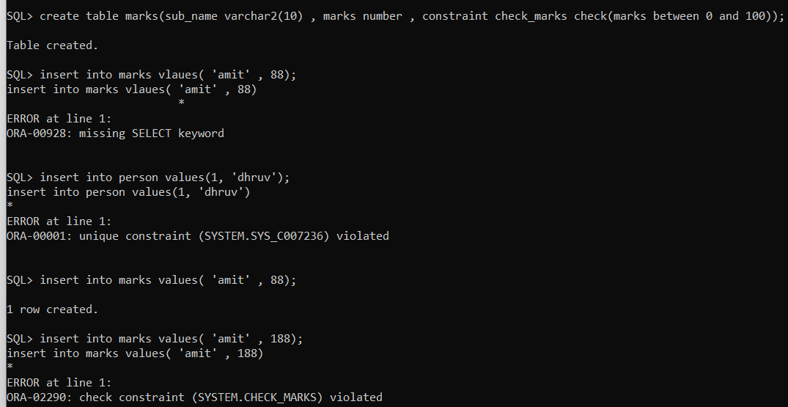
  - Write a query by using check constraint.

  - Write a query by using primary and foreign key constraint.
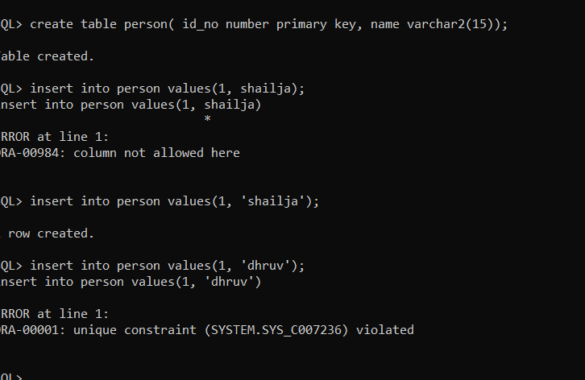

Experiment: 11
Aim: Implementation of clauses in sql :

- write a query for implementing order by clause in ascending and descending order .
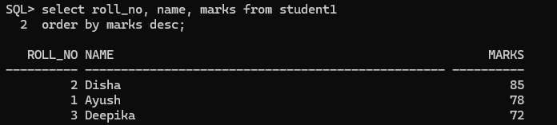
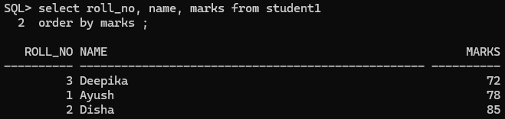
- write a query for implementing group by clause in sql.
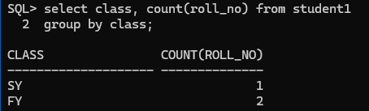

3. Write a query for implementing having clause in sql
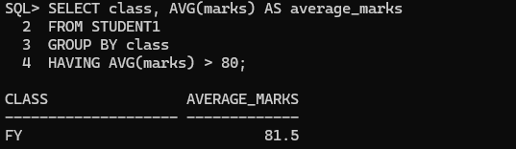

Experiment: 12
Aim :Implementing of various types of subqueries.

1 write a subquery for the particular query.
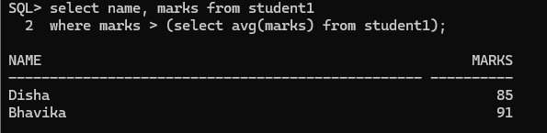
2 write a query for union and union all commands .

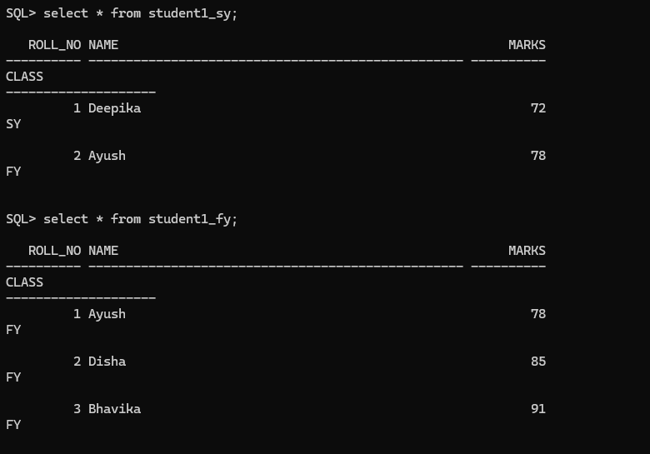

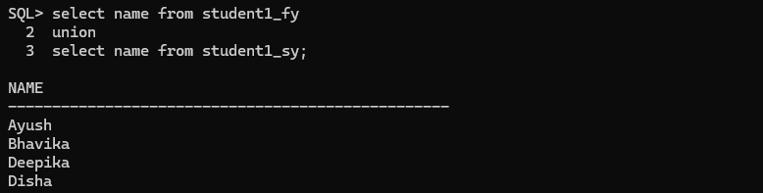

3 write a query for intersect and also for minus commands.
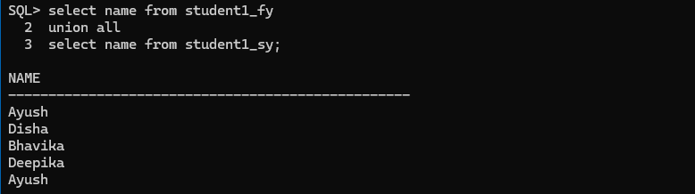
4 Write a subquery along with set operators .
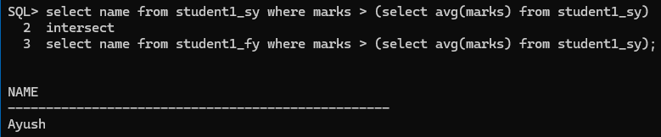

Experiment: 13
Aim :Implementation of views in sql .

1 write a query for showing limited fields in views.
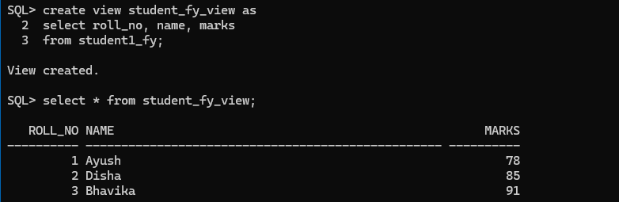
2 write a query for updating or replacing the views .
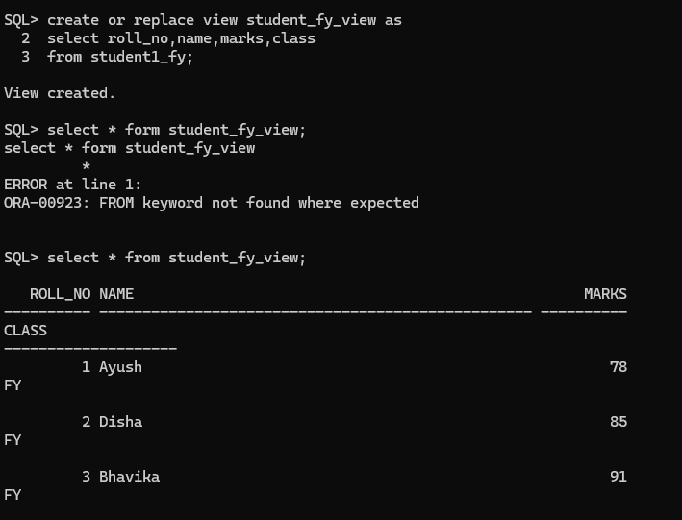
3 write a query for showing only single view.
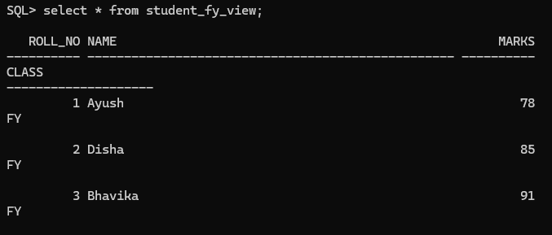
Experiment: 14

Aim :Implementation of store procedure in sql:

1 write a query for input variables in sql.
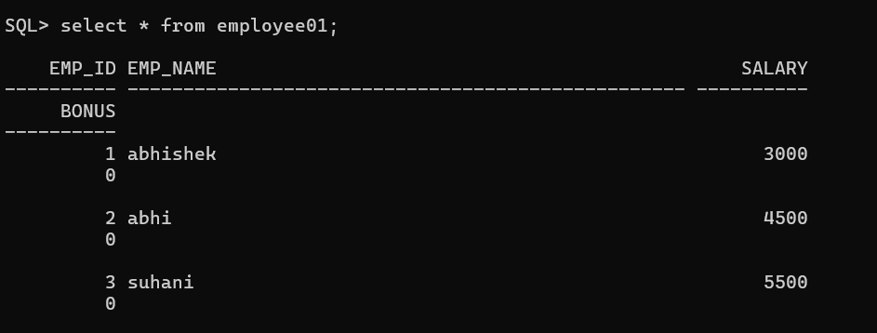
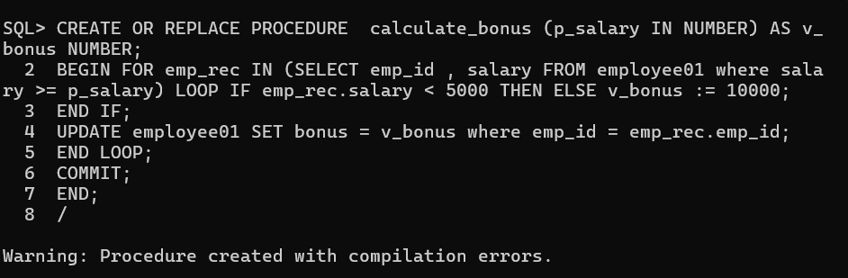

2 write a query for define and bind variables

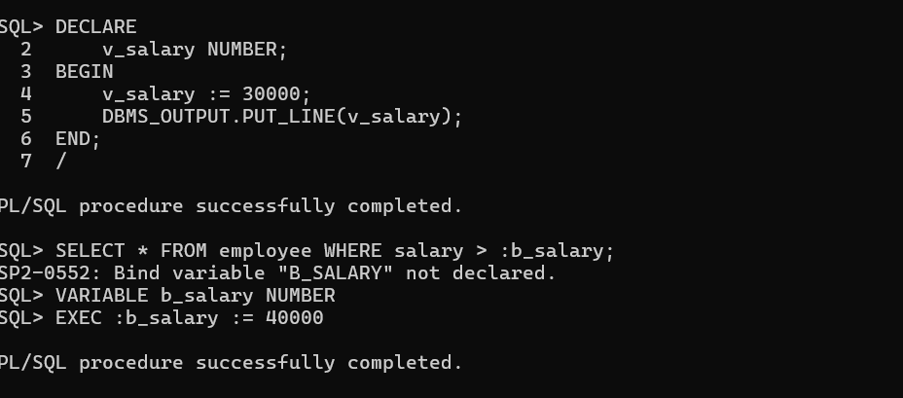

3 write a query for if / else statements in sql

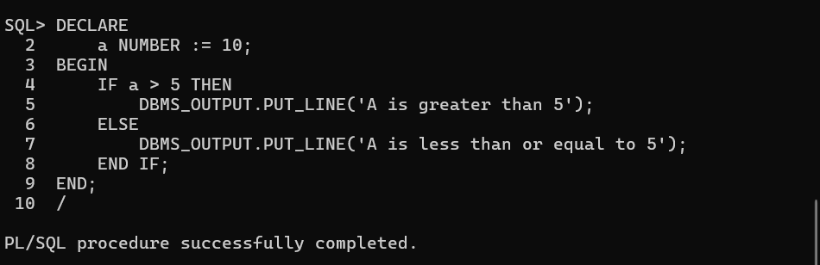
4 write a query for loop structures in sql .
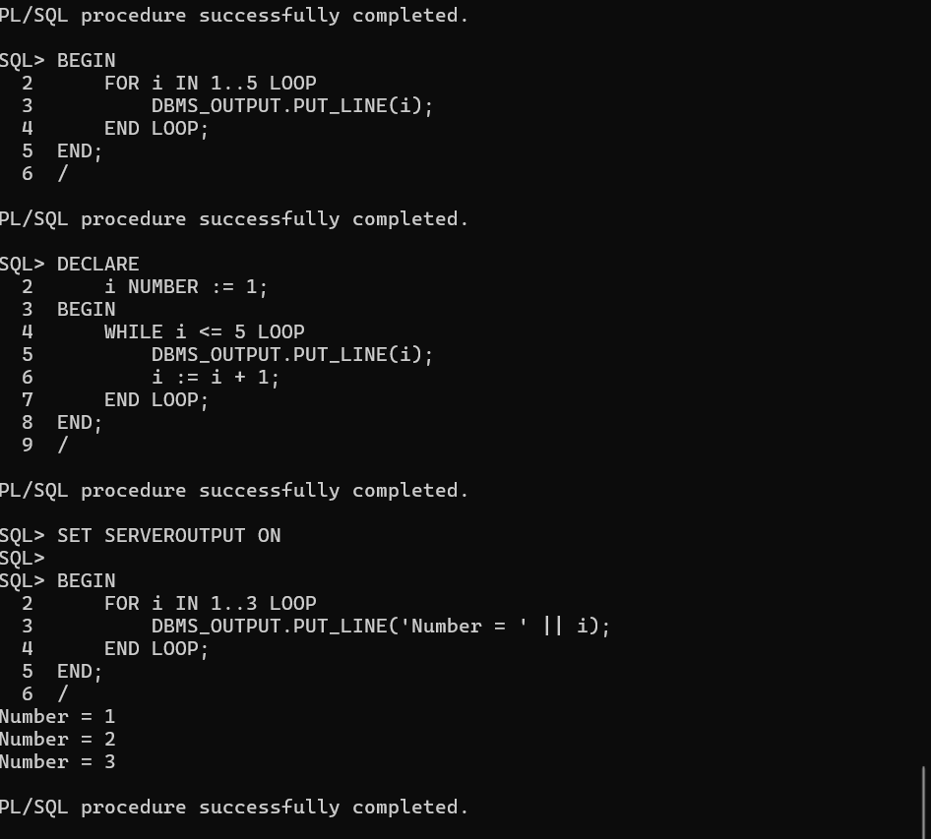

Experiment: 15
Aim : Implementation of pl commands:

1 implementation of cursor command in different ways.

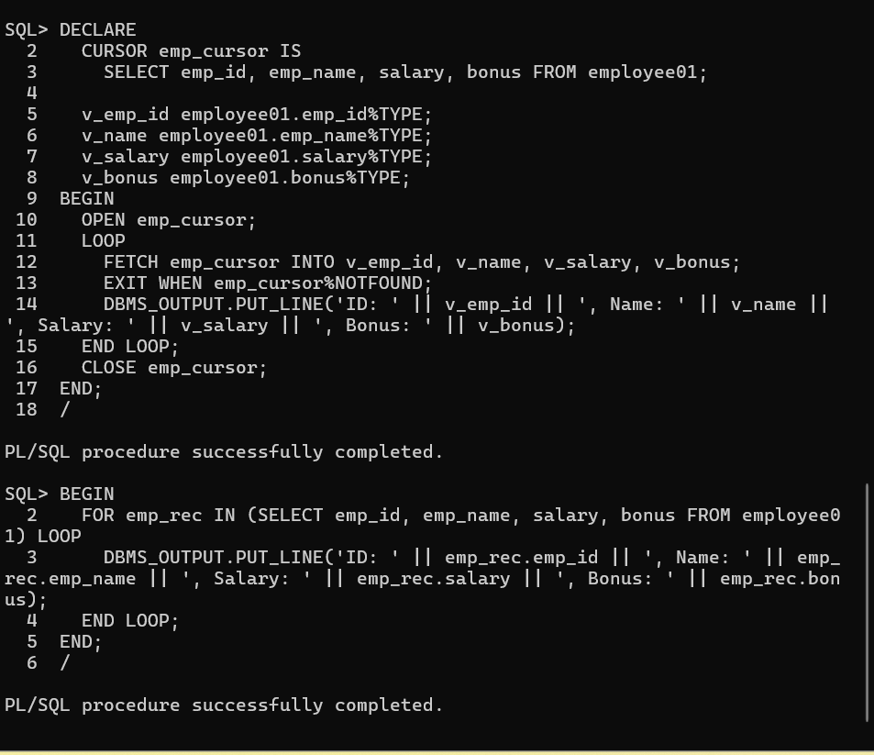

2 implementation of trigger command in different ways .
Before insert trigger
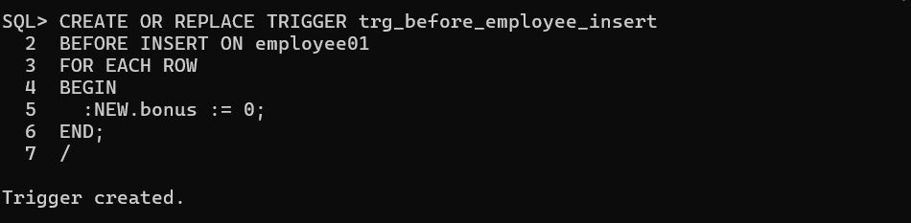
After insert trigger
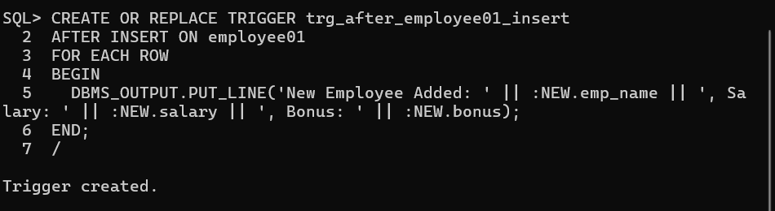
Before Update Trigger
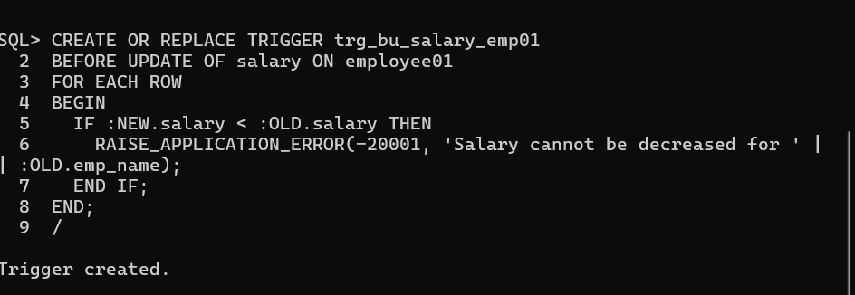
After update Trigger
