Game Design Document

Fill up the following document

1. Write the title of your project.

Squirrel Hunt

1. What is the goal of the game?

Stay alive long enough to collect 30 nuts. (get golden nuts, nuts and avoid snakes)

1. Write a brief story of your game.

You are a squirrel who’s family lives in a forest. They are hungry and want

eat, so you need to go forage for nuts in the forest (maze). You can find

lots of nuts, but a snake is chasing you! You need to collect 30 nuts and

reach safely to your family before you lose all lives.

1. Which are the playing characters of this game?

* Playing characters are the ones who respond to the user based on the input from the user.
* Cars, monkeys, dinos, wizards, etc., are the playing characters in the game.

|  |  |  |
| --- | --- | --- |
| Number | Character Name | What can this character do? |
| 1 | Squirrel | It can move using arrow keys to collect all nuts and avoid snakes. |
| 2 |  |  |
| 3 |  |  |
| 4 |  |  |
| 5 |  |  |
| 6 |  |  |
| 7 |  |  |
| 8 |  |  |

1. Which are the Non-Playing Characters of this game?

* Non-Playing characters are the ones that don't have an action or behavior when the user interacts with the game.
* Hurdles, stones, bananas, coins, etc., are non-playing characters in the game.

|  |  |  |
| --- | --- | --- |
| Number | Character Name | What can this character do? |
| 1 | Snake | Chases squirrel, bites squirrel, takes lives from squirrel. |
| 2 | Nut | Gives squirrel 1 nut point |
| 3 | Golden Nut | Gives squirrel 1 life and 1 nut point |
| 4 |  |  |
| 5 |  |  |
| 6 |  |  |
| 7 |  |  |
| 8 |  |  |

Draw your imagination of this game. What does this game look like?

* Draw the game either on your computer or on paper.
* Add images of the game scenes to show each of the playing and non-playing characters at least once.

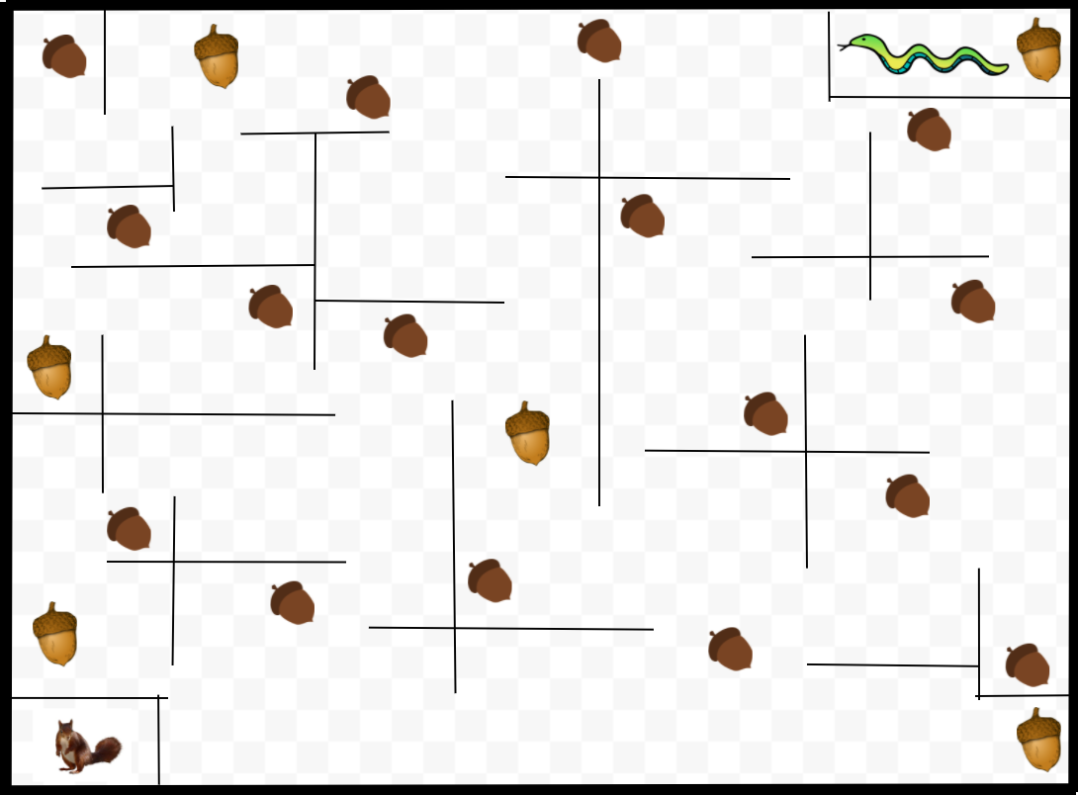

How do you plan to make your game engaging?

The maze starts becoming smaller and smaller as the game progresses.

Nuts are all scattered depending on what you collected.

Nuts can be gone outside maze and you might not even have enough to get up to 30

Since space is smaller, snake might catch up to you

What platform will you use?

VS code and the p5 library