SHRI RAMDEOBABA COLLEGE OF ENGINEERING AND MANAGEMENT, NAGPUR
School of Computer Science and Engineering
Department of Computer Science and Engineering

INNOVATIVE SELF-LEARNING ACTIVITY
DATA DETECTIVE CHALLENGE
Road Accident & Traffic Safety Analytics

Session | 2026–27
Programme | B.Tech. (Cyber Security)
Semester | VII
Course | Data Visualization Techniques
Course Code | CCP7005
Group | 1

Group Members
1 – Arya Bhangadia
18 – Harshvardhan Tendulka
36 – Mishthi Jain
54 – Shreya Mishra

1. Project Objective
Our group was assigned the domain Road Accident & Traffic Safety Analytics. We selected a real-world state-level road safety dataset and used it to compare fatal-collision rates, driver behaviour percentages and insurance-related values. The main aim is to identify visible patterns and present them through an interactive Streamlit dashboard.

2. Dataset Source
Dataset: FiveThirtyEight – bad-drivers dataset
Repository: https://github.com/fivethirtyeight/data/tree/master/bad-drivers
Raw CSV: https://raw.githubusercontent.com/fivethirtyeight/data/master/bad-drivers/bad-drivers.csv
The dataset contains one row for each U.S. state plus the District of Columbia. It is a cross-sectional dataset, so it has a geographical variable (State) but no time/year column.

3. Dataset Discovery Summary
Item | Observation
Records | 51
Original attributes | 8
Numerical variables | 7 numerical variables related to collisions, driver behaviour and insurance
Categorical / geographical variable | State
Temporal variable | Not available
Missing values | 0
Duplicate rows | 0
Outliers | No fatal-collision-rate outlier by the 1.5×IQR rule
Average fatal-collision rate | 15.79 drivers per billion miles
Median fatal-collision rate | 15.6 drivers per billion miles

4. Variables Used
Variable | Type | Meaning
State | Categorical / geographic | State or District name
Fatal collision rate | Numerical | Drivers involved in fatal collisions per billion miles
Speeding % | Numerical | Percentage of involved drivers who were speeding
Alcohol-impaired % | Numerical | Percentage of involved drivers who were alcohol-impaired
Not distracted % | Numerical | Percentage of involved drivers recorded as not distracted
No previous accidents % | Numerical | Percentage with no previous accidents
Insurance premium | Numerical | Average car insurance premium in dollars
Insurance losses | Numerical | Losses incurred per insured driver in dollars

5. Five Analytical Questions and Visualizations
Analytical Question | Variables Required | Proposed Visualization | Why Appropriate?
Q1. How does the fatal-collision rate vary geographically? | State, fatal-collision rate | U.S. choropleth map | A map makes state-wise geographical differences easy to see.
Q2. Which states have the highest fatal-collision rates? | State, fatal-collision rate | Sorted horizontal bar chart | Bars give a clear ranking and use a common numerical scale.
Q3. Is alcohol impairment related to the fatal-collision rate? | Alcohol-impaired %, fatal-collision rate, region | Scatter plot with trend line | A scatter plot is suitable for checking association between two numerical variables.
Q4. How do fatal-collision rates differ across regions? | Region, fatal-collision rate | Box plot | A box plot compares distribution, median and spread between groups.
Q5. Which numerical variables move together? | All numerical attributes | Correlation heatmap | A heatmap summarizes pairwise linear correlation values in one view.

6. Dashboard
The dashboard is built using Streamlit with Plotly charts. The sidebar has filters for region, fatal-collision-rate range and state search. The dashboard also includes four KPIs, five analytical visualizations, findings, recommendations, the wrong visualization challenge, the AI critique and the dataset source.
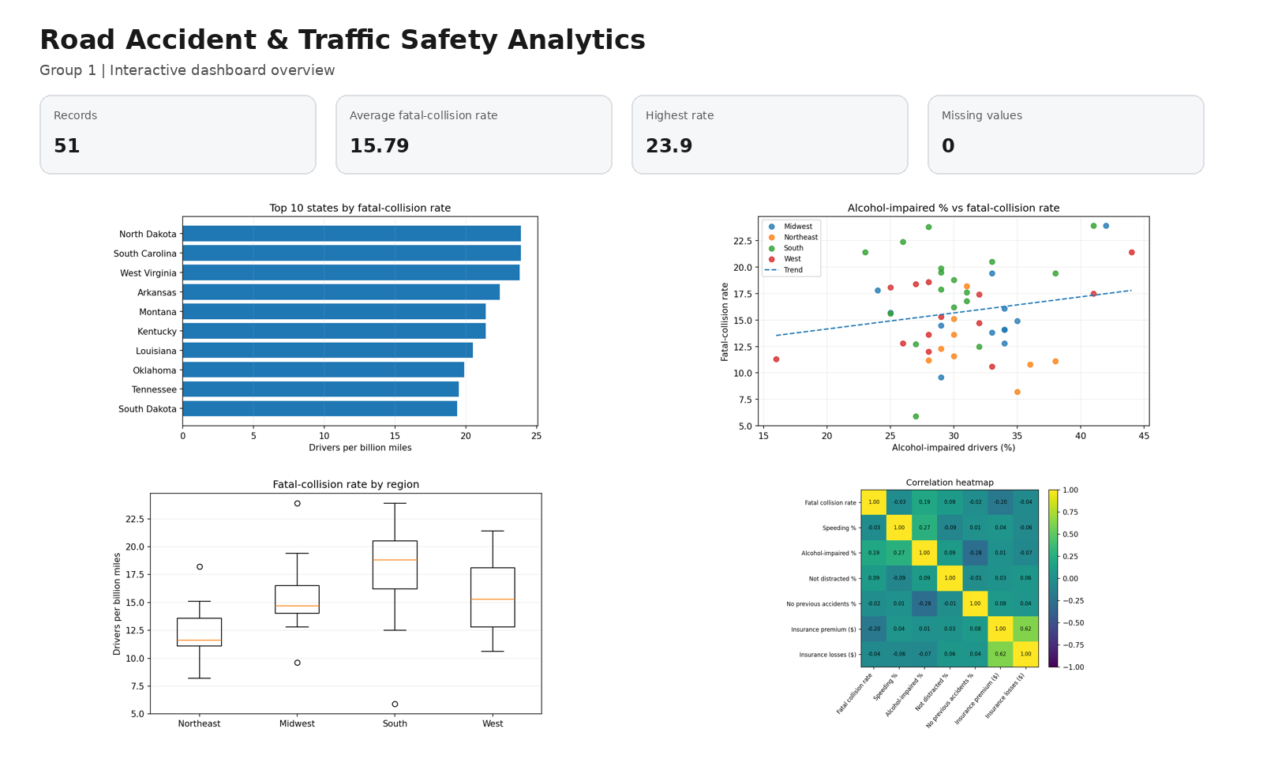
Figure 1. Dashboard overview used for the project documentation.

7. Main Analysis and Observations

7.1 Highest and Lowest Fatal-Collision Rates
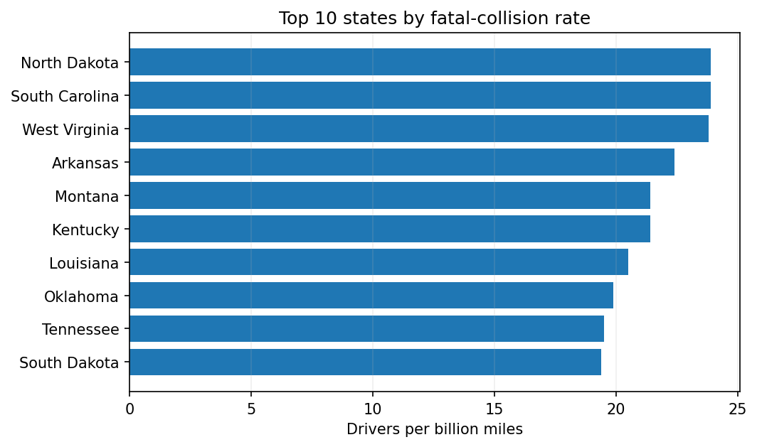
- North Dakota and South Carolina have the highest value in the dataset: 23.9 drivers involved in fatal collisions per billion miles.
- West Virginia is very close at 23.8.
- District of Columbia has the lowest value at 5.9, followed by Massachusetts at 8.2.

7.2 Alcohol-Impaired Percentage vs Fatal-Collision Rate
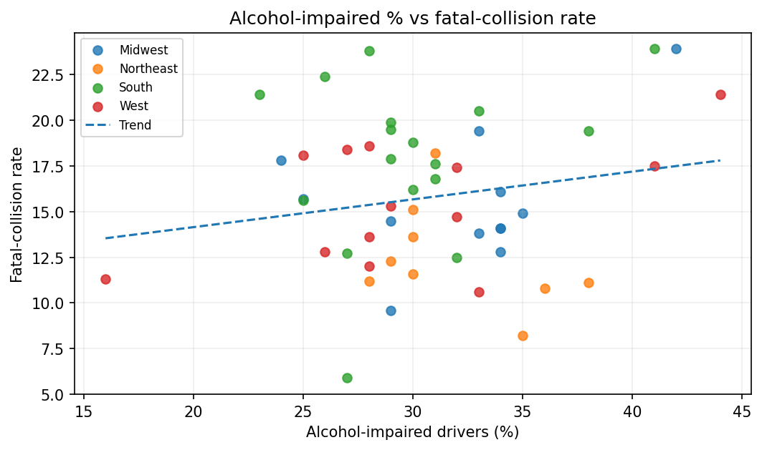
The Pearson correlation is r = 0.19. This is a weak positive linear relationship in this dataset. We should not say that alcohol percentage alone causes a higher total fatal-collision rate because many other road and driver factors can affect the outcome.

7.3 Region-wise Comparison
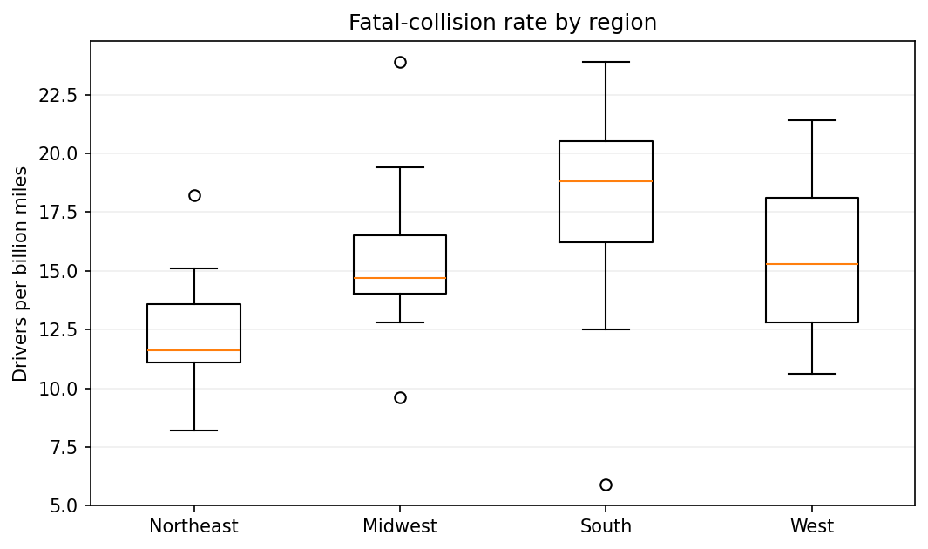
The box plot shows the spread of state values in each broad U.S. region. It helps us compare distributions instead of only comparing one state at a time.

8. Five Major Findings
- North Dakota and South Carolina share the highest fatal-collision rate (23.9), while West Virginia is close at 23.8.
- District of Columbia has the lowest rate (5.9), followed by Massachusetts (8.2) and Minnesota (9.6).
- Alcohol-impaired percentage has a weak positive relationship with the fatal-collision rate (r = 0.19).
- Speeding percentage has almost no linear relationship with the fatal-collision rate in this state-level dataset (r = -0.03).
- Insurance premium and loss values do not directly follow the road-safety ranking, so insurance cost should not be treated as a simple substitute for collision risk.

9. Three Actionable Recommendations
- States with high fatal-collision rates should be selected first for deeper road-safety review and targeted enforcement.
- Alcohol-impaired driving should be monitored as one important factor, but decisions should use multiple variables instead of one correlation.
- For a stronger future version, combine this dataset with road type, weather, seat-belt use, time of crash and vehicle information.

10. Wrong Visualization Challenge
Selected question: Which states have the highest fatal-collision rates?
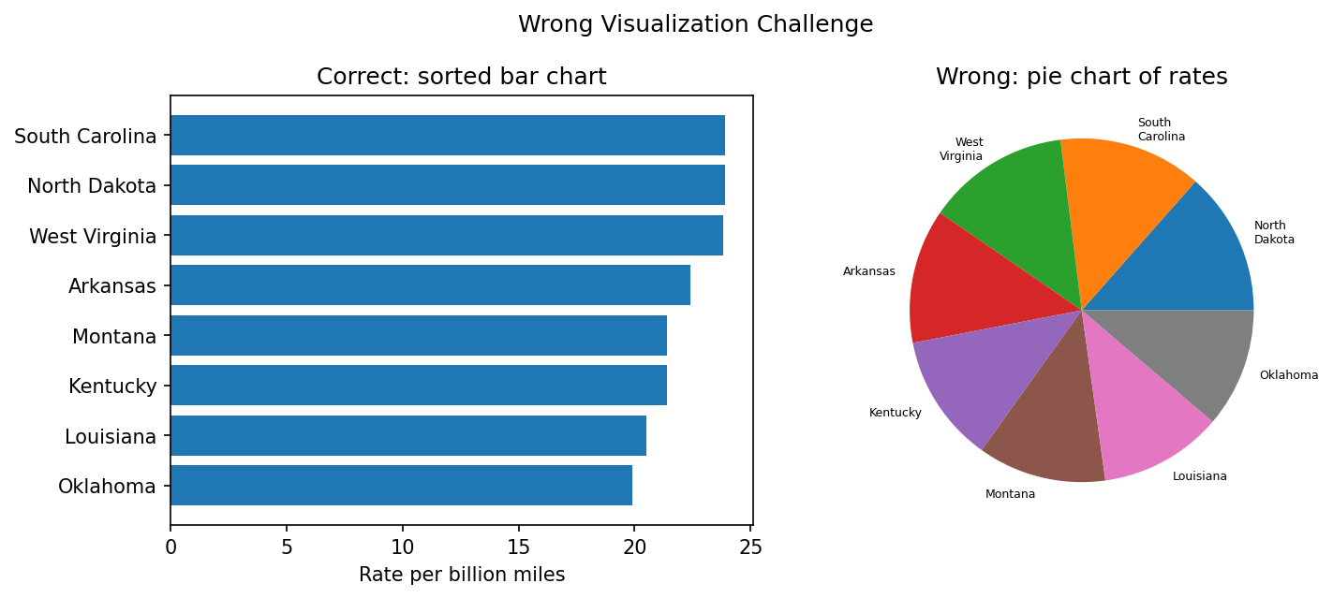
Correct visualization: A sorted bar chart. It places every state on the same scale, so differences can be compared directly.
Wrong visualization: A pie chart. Fatal-collision rates are not parts of one total. Turning them into pie slices can make the viewer think the slices represent a meaningful whole, which is not true.
Possible effect on interpretation: The audience may focus on slice area and percentages rather than the actual rate values, making comparisons harder and potentially misleading.

11. AI as a Critic
Visualization reviewed: Alcohol-impaired % vs fatal-collision rate scatter plot
AI recommendation: Add a trend line, keep state names available on hover, and avoid using causal wording such as “alcohol causes the total rate.”
Decision: PARTIALLY ACCEPTED
Team justification: We accepted the trend line and hover labels because they make the plot easier to understand. We also changed our wording to “relationship” instead of “cause.” We kept region colours because they help compare geographical groups during the live dashboard demonstration.

12. 2-Minute Data Story
Our group studied road accident and traffic safety using the FiveThirtyEight bad-drivers dataset. The dataset has 51 state-level records and includes fatal-collision rates, speeding percentage, alcohol-impaired percentage and insurance variables. We first looked at where fatal-collision rates are high and low. North Dakota and South Carolina have the highest value of 23.9 drivers per billion miles, while the District of Columbia has the lowest at 5.9. We then checked whether common driver-related factors move with the total fatal-collision rate. Alcohol-impaired percentage shows only a weak positive relationship, and speeding percentage shows almost no linear relationship in this dataset. This was important because it reminded us not to make a conclusion only because two variables appear together. Our dashboard allows the user to filter regions and collision-rate ranges and then compare the map, ranking chart, scatter plot, box plot and correlation heatmap. The main action we suggest is to first study the high-rate states in more detail, but combine this data with additional information such as weather, road type, seat-belt use and time of crash before making a policy decision. The project shows how choosing the correct visualization can turn a small dataset into useful and understandable insights.

13. Files Prepared for Submission
- bad-drivers.csv – dataset used in the dashboard
- streamlit_app.py – complete Streamlit dashboard code
- requirements.txt – Python packages required to run the app
- Data_Detective_Group1_Road_Safety_Final.docx – this report
- Data_Detective_Group1_Road_Safety_Final.pptx – 3-slide presentation
- dashboard_overview.png – dashboard screenshot for documentation

14. How to Run the Dashboard
Open a terminal in the folder containing the files and run:
pip install -r requirements.txt
streamlit run streamlit_app.py
For the live presentation, the same files can be deployed to Streamlit Community Cloud after signing in and connecting a GitHub repository.

