A project report on
A CROSS-ATTENTION DEEP LEARNING FRAMEWORK FOR MULTIMODAL NEUROIMAGING FUSION IN VISION DEFECT DETECTION AND CLASSIFICATION
Submitted in partial fulfillment for the award of the degree of
Bachelor of Technology in Computer Science and Engineering (Artificial Intelligence and Machine Learning)
by
MISHTHI JAIN ([Reg. No.])

SCHOOL OF COMPUTER SCIENCE AND ENGINEERING
[November, 2026]
A CROSS-ATTENTION DEEP LEARNING FRAMEWORK FOR MULTIMODAL NEUROIMAGING FUSION IN VISION DEFECT DETECTION AND CLASSIFICATION
Submitted in partial fulfillment for the award of the degree of
Bachelor of Technology in Computer Science and Engineering (Artificial Intelligence and Machine Learning)
by
MISHTHI JAIN
Registration No.: [Reg. No.]
Course: BCSE497J
Guide: [Guide name, Designation]
SCHOOL OF COMPUTER SCIENCE AND ENGINEERING
Vellore Institute of Technology, Chennai
Submission date: [November, 2026]
DECLARATION
I hereby declare that the thesis entitled “A Cross-Attention Deep Learning Framework for Multimodal Neuroimaging Fusion in Vision Defect Detection and Classification” submitted by MISHTHI JAIN ([Reg. No.]), for the award of the degree of Bachelor of Technology in Computer Science and Engineering, Vellore Institute of Technology, Chennai is a record of bonafide work carried out by me under the supervision of [Guide name].
I further declare that the work reported in this thesis has not been submitted and will not be submitted, either in part or in full, for the award of any other degree or diploma in this institute or any other institute or university.

Place: Chennai
Date: [dd Month yyyy] Signature of the Candidate
School of Computer Science and Engineering
CERTIFICATE
This is to certify that the report entitled “A Cross-Attention Deep Learning Framework for Multimodal Neuroimaging Fusion in Vision Defect Detection and Classification” is prepared and submitted by MISHTHI JAIN ([Reg. No.]) to Vellore Institute of Technology, Chennai, in partial fulfillment of the requirement for the award of the degree of Bachelor of Technology in Computer Science and Engineering (Artificial Intelligence and Machine Learning) is a bonafide record carried out under my guidance. The project fulfills the requirements as per the regulations of this University and in my opinion meets the necessary standards for submission. The contents of this report have not been submitted and will not be submitted either in part or in full, for the award of any other degree or diploma and the same is certified.
Signature of the Guide:
Name: [Dr./Prof. Guide name]
Date:

Signature of the Examiner Signature of the Examiner
Name: Name:
Date: Date:

Approved by the Head of Department,
Computer Science and Engineering
(Artificial Intelligence and Machine Learning)
Name: Dr. Tulasi Prasad Sariki
Date:
[Seal of the School]

ABSTRACT
Vision depends on an intact pathway from the retina to the visual cortex. Disorders such as glaucoma, optic neuritis and cortical visual impairment alter both the structure of this pathway, which is visible on magnetic resonance imaging (MRI), and the timing of its electrical response, which is recorded as the visual evoked potential (VEP). Most computational tools analyse only one of these sources of evidence. This project presents a research prototype, the Cross-Attention Fusion Network (CAFN), that combines a three-dimensional MRI volume with a one-dimensional VEP waveform to classify a case as Healthy Control, Glaucoma, or Optic Neuritis / Cortical Visual Impairment. A 3D residual network and a 1D convolutional network map the two inputs to 64 spatial and 16 temporal tokens in a shared 128-dimensional space. Multi-head cross-attention, in which spatial tokens query temporal tokens, fuses them, and a multi-task loss with two auxiliary unimodal heads supervises training. VEP conditioning uses zero-phase filtering so that P100 latency is preserved, and 3D Grad-CAM and an attention heatmap provide explanations. Because no public dataset offers the required diagnosis labels, the system was developed and verified on class-conditioned synthetic data. On 150 synthetic recordings, conditioning kept the P100 latency within one sample (4 ms) of the ground truth in 149 cases and attenuated the injected 50 Hz interference by 22 dB on average. The model has 1.06 million parameters, and an 86-test suite reaches about 95% statement coverage. No diagnostic accuracy is claimed. The work provides a tested foundation for evaluation on a labelled clinical cohort.

ACKNOWLEDGEMENT
It is my pleasure to express with deep sense of gratitude to [Guide name], [Designation], School of Computer Science and Engineering, Vellore Institute of Technology, Chennai, for [his/her] constant guidance, continual encouragement, understanding; more than all, [he/she] taught me patience in my endeavor. My association with [him/her] is not confined to academics only, but it is a great opportunity on my part of work with an intellectual and expert in the field of [area of expertise].
It is with gratitude that I would like to extend my thanks to the visionary leader Dr. G. Viswanathan our Honorable Chancellor, Mr. Sankar Viswanathan, Dr. Sekar Viswanathan, Dr. G V Selvam Vice Presidents, Dr. Sandhya Pentareddy, Executive Director, Ms. Kadhambari S. Viswanathan, Assistant Vice-President, Dr. V. S. Kanchana Bhaaskaran Vice-Chancellor, Dr. T. Thyagarajan Pro-Vice Chancellor, VIT Chennai and Dr. P. K. Manoharan, Additional Registrar for providing an exceptional working environment and inspiring all of us during the tenure of the course.
Special mention to Dr. Viswanathan V, Dean, Dr. Nithyanandam P, Associate Dean, Dr. Suganya G, Associate Dean, Dr. Sweetlin Hemalatha C, Associate Dean, School of Computer Science and Engineering, Vellore Institute of Technology, Chennai for spending their valuable time and efforts in sharing their knowledge and for helping us in every aspect.
In jubilant state, I express ingeniously my whole-hearted thanks to Dr. Tulasi Prasad Sariki, Head of the Department, B.Tech. Computer Science and Engineering (Artificial Intelligence and Machine Learning) and the Project Coordinators for their valuable support and encouragement to take up and complete the thesis.
My sincere thanks to all the faculties and staffs at Vellore Institute of Technology, Chennai who helped me acquire the requisite knowledge. I would like to thank my parents for their support. It is indeed a pleasure to thank my friends who encouraged me to take up and complete this task.
Place: Chennai
Date: [dd Month yyyy] Mishthi Jain

CONTENTS
ABSTRACT i
ACKNOWLEDGEMENT ii
CONTENTS iii
LIST OF TABLES vi
LIST OF FIGURES viii
LIST OF SYMBOLS, ABBREVIATIONS AND NOMENCLATURE x
CHAPTER 1 INTRODUCTION 1
1.1 BACKGROUND 1
1.2 MOTIVATION AND CHALLENGES 2
1.2.1 UNIMODAL ISOLATION 2
1.2.2 CROSS-MODAL HETEROGENEITY 2
1.2.3 LIMITED INTERPRETABILITY 2
1.3 PROBLEM STATEMENT 3
1.4 OBJECTIVES AND RESEARCH QUESTIONS 3
1.4.1 OBJECTIVES 3
1.4.2 RESEARCH QUESTIONS 4
1.4.3 WORKING HYPOTHESES 4
1.5 SCOPE OF THE PROJECT 5
1.6 LIMITATIONS OF THE STUDY 5
1.7 CONTRIBUTIONS AND DISTINCTION FROM EXISTING WORK 5
1.8 ORGANISATION OF THE REPORT 6
CHAPTER 2 LITERATURE REVIEW 7
2.1 INTRODUCTION 7
2.2 CLINICAL BACKGROUND 7
2.2.1 GLAUCOMA, OPTIC NEURITIS AND CORTICAL VISUAL IMPAIRMENT 7
2.2.2 THE VISUAL EVOKED POTENTIAL AND THE P100 COMPONENT 8
2.3 DEEP LEARNING FOR VOLUMETRIC NEUROIMAGING 8
2.4 DEEP LEARNING FOR ONE-DIMENSIONAL ELECTROPHYSIOLOGICAL SIGNALS 9
2.5 MULTIMODAL DATA FUSION 9
2.6 ATTENTION AND CROSS-ATTENTION 10
2.7 EXPLAINABILITY 11
2.8 PUBLIC DATA RESOURCES AND THE LABELLING GAP 11
2.9 RESEARCH GAP AND POSITION OF THIS PROJECT 12
CHAPTER 3 METHODOLOGY 13
3.1 OVERVIEW OF THE APPROACH 13
3.2 DESIGN PRINCIPLES 14
3.3 TOOLS AND ENVIRONMENT 15
3.4 DATA SOURCES 15
3.5 SYNTHETIC DATA GENERATION 16
3.5.1 SYNTHETIC MRI VOLUMES 16
3.5.2 SYNTHETIC VEP WAVEFORMS 17
3.5.3 DATASET BEHAVIOUR 18
3.6 DATA INTERFACE 18
3.7 MRI PREPROCESSING 19
3.8 VEP PREPROCESSING 20
3.9 EVALUATION STRATEGY 22
CHAPTER 4 SYSTEM DESIGN AND IMPLEMENTATION 23
4.1 ARCHITECTURE OVERVIEW 23
4.2 SPATIAL ENCODER (3D RESIDUAL CNN) 24
4.3 TEMPORAL ENCODER (1D CNN) 24
4.4 CROSS-ATTENTION FUSION MODULE 25
4.5 CLASSIFICATION HEADS AND MULTI-TASK LOSS 26
4.6 TRAINING PROCEDURE 27
4.7 EXPLAINABILITY 28
4.7.1 3D GRAD-CAM ON THE FUSED LOGIT 28
4.7.2 CROSS-ATTENTION HEATMAP 29
4.8 SOFTWARE STRUCTURE AND CONFIGURATION 29
4.9 TEST DESIGN 30
CHAPTER 5 RESULTS 32
5.1 INTRODUCTION 32
5.2 SIGNAL CONDITIONING RESULTS 32
5.2.1 FREQUENCY RESPONSE 32
5.2.2 MAINS-INTERFERENCE ATTENUATION 33
5.2.3 P100 LATENCY 34
5.2.4 CONDITIONED-WAVEFORM STATISTICS 35
5.2.5 NOMINAL TEMPORAL-TOKEN BINS 36
5.3 SYNTHETIC MRI CHARACTERISATION 36
5.4 MODEL COMPLEXITY 36
5.5 INTERFACE AND SHAPE VERIFICATION 37
5.6 SOFTWARE VERIFICATION RESULTS 37
5.7 TRAINING ACCEPTANCE CRITERIA 39
5.8 SUMMARY OF RESULTS 40
CHAPTER 6 DISCUSSION 41
6.1 INTRODUCTION 41
6.2 INTERPRETATION OF THE RESULTS 41
6.2.1 SIGNAL CONDITIONING 41
6.2.2 SYNTHETIC DATA AND THE FOREGROUND MASK 42
6.2.3 MODEL SIZE AND COST 42
6.2.4 VERIFICATION 43
6.3 ASSESSMENT AGAINST THE OBJECTIVES, QUESTIONS AND HYPOTHESES 43
6.4 DESIGN OBSERVATIONS 44
6.4.1 COARSE TEMPORAL TOKENS 44
6.4.2 SYNTHETIC SEPARABILITY 44
6.4.3 MULTI-TASK SUPERVISION AND ATTENTION 44
6.5 COMPARISON WITH THE LITERATURE 45
6.6 CONSTRAINTS AND THREATS TO VALIDITY 45
CHAPTER 7 CONCLUSION, RECOMMENDATIONS AND FUTURE WORK 47
7.1 CONCLUSION 47
7.2 CONCLUSIONS AGAINST THE OBJECTIVES 47
7.3 RECOMMENDATIONS 48
7.4 FUTURE WORK 49
7.5 CLOSING REMARKS 49
REFERENCES 51
APPENDIX 1 DEFAULT CONFIGURATION 56
A1.1 CONFIGURATION PARAMETERS 56
APPENDIX 2 SOURCE CODE LISTINGS 57
A2.1 OVERVIEW 57
A2.2 LISTINGS 57
APPENDIX 3 TEST INVENTORY 73
A3.1 TEST FILES 73
A3.2 TEST FUNCTIONS 73
APPENDIX 4 REPRODUCTION NOTES 76
A4.1 SOFTWARE ENVIRONMENT 76
A4.2 COMMANDS 76
A4.3 MEASUREMENTS REPORTED IN CHAPTER 5 76
A4.4 ITEMS NOT REPRODUCED HERE 76

LIST OF TABLES
Table 1.1 Organisation of the report. 6
Table 2.1 Clinical conditions considered and the way each is encoded in the synthetic data. 8
Table 2.2 Canonical fusion strategies and the position of this project. 10
Table 2.3 Key references and where each is used in the project. 12
Table 3.1 Tensor contract at the default configuration. 14
Table 3.2 Software stack. The last three libraries are listed in requirements.txt but are not imported by the current source or tests. 15
Table 3.3 Public data resources identified in the project blueprint (descriptions as stated there; not independently re-verified for this report). 16
Table 3.4 Class-conditioned parameters of the synthetic generators. 17
Table 3.5 MRI preprocessing parameters (MRIConfig). 20
Table 3.6 VEP preprocessing parameters (VEPConfig). 21
Table 3.7 Evaluation strategy: what is measured, how, and which objective it supports. 22
Table 4.1 Spatial encoder layers (batch size 1) and trainable parameters. 24
Table 4.2 Temporal encoder layers (batch size 1) and trainable parameters. 25
Table 4.3 Training configuration (TrainConfig) and model configuration (ModelConfig) at the default values. 28
Table 4.4 Source modules, line counts and responsibilities. 30
Table 4.5 Test files and what they verify. 31
Table 5.1 Effective magnitude response (dB) at selected frequencies. 33
Table 5.2 Detected P100 latency (ms; mean ± SD over 50 trials per class) and mean error against the ground truth. 34
Table 5.3 Group delay of the single-pass (causal) implementation of the same filters. 35
Table 5.4 Synthetic MRI: mean intensity of regions of interest and effect of the 60th-percentile foreground mask. 36
Table 5.5 Trainable parameters and multiply-accumulates (millions) per sample at the default configuration. 36
Table 5.6 Statement coverage by module (reconstructed from the recorded coverage data). 38
Table 5.7 Training-loop acceptance criteria asserted by tests/integration/test_training_loop.py. 39
Table 5.8 Summary of the objective results. 40
Table 6.1 Assessment of research questions and hypotheses against the evidence. 43
Table 6.2 Constraints of the study and their consequence for the conclusions. 45
Table 7.1 Status of each objective. 47
Table 7.2 Prioritised recommendations. 48
Table A1.1 Default configuration values (src/config.py). 56
Table A2.1 Source files reproduced in this appendix. 57
Table A3.1 Test files, number of test functions and the component each exercises. 73

LIST OF FIGURES
Figure 1.1 Conceptual motivation: MRI answers where, the VEP answers when, and cross-attention fusion links the two while producing material that can be inspected. 3
Figure 3.1 End-to-end data flow of the proposed framework. Spatial tokens act as queries (Q); temporal tokens act as keys and values (K, V). Dashed arrow: explainability outputs. 14
Figure 3.2 Axial slices of synthetic MRI volumes generated by the project's own generator (seeded). Dashed boxes mark the class-specific region: lesion proxy (Optic neuritis / CVI, index 20) and atrophy proxy (Glaucoma, index 60). 17
Figure 3.3 Synthetic VEP waveforms for the three classes, before (left) and after (right) the project's conditioning function clean_vep_signal. Dotted line: ground-truth P100 latency. 18
Figure 3.4 The two dataset classes share one preprocessing path. The manifest-driven class is intended for a future labelled cohort; the in-memory synthetic class is used in the current prototype. 19
Figure 3.5 Preprocessing chains for the MRI stream (top) and the VEP stream (bottom), with the function responsible for each step. 19
Figure 4.1 CAFN architecture with tensor shapes (default configuration). The two auxiliary heads read the mean-pooled unimodal tokens; the fused head reads the mean-pooled fused tokens. 23
Figure 4.2 Nominal mapping of the 16 temporal tokens onto the 2 s epoch (125 ms per token) over an example conditioned VEP. The shaded region is token 0. 25
Figure 4.3 Structure of the cross-attention fusion module (CAFM). The attention-weight tensor has shape (B, 4, 64, 16) and is returned for inspection. 26
Figure 4.4 Training and evaluation flow. A seeded permutation splits the data; each epoch is followed by validation; the trained model can be checkpointed and passed to the explainability tools. 27
Figure 4.5 Generation of the two explanation artefacts: the Grad-CAM map (A) and the cross-attention heatmap (B). 29
Figure 4.6 Module structure and dependencies of the code base. 30
Figure 5.1 Magnitude response of the conditioning filters in the effective (forward-backward) form. 33
Figure 5.2 Amplitude spectrum of one synthetic VEP before and after conditioning. The dotted line marks 50 Hz. 34
Figure 5.3 Left: group delay of the single-pass filters versus the zero-phase pipeline (shaded band: ±1 sample, 4 ms). Right: mean P100 latency error by class (shaded band: ±4 ms). 35
Figure 5.4 Distributions over 50 synthetic trials per class: detected P100 latency after conditioning (left) and peak value after z-scoring (right). 35
Figure 5.5 Left: trainable parameters by component. Right: multiply-accumulate operations per sample by component group. 37
Figure 5.6 Left: number of test functions per test file (blue: unit; green: integration). Right: statement coverage per module (red: below 90%). 38

LIST OF SYMBOLS, ABBREVIATIONS AND NOMENCLATURE
1D / 3D | One- / three-dimensional
BN | Batch normalisation
CAFN | Cross-Attention Fusion Network (the model developed in this project)
CNN | Convolutional neural network
CSV | Comma-separated values (file format)
CVI | Cortical (cerebral) visual impairment
EEG | Electroencephalography
ERG | Electroretinography
FFN | Position-wise feed-forward network
Grad-CAM | Gradient-weighted class activation mapping
HCP | Human Connectome Project
IIR | Infinite impulse response (filter)
ISCEV | International Society for Clinical Electrophysiology of Vision
LN | Layer normalisation
MAC | Multiply–accumulate operation
MONAI | Medical Open Network for AI (software framework)
MRI / sMRI | (Structural) magnetic resonance imaging
N75, P100, N135 | Components of the pattern-reversal VEP: negative peak near 75 ms, positive peak near 100 ms, negative peak near 135 ms
NIfTI | Neuroimaging Informatics Technology Initiative (file format)
OASIS | Open Access Series of Imaging Studies
RAS | Right–anterior–superior (canonical image orientation)
ReLU | Rectified linear unit
ROI | Region of interest
SD | Standard deviation
VEP | Visual evoked potential
A | Amplitude of the synthetic P100 component (Equation 3.1)
τ | Latency of the P100 component; also the percentile threshold τ_{p} in Equation 3.3
d_{model} | Width of the token embedding (128 by default)
H, d_{h} | Number of attention heads (4) and dimension per head
X_{s}, X_{t} | Spatial and temporal token matrices
Q, K, V | Query, key and value matrices of the cross-attention module
W_{Q}, W_{K}, W_{V}, W_{O} | Learned projection matrices of the cross-attention module
A_{h}, O_{h} | Attention weights and output of head h
L_{f}, L_{s}, L_{t} | Cross-entropy losses of the fused, spatial and temporal heads
λ | Weight of the auxiliary losses (0.3)
μ, σ, ε | Mean, standard deviation and stabilising constant of z-score normalisation
α_{k}, M | Grad-CAM channel weights and resulting activation map

Chapter 1
Introduction

1.1 BACKGROUND
Vision depends on an uninterrupted chain of structures: the retina, the optic nerve, the optic chiasm, the lateral geniculate nucleus, the optic radiations and, finally, the primary and associated visual cortices (areas V1, V2 and V3). A lesion at any point of this chain can degrade sight, and the clinical picture depends on where along the pathway the damage lies and on whether it disturbs the anatomy, the conduction of the electrical signal, or both.
Three conditions illustrate the range. Glaucoma is a progressive optic neuropathy; a systematic review and meta-analysis estimated its global prevalence at 3.54% among people aged 40 to 80 years, corresponding to about 64.3 million people in 2013 and a projected 111.8 million by 2040 (Tham et al., 2014). Histological work has shown that the degeneration in human glaucoma is not confined to the eye but extends to the intracranial optic nerve, the lateral geniculate nucleus and the visual cortex (Gupta et al., 2006). Optic neuritis is an inflammatory, usually demyelinating, disorder of the optic nerve whose electrophysiological hallmark is a delayed P100 peak of the visual evoked potential (Halliday et al., 1972). Cortical or cerebral visual impairment (CVI) denotes reduced vision that arises from damage to the brain's visual pathways rather than the eye; the literature uses a variety of terms and definitions for it (Sakki et al., 2018).
Two investigations are routinely used to examine this pathway, and they answer different questions. Structural magnetic resonance imaging (sMRI) provides a three-dimensional picture of anatomy, so that atrophy and focal lesions can be localised. The visual evoked potential (VEP) is a one-dimensional electrophysiological recording of the cortical response to a visual stimulus; its latency and amplitude, in particular those of the P100 component, reflect the integrity and speed of conduction along the visual pathway, and its recording and interpretation are standardised by the International Society for Clinical Electrophysiology of Vision (ISCEV) (Odom et al., 2016). Neither investigation alone tells the whole story: MRI carries no timing information and the VEP carries no spatial localisation.
Multimodal data fusion has long been proposed as a way to exploit such complementary information (Calhoun & Sui, 2016). Deep learning has made it possible to learn fusion functions directly from data, and the attention mechanism introduced for sequence modelling (Vaswani et al., 2017) offers a particularly flexible way to let one stream of features select what it needs from another. This project investigates that idea for the pairing of 3D structural MRI and 1D visual evoked potentials.

1.2 MOTIVATION AND CHALLENGES
Automated, data-driven support for the diagnosis and classification of visual-pathway disorders faces three principal bottlenecks. They motivate the design choices described in the rest of this report.

1.2.1 UNIMODAL ISOLATION
Most computational pipelines analyse either imaging or electrophysiology, not both. A model that only sees the MRI volume can detect structural change but is blind to a conduction delay that has not yet produced visible atrophy; a model that only sees the VEP can detect the delay but cannot say where in the pathway it originates.

1.2.2 CROSS-MODAL HETEROGENEITY
A volumetric MRI array of shape (1, D, H, W) and a waveform of shape (1, L) differ in dimensionality, sampling, noise structure and units. Simple fusion strategies, such as concatenating pooled features or averaging unimodal predictions, give every feature the same standing and cannot express which spatial feature is relevant to which temporal feature. Subtle pathology markers can be diluted as a result.

1.2.3 LIMITED INTERPRETABILITY
A black-box classifier is difficult to trust in a clinical setting. A clinician needs to see which parts of the image and which parts of the waveform drove a decision, so that the output can be checked against clinical knowledge.
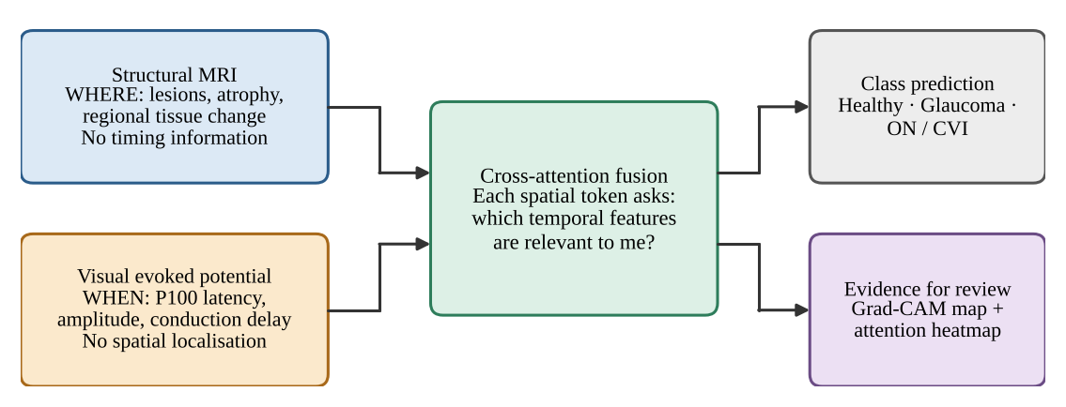
Figure 1.1: Conceptual motivation: MRI answers where, the VEP answers when, and cross-attention fusion links the two while producing material that can be inspected.

1.3 PROBLEM STATEMENT
To design, implement and verify an end-to-end deep-learning framework that ingests a paired 3D structural MRI volume and a 1D visual evoked potential, fuses them with an attention mechanism that lets spatial features query temporal features, classifies the pair into Healthy Control, Glaucoma or Optic Neuritis / Cortical Visual Impairment, and exposes spatial and spatial–temporal explanations of each decision.
The problem is therefore both a modelling problem (how to relate two incompatible feature spaces) and an engineering problem (how to build a pipeline whose interfaces, preprocessing and training behaviour can be tested before a clinical cohort is available).

1.4 OBJECTIVES AND RESEARCH QUESTIONS

1.4.1 OBJECTIVES
The project pursues the following objectives. They are revisited, one by one, in the conclusions (Chapter 7).
1. O1: Data interface. Provide a single dataset abstraction that reads paired MRI and VEP records from a manifest and standardises them to fixed-shape tensors (1 × 64 × 64 × 64 and 1 × 500).
2. O2: Signal conditioning. Implement MRI standardisation (RAS orientation, 1 mm isotropic resampling, foreground masking, intensity scaling) and VEP conditioning (zero-phase 1–100 Hz band-pass, 50 Hz notch, resampling, z-score) so that clinically meaningful timing is not distorted.
3. O3: Dual encoders. Build a 3D residual CNN and a 1D CNN that map the two modalities to 64 spatial and 16 temporal tokens in a shared 128-dimensional space.
4. O4: Cross-attention fusion. Implement multi-head cross-attention in which spatial tokens are queries and temporal tokens are keys and values, and train it with a fused head plus two auxiliary unimodal heads (multi-task supervision).
5. O5: Explainability. Provide 3D Grad-CAM activation maps and a spatial–temporal cross-attention heatmap.
6. O6: Verification. Verify interfaces and behaviour with an automated unit and integration test suite, and quantify what can be quantified without clinical data (filter behaviour, model size, test coverage).
7. O7: Honest scoping. State clearly what has and has not been demonstrated, and define the path from prototype to clinically credible evaluation.

1.4.2 RESEARCH QUESTIONS
1. RQ1. Can paired 3D MRI and 1D VEP data be brought into a common token representation through one manifest-driven pipeline?
2. RQ2. Does the conditioning pipeline preserve the P100 latency, the landmark that carries diagnostic meaning in the VEP?
3. RQ3. Can the cross-attention fusion network be optimised end-to-end under multi-task supervision, and what is its computational footprint?
4. RQ4. Can the system emit explanation artefacts (spatial maps and attention matrices) from the same forward pass that produces the prediction?

1.4.3 WORKING HYPOTHESES
Because no labelled clinical data are available, the hypotheses are engineering hypotheses that can be tested on synthetic data: (H1) zero-phase filtering keeps the detected P100 latency within one sample period (4 ms at 250 Hz) of the ground truth; (H2) the multi-task training loop reduces training loss substantially on a class-conditioned synthetic task and exceeds chance-level validation accuracy; and (H3) all modules respect a single shape contract so that the preprocessing, encoders, fusion module and heads cannot silently disagree.

1.5 SCOPE OF THE PROJECT
In scope. The project covers (i) the data-loading and preprocessing layer for MRI (NIfTI) and VEP (CSV) files; (ii) a synthetic, class-conditioned data generator that exposes the same interface as real data; (iii) the CAFN model (two encoders, a cross-attention fusion module and three classification heads); (iv) a multi-task training loop with checkpointing; (v) the explainability tools; and (vi) an automated test suite.
Out of scope. The project does not include clinical data acquisition, expert labelling, clinical-grade brain extraction, anatomical registration of features to named cortical areas, prospective clinical validation or regulatory work. The command-line trainer is wired only to the synthetic dataset; the real-data dataset class is available through the Python interface.

1.6 LIMITATIONS OF THE STUDY
- No labelled clinical cohort. The public repositories surveyed for the project provide structural or retinotopic scans and generic electrophysiology but not the Healthy / Glaucoma / Optic Neuritis-CVI diagnosis labels required for training. All learning experiments are therefore confined to synthetic data, which are deliberately simple and cannot support any claim about clinical performance.
- Prototype preprocessing. Foreground masking is a percentile threshold, not validated skull-stripping, and no anatomical registration is carried through to the model.
- Learned, uncalibrated tokens. Spatial and temporal tokens are learned feature positions, not anatomically registered brain regions or calibrated millisecond bins.
- No external baselines or uncertainty estimates. The repository contains no unimodal or concatenation baseline comparison, no missing-modality handling, and no calibration.

1.7 CONTRIBUTIONS AND DISTINCTION FROM EXISTING WORK
It is important to separate what this project contributes from what it reuses. The reused building blocks are standard: scaled dot-product and multi-head attention (Vaswani et al., 2017), residual convolutional blocks (He et al., 2016), Grad-CAM (Selvaraju et al., 2017), Butterworth and notch filtering through SciPy (Virtanen et al., 2020), and MONAI transforms for volumetric resampling and cropping (Cardoso et al., 2022). The contribution of the project is their integration into one tested, configuration-driven pipeline for the specific pairing of 3D MRI and 1D VEP:
- a shared shape contract (a single configuration module) enforced across preprocessing, both encoders, the fusion module and the training loop;
- a cross-attention fusion design in which spatial tokens query temporal tokens, with attention weights returned for inspection;
- a multi-task objective with auxiliary unimodal heads to discourage collapse onto one modality;
- a class-conditioned synthetic data generator and an end-to-end test suite that exercise the real file path (NIfTI and CSV on disk) through to an optimiser step and the explainability outputs; and
- a transparent record of limitations and of the steps required before clinical evaluation.

1.8 ORGANISATION OF THE REPORT
Table 1.1: Organisation of the report.
Chapter | Content
1 Introduction | Background, motivation, problem statement, objectives, scope and limitations.
2 Literature Review | Clinical background, deep learning for MRI and electrophysiology, multimodal fusion, attention, explainability, public data resources and the research gap.
3 Methodology | Overall approach, tools, data sources, synthetic data, data interface, MRI and VEP preprocessing, and the evaluation strategy.
4 System Design and Implementation | CAFN architecture, cross-attention fusion, multi-task loss, training, explainability, software structure and test design.
5 Results | Objective presentation of the measurements: filter behaviour, synthetic data statistics, model size, test results and coverage, and training acceptance criteria.
6 Discussion | Interpretation of the results, design observations, comparison with the literature and threats to validity.
7 Conclusion, Recommendations and Future Work | Conclusions against the objectives, prioritised recommendations and future work.
 | References (APA) and Appendices (configuration, source listings, test inventory, reproduction notes).

Chapter 2
Literature Review

2.1 INTRODUCTION
This chapter summarises the research and technical background on which the project rests. It first describes the clinical conditions and the two investigations considered, then reviews deep learning for volumetric imaging and for one-dimensional signals, multimodal fusion strategies, attention and cross-attention, explainability, and the public data resources that were surveyed. It closes by stating the gap that the project addresses and the position it takes.

2.2 CLINICAL BACKGROUND

2.2.1 GLAUCOMA, OPTIC NEURITIS AND CORTICAL VISUAL IMPAIRMENT
Glaucoma is a progressive optic neuropathy and a leading cause of irreversible visual loss; its burden is large and growing (Tham et al., 2014). Although it is usually described through damage to the optic nerve head, post-mortem evidence indicates that degeneration also affects the intracranial optic nerve, the lateral geniculate nucleus and the visual cortex (Gupta et al., 2006). Electrophysiological abnormalities have been reported in ocular hypertension and glaucoma with pattern electroretinography and visual evoked potentials (Parisi et al., 2006). The synthetic data used in this project encode glaucoma by a focal loss of MRI intensity (an atrophy proxy) and a reduced VEP amplitude with near-normal latency.
Optic neuritis is inflammation of the optic nerve. Its classical electrophysiological signature is a prolonged P100 latency of the pattern-reversal VEP with a relatively preserved waveform (Halliday et al., 1972), and the lesion is typically visible on MRI as a focal signal abnormality. Cortical or cerebral visual impairment arises from damage to the posterior visual pathways and visual cortex; the terminology and definitions used for it are not uniform across the literature (Sakki et al., 2018). In this project, optic neuritis and CVI are grouped into a single class and encoded synthetically by a focal MRI hyperintensity (a lesion proxy) and a delayed P100.
Table 2.1: Clinical conditions considered and the way each is encoded in the synthetic data.
Condition | Structural (MRI) signature | Electrophysiological (VEP) signature | Synthetic encoding in this project
Healthy control | No focal abnormality | P100 near 100 ms with normal amplitude | Background-like volume; P100 at 100 ms, amplitude 6.0
Glaucoma | Atrophy along the visual pathway (Gupta et al., 2006) | Amplitude and/or latency abnormalities reported (Parisi et al., 2006) | Focal intensity reduction (×0.4); P100 at 108 ms, amplitude 2.5
Optic neuritis / CVI | Focal lesion; posterior-pathway damage in CVI | Delayed P100 (Halliday et al., 1972) | Focal hyperintensity (×1.8); P100 at 140 ms, amplitude 4.0

2.2.2 THE VISUAL EVOKED POTENTIAL AND THE P100 COMPONENT
The VEP is the scalp-recorded cortical response to a visual stimulus, most commonly a pattern reversal. In the ISCEV standard, the principal landmarks of the pattern-reversal response are a negative N75, a positive P100 and a negative N135 component, and the timing of the P100 is the key quantitative measure (Odom et al., 2016). Because a clinically significant delay may amount to a few tens of milliseconds, any signal-processing step applied before analysis must not shift the waveform in time. This requirement is the reason the project uses zero-phase filtering, discussed in Section 3.8.

2.3 DEEP LEARNING FOR VOLUMETRIC NEUROIMAGING
Convolutional neural networks extended to three dimensions are the standard way to learn directly from volumetric scans. Efficient multi-scale 3D CNNs were developed for brain-lesion segmentation (Kamnitsas et al., 2017), and the 3D U-Net demonstrated dense volumetric segmentation from sparse annotation (Çiçek et al., 2016). Residual connections, which make deep networks easier to optimise (He et al., 2016), are routinely carried over to the 3D setting. The spatial encoder of this project follows that tradition: a small 3D residual network that reduces a 64 × 64 × 64 volume to a 4 × 4 × 4 grid of 128-dimensional features.
Volumetric pipelines depend on preprocessing. Brain extraction (skull-stripping) is a prerequisite for many analyses, and dedicated tools exist: HD-BET, a neural-network brain extractor for multi-sequence MRI (Isensee et al., 2019), and SynthStrip, a skull-stripping method designed to work across image types (Hoopes et al., 2022). The MONAI framework provides open-source, domain-specific transforms and training components for medical imaging (Cardoso et al., 2022), and nibabel provides access to NIfTI files and their orientation metadata (NiBabel Developers, n.d.). The present project uses nibabel and MONAI for loading, orientation, resampling and cropping, and replaces dedicated skull-stripping with a lightweight intensity-percentile mask that is explicitly labelled a placeholder (Section 3.7).

2.4 DEEP LEARNING FOR ONE-DIMENSIONAL ELECTROPHYSIOLOGICAL SIGNALS
One-dimensional convolutional networks learn local temporal patterns, such as the rise and fall of a waveform component, with learned filters; stacked strided convolutions then expand the receptive field. Before learning, evoked-potential recordings are conventionally conditioned to remove baseline drift, muscle (EMG) noise and mains interference. A Butterworth filter has a maximally flat pass-band (Butterworth, 1930), and a narrow IIR notch removes the mains frequency; applying either filter forward and backward over the record (as implemented by SciPy's sosfiltfilt and filtfilt, following Gustafsson, 1996) cancels the phase response so that waveform timing is unchanged (Oppenheim & Schafer, 2010). This project adopts exactly this conditioning chain for the VEP and a four-stage 1D CNN as the temporal encoder.

2.5 MULTIMODAL DATA FUSION
Calhoun and Sui (2016) argued that combining brain-imaging modalities can reveal relationships invisible to any single modality because each modality carries complementary information. Surveys of multimodal machine learning (Baltrušaitis et al., 2019) and of deep multimodal learning (Ramachandram & Taylor, 2017) distinguish where in the processing chain the modalities are combined. Table 2.2 summarises the three canonical strategies and the position of the present work.
Table 2.2: Canonical fusion strategies and the position of this project.
Strategy | How modalities are combined | Advantages | Disadvantages for MRI + VEP
Early (input-level) | Raw or minimally processed inputs are joined before learning | Simple; allows low-level interaction | A 3D volume and a 1D waveform have no natural common input space; severe misalignment
Late (decision-level) | Unimodal predictions are averaged or voted | Modular; tolerant of a missing modality | No interaction between modalities before the decision; subtle cross-modal evidence is lost
Intermediate (feature-level) | Learned features are combined, by concatenation, gating or attention | Learns task-specific interactions | Concatenation weights all features equally; attention is needed to express relevance
This project | Intermediate fusion by cross-attention: spatial tokens query temporal tokens, plus auxiliary unimodal heads | Selective, inspectable interaction; unimodal supervision limits modality collapse | Requires paired data; learned tokens are not calibrated anatomy or time

2.6 ATTENTION AND CROSS-ATTENTION
The Transformer replaced recurrence with scaled dot-product attention, in which queries are compared with keys and the resulting weights are used to average values (Vaswani et al., 2017). Attention is self-attention when queries, keys and values come from one sequence and cross-attention when the queries come from one sequence and the keys and values from another. Vision Transformers showed that images can be treated as sequences of patch tokens (Dosovitskiy et al., 2021), which is the same device used here to turn a volume into 64 spatial tokens. Cross-modal attention has been used to relate modalities that are not time-aligned: the multimodal transformer lets one modality attend to another without requiring explicit alignment (Tsai et al., 2019), and ViLBERT uses co-attentional layers to exchange information between visual and linguistic streams (Lu et al., 2019).
The central design choice of this project follows from that line of work. Rather than flattening and concatenating the two modalities, each spatial token is treated as a query that asks which temporal tokens are relevant to it. The softmax over temporal tokens yields an attention matrix that can be inspected.
Two normalisation layers that appear in the model are also drawn from the literature: batch normalisation in the convolutional encoders (Ioffe & Szegedy, 2015) and layer normalisation in the fusion block (Ba et al., 2016). The optimiser is Adam (Kingma & Ba, 2015).

2.7 EXPLAINABILITY
Gradient-weighted class activation mapping (Grad-CAM) uses the gradients of a class score with respect to the activations of a convolutional layer to produce a coarse localisation map (Selvaraju et al., 2017). The project applies the same idea in three dimensions, starting the back-propagation from the fused logit so that the map reflects the multimodal decision.
The literature also warns against over-interpreting explanation artefacts. Attention weights are not automatically faithful explanations of a model's output (Jain & Wallace, 2019), although whether they can serve as explanations depends on how that question is defined and tested (Wiegreffe & Pinter, 2019). Saliency methods can also produce visually plausible maps that are insensitive to the model's learned parameters, which motivates sanity checks such as randomising weights (Adebayo et al., 2018). These cautions shape how the outputs of this project are described: as inspection aids, not as clinical evidence.

2.8 PUBLIC DATA RESOURCES AND THE LABELLING GAP
Several public repositories were identified in the project blueprint as sources of structural and functional neuroimaging and of electrophysiology: OpenNeuro datasets (the project lists ds003787 and ds004496) (OpenNeuro, n.d.-a, n.d.-b), the Human Connectome Project including its 7 T retinotopy data (Van Essen et al., 2013; Benson et al., 2018), the OASIS-3 database (LaMontagne et al., 2019), the MNE-Python sample dataset (Gramfort et al., 2013) and PhysioNet (Goldberger et al., 2000). They are valuable for developing preprocessing and for retinotopic mapping of the visual cortex, but, as the project blueprint itself notes, none of them provides the Healthy / Glaucoma / Optic Neuritis-CVI diagnosis labels that this model targets. A labelled, paired clinical cohort, or a clinical partner to label a subset, is still needed before real training is possible. This labelling gap is the reason for the synthetic data generator described in Section 3.5.

2.9 RESEARCH GAP AND POSITION OF THIS PROJECT
The literature reviewed above establishes the ingredients: complementary information in MRI and VEP, 3D and 1D convolutional encoders, cross-modal attention and Grad-CAM. What is missing from an engineering perspective is a transparent, tested, configuration-driven pipeline that connects them for the specific pairing of 3D structural MRI and 1D VEP, and that can be exercised end-to-end before a labelled clinical cohort exists. The project fills that gap at the level of a research prototype. It does not claim a new learning algorithm, and no clinical performance claim is made.
Table 2.3: Key references and where each is used in the project.
Reference | Contribution | Use in this project
Vaswani et al. (2017) | Scaled dot-product and multi-head attention | Cross-attention fusion module (Section 4.4)
He et al. (2016) | Residual learning | 3D residual blocks of the spatial encoder (Section 4.2)
Selvaraju et al. (2017) | Grad-CAM | 3D Grad-CAM on the fused logit (Section 4.7)
Odom et al. (2016) | ISCEV standard for clinical VEP | P100 as the timing landmark; epoch and filter choices (Section 3.8)
Butterworth (1930); Gustafsson (1996) | Maximally flat filter; forward-backward filtering | Zero-phase 1–100 Hz band-pass (Section 3.8)
Cardoso et al. (2022) | MONAI medical imaging framework | Resize, ScaleIntensity, ResizeWithPadOrCrop (Section 3.7)
Paszke et al. (2019) | PyTorch | All neural-network modules and training
Kingma & Ba (2015) | Adam optimiser | Training loop (Section 4.6)
Jain & Wallace (2019); Adebayo et al. (2018) | Limits of attention and saliency as explanations | Interpretation of explainability outputs (Chapter 6)

Chapter 3
Methodology

3.1 OVERVIEW OF THE APPROACH
The project follows an iterative engineering methodology in which the interfaces are fixed first and each stage is then implemented and tested against them. Because no labelled clinical data were available, the methodology deliberately separates software correctness (which can be established now) from clinical validity (which cannot). The work proceeded in the following steps.
1. Define the shape contract. All tensor shapes, sampling parameters and hyper-parameters are fixed in a single configuration module before any model code is written (Section 4.8).
2. Specify the data interface. A manifest of paired records (subject, MRI path, VEP path, sampling rate, label) drives a PyTorch dataset that returns standardised tensors (Section 3.6).
3. Implement preprocessing. MRI standardisation and VEP conditioning are implemented as separate, validated, side-effect-free functions (Sections 3.7 and 3.8).
4. Generate class-conditioned synthetic data. Because labelled data are missing, synthetic volumes and waveforms with the same interface as real data are produced so that the entire pipeline can be exercised (Section 3.5).
5. Build the model. A 3D residual spatial encoder, a 1D temporal encoder, a cross-attention fusion module and three classification heads are implemented (Chapter 4).
6. Train with multi-task supervision. A fused loss and two auxiliary unimodal losses are optimised jointly (Section 4.6).
7. Add explainability. 3D Grad-CAM and the cross-attention heatmap are generated from the trained model (Section 4.7).
8. Verify. A unit and integration test suite, plus measurements on the synthetic data, establish what the prototype does and does not demonstrate (Section 3.9 and Chapter 5).
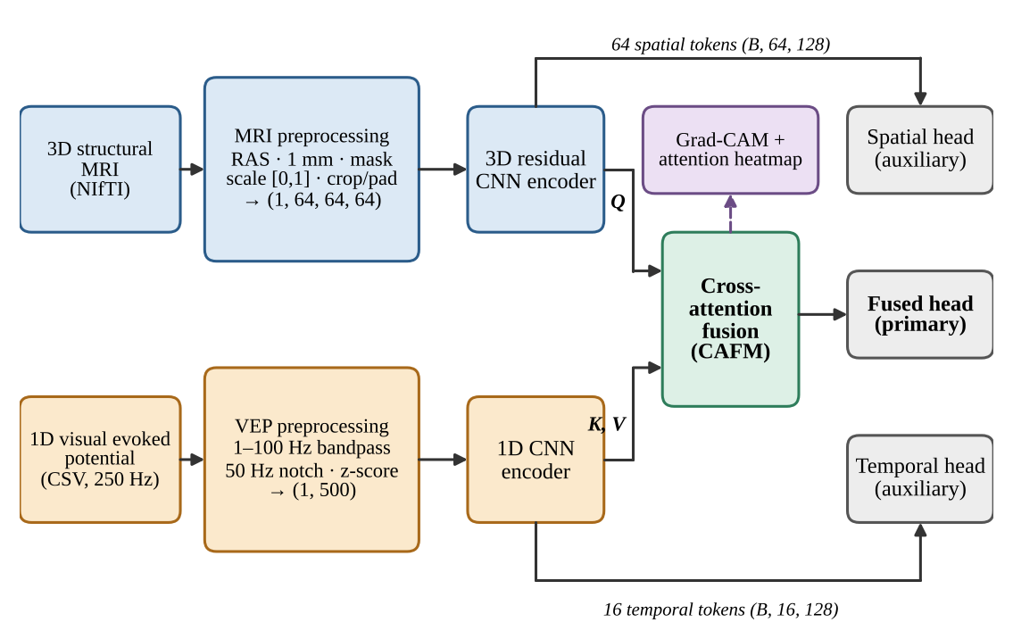
Figure 3.1: End-to-end data flow of the proposed framework. Spatial tokens act as queries (Q); temporal tokens act as keys and values (K, V). Dashed arrow: explainability outputs.
At the default configuration a paired sample moves through the tensor contract of Table 3.1. The batch dimension B is added by the data loader; the channel dimension is part of each sample.
Table 3.1: Tensor contract at the default configuration.
Stage | MRI stream | VEP stream
Raw / loaded | 3D array from NIfTI | 1D numeric waveform
After preprocessing | (1, 64, 64, 64) | (1, 500)
Encoder output (tokens) | (B, 64, 128) | (B, 16, 128)
Cross-attention weights | (B, 4, 64, 16): 4 heads × 64 spatial queries × 16 temporal keys
Fused tokens | (B, 64, 128) | n/a
Logits | Fused (B, 3); spatial auxiliary (B, 3) | Temporal auxiliary (B, 3)

3.2 DESIGN PRINCIPLES
- Single source of truth. Every shape and hyper-parameter lives in frozen dataclasses in src/config.py; the preprocessing stream, both encoders, the fusion module and the training loop read from it, so they cannot silently disagree.
- Fail loudly on invalid input. Preprocessing functions validate dimensionality, finiteness, sampling limits (for example, a band-pass upper edge above the Nyquist frequency is rejected) and signal length, and raise explicit errors.
- Same interface for real and synthetic data. The synthetic generator writes real NIfTI and CSV files and a manifest, so the exact code path that a clinical cohort would use is tested.
- Replaceable placeholders. Components known to be prototype-grade, notably the foreground mask, are isolated behind one function so a validated tool can be substituted without changing anything downstream.
- Test every module and the whole system. Each module has unit tests; two integration suites test the raw-file-to-optimiser-step path and the training loop.

3.3 TOOLS AND ENVIRONMENT
Table 3.2: Software stack. The last three libraries are listed in requirements.txt but are not imported by the current source or tests.
Component | Role in the project
Python 3 | Implementation language (the exact version is not recorded in the repository)
PyTorch (Paszke et al., 2019) | Tensors, neural-network modules, automatic differentiation, optimisation, data loading; default training device is the CPU
MONAI (Cardoso et al., 2022) | Resize (trilinear), ScaleIntensity, ResizeWithPadOrCrop for the MRI stream
NiBabel (NiBabel Developers, n.d.) | NIfTI reading and writing; reorientation to the closest canonical (RAS) frame
SciPy (Virtanen et al., 2020) | butter, sosfiltfilt, iirnotch, filtfilt for VEP conditioning
NumPy (Harris et al., 2020) | Array computation; synthetic data generation
Matplotlib (Hunter, 2007) | Grad-CAM slice overlays and the attention heatmap
pytest, pytest-cov | Unit and integration tests and coverage measurement
nilearn, MNE-Python (Gramfort et al., 2013), scikit-learn (Pedregosa et al., 2011) | Listed as dependencies for data access and future evaluation; not yet used

The source code is held in a Git repository (NeuroImaging). It comprises 1,054 lines of source in twelve modules and 1,004 lines of tests in twelve test files, plus a configuration module and test fixtures.

3.4 DATA SOURCES
The project blueprint identifies the public repositories in Table 3.3. They are useful for developing and testing preprocessing, and for retinotopic mapping of visual cortex, but none carries the diagnostic labels required for supervised training.
Table 3.3: Public data resources identified in the project blueprint (descriptions as stated there; not independently re-verified for this report).
Modality | Resource | Stated utility
3D sMRI / fMRI | OpenNeuro ds004496 | High-resolution visual cortex mapping under retinotopic stimulation
3D sMRI / fMRI | OpenNeuro ds003787 | Multimodal structural and functional visual-pathway benchmarks
3D sMRI / fMRI | Human Connectome Project 7 T retinotopy (Van Essen et al., 2013; Benson et al., 2018) | 7 T structural and retinotopic functional scans of cortical visual areas V1, V2, V3
3D sMRI | OASIS (LaMontagne et al., 2019) | Large-scale structural MRI for normalisation and grey-matter segmentation baselines
1D VEP / EEG | MNE-Python sample dataset (Gramfort et al., 2013) | Visual and auditory stimulus responses on occipital sensors
1D VEP / ERG | PhysioNet (Goldberger et al., 2000) | Standardised clinical electrophysiology recordings

The labelling gap. None of the resources in Table 3.3 ships Healthy / Glaucoma / Optic Neuritis-CVI diagnoses. Real training therefore requires a labelled, paired clinical cohort or a clinical partner able to label a subset. The data interface described in Section 3.6 is ready for such a cohort: a manifest with the columns subject_id, mri_path, vep_path, fs, label is all that is needed.

3.5 SYNTHETIC DATA GENERATION
To close the labelling gap for software development, src/data/synthetic.py generates class-conditioned MRI-like volumes and VEP-like waveforms. The conditioning is deliberately simple but structured so that a model can learn from it. The data are useful for software validation and for testing the learning loop; they are not evidence of clinical performance.

3.5.1 SYNTHETIC MRI VOLUMES
A volume of shape (80, 96, 64) is drawn from a normal distribution with mean 100 and standard deviation 15, clipped at zero. Class conditioning is applied to one octant-like region: for Glaucoma the intensities in the block with indices [D/2:, :H/2, :W/2] are multiplied by 0.4 (a proxy for atrophy), and for Optic Neuritis / CVI the block [:D/2, H/2:, W/2:] is multiplied by 1.8 (a proxy for a hyperintense lesion). Healthy volumes are left unstructured. Figure 3.2 shows example axial slices.
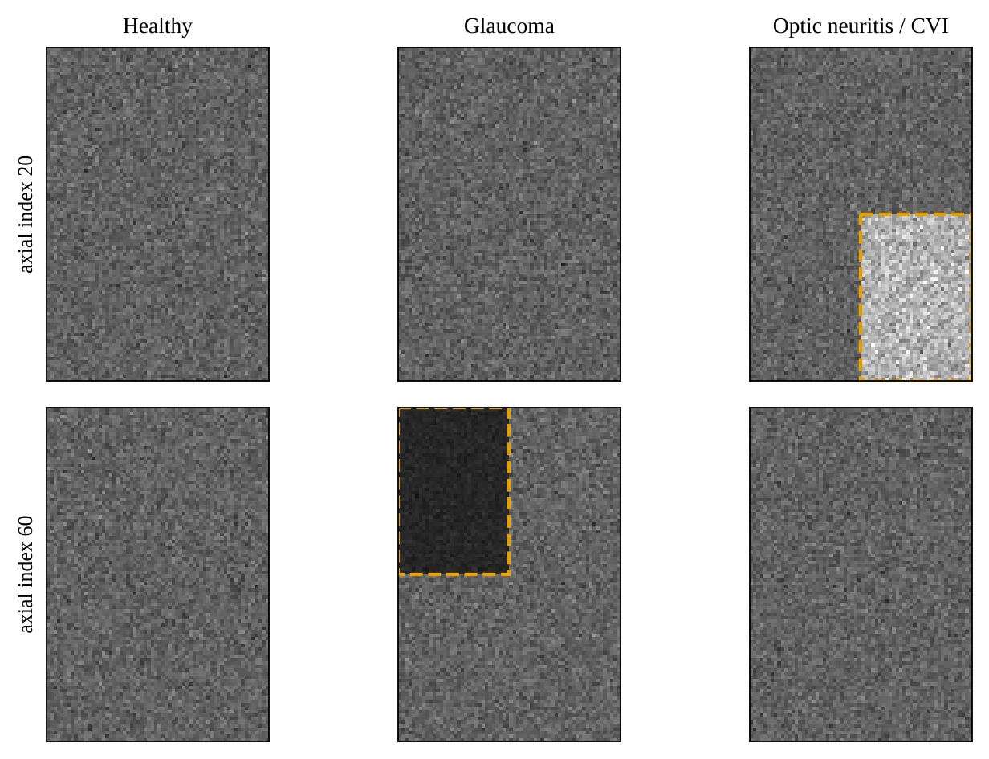
Figure 3.2: Axial slices of synthetic MRI volumes generated by the project's own generator (seeded). Dashed boxes mark the class-specific region: lesion proxy (Optic neuritis / CVI, index 20) and atrophy proxy (Glaucoma, index 60).

3.5.2 SYNTHETIC VEP WAVEFORMS
A waveform sampled at 250 Hz for 2 s (500 samples) is built from three Gaussian components that mimic the N75-P100-N145 complex, with latency τ and amplitude A that depend on the class (Table 3.4):
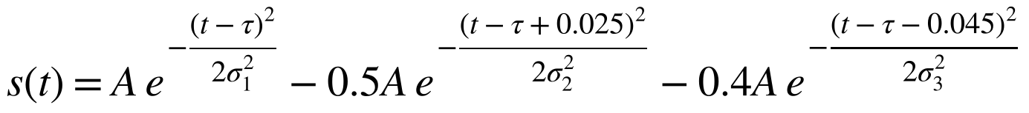 (3.1)
with σ₁ = 12 ms, σ₂ = 10 ms and σ₃ = 15 ms. Three artefacts are then added: a slow baseline drift 0.3 sin(2π · 0.3 t), mains interference 0.15 sin(2π · 50 t) and Gaussian muscle noise with standard deviation 0.3. These are exactly the artefacts that the conditioning pipeline of Section 3.8 is designed to remove.
Table 3.4: Class-conditioned parameters of the synthetic generators.
Class (label) | MRI conditioning | P100 latency τ | P100 amplitude A
Healthy Control (0) | None (background-like) | 100 ms | 6.0
Glaucoma (1) | Block × 0.4 (atrophy proxy) | 108 ms | 2.5
Optic Neuritis / CVI (2) | Block × 1.8 (lesion proxy) | 140 ms | 4.0

3.5.3 DATASET BEHAVIOUR
SyntheticNeuroDataset creates a balanced list of labels and shuffles it deterministically from a seed. The raw sample for an index is generated when the item is requested, using a shared random-number generator. Consequently the same index is not guaranteed to return identical noise on repeated access. The function write_synthetic_dataset writes the samples to disk as sub-XXXX_mri.nii.gz and sub-XXXX_vep.csv files with a manifest.csv, which is how the end-to-end tests exercise the real file path.
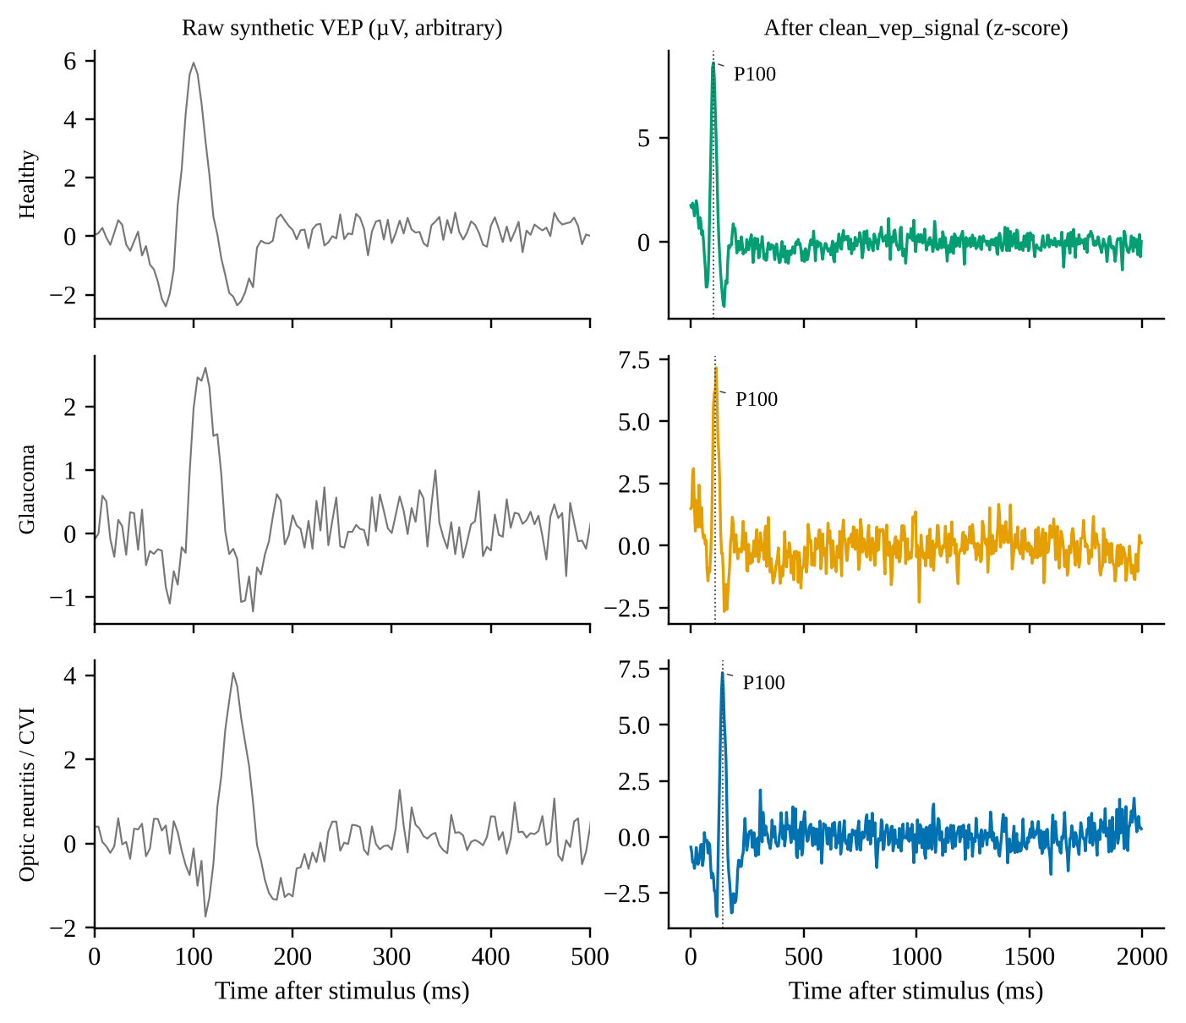
Figure 3.3: Synthetic VEP waveforms for the three classes, before (left) and after (right) the project's conditioning function clean_vep_signal. Dotted line: ground-truth P100 latency.

3.6 DATA INTERFACE
PairedNeuroDataset reads a manifest CSV with the columns subject_id, mri_path, vep_path, fs, label and raises an error if the manifest is empty. For each row, __getitem__ performs the following steps: (1) load and standardise the MRI with preprocess_mri_file; (2) read the VEP CSV with numpy.loadtxt, skipping the header; (3) take the sampling rate from the row, falling back to the configured 250 Hz when it is missing; (4) condition the waveform with clean_vep_signal; and (5) return a dictionary with the MRI tensor (1, D, H, W), the VEP tensor (1, L), a long-integer label and the subject identifier.
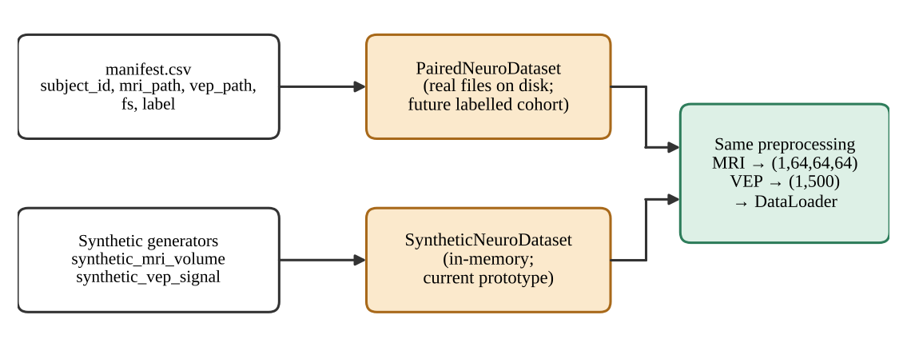
Figure 3.4: The two dataset classes share one preprocessing path. The manifest-driven class is intended for a future labelled cohort; the in-memory synthetic class is used in the current prototype.

3.7 MRI PREPROCESSING
MRI standardisation (src/preprocessing/mri_transforms.py) consists of five steps (Figure 3.5). The parameters are held in MRIConfig.
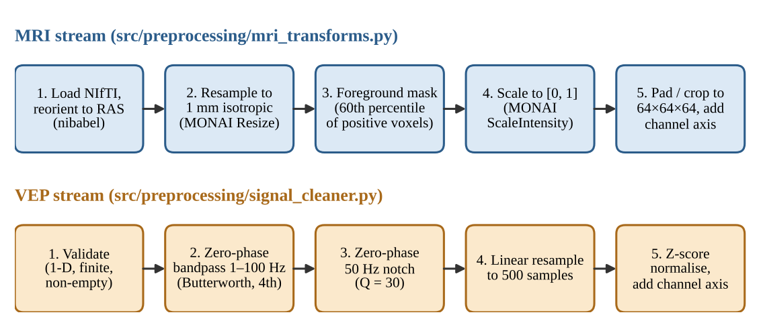
Figure 3.5: Preprocessing chains for the MRI stream (top) and the VEP stream (bottom), with the function responsible for each step.
1. Load and canonicalise. load_nifti reads the NIfTI file with NiBabel and reorients it to the closest canonical (RAS) frame. It verifies that the image is three-dimensional and that all voxel spacings are positive, and returns the data, the affine and the voxel zooms.
2. Resample to isotropic spacing. For voxel zooms z and target spacing s (1 mm), the new shape is computed from the original shape n (Equation 3.2) and the volume is resampled with MONAI's trilinear Resize.
3. Foreground masking. The p-th percentile (default 60) of the strictly positive voxels is computed and all voxels below it are set to zero (Equation 3.3).
4. Intensity scaling. If the masked volume has a non-zero range, MONAI ScaleIntensity maps it to [0, 1] (Equation 3.4); a constant volume is preserved as a float array.
5. Pad or crop. ResizeWithPadOrCrop brings the volume to (64, 64, 64) and the channel axis is added, giving (1, 64, 64, 64).
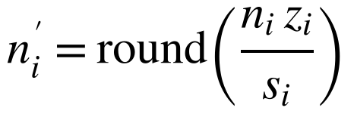 (3.2)
(3.3)
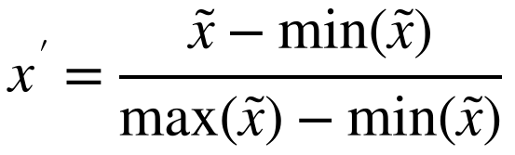 (3.4)
Important caveat. The percentile mask is a lightweight, dependency-free stand-in for skull-stripping. It is not clinical-grade brain extraction and does not replace validated tools such as HD-BET (Isensee et al., 2019) or SynthStrip (Hoopes et al., 2022). It is isolated in the function foreground_mask_threshold so that it can be replaced without changing any downstream code.
Table 3.5: MRI preprocessing parameters (MRIConfig).
Parameter | Default | Meaning
target_shape | (64, 64, 64) | Output spatial size after pad or crop
target_spacing | (1.0, 1.0, 1.0) mm | Isotropic resampling target
orientation | RAS | Canonical orientation
foreground_percentile | 60.0 | Percentile of positive voxels used as the mask threshold

3.8 VEP PREPROCESSING
VEP conditioning (src/preprocessing/signal_cleaner.py) removes baseline drift, high-frequency muscle noise and mains interference without shifting the waveform in time. The parameters are held in VEPConfig (Table 3.6).
1. Validate. The input is converted to 64-bit floats and rejected if it is not one-dimensional, is empty, or contains NaN or infinite values.
2. Band-pass. butterworth_bandpass applies a fourth-order Butterworth band-pass between 1 Hz and 100 Hz in second-order-section form with sosfiltfilt, i.e. forward and backward. The upper edge must lie below the Nyquist frequency (125 Hz at 250 Hz sampling) and the record must be long enough for zero-phase padding; otherwise an error is raised.
3. Notch. notch_filter applies a zero-phase IIR notch at 50 Hz with quality factor 30 to suppress AC power-line interference.
4. Resample. resample_to_length linearly interpolates the record to exactly 500 samples.
5. Normalise. zscore_normalize subtracts the mean and divides by the standard deviation plus a small constant (Equation 3.6); the result is returned as 32-bit floats and a channel axis is added.
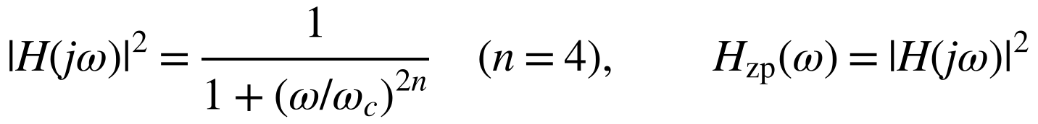 (3.5)
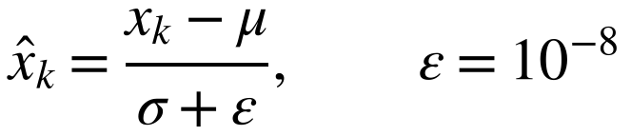 (3.6)
Why zero-phase filtering. An ordinary single-pass (causal) filter delays different frequency components by different amounts (its group delay). Because the P100 latency is itself the clinical measurement, such a delay would corrupt the very quantity of interest. Filtering forward and then backward cancels the phase response, so the effective frequency response is the squared magnitude of the single-pass filter and has zero phase (Oppenheim & Schafer, 2010; Gustafsson, 1996). The price is that the filter is non-causal and the effective roll-off is steeper; both are acceptable for offline analysis.
Table 3.6: VEP preprocessing parameters (VEPConfig).
Parameter | Default | Meaning
length | 500 | Samples after resampling
sample_rate | 250 Hz | 500 samples span a 2.0 s sweep
bandpass_low / bandpass_high | 1.0 Hz / 100.0 Hz | Edges of the fourth-order Butterworth band-pass
notch_freq | 50 Hz | Mains frequency
notch_quality | 30 | Q factor; notch bandwidth = f₀ / Q ≈ 1.67 Hz

3.9 EVALUATION STRATEGY
Because the data are synthetic, the evaluation is organised around evidence that is meaningful for a software prototype. It is designed to answer the research questions of Section 1.4 without implying clinical performance.
Table 3.7: Evaluation strategy: what is measured, how, and which objective it supports.
Evidence | Method | Supports
Signal-conditioning behaviour | The project's own functions are run on 150 synthetic VEPs (50 per class, fixed seeds): frequency response, mains attenuation, group delay, detected P100 latency against ground truth | O2, RQ2, H1
Synthetic data characterisation | Region-of-interest statistics of generated MRI volumes; effect of the foreground mask; per-class VEP statistics | O2, O7
Model size and cost | Trainable parameters and multiply-accumulate operations counted analytically from the layer definitions | O3, O4, RQ3
Software verification | 86 test functions (unit and integration); statement coverage from the recorded coverage data | O1, O6, H3
Training acceptance criteria | Thresholds asserted by the training-loop integration tests (loss reduction, above-chance validation accuracy, checkpoint round-trip) | O4, RQ3, H2

Classification metrics such as accuracy, sensitivity, specificity or area under the curve are not reported as evidence of diagnostic ability, because they would be computed on a synthetic task that was designed to be separable. The reasons are discussed further in Chapter 6.

Chapter 4
System Design and Implementation

4.1 ARCHITECTURE OVERVIEW
The Cross-Attention Fusion Network (CAFN), implemented in src/models/cafn.py, has three parts: two modality-specific encoders that turn each input into a sequence of 128-dimensional tokens, a cross-attention fusion module that lets spatial tokens query temporal tokens, and three linear classification heads (fused, spatial-auxiliary and temporal-auxiliary). Figure 4.1 shows the layer-by-layer structure with the tensor shape after each operation for a batch of size B.
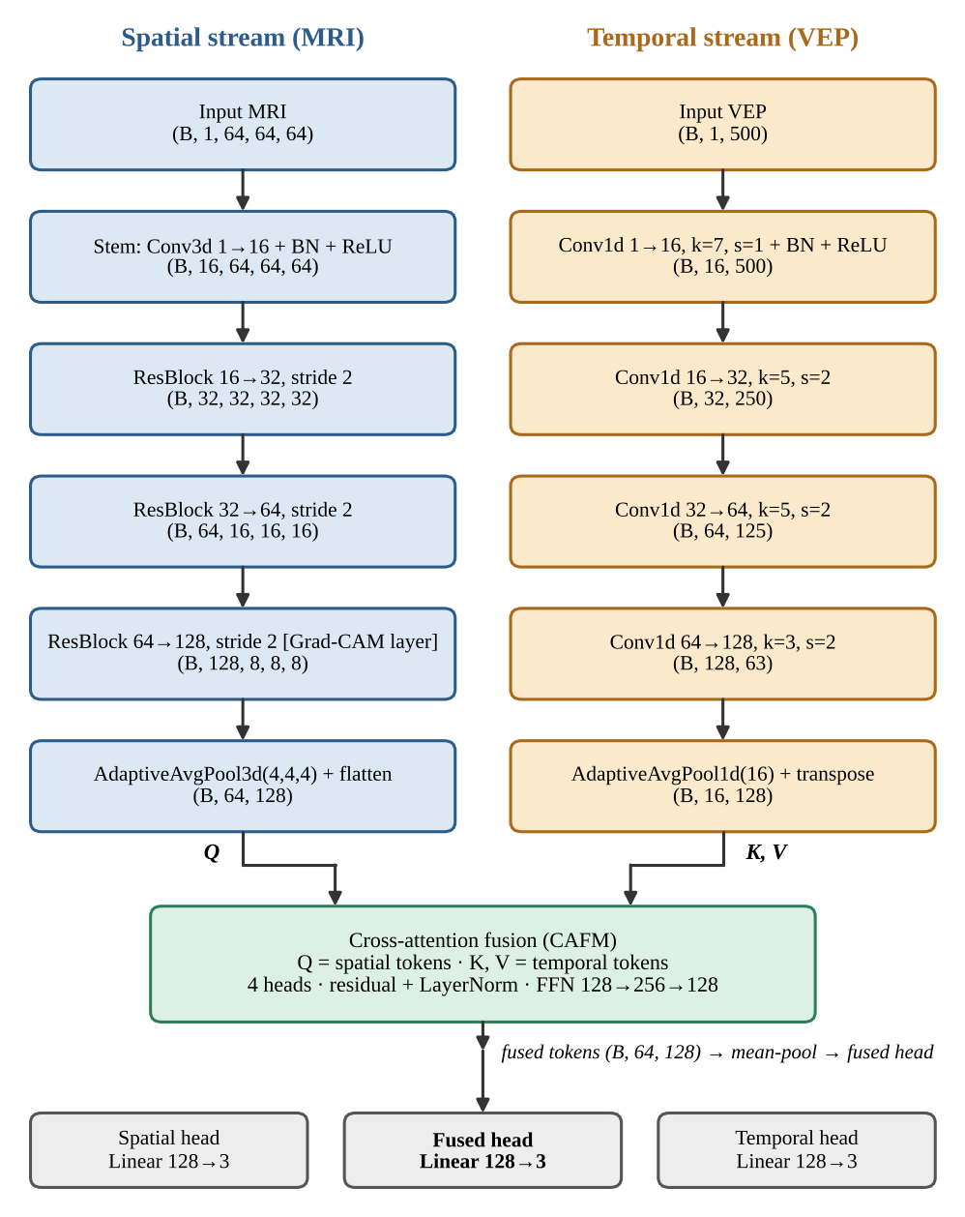
Figure 4.1: CAFN architecture with tensor shapes (default configuration). The two auxiliary heads read the mean-pooled unimodal tokens; the fused head reads the mean-pooled fused tokens.
The complete model has 1,055,081 trainable parameters, about 4.2 MB in 32-bit floating point (Section 5.4).

4.2 SPATIAL ENCODER (3D RESIDUAL CNN)
SpatialEncoder3D (src/models/spatial_encoder.py) converts a standardised MRI volume of shape (B, 1, 64, 64, 64) into a sequence of 64 tokens. It consists of a convolutional stem, three residual blocks that each halve the spatial resolution and increase the channel count, and an adaptive average pool to a 4 × 4 × 4 grid (Table 4.1).
Table 4.1: Spatial encoder layers (batch size 1) and trainable parameters.
Layer | Operation | Output shape | Parameters
Stem | Conv3d 1→16 (3×3×3, stride 1) + BatchNorm + ReLU | (16, 64, 64, 64) | 464
Residual block 1 | 16→32, stride 2 | (32, 32, 32, 32) | 42,176
Residual block 2 | 32→64, stride 2 | (64, 16, 16, 16) | 168,320
Residual block 3 | 64→128, stride 2 (Grad-CAM target last_conv) | (128, 8, 8, 8) | 672,512
Pool and tokens | AdaptiveAvgPool3d (4,4,4); flatten; transpose | (64, 128) | 0
Total |  |  | 883,472

Each residual block applies two 3 × 3 × 3 convolutions with batch normalisation (Ioffe & Szegedy, 2015); the first has the block's stride. The input is added to the output through an identity shortcut, or through a 1 × 1 × 1 convolution with batch normalisation when the stride or the channel count changes, and a ReLU follows the addition (He et al., 2016). The spatial size of a convolutional layer with kernel k, stride s and padding p follows Equation 4.1.
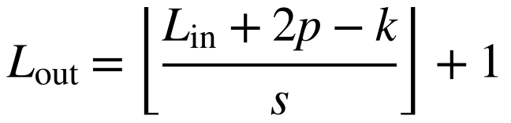 (4.1)
After the three stride-2 blocks the feature map is 8 × 8 × 8; adaptive average pooling reduces it to 4 × 4 × 4, so each of the 64 tokens summarises a 2 × 2 × 2 neighbourhood of feature-map positions, i.e. a nominal 16 × 16 × 16 voxel cube of the standardised (1 mm) volume. The final residual block is stored under the name last_conv so that the Grad-CAM implementation can attach its hooks to it.

4.3 TEMPORAL ENCODER (1D CNN)
TemporalEncoder1D (src/models/temporal_encoder.py) maps a conditioned VEP of shape (B, 1, 500) to 16 tokens through four convolutional stages, each followed by batch normalisation and a ReLU, and an adaptive average pool (Table 4.2).
Table 4.2: Temporal encoder layers (batch size 1) and trainable parameters.
Stage | Convolution | Output length | Parameters
1 | Conv1d 1→16, kernel 7, stride 1 | 500 | 144
2 | Conv1d 16→32, kernel 5, stride 2 | 250 | 2,624
3 | Conv1d 32→64, kernel 5, stride 2 | 125 | 10,368
4 | Conv1d 64→128, kernel 3, stride 2 | 63 | 24,832
Pool | AdaptiveAvgPool1d (16); transpose → (16, 128) | 16 | 0
Total |  |  | 37,968

The cascade has a receptive field of 27 samples (108 ms at 250 Hz) and an output stride of 8 samples (32 ms). The 63 output positions are averaged into 16 tokens, so each token nominally summarises about 125 ms of the 2 s epoch (Figure 4.2). The tokens are learned feature positions: without further temporal registration they should not be read as calibrated millisecond bins.
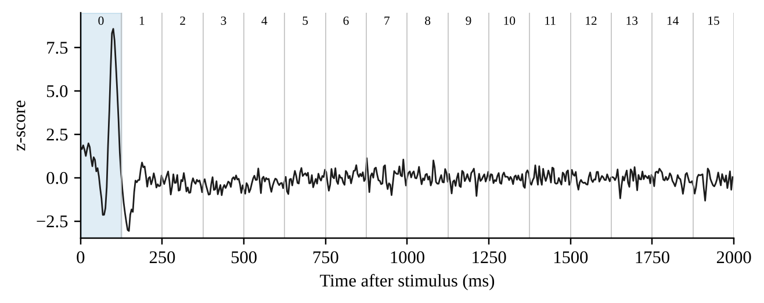
Figure 4.2: Nominal mapping of the 16 temporal tokens onto the 2 s epoch (125 ms per token) over an example conditioned VEP. The shaded region is token 0.

4.4 CROSS-ATTENTION FUSION MODULE
The fusion module (src/models/cross_attention.py) is the central component. The spatial tokens X_{s} (64 × 128) supply the queries; the temporal tokens X_{t} (16 × 128) supply the keys and values (Equation 4.2). Each spatial token can therefore attend to any of the 16 temporal tokens.
(4.2)
With d_{model} = 128 and H = 4 heads, each head has dimension d_{h} = 32. For head h the scaled dot-product attention is computed (Vaswani et al., 2017), with a softmax over the 16 temporal tokens, followed by dropout on the attention weights (p = 0.1):
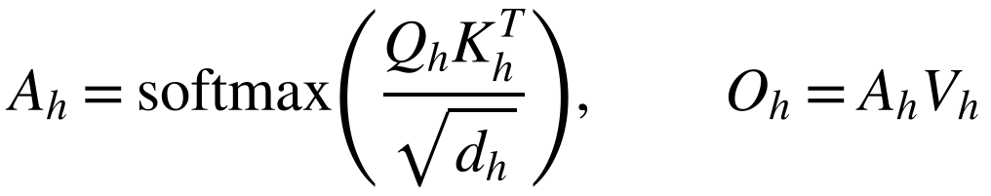 (4.3)
The head outputs are concatenated and projected, added to the original spatial tokens through a residual connection, normalised (Ba et al., 2016), passed through a position-wise feed-forward block (128 → 256 → 128 with ReLU and dropout) and normalised again after a second residual connection:
(4.4)
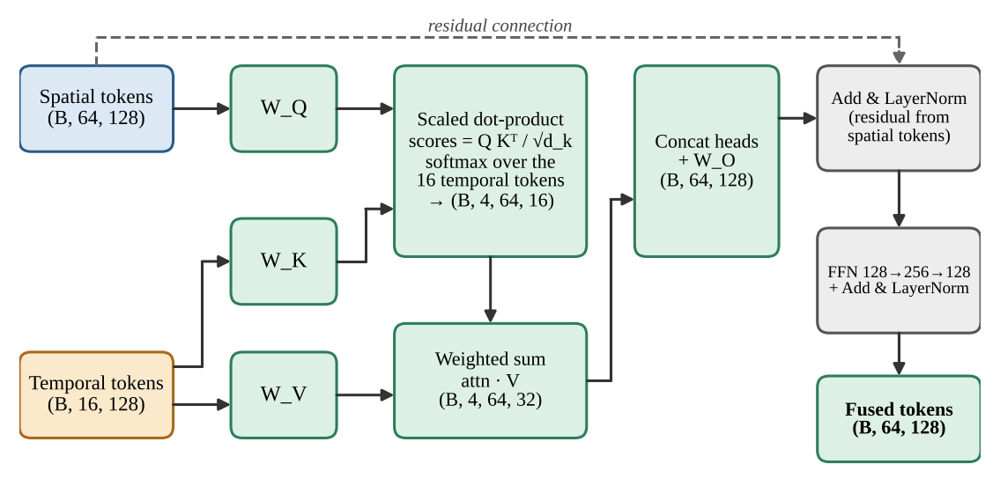
Figure 4.3: Structure of the cross-attention fusion module (CAFM). The attention-weight tensor has shape (B, 4, 64, 16) and is returned for inspection.
The output F keeps the shape (B, 64, 128): the spatial-token sequence is preserved and each token is enriched with temporal context. The module accepts queries and keys of different lengths and rejects configurations in which d_{model} is not divisible by the number of heads. The projection matrices, the output projection and the feed-forward block account for 132,480 trainable parameters (Table 5.5).

4.5 CLASSIFICATION HEADS AND MULTI-TASK LOSS
CAFN.forward mean-pools three token sequences, the fused tokens, the spatial tokens and the temporal tokens, and passes each pooled 128-dimensional embedding through its own linear layer to obtain three sets of logits of shape (B, 3). The fused head is the primary prediction used at evaluation time. The two auxiliary heads provide unimodal supervision: they encourage each encoder to carry class information on its own and reduce the chance that the fused pathway learns to ignore one modality entirely. With cross-entropy L_{f}, L_{s} and L_{t} for the fused, spatial and temporal heads, the objective is
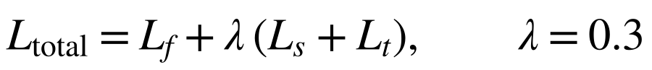 (4.5)
The function CAFN.multi_task_loss returns the total together with the three component values, so that each can be logged.

4.6 TRAINING PROCEDURE
Training is implemented in src/train.py and summarised in Figure 4.4. For each epoch, train_model performs the following steps.
1. Put the model in training mode and iterate over a shuffled DataLoader (batch size 8).
2. Move the MRI, VEP and label tensors to the selected device (default: CPU).
3. Clear gradients, run the forward pass and compute the multi-task loss with the configured auxiliary weight.
4. Back-propagate and take an Adam step (learning rate 10⁻³, weight decay 10⁻⁴); accumulate the sample-weighted training loss.
5. If a validation loader is supplied, evaluate the fused-head loss and accuracy with gradients disabled and the model in evaluation mode.
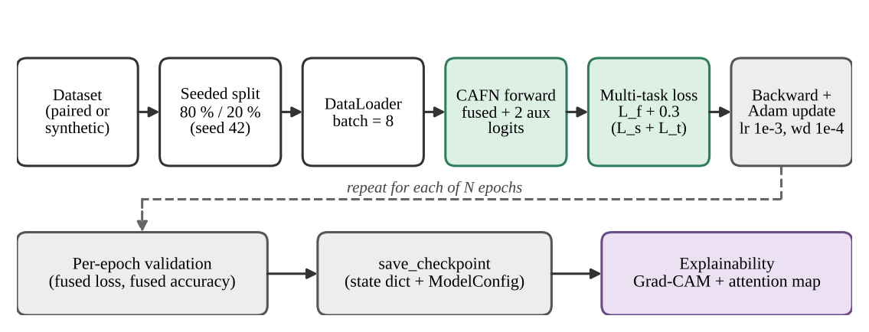
Figure 4.4: Training and evaluation flow. A seeded permutation splits the data; each epoch is followed by validation; the trained model can be checkpointed and passed to the explainability tools.
Table 4.3: Training configuration (TrainConfig) and model configuration (ModelConfig) at the default values.
Parameter | Default | Parameter | Default
batch_size | 8 | d_model | 128
epochs | 20 | num_heads | 4
lr (Adam) | 1e-3 | spatial_tokens / spatial_pool | 64 / (4, 4, 4)
weight_decay | 1e-4 | temporal_tokens | 16
aux_loss_weight (λ) | 0.3 | ffn_hidden | 256
val_split | 0.2 | dropout | 0.1
seed | 42 | num_classes | 3
checkpoint_dir | checkpoints

Splitting. train_val_split draws a deterministic random permutation with a seeded generator, assigns the first max(1, int(n · val_split)) indices to validation and the rest to training, and falls back to using all samples for training when a very small dataset would otherwise leave none. Checkpoints. save_checkpoint stores the model's state dictionary together with its ModelConfig; load_checkpoint rebuilds the model from the stored configuration and loads the weights on the CPU. Command line. The module can be run as python -m src.train --epochs 20 --synthetic-samples 64; this entry point trains on the synthetic dataset only. Not implemented. The loop has no learning-rate scheduler, early stopping, mixed precision, class weighting or per-epoch checkpointing.

4.7 EXPLAINABILITY

4.7.1 3D GRAD-CAM ON THE FUSED LOGIT
GradCAM3D (src/explainability/grad_cam_3d.py) registers a forward hook and a backward hook on the spatial encoder's last residual block. It back-propagates from the selected fused logit, by default that of the predicted class, so that the gradients flow through the cross-attention module into the spatial encoder and the map reflects the multimodal decision. With activations A^{k} of channel k and class score y^{c}, the channel weights are the spatially averaged gradients and the map is a rectified weighted sum (Selvaraju et al., 2017):
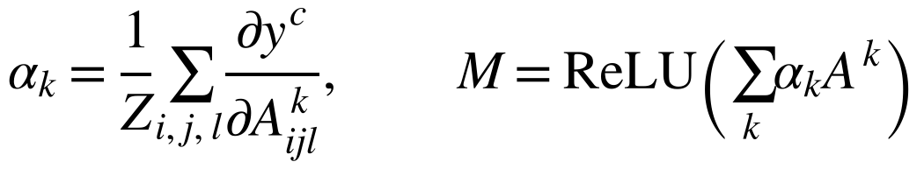 (4.6)
The map is upsampled by trilinear interpolation to the input shape and normalised per sample to [0, 1]. The helper plot_gradcam_slices overlays it on the mid axial, coronal and sagittal slices and saves a PNG. The model is returned to its original training or evaluation mode and the hooks are removed after use.

4.7.2 CROSS-ATTENTION HEATMAP
cross_attention_heatmap averages the attention tensor (B, H, S, T) over the batch and the heads to a matrix of shape (S, T), 64 × 16 at the default configuration, and plot_cross_attention renders it as a heatmap with spatial tokens on one axis and temporal tokens on the other.
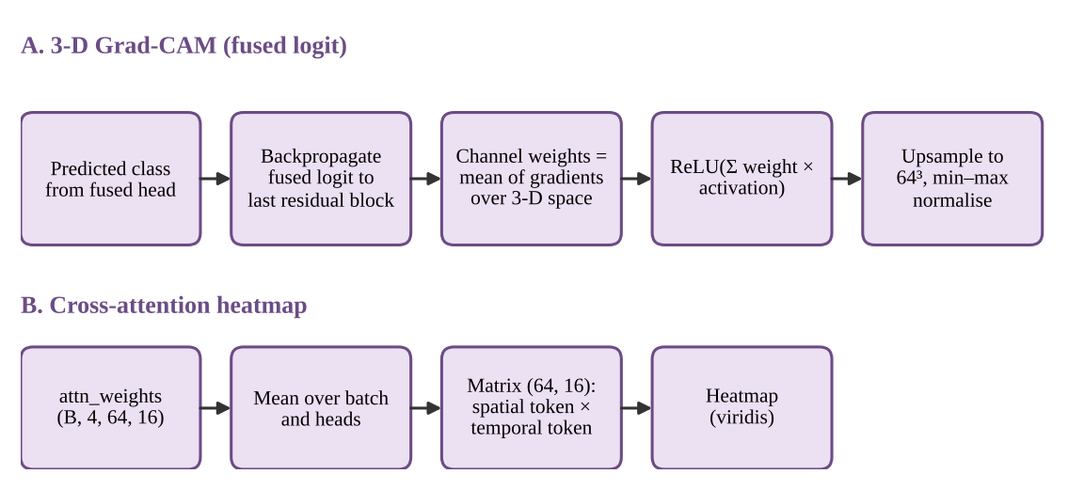
Figure 4.5: Generation of the two explanation artefacts: the Grad-CAM map (A) and the cross-attention heatmap (B).
Interpretation caveat. Both artefacts are inspection aids. The Grad-CAM map shows which feature locations influenced the selected logit; it does not by itself identify V1, V2, V3, the optic nerve or any other anatomical structure. The heatmap axes are learned token indices, not registered brain regions or calibrated milliseconds. Chapter 6 discusses why attention and saliency maps must be validated before being offered as clinical evidence.

4.8 SOFTWARE STRUCTURE AND CONFIGURATION
The code base is organised by responsibility (Figure 4.6 and Table 4.4). The configuration module is the only place in which shapes and hyper-parameters are defined; the remaining modules import it.
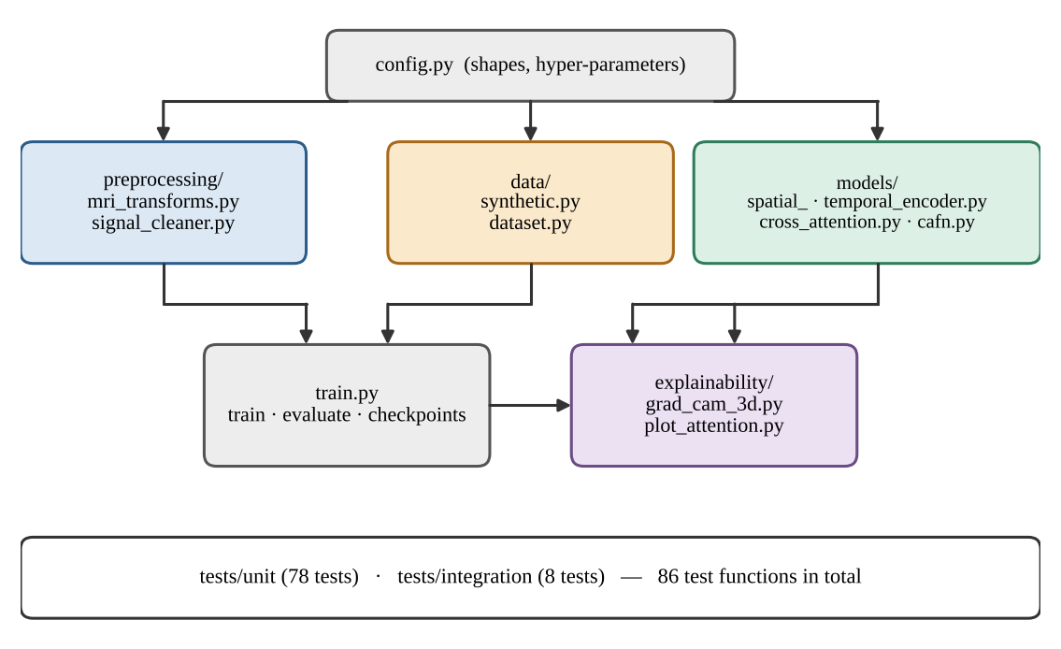
Figure 4.6: Module structure and dependencies of the code base.
Table 4.4: Source modules, line counts and responsibilities.
Module | Lines | Responsibility
src/config.py | 64 | Frozen dataclasses (MRI, VEP, model, training); class names
src/data/synthetic.py | 125 | Synthetic MRI and VEP generators; on-disk dataset writer
src/data/dataset.py | 88 | PairedNeuroDataset (manifest) and SyntheticNeuroDataset
src/preprocessing/mri_transforms.py | 101 | NIfTI loading, resampling, masking, scaling, pad/crop
src/preprocessing/signal_cleaner.py | 109 | Validation, band-pass, notch, resampling, z-score
src/models/spatial_encoder.py | 61 | 3D residual CNN producing spatial tokens
src/models/temporal_encoder.py | 35 | 1D CNN producing temporal tokens
src/models/cross_attention.py | 75 | Multi-head cross-attention and fusion block
src/models/cafn.py | 61 | Full model, heads and multi-task loss
src/train.py | 161 | Training, evaluation, split, checkpoints, command line
src/explainability/grad_cam_3d.py | 127 | 3D Grad-CAM engine and slice plots
src/explainability/plot_attention.py | 47 | Attention reduction and heatmap

4.9 TEST DESIGN
The test suite (tests/) contains 86 test functions in 12 files: 78 unit tests and 8 integration tests. A shared tiny_config fixture scales the model down (MRI shape 32³, VEP length 200, d_{model} = 32, two heads, eight spatial and eight temporal tokens, three epochs) so that tests run quickly while exercising the same interfaces. Fixtures also provide a seeded random generator, a factory that writes synthetic NIfTI files with non-isotropic spacing, and a VEP-like array with known 10 Hz and 50 Hz components. All tests run with fixed seeds.
Table 4.5: Test files and what they verify.
Test file | Tests | Properties verified
unit/test_signal_cleaner.py | 18 | Output shape; attenuation of drift and mains hum; preservation of in-band content; rejection of invalid input (non-1D, NaN, too short, cut-off above Nyquist); mean 0 / std 1; P100-like peak latency is not shifted
unit/test_mri_transforms.py | 12 | RAS orientation; voxel zooms; low-intensity voxels zeroed; all-zero volume unchanged; anisotropic spacing resampled along the correct axis; output shape and range; constant volumes produce no NaN; full file pipeline
unit/test_cross_attention.py | 8 | Output and attention shapes; attention rows sum to one; mismatched query/key lengths; divisibility check; finite outputs; gradients reach all parameters; temporal input actually changes the output
unit/test_grad_cam_3d.py | 8 | Map shape and [0, 1] range; explicit target class respected; hooks removed; training mode restored; PNG written; mismatched shapes rejected
unit/test_cafn_model.py | 7 | Output keys and shapes; batch size one; finite logits; loss equals the weighted sum of parts; backward reaches every parameter; optimiser step changes weights
unit/test_dataset.py | 7 | Item shapes and types; length; balanced labels; data-loader batching; seed dependence; manifest reading; empty-manifest error
unit/test_spatial_encoder.py | 5 | Output shape; batch size one; gradient flow; hook target participates in forward pass; eval-mode determinism
unit/test_plot_attention.py | 5 | Reduction over batch and heads; non-negative values; dimensionality check; PNG written; matches manual reduction
unit/test_temporal_encoder.py | 4 | Output shape; batch size one; gradient flow; robustness to input length
unit/test_train_utils.py | 4 | Split partitions the dataset; single-sample fallback; determinism for a fixed seed; empty loader returns NaN
integration/test_pipeline_end_to_end.py | 4 | Raw files → preprocessing → model → loss → backward → optimiser step; shape compatibility; Grad-CAM and attention plots from real pipeline output; glaucoma and neuritis VEP peaks distinguishable
integration/test_training_loop.py | 4 | Training loss falls substantially; model separates synthetic classes above a minimum validation accuracy; training without a validation set; checkpoint round-trip leaves logits unchanged

Chapter 5
Results

5.1 INTRODUCTION
This chapter presents the measurements obtained for the project. Following the evaluation strategy of Section 3.9, the results concern (i) the behaviour of the signal-conditioning pipeline, (ii) the properties of the synthetic data, (iii) the size and computational cost of the model, and (iv) the results of the automated verification (test suite and coverage). They are presented without interpretation; the interpretation follows in Chapter 6.
Two points about what is not reported are stated here to avoid ambiguity. First, no diagnostic-performance metrics are reported, because no labelled clinical data exist and the synthetic task is separable by construction. Second, measured training curves and validation accuracies are not reported, because the training experiments could not be executed in the environment used to prepare this report; the training behaviour is instead described through the acceptance criteria that the repository's integration tests enforce (Section 5.7). All measurements below were produced by running the project's own functions on seeded synthetic data (50 trials per class, 150 in total; sampling rate 250 Hz; 500 samples per record) or by analysing the repository's code and recorded test data.

5.2 SIGNAL CONDITIONING RESULTS

5.2.1 FREQUENCY RESPONSE
The combined frequency response of the zero-phase conditioning filters (fourth-order Butterworth band-pass, 1–100 Hz, followed by a 50 Hz notch with Q = 30, each applied forward and backward) is shown in Figure 5.1 and sampled at selected frequencies in Table 5.1. The −6 dB bandwidth of the notch (the −3 dB point of a single pass) extends from 49.18 to 50.83 Hz.
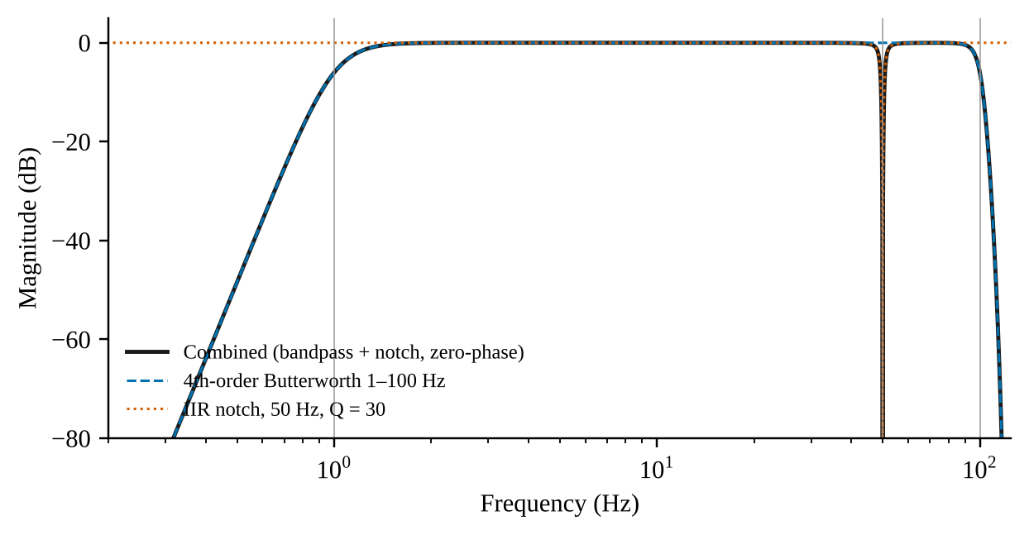
Figure 5.1: Magnitude response of the conditioning filters in the effective (forward-backward) form.
Table 5.1: Effective magnitude response (dB) at selected frequencies.
Frequency (Hz) | Band-pass | Notch | Combined
0.3 | -82.73 | 0.00 | -82.73
1.0 | -5.78 | 0.00 | -5.78
10.0 | 0.00 | 0.00 | 0.00
49.0 | 0.00 | -4.52 | -4.52
50.0 | 0.00 | -97.45 | -97.45
51.0 | 0.00 | -4.65 | -4.65
100.0 | -6.03 | 0.00 | -6.03

5.2.2 MAINS-INTERFERENCE ATTENUATION
A least-squares sinusoid fit at 50 Hz was used to measure the amplitude of the injected mains component before and after band-pass and notch filtering. Averaged over the 150 trials, the fitted 50 Hz amplitude fell from 0.152 to 0.0125 (arbitrary units), a mean reduction of 22.0 dB. For reference, the residual amplitude fitted at 47 Hz after filtering, a frequency at which no component was injected, was 0.0212. Figure 5.2 shows the amplitude spectrum of one example record.
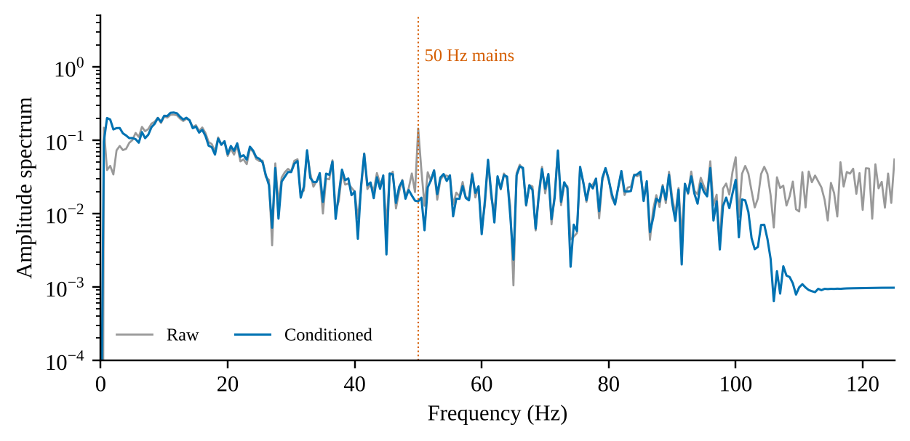
Figure 5.2: Amplitude spectrum of one synthetic VEP before and after conditioning. The dotted line marks 50 Hz.

5.2.3 P100 LATENCY
The P100 latency was estimated as the time of the maximum within 60–220 ms. Table 5.2 compares the estimates from the raw signal, from the project's zero-phase conditioning, and from an ordinary single-pass (causal) implementation of the same filters, with the ground-truth latency of the generator. Estimates are quantised by the sampling interval of 4 ms.
Table 5.2: Detected P100 latency (ms; mean ± SD over 50 trials per class) and mean error against the ground truth.
Class | True | Raw | Zero-phase | Single-pass | Err. zero-phase | Err. single-pass
Healthy Control | 100 | 101.8 ± 2.3 | 100.6 ± 1.9 | 101.1 ± 1.8 | +0.64 | +1.12
Glaucoma | 108 | 107.4 ± 2.7 | 108.0 ± 2.9 | 108.2 ± 2.3 | +0.00 | +0.24
Optic Neuritis / CVI | 140 | 141.3 ± 2.5 | 140.8 ± 2.1 | 141.0 ± 2.7 | +0.80 | +1.04

With zero-phase conditioning, 149 of 150 trials (99.3%) gave a latency within one sample period (4 ms) of the ground truth; the largest absolute error was 8 ms, which occurred in one Glaucoma trial. For the single-pass implementation the corresponding count was 149 of 150, and the largest raw-signal error was 8 ms. The group delay of the single-pass filter, computed from its transfer function, is given in Table 5.3 (the zero-phase pipeline has zero group delay at all frequencies) and plotted in Figure 5.3.
Table 5.3: Group delay of the single-pass (causal) implementation of the same filters.
Frequency (Hz) | Group delay (ms)
1 | 593.1
2 | 120.7
5 | 18.8
10 | 6.1
20 | 3.1
30 | 2.8
40 | 3.9
60 | 4.8

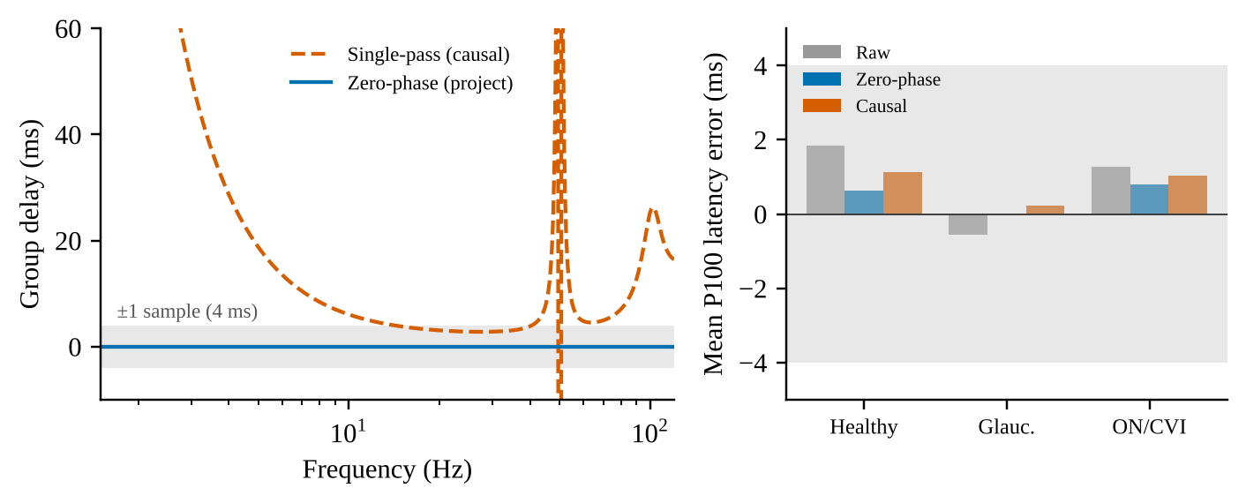
Figure 5.3: Left: group delay of the single-pass filters versus the zero-phase pipeline (shaded band: ±1 sample, 4 ms). Right: mean P100 latency error by class (shaded band: ±4 ms).

5.2.4 CONDITIONED-WAVEFORM STATISTICS
After conditioning and z-scoring, the peak value of the P100 window was 8.38 ± 0.27 for Healthy Control, 6.85 ± 0.41 for Glaucoma and 7.51 ± 0.54 for Optic Neuritis / CVI (mean ± SD, 50 trials per class). Figure 5.4 shows the distributions of the detected latency and of the peak value.
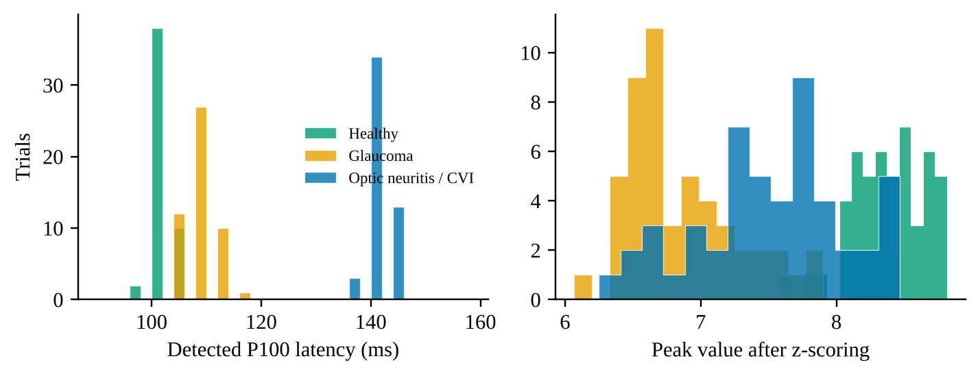
Figure 5.4: Distributions over 50 synthetic trials per class: detected P100 latency after conditioning (left) and peak value after z-scoring (right).

5.2.5 NOMINAL TEMPORAL-TOKEN BINS
The temporal encoder reduces the 500-sample record to 16 tokens, so that each token nominally spans 125 ms of the 2.0 s record. The ground-truth P100 latencies of the three classes (100, 108 and 140 ms) fall in token 0 for Healthy Control, token 0 for Glaucoma and token 1 for Optic Neuritis / CVI (the token mapping is illustrated in Figure 4.2).

5.3 SYNTHETIC MRI CHARACTERISATION
One seeded synthetic volume of shape (80, 96, 64) was generated per class and the intensity statistics of the class-specific regions of interest (ROI) were measured, together with the effect of the project's foreground-mask function at its default 60th percentile (Table 5.4). The ROIs are the atrophy-proxy block [D/2:, :H/2, :W/2] and the lesion-proxy block [:D/2, H/2:, W/2:] described in Section 3.5.
Table 5.4: Synthetic MRI: mean intensity of regions of interest and effect of the 60th-percentile foreground mask.
Class | Mean, rest of volume | Mean, atrophy ROI | Mean, lesion ROI | Voxels zeroed (%) | Atrophy ROI retained (%) | Lesion ROI retained (%)
Healthy Control | 100.0 | 99.9 | 100.0 | 60.0 | 39.7 | 40.0
Glaucoma | 100.0 | 40.0 | 100.0 | 60.0 | 0.0 | 45.7
Optic Neuritis / CVI | 100.0 | 100.1 | 179.9 | 60.0 | 31.7 | 99.7

5.4 MODEL COMPLEXITY
The number of trainable parameters and the multiply-accumulate (MAC) operations per sample were counted analytically from the layer definitions in src/models/*.py at the default configuration (Table 5.5). Batch-normalisation running statistics are buffers, not trainable parameters, and are excluded; MAC counts include convolutions and linear layers and the attention matrix products, and exclude normalisation, activation, pooling and the softmax. In total the model has 1,055,081 trainable parameters and about 2.53 billion MACs per sample.
Table 5.5: Trainable parameters and multiply-accumulates (millions) per sample at the default configuration.
Component | Parameters | MACs (millions)
Spatial stem (Conv3d + BN) | 464 | 113.25
Spatial residual block 1 (16→32) | 42,176 | 1,375.73
Spatial residual block 2 (32→64) | 168,320 | 687.87
Spatial residual block 3 (64→128) | 672,512 | 343.93
Temporal encoder (4 stages) | 37,968 | 3.52
Cross-attention projections (W_Q, W_K, W_V, W_O) | 66,048 | 2.88
Feed-forward block (128→256→128) | 65,920 | 4.19
Layer normalisation (×2) | 512 | —
Classification heads (×3) | 1,161 | 0.00
Total | 1,055,081 | 2,531.38

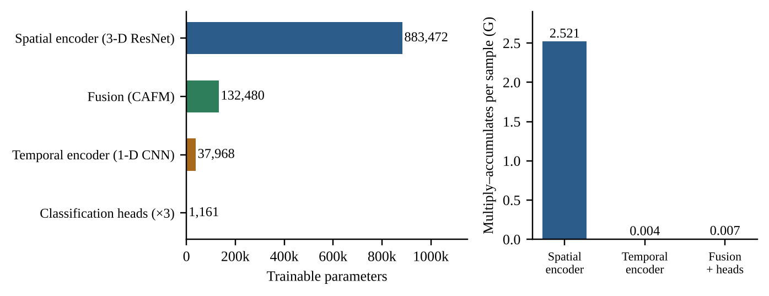
Figure 5.5: Left: trainable parameters by component. Right: multiply-accumulate operations per sample by component group.
The spatial encoder accounts for 83.7% of the parameters, the fusion module for 12.6%, the temporal encoder for 3.6% and the three heads for 0.11%. The attention-score tensor has 4,096 elements per sample (4 heads × 64 queries × 16 keys).

5.5 INTERFACE AND SHAPE VERIFICATION
The tensor contract of Table 3.1 is asserted by the test suite: the preprocessing outputs (1, 64, 64, 64) and (1, 500) at the default configuration; the spatial and temporal encoders return (B, 64, 128) and (B, 16, 128); the cross-attention module returns fused tokens (B, 64, 128) and attention weights (B, 4, 64, 16) whose rows sum to one; the model returns three logits tensors of shape (B, 3); Grad-CAM returns (B, D, H, W) values in [0, 1]; and the attention heatmap has shape (64, 16). A scaled-down configuration (the tiny_config fixture) is used for speed in the tests and exercises the same code.

5.6 SOFTWARE VERIFICATION RESULTS
The repository's recorded pytest node identifiers list 86 test functions in 12 files (78 unit and 8 integration tests; Figure 5.6, left), matching the count in the project documentation. The tests could not be re-executed in the environment used to prepare this report (Section 5.1), so pass/fail status is not independently re-verified here. Statement coverage was reconstructed from the recorded coverage data file of the development machine by matching the executed line numbers against the executable statements of each source file. The total was 521 of 548 statements (95.1%), consistent with the 95% reported in the project documentation. Table 5.6 gives the per-module values; they may differ from the values printed by the coverage tool by a statement or so, because the executable-statement set was derived from the syntax tree rather than from the tool's own parser.
Table 5.6: Statement coverage by module (reconstructed from the recorded coverage data).
Module | Statements | Executed | Coverage (%)
src/config.py | 38 | 38 | 100.0
src/data/dataset.py | 43 | 43 | 100.0
src/data/synthetic.py | 62 | 62 | 100.0
src/explainability/grad_cam_3d.py | 70 | 69 | 98.6
src/explainability/plot_attention.py | 22 | 22 | 100.0
src/models/cafn.py | 31 | 31 | 100.0
src/models/cross_attention.py | 45 | 45 | 100.0
src/models/spatial_encoder.py | 37 | 37 | 100.0
src/models/temporal_encoder.py | 14 | 14 | 100.0
src/preprocessing/mri_transforms.py | 42 | 41 | 97.6
src/preprocessing/signal_cleaner.py | 51 | 49 | 96.1
src/train.py | 93 | 70 | 75.3
Total | 548 | 521 | 95.1

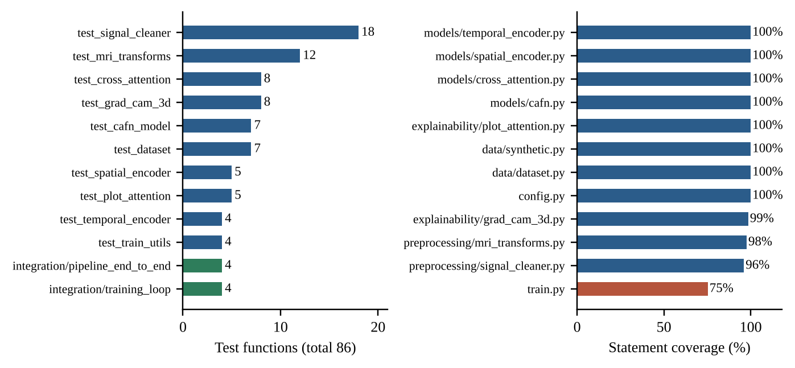
Figure 5.6: Left: number of test functions per test file (blue: unit; green: integration). Right: statement coverage per module (red: below 90%).
The lowest-covered module is src/train.py (75%). Its uncovered statements are mainly the body of the command-line main() function, which parses arguments, builds the synthetic dataset and writes a checkpoint, together with a few verbose-logging and edge-case branches.

5.7 TRAINING ACCEPTANCE CRITERIA
The training loop is verified by the four integration tests in tests/integration/test_training_loop.py, which train a scaled-down model on synthetic data. The configuration and the thresholds that they assert are given in Table 5.7. The tests assert thresholds, not point values; the exact loss and accuracy reached are therefore not part of the recorded results.
Table 5.7: Training-loop acceptance criteria asserted by tests/integration/test_training_loop.py.
Item | Specification
Data | 24 synthetic samples (raw volume 40 × 48 × 32), validation split 25%, seed 0
Model | d_model 32, 2 heads, 8 spatial and 8 temporal tokens, FFN 64, dropout 0.1; MRI shape 32³; VEP length 200
Training | 15 epochs, batch size 4, Adam, learning rate 1e-3, weight decay 1e-4, auxiliary weight 0.3
Criterion 1 | Final training loss < 0.7 × initial training loss
Criterion 2 | Validation accuracy of the fused head > 0.5 (chance level for three balanced classes is 0.33)
Criterion 3 | Training runs without a validation set (history of validation loss is empty)
Criterion 4 | A saved and reloaded checkpoint reproduces the fused logits exactly (assert_close)

The four tests of tests/integration/test_pipeline_end_to_end.py exercise the raw-file path: synthetic NIfTI and CSV files are written and read through PairedNeuroDataset; the preprocessed tensors are passed through the model without shape errors; the loss is back-propagated and at least one parameter is shown to change after an optimiser step; Grad-CAM and attention plots are produced from a dataset sample; and the preprocessed Glaucoma and Optic Neuritis VEP peaks are shown to occur at different sample indices.

5.8 SUMMARY OF RESULTS
Table 5.8: Summary of the objective results.
Item | Result
H1: P100 latency preserved | 149 of 150 synthetic trials within one sample (4 ms) of ground truth; one Glaucoma trial at 8 ms; mean errors between +0.00 and +0.80 ms
Mains attenuation | Mean 22.0 dB reduction of the 50 Hz component; notch −6 dB band 49.18–50.83 Hz
Foreground mask on synthetic MRI | Exactly 60.0% of voxels zeroed in every class; atrophy-proxy ROI fully zeroed in the Glaucoma volume
Model size | 1,055,081 trainable parameters; about 2.53 G MACs per sample
Test suite | 86 test functions (78 unit, 8 integration) in 12 files; not re-executed for this report
Statement coverage | 95.1% overall; src/train.py 75%
H2: training acceptance | Thresholds defined and asserted by integration tests (loss < 70% of initial; validation accuracy > 0.5); measured values not reported here

Chapter 6
Discussion

6.1 INTRODUCTION
This chapter interprets the measurements of Chapter 5, relates them to the objectives, research questions and hypotheses of Section 1.4, compares the design with the literature of Chapter 2, and states the constraints under which the conclusions hold. The guiding principle is that every statement is limited to what the evidence supports: the project is a tested research prototype, and the evidence concerns software behaviour on synthetic data, not diagnostic performance.

6.2 INTERPRETATION OF THE RESULTS

6.2.1 SIGNAL CONDITIONING
The frequency response confirms the intended behaviour of the conditioning chain (Table 5.1): the pass-band is flat to better than 0.001 dB at 10 Hz, the 50 Hz component is removed by about 97 dB in the ideal response, and the −6 dB band of the notch is only 1.65 Hz wide, so that neighbouring frequencies are barely affected. The effective response at 1 Hz is about −5.8 dB, which is the −3 dB corner of the single-pass filter applied twice; the 1 Hz edge therefore removes baseline drift without cutting into the region around 10 Hz that carries the main VEP components.
The measured reduction of the injected 50 Hz component was 22 dB on average, much smaller than the 97 dB of the ideal response. This is not a failure of the filter. After filtering, the fitted 50 Hz amplitude (0.0125) is of the same order as the fitted amplitude at 47 Hz (0.0212), where nothing was injected: the residual is dominated by the broadband noise of the synthetic record, and the measured figure is therefore a lower bound on the notch's attenuation.
For the P100 latency, hypothesis H1 is supported at the level of the class means (errors of +0.64, +0.00 and +0.80 ms against a 4 ms sampling interval) and in 149 of 150 individual trials. The one exception, a Glaucoma record with an 8 ms error, is not specific to the zero-phase pipeline: the raw and single-pass results for the same class also reach a maximum error of 8 ms, so it is most likely due to the noise realisation and not to the filtering. The ordering of the three classes by detected latency (about 100, 108 and 141 ms) is preserved after conditioning, which is the property that matters for the downstream task.
A noteworthy observation is that the benefit of zero-phase over single-pass filtering cannot be demonstrated by these data. The mean difference in detected latency between the two implementations is below 0.5 ms in every class, i.e. much smaller than one sample, even though the single-pass filter has a group delay of 3 to 6 ms in the 10–30 Hz range (Table 5.3). The likely reason is that the synthetic P100 is a smooth, low-frequency peak whose maximum is insensitive to a small delay that is nearly constant across its bandwidth. The justification for zero-phase processing in this project therefore rests on the principle that latency is the clinical quantity (Odom et al., 2016) and on the absence of any cost to using it on offline records, not on an empirical gain at the project's sampling rate. At a higher sampling rate, or for sharper real waveforms, the difference could become measurable.

6.2.2 SYNTHETIC DATA AND THE FOREGROUND MASK
The class-conditioned generators behave as specified: the mean intensity of the atrophy region in the Glaucoma volume is 40 against about 100 elsewhere, the lesion region in the Optic Neuritis / CVI volume is about 180, and the Healthy Control volume is homogeneous (Table 5.4). The synthetic VEP classes differ in latency and amplitude as intended (Table 5.2 and Figure 5.4).
The mask results expose a limitation of the placeholder preprocessing. By construction the 60th-percentile threshold zeroes 60% of the voxels in every volume, whatever their content. In the Glaucoma volume this removes the entire atrophy region, so that the structural signature survives only as a contiguous block of zeros and no longer as a reduced intensity, while the lesion region of the Optic Neuritis / CVI volume is retained almost completely (99.7%). The mask is therefore not neutral with respect to the classes. This does not affect the correctness of the software, which was designed with the mask isolated for replacement (Section 3.7), but it shows that conclusions about what the spatial encoder can learn from the synthetic MRI depend on the preprocessing and cannot be carried over to real, skull-stripped scans.

6.2.3 MODEL SIZE AND COST
With 1,055,081 parameters, the model is small by the standards of current deep-learning systems, and about 84% of the parameters sit in the 3D residual encoder, as expected because the channel count reaches 128 in its last block. The compute is concentrated differently: because the early 3D convolutions operate on the high-resolution feature maps, the first residual block alone accounts for 54% of the 2.53 billion MACs and the first two residual blocks for 82% (Table 5.5, Figure 5.5). The fusion module, which is the conceptual core of the project, accounts for only 13% of the parameters and well under 1% of the compute. A practical consequence is that the cost of the attention mechanism is negligible compared with the cost of reading the volume, and that any reduction in training time should target the early 3D stages, for example by lowering the input resolution or the width of the first blocks.

6.2.4 VERIFICATION
The test suite covers every module, and the line coverage reconstructed from the recorded data is consistent with the 95% in the project documentation. Coverage measures execution, not correctness, so it is best read together with the content of the tests, which assert shapes, value ranges, normalisation of attention rows, determinism, error handling and end-to-end gradient flow (Section 4.9). The least-covered module is the training script's command-line entry point, which is the least critical for correctness. The training acceptance criteria are meaningful in that they test learning (loss reduction and above-chance accuracy) and not only execution, but as thresholds on a toy configuration they say nothing about performance on real data.

6.3 ASSESSMENT AGAINST THE OBJECTIVES, QUESTIONS AND HYPOTHESES
Table 6.1: Assessment of research questions and hypotheses against the evidence.
Item | Evidence | Assessment
RQ1: common token representation through one pipeline | Shape contract asserted by tests; end-to-end tests from raw NIfTI and CSV files (Sections 5.5, 5.6) | Supported (software level)
RQ2 / H1: P100 latency preserved | Class-mean errors below one sample; 149 of 150 trials within 4 ms (Table 5.2) | Supported on synthetic data
RQ3 / H2: end-to-end optimisation and cost | Loss-reduction and accuracy thresholds asserted by tests; 1.06 M parameters, 2.53 G MACs (Tables 5.5, 5.7) | Supported by test design; measured curves not reported
RQ4: explanations from the same forward pass | Tests produce Grad-CAM maps and a 64 × 16 attention heatmap from a dataset sample (Section 5.6) | Supported (artefacts produced); faithfulness not assessed
H3: single shape contract | Shape tests across all modules; one configuration module (Section 4.8) | Supported
Diagnostic accuracy on real patients | No labelled clinical data | Not assessed
Benefit of cross-attention over simpler fusion | No baseline in the repository | Not assessed

6.4 DESIGN OBSERVATIONS

6.4.1 COARSE TEMPORAL TOKENS
With 16 temporal tokens over a 2.0 s record, each token nominally covers 125 ms. The synthetic P100 peaks of the Healthy Control (100 ms) and Glaucoma (108 ms) classes both fall in the first token, while the delayed peak of Optic Neuritis / CVI (140 ms) falls in the second (Figure 4.2). The latency difference between the first two classes (8 ms) is therefore far below the nominal token resolution. This is not necessarily a defect, because the tokens are learned, overlapping features with a large receptive field and not literal time bins, but it means that the temporal tokens should not be read as calibrated time axes, and the attention heatmap cannot be read as pointing at a millisecond (Section 4.7).

6.4.2 SYNTHETIC SEPARABILITY
The synthetic classes differ in effects that are large relative to the noise (a 60% intensity reduction, an 80% intensity increase, shifts of up to 40 ms and a 2.4-fold amplitude change). A model that separates them has shown that the pipeline can learn from signals of this type, not that it can resolve the subtle, overlapping and heterogeneous changes present in patients. The same applies to the test thresholds. For this reason accuracy on this task is deliberately not presented as a result.

6.4.3 MULTI-TASK SUPERVISION AND ATTENTION
The auxiliary unimodal heads give each encoder its own gradient signal and so guard against the fused head ignoring one modality, a risk that is known for multimodal networks; whether they help in practice is an ablation that the repository does not contain. Likewise, the cross-attention weights are returned for inspection, but attention weights do not automatically constitute an explanation (Jain & Wallace, 2019; Wiegreffe & Pinter, 2019), and gradient-based maps can look plausible even when insensitive to the model's parameters (Adebayo et al., 2018). The explainability outputs of this project are accordingly presented as inspection aids whose faithfulness has not been tested.

6.5 COMPARISON WITH THE LITERATURE
The design follows the established practice of intermediate fusion of learned features (Baltrušaitis et al., 2019; Ramachandram & Taylor, 2017) and uses cross-attention in the sense of the multimodal transformer and co-attentional models (Tsai et al., 2019; Lu et al., 2019), with queries from the structural stream and keys and values from the electrophysiological stream. It differs from those works in the modalities (a volume and a short waveform, not language and vision), in scale (about 1 million parameters, compared with the large pre-trained models in that literature), and, most importantly, in evidence: those studies report results on benchmark datasets, whereas this project reports engineering verification on synthetic data. No numerical comparison with published classification results is therefore made or attempted, since it would not be like-for-like.
The preprocessing choices are in line with the recommendations of the VEP standard on the importance of latency (Odom et al., 2016) and with the signal-processing literature on zero-phase filtering (Gustafsson, 1996; Oppenheim & Schafer, 2010). The use of an intensity-percentile mask, by contrast, is below the standard of the neuroimaging literature, where dedicated tools such as HD-BET and SynthStrip are used (Isensee et al., 2019; Hoopes et al., 2022); the project acknowledges this explicitly.

6.6 CONSTRAINTS AND THREATS TO VALIDITY
Table 6.2: Constraints of the study and their consequence for the conclusions.
Constraint | Consequence
Synthetic data only; no clinical cohort | No statement about diagnostic accuracy, sensitivity, specificity or generalisation to patients is possible.
Training could not be executed for this report (the deep-learning libraries could not be installed in the environment used) | No measured training curves or validation metrics are reported; test thresholds are given instead. The tests were not re-run, so their pass status rests on the project's own records.
Single-seed, single-configuration measurements | The conditioning statistics are averaged over 150 seeded records, but no confidence intervals for the training behaviour exist.
Analytic complexity counts | Counts of parameters and MACs are derived from the layer definitions, not profiled; memory use and run time were not measured.
Coverage reconstructed from the recorded data file | Per-module values may differ from the tool's own report by a statement or so; the total agrees with the documented 95%.
Placeholder foreground mask | Conclusions about the spatial encoder depend on the mask and cannot be transferred to skull-stripped real scans.
No baselines or ablations | The added value of cross-attention and of the auxiliary heads is untested.

Chapter 7
Conclusion, Recommendations and Future Work

7.1 CONCLUSION
This project designed, implemented and verified a research prototype of a cross-attention fusion network (CAFN) that classifies paired 3D structural MRI and 1D visual evoked potentials into Healthy Control, Glaucoma and Optic Neuritis / Cortical Visual Impairment, and that produces 3D Grad-CAM maps and a spatial–temporal attention heatmap for each prediction. The work resolves the engineering problem posed in Section 1.3: the two modalities are brought to a common token space through a single configuration-driven pipeline, fused by letting 64 spatial tokens query 16 temporal tokens, and supervised by a fused head and two auxiliary unimodal heads. The pipeline can be exercised from raw NIfTI and CSV files through to an optimiser step and the explainability outputs, and it is covered by 86 automated tests with about 95% statement coverage.
What the project does not establish is equally important. Because no public dataset provides the required diagnosis labels, all learning experiments use a class-conditioned synthetic generator. The project therefore makes no claim about diagnostic accuracy, and no classification metric is presented as evidence. Its value is as a transparent, tested foundation on which an evaluation with real, labelled data can be built.

7.2 CONCLUSIONS AGAINST THE OBJECTIVES
Table 7.1: Status of each objective.
Objective | Outcome | Evidence
O1 Data interface | Achieved | Manifest-driven dataset yielding (1, 64, 64, 64) and (1, 500) tensors; end-to-end tests from raw files (Section 3.6, Section 5.5)
O2 Signal conditioning | Achieved for the VEP; MRI masking is a placeholder | Zero-phase pipeline keeps P100 latency within one sample in 149 of 150 trials; notch −6 dB band 1.65 Hz; percentile mask is not skull-stripping (Sections 5.2, 5.3)
O3 Dual encoders | Achieved | 3D residual encoder (883,472 parameters) and 1D CNN (37,968) produce (B, 64, 128) and (B, 16, 128) tokens (Section 4.2, 4.3, Table 5.5)
O4 Cross-attention fusion | Achieved at the implementation level | Multi-head cross-attention with three heads and the multi-task loss; training acceptance criteria asserted by tests; no measured performance (Sections 4.4–4.6, 5.7)
O5 Explainability | Achieved at the implementation level | 3D Grad-CAM on the fused logit and a 64 × 16 attention heatmap; faithfulness not evaluated (Section 4.7)
O6 Verification | Achieved | 86 tests; 95.1% reconstructed coverage; filter, data and complexity measurements (Chapter 5)
O7 Honest scoping | Achieved | Limitations stated in Section 1.6, Chapter 5 and Section 6.6; excluded results listed

7.3 RECOMMENDATIONS
The recommendations below are ordered by priority. Priority 1 items are prerequisites for any claim about the usefulness of the system, Priority 2 items raise the scientific quality of such a claim, and Priority 3 items improve robustness and usability. Effort estimates are indicative for a small research team.
Table 7.2: Prioritised recommendations.
Priority | Recommendation | Basis in the findings | Indicative effort
1 | Obtain a labelled, paired MRI–VEP cohort (or a clinical partner to label a subset), with ethics approval, diagnostic criteria and patient-level identifiers | Public data lack the diagnosis labels (Section 2.8); all current results are synthetic | Months; dependent on partners
1 | Run the training end-to-end in an environment with PyTorch, MONAI and NiBabel installed, and record the loss and accuracy curves, the seed and the configuration for every run | Training curves could not be reported (Section 6.6) | Days
1 | Add unimodal (MRI-only, VEP-only) and concatenation-fusion baselines, and ablations of the auxiliary-loss weight and of the number of tokens | The benefit of cross-attention is untested (Table 6.1) | 1–2 weeks
2 | Replace the percentile mask with validated skull-stripping (for example HD-BET or SynthStrip) as an optional step, and add registration or quality-control checks | The mask zeroes the atrophy region and is class-dependent (Section 6.2.2) | 1–2 weeks
2 | Adopt patient-level splits and cross-validation; report sensitivity, specificity, area under the ROC curve, confidence intervals and calibration, not accuracy alone | Only toy thresholds are asserted now | 1–2 weeks
2 | Test the explanation outputs: parameter-randomisation sanity checks for Grad-CAM, and comparison of the attention and saliency maps with clinician-marked regions | Attention and saliency are not automatically faithful (Section 6.4.3) | 2–4 weeks
3 | Expose the real-data dataset through the command-line interface, add handling of a missing modality, and raise the coverage of the training entry point | The CLI only reads synthetic data; src/train.py is the least-covered module (Table 5.6) | 1 week
3 | Reduce the cost of the early 3D stages (lower input resolution, mixed precision, gradient checkpointing) if memory or time limits training | Most MACs are in the first residual blocks (Table 5.5) | 1 week
3 | Prepare a model card and data statement, and consider regulatory requirements early if clinical use is intended | The system is a research prototype | Ongoing

7.4 FUTURE WORK
- Real-data training and external validation. Train on the labelled cohort, validate on an independent site, and report performance with uncertainty.
- Anatomically grounded tokens. Register spatial features to named structures of the visual pathway (optic nerve, lateral geniculate nucleus, visual cortex) so that attention can be reported against anatomy, and align temporal tokens with the VEP landmarks N75, P100 and N135.
- Richer electrophysiology. Extend the temporal stream to multi-channel VEP, pattern electroretinography or full-field stimuli, which could allow localisation along the pathway.
- Uncertainty and abstention. Add calibrated probabilities and the option to defer ambiguous cases to a clinician.
- Longitudinal modelling. Use repeated MRI and VEP over time to model progression in glaucoma and recovery in optic neuritis.
- Alternative fusion mechanisms. Compare cross-attention with gating, bilinear pooling and bidirectional (two-way) cross-attention under the same training protocol.

7.5 CLOSING REMARKS
The prototype shows that a clean interface between a volumetric and a one-dimensional modality, a fusion module that makes the interaction explicit, and a testing discipline that reaches from file readers to explanation plots can be assembled in a compact, readable code base. The next stage of work is not another architecture but data: with a labelled cohort, the baselines and the sanity checks listed above would turn this prototype into an experiment whose results can be believed.

REFERENCES
Adebayo, J., Gilmer, J., Muelly, M., Goodfellow, I., Hardt, M., & Kim, B. (2018). Sanity checks for saliency maps. Advances in Neural Information Processing Systems, 31, 9505–9515.
Ba, J. L., Kiros, J. R., & Hinton, G. E. (2016). Layer normalization (arXiv:1607.06450). arXiv. https://arxiv.org/abs/1607.06450
Baltrušaitis, T., Ahuja, C., & Morency, L.-P. (2019). Multimodal machine learning: A survey and taxonomy. IEEE Transactions on Pattern Analysis and Machine Intelligence, 41(2), 423–443. https://doi.org/10.1109/TPAMI.2018.2798607
Benson, N. C., Jamison, K. W., Arcaro, M. J., Vu, A. T., Glasser, M. F., Coalson, T. S., Van Essen, D. C., Yacoub, E., Ugurbil, K., Winawer, J., & Kay, K. (2018). The Human Connectome Project 7 Tesla retinotopy dataset: Description and population receptive field analysis. Journal of Vision, 18(13), Article 23. https://doi.org/10.1167/18.13.23
Butterworth, S. (1930). On the theory of filter amplifiers. Experimental Wireless and the Wireless Engineer, 7, 536–541.
Calhoun, V. D., & Sui, J. (2016). Multimodal fusion of brain imaging data: A key to finding the missing link(s) in complex mental illness. Biological Psychiatry: Cognitive Neuroscience and Neuroimaging, 1(3), 230–244. https://doi.org/10.1016/j.bpsc.2015.12.005
Cardoso, M. J., Li, W., Brown, R., Ma, N., Kerfoot, E., Wang, Y., Murrey, B., Myronenko, A., Zhao, C., Yang, D., Nath, V., He, Y., Xu, Z., Hatamizadeh, A., Zhu, W., Liu, Y., Zheng, M., Tang, Y., Yang, I., . . . Feng, A. (2022). MONAI: An open-source framework for deep learning in healthcare (arXiv:2211.02701). arXiv. https://arxiv.org/abs/2211.02701
Çiçek, Ö., Abdulkadir, A., Lienkamp, S. S., Brox, T., & Ronneberger, O. (2016). 3D U-Net: Learning dense volumetric segmentation from sparse annotation. In S. Ourselin, L. Joskowicz, M. R. Sabuncu, G. Unal, & W. Wells (Eds.), Medical image computing and computer-assisted intervention – MICCAI 2016 (pp. 424–432). Springer. https://doi.org/10.1007/978-3-319-46723-8_49
Dosovitskiy, A., Beyer, L., Kolesnikov, A., Weissenborn, D., Zhai, X., Unterthiner, T., Dehghani, M., Minderer, M., Heigold, G., Gelly, S., Uszkoreit, J., & Houlsby, N. (2021). An image is worth 16×16 words: Transformers for image recognition at scale. International Conference on Learning Representations. https://arxiv.org/abs/2010.11929
Goldberger, A. L., Amaral, L. A. N., Glass, L., Hausdorff, J. M., Ivanov, P. C., Mark, R. G., Mietus, J. E., Moody, G. B., Peng, C.-K., & Stanley, H. E. (2000). PhysioBank, PhysioToolkit, and PhysioNet: Components of a new research resource for complex physiologic signals. Circulation, 101(23), e215–e220. https://doi.org/10.1161/01.CIR.101.23.e215
Gramfort, A., Luessi, M., Larson, E., Engemann, D. A., Strohmeier, D., Brodbeck, C., Goj, R., Jas, M., Brooks, T., Parkkonen, L., & Hämäläinen, M. (2013). MEG and EEG data analysis with MNE-Python. Frontiers in Neuroscience, 7, Article 267. https://doi.org/10.3389/fnins.2013.00267
Gupta, N., Ang, L.-C., Noël de Tilly, L., Bidaisee, L., & Yücel, Y. H. (2006). Human glaucoma and neural degeneration in intracranial optic nerve, lateral geniculate nucleus, and visual cortex. British Journal of Ophthalmology, 90(6), 674–678. https://doi.org/10.1136/bjo.2005.086769
Gustafsson, F. (1996). Determining the initial states in forward-backward filtering. IEEE Transactions on Signal Processing, 44(4), 988–992. https://doi.org/10.1109/78.492552
Halliday, A. M., McDonald, W. I., & Mushin, J. (1972). Delayed visual evoked response in optic neuritis. The Lancet, 299(7758), 982–985. https://doi.org/10.1016/S0140-6736(72)91155-5
Harris, C. R., Millman, K. J., van der Walt, S. J., Gommers, R., Virtanen, P., Cournapeau, D., Wieser, E., Taylor, J., Berg, S., Smith, N. J., Kern, R., Picus, M., Hoyer, S., van Kerkwijk, M. H., Brett, M., Haldane, A., del Río, J. F., Wiebe, M., Peterson, P., . . . Oliphant, T. E. (2020). Array programming with NumPy. Nature, 585(7825), 357–362. https://doi.org/10.1038/s41586-020-2649-2
He, K., Zhang, X., Ren, S., & Sun, J. (2016). Deep residual learning for image recognition. Proceedings of the IEEE Conference on Computer Vision and Pattern Recognition, 770–778. https://doi.org/10.1109/CVPR.2016.90
Hoopes, A., Mora, J. S., Dalca, A. V., Fischl, B., & Hoffmann, M. (2022). SynthStrip: Skull-stripping for any brain image. NeuroImage, 260, Article 119474. https://doi.org/10.1016/j.neuroimage.2022.119474
Hunter, J. D. (2007). Matplotlib: A 2D graphics environment. Computing in Science & Engineering, 9(3), 90–95. https://doi.org/10.1109/MCSE.2007.55
Ioffe, S., & Szegedy, C. (2015). Batch normalization: Accelerating deep network training by reducing internal covariate shift. Proceedings of the 32nd International Conference on Machine Learning, 37, 448–456.
Isensee, F., Schell, M., Pflueger, I., Brugnara, G., Bonekamp, D., Neuberger, U., Wick, A., Schlemmer, H.-P., Heiland, S., Wick, W., Bendszus, M., Maier-Hein, K. H., & Kickingereder, P. (2019). Automated brain extraction of multisequence MRI using artificial neural networks. Human Brain Mapping, 40(17), 4952–4964. https://doi.org/10.1002/hbm.24750
Jain, S., & Wallace, B. C. (2019). Attention is not explanation. Proceedings of the 2019 Conference of the North American Chapter of the Association for Computational Linguistics: Human Language Technologies, 3543–3556. https://doi.org/10.18653/v1/N19-1357
Kamnitsas, K., Ledig, C., Newcombe, V. F. J., Simpson, J. P., Kane, A. D., Menon, D. K., Rueckert, D., & Glocker, B. (2017). Efficient multi-scale 3D CNN with fully connected CRF for accurate brain lesion segmentation. Medical Image Analysis, 36, 61–78. https://doi.org/10.1016/j.media.2016.10.004
Kingma, D. P., & Ba, J. (2015). Adam: A method for stochastic optimization. International Conference on Learning Representations. https://arxiv.org/abs/1412.6980
LaMontagne, P. J., Benzinger, T. L. S., Morris, J. C., Keefe, S., Hornbeck, R., Xiong, C., Grant, E., Hassenstab, J., Moulder, K., Vlassenko, A. G., Raichle, M. E., Cruchaga, C., & Marcus, D. (2019). OASIS-3: Longitudinal neuroimaging, clinical, and cognitive dataset for normal aging and Alzheimer disease [Preprint]. medRxiv. https://doi.org/10.1101/2019.12.13.19014902
Lu, J., Batra, D., Parikh, D., & Lee, S. (2019). ViLBERT: Pretraining task-agnostic visiolinguistic representations for vision-and-language tasks. Advances in Neural Information Processing Systems, 32, 13–23.
NiBabel Developers. (n.d.). NiBabel: Access a cacophony of neuro-imaging file formats [Computer software documentation]. https://nipy.org/nibabel/
Odom, J. V., Bach, M., Brigell, M., Holder, G. E., McCulloch, D. L., Mizota, A., & Tormene, A. P. (2016). ISCEV standard for clinical visual evoked potentials: (2016 update). Documenta Ophthalmologica, 133(1), 1–9. https://doi.org/10.1007/s10633-016-9553-y
OpenNeuro. (n.d.-a). Dataset ds003787 [Data set]. https://openneuro.org/datasets/ds003787
OpenNeuro. (n.d.-b). Dataset ds004496 [Data set]. https://openneuro.org/datasets/ds004496
Oppenheim, A. V., & Schafer, R. W. (2010). Discrete-time signal processing (3rd ed.). Pearson.
Parisi, V., Miglior, S., Manni, G., Centofanti, M., & Bucci, M. G. (2006). Clinical ability of pattern electroretinograms and visual evoked potentials in detecting visual dysfunction in ocular hypertension and glaucoma. Ophthalmology, 113(2), 216–228. https://doi.org/10.1016/j.ophtha.2005.10.044
Paszke, A., Gross, S., Massa, F., Lerer, A., Bradbury, J., Chanan, G., Killeen, T., Lin, Z., Gimelshein, N., Antiga, L., Desmaison, A., Köpf, A., Yang, E., DeVito, Z., Raison, M., Tejani, A., Chilamkurthy, S., Steiner, B., Fang, L., . . . Chintala, S. (2019). PyTorch: An imperative style, high-performance deep learning library. Advances in Neural Information Processing Systems, 32, 8024–8035.
Pedregosa, F., Varoquaux, G., Gramfort, A., Michel, V., Thirion, B., Grisel, O., Blondel, M., Prettenhofer, P., Weiss, R., Dubourg, V., Vanderplas, J., Passos, A., Cournapeau, D., Brucher, M., Perrot, M., & Duchesnay, É. (2011). Scikit-learn: Machine learning in Python. Journal of Machine Learning Research, 12, 2825–2830.
Ramachandram, D., & Taylor, G. W. (2017). Deep multimodal learning: A survey on recent advances and trends. IEEE Signal Processing Magazine, 34(6), 96–108. https://doi.org/10.1109/MSP.2017.2738401
Sakki, H. E. A., Dale, N. J., Sargent, J., Perez-Roche, T., & Bowman, R. (2018). Is there consensus in defining childhood cerebral visual impairment? A systematic review of terminology and definitions. British Journal of Ophthalmology, 102(4), 424–432. https://doi.org/10.1136/bjophthalmol-2017-310694
Selvaraju, R. R., Cogswell, M., Das, A., Vedantam, R., Parikh, D., & Batra, D. (2017). Grad-CAM: Visual explanations from deep networks via gradient-based localization. Proceedings of the IEEE International Conference on Computer Vision, 618–626. https://doi.org/10.1109/ICCV.2017.74
Tham, Y.-C., Li, X., Wong, T. Y., Quigley, H. A., Aung, T., & Cheng, C.-Y. (2014). Global prevalence of glaucoma and projections of glaucoma burden through 2040: A systematic review and meta-analysis. Ophthalmology, 121(11), 2081–2090. https://doi.org/10.1016/j.ophtha.2014.05.013
Tsai, Y.-H. H., Bai, S., Liang, P. P., Kolter, J. Z., Morency, L.-P., & Salakhutdinov, R. (2019). Multimodal transformer for unaligned multimodal language sequences. Proceedings of the 57th Annual Meeting of the Association for Computational Linguistics, 6558–6569. https://doi.org/10.18653/v1/P19-1656
Van Essen, D. C., Smith, S. M., Barch, D. M., Behrens, T. E. J., Yacoub, E., & Ugurbil, K. (2013). The WU-Minn Human Connectome Project: An overview. NeuroImage, 80, 62–79. https://doi.org/10.1016/j.neuroimage.2013.05.041
Vaswani, A., Shazeer, N., Parmar, N., Uszkoreit, J., Jones, L., Gomez, A. N., Kaiser, Ł., & Polosukhin, I. (2017). Attention is all you need. Advances in Neural Information Processing Systems, 30, 5998–6008.
Virtanen, P., Gommers, R., Oliphant, T. E., Haberland, M., Reddy, T., Cournapeau, D., Burovski, E., Peterson, P., Weckesser, W., Bright, J., van der Walt, S. J., Brett, M., Wilson, J., Millman, K. J., Mayorov, N., Nelson, A. R. J., Jones, E., Kern, R., Larson, E., . . . SciPy 1.0 Contributors. (2020). SciPy 1.0: Fundamental algorithms for scientific computing in Python. Nature Methods, 17(3), 261–272. https://doi.org/10.1038/s41592-019-0686-2
Wiegreffe, S., & Pinter, Y. (2019). Attention is not not explanation. Proceedings of the 2019 Conference on Empirical Methods in Natural Language Processing and the 9th International Joint Conference on Natural Language Processing, 11–20. https://doi.org/10.18653/v1/D19-1002

Appendix 1
Default Configuration

A1.1 CONFIGURATION PARAMETERS
All shapes and hyperparameters are defined in src/config.py. Table A1.1 summarises the default values used throughout the report; the full source is reproduced in Appendix 2.
Table A1.1: Default configuration values (src/config.py).
Group | Parameter | Default value
MRI | target_shape / target_spacing / orientation / foreground_percentile | (64, 64, 64) / (1.0, 1.0, 1.0) mm / RAS / 60
VEP | length / sample_rate / bandpass / notch_freq / notch_quality | 500 / 250 Hz / 1–100 Hz / 50 Hz / 30
Model | d_model / num_heads / spatial_tokens / temporal_tokens | 128 / 4 / 64 / 16
Model | ffn_hidden / dropout / num_classes / spatial_pool | 256 / 0.1 / 3 / (4, 4, 4)
Training | batch_size / epochs / lr / weight_decay | 8 / 20 / 1e-3 / 1e-4
Training | aux_loss_weight / val_split / seed / checkpoint_dir | 0.3 / 0.2 / 42 / checkpoints

Appendix 2
Source Code Listings

A2.1 OVERVIEW
The listings below reproduce the source files of the src/ package verbatim from the repository (commit 87362ec). Line wrapping is introduced by the page width. The test suite is available in the repository under tests/.
Table A2.1: Source files reproduced in this appendix.
File | Purpose
src/config.py | Central configuration (shape contract and hyperparameters).
src/data/synthetic.py | Class-conditioned synthetic MRI and VEP generators.
src/data/dataset.py | Manifest-driven and synthetic PyTorch datasets.
src/preprocessing/mri_transforms.py | MRI loading, resampling, masking, scaling and padding or cropping.
src/preprocessing/signal_cleaner.py | VEP validation, zero-phase filtering, resampling and normalisation.
src/models/spatial_encoder.py | 3D residual CNN producing spatial tokens.
src/models/temporal_encoder.py | 1D CNN producing temporal tokens.
src/models/cross_attention.py | Multi-head cross-attention fusion module.
src/models/cafn.py | The complete CAFN model and the multi-task loss.
src/train.py | Training loop, evaluation, checkpointing and command-line entry point.
src/explainability/grad_cam_3d.py | 3D Grad-CAM on the fused logit.
src/explainability/plot_attention.py | Spatial–temporal attention heatmap.

A2.2 LISTINGS
Listing A2.1: src/config.py
"""Central configuration for shapes, hyperparameters, and class labels.

Keeping these in one place guarantees the preprocessing stream, both
encoders, the fusion module, and the training loop all agree on tensor
shapes without hardcoding magic numbers in multiple files.
"""

from dataclasses import dataclass, field

CLASS_NAMES = ("Healthy Control", "Glaucoma", "Optic Neuritis / CVI")

@dataclass(frozen=True)
class MRIConfig:
target_shape: tuple[int, int, int] = (64, 64, 64)
target_spacing: tuple[float, float, float] = (1.0, 1.0, 1.0)
orientation: str = "RAS"
foreground_percentile: float = 60.0 # intensity-threshold skull-strip approx

@dataclass(frozen=True)
class VEPConfig:
length: int = 500
sample_rate: float = 250.0 # Hz -> 500 samples spans 2.0s per ISCEV sweep
bandpass_low: float = 1.0
bandpass_high: float = 100.0
notch_freq: float = 50.0
notch_quality: float = 30.0

@dataclass(frozen=True)
class ModelConfig:
d_model: int = 128
num_heads: int = 4
spatial_tokens: int = 64 # 4x4x4 adaptive pool
temporal_tokens: int = 16
spatial_pool: tuple[int, int, int] = (4, 4, 4)
ffn_hidden: int = 256
dropout: float = 0.1
num_classes: int = len(CLASS_NAMES)

@dataclass(frozen=True)
class TrainConfig:
batch_size: int = 8
epochs: int = 20
lr: float = 1e-3
weight_decay: float = 1e-4
aux_loss_weight: float = 0.3
val_split: float = 0.2
seed: int = 42
checkpoint_dir: str = "checkpoints"

@dataclass(frozen=True)
class Config:
mri: MRIConfig = field(default_factory=MRIConfig)
vep: VEPConfig = field(default_factory=VEPConfig)
model: ModelConfig = field(default_factory=ModelConfig)
train: TrainConfig = field(default_factory=TrainConfig)

DEFAULT_CONFIG = Config()
Listing A2.2: src/data/synthetic.py
"""Synthetic MRI + VEP generators.

The datasets named in Project.md (OpenNeuro, HCP Retinotopy, OASIS, MNE
sample, PhysioNet) provide structural/functional scans and generic
electrophysiology, but none carry the clinical Healthy/Glaucoma/Optic
Neuritis-CVI labels this model targets -- that requires a curated clinical
cohort. This module generates class-conditioned synthetic MRI volumes and
VEP waveforms with the same interface real data would have, so the rest of
the system (preprocessing, model, training, explainability) can be built,
exercised, and tested end-to-end while a labeled cohort is sourced
separately.

Class-conditioning is deliberately simplistic but structured so a model can
learn from it: label 0 (Healthy) is unstructured background; label 1
(Glaucoma) has focal MRI intensity loss (atrophy proxy) and reduced VEP
amplitude; label 2 (Optic Neuritis / CVI) has focal MRI hyperintensity
(lesion proxy) and delayed VEP P100 latency (the clinical hallmark of optic
neuritis).
"""

import csv
import os

import nibabel as nib
import numpy as np

from src.config import Config, DEFAULT_CONFIG

NUM_CLASSES = DEFAULT_CONFIG.model.num_classes

def synthetic_mri_volume(
label: int, shape: tuple[int, int, int] = (80, 96, 64), rng: np.random.Generator | None = None
) -> np.ndarray:
"""Generate a class-conditioned synthetic 3D MRI-like volume."""
rng = rng or np.random.default_rng()
volume = rng.normal(loc=100.0, scale=15.0, size=shape).clip(min=0)
d, h, w = shape
if label == 1: # Glaucoma: focal atrophy (intensity loss)
volume[d // 2 :, : h // 2, : w // 2] *= 0.4
elif label == 2: # Optic Neuritis / CVI: focal lesion (hyperintensity)
volume[: d // 2, h // 2 :, w // 2 :] *= 1.8
return volume.astype(np.float32)

def synthetic_vep_signal(
label: int, fs: float = 250.0, duration_s: float = 2.0, rng: np.random.Generator | None = None
) -> np.ndarray:
"""Generate a class-conditioned synthetic VEP waveform (N75-P100-N145)."""
rng = rng or np.random.default_rng()
t = np.arange(0.0, duration_s, 1.0 / fs)

if label == 0: # Healthy
latency, amplitude = 0.100, 6.0
elif label == 1: # Glaucoma: reduced amplitude, near-normal latency
latency, amplitude = 0.108, 2.5
else: # Optic Neuritis / CVI: delayed P100 latency
latency, amplitude = 0.140, 4.0

p100 = amplitude * np.exp(-((t - latency) ** 2) / (2 * 0.012**2))
n75 = -0.5 * amplitude * np.exp(-((t - (latency - 0.025)) ** 2) / (2 * 0.010**2))
n145 = -0.4 * amplitude * np.exp(-((t - (latency + 0.045)) ** 2) / (2 * 0.015**2))
waveform = p100 + n75 + n145

drift = 0.3 * np.sin(2 * np.pi * 0.3 * t)
mains = 0.15 * np.sin(2 * np.pi * 50.0 * t)
emg_noise = rng.normal(0.0, 0.3, size=t.shape)

return (waveform + drift + mains + emg_noise).astype(np.float64)

def write_synthetic_dataset(
root: str,
samples_per_class: int = 4,
cfg: Config = DEFAULT_CONFIG,
seed: int = 0,
) -> str:
"""Write synthetic NIfTI + VEP CSV files and a manifest.csv under `root`.

Mirrors the data/raw/{mri,vep} layout described in Project.md. Returns
the manifest CSV path, with columns: subject_id, mri_path, vep_path, fs, label.
"""
rng = np.random.default_rng(seed)
mri_dir = os.path.join(root, "mri")
vep_dir = os.path.join(root, "vep")
os.makedirs(mri_dir, exist_ok=True)
os.makedirs(vep_dir, exist_ok=True)

manifest_path = os.path.join(root, "manifest.csv")
rows = []
subject_idx = 0
for label in range(NUM_CLASSES):
for _ in range(samples_per_class):
subject_id = f"sub-{subject_idx:04d}"
volume = synthetic_mri_volume(label, rng=rng)
affine = np.diag([1.0, 1.0, 1.0, 1.0])
img = nib.Nifti1Image(volume, affine)
mri_path = os.path.join(mri_dir, f"{subject_id}_mri.nii.gz")
nib.save(img, mri_path)

signal = synthetic_vep_signal(label, fs=cfg.vep.sample_rate, rng=rng)
vep_path = os.path.join(vep_dir, f"{subject_id}_vep.csv")
with open(vep_path, "w", newline="") as f:
writer = csv.writer(f)
writer.writerow(["amplitude"])
for value in signal:
writer.writerow([value])

rows.append(
{
"subject_id": subject_id,
"mri_path": mri_path,
"vep_path": vep_path,
"fs": cfg.vep.sample_rate,
"label": label,
}
)
subject_idx += 1

with open(manifest_path, "w", newline="") as f:
writer = csv.DictWriter(f, fieldnames=["subject_id", "mri_path", "vep_path", "fs", "label"])
writer.writeheader()
writer.writerows(rows)

return manifest_path
Listing A2.3: src/data/dataset.py
"""PyTorch Dataset classes for paired MRI + VEP samples.

`PairedNeuroDataset` reads a manifest CSV (subject_id, mri_path, vep_path,
fs, label) and applies the real preprocessing pipeline -- this is what a
labeled clinical cohort would plug into. `SyntheticNeuroDataset` generates
class-conditioned synthetic samples in-memory (no disk I/O) through the same
preprocessing pipeline, used for fast unit tests, integration tests, and
development/training-loop validation ahead of real labeled data.
"""

import csv

import numpy as np
import torch
from torch.utils.data import Dataset

from src.config import Config, DEFAULT_CONFIG
from src.data.synthetic import synthetic_mri_volume, synthetic_vep_signal
from src.preprocessing.mri_transforms import preprocess_mri_file, preprocess_mri_volume
from src.preprocessing.signal_cleaner import clean_vep_signal

class PairedNeuroDataset(Dataset):
"""Loads (MRI volume, VEP signal, label) triples from a manifest CSV."""

def __init__(self, manifest_path: str, cfg: Config = DEFAULT_CONFIG):
self.cfg = cfg
with open(manifest_path, newline="") as f:
self.rows = list(csv.DictReader(f))
if not self.rows:
raise ValueError(f"Manifest at {manifest_path} has no rows")

def __len__(self) -> int:
return len(self.rows)

def __getitem__(self, idx: int) -> dict:
row = self.rows[idx]
mri = preprocess_mri_file(row["mri_path"], self.cfg.mri)

raw_signal = np.loadtxt(row["vep_path"], delimiter=",", skiprows=1)
fs = float(row.get("fs") or self.cfg.vep.sample_rate)
vep = clean_vep_signal(raw_signal, fs, self.cfg.vep)

return {
"mri": torch.from_numpy(mri),
"vep": torch.from_numpy(vep).unsqueeze(0),
"label": torch.tensor(int(row["label"]), dtype=torch.long),
"subject_id": row["subject_id"],
}

class SyntheticNeuroDataset(Dataset):
"""In-memory class-conditioned synthetic dataset, real preprocessing applied."""

def __init__(
self,
num_samples: int,
cfg: Config = DEFAULT_CONFIG,
seed: int = 0,
raw_mri_shape: tuple[int, int, int] = (80, 96, 64),
):
self.cfg = cfg
self.num_samples = num_samples
self.raw_mri_shape = raw_mri_shape
self.rng = np.random.default_rng(seed)
num_classes = cfg.model.num_classes
# Balanced labels, deterministically shuffled.
base_labels = [i % num_classes for i in range(num_samples)]
self.rng.shuffle(base_labels)
self.labels = base_labels

def __len__(self) -> int:
return self.num_samples

def __getitem__(self, idx: int) -> dict:
label = self.labels[idx]
raw_volume = synthetic_mri_volume(label, shape=self.raw_mri_shape, rng=self.rng)
mri = preprocess_mri_volume(raw_volume, zooms=(1.0, 1.0, 1.0), cfg=self.cfg.mri)

raw_signal = synthetic_vep_signal(label, fs=self.cfg.vep.sample_rate, rng=self.rng)
vep = clean_vep_signal(raw_signal, self.cfg.vep.sample_rate, self.cfg.vep)

return {
"mri": torch.from_numpy(mri),
"vep": torch.from_numpy(vep).unsqueeze(0),
"label": torch.tensor(label, dtype=torch.long),
"subject_id": f"synthetic-{idx:04d}",
}
Listing A2.4: src/preprocessing/mri_transforms.py
"""3D sMRI spatial standardization: RAS reorientation, 1mm isotropic
resampling, intensity-threshold foreground masking, and normalization.

Note on skull-stripping: true skull-stripping (FSL BET / HD-BET / SynthStrip)
requires an external binary or a pretrained segmentation network that is not
pip-installable. This module ships a lightweight intensity-percentile
foreground mask as a prototype-stage approximation -- it zeroes low-intensity
background/skull voxels without needing an external dependency. Swap in
HD-BET or SynthStrip for clinical-grade deployment; the rest of the pipeline
is agnostic to which foreground mask produced its input.
"""

import nibabel as nib
import numpy as np
from monai.transforms import Resize, ResizeWithPadOrCrop, ScaleIntensity

from src.config import MRIConfig, DEFAULT_CONFIG

def load_nifti(path: str) -> tuple[np.ndarray, np.ndarray, tuple[float, float, float]]:
"""Load a NIfTI volume, reoriented to RAS (nibabel's closest-canonical).

Returns (data, affine, voxel_zooms).
"""
img = nib.load(path)
img = nib.as_closest_canonical(img)
data = np.asarray(img.get_fdata(), dtype=np.float32)
if data.ndim != 3:
raise ValueError(f"Expected a 3D volume, got shape {data.shape}")
zooms = tuple(float(z) for z in img.header.get_zooms()[:3])
if any(z <= 0 for z in zooms):
raise ValueError(f"Invalid voxel spacing in header: {zooms}")
return data, img.affine, zooms

def foreground_mask_threshold(volume: np.ndarray, percentile: float) -> np.ndarray:
"""Zero out background/skull voxels below an intensity percentile.

Percentile is computed over strictly-positive voxels so that an
already-large air/background region does not collapse the threshold to
zero.
"""
nonzero = volume[volume > 0]
if nonzero.size == 0:
return volume
threshold = np.percentile(nonzero, percentile)
masked = volume.copy()
masked[masked < threshold] = 0.0
return masked

def resample_isotropic(
volume: np.ndarray,
zooms: tuple[float, float, float],
target_spacing: tuple[float, float, float] = (1.0, 1.0, 1.0),
) -> np.ndarray:
"""Resample a volume to isotropic spacing by scaling voxel counts.

MONAI's shape-based `Resize` combined with a zoom-derived target shape
is mathematically equivalent to physical-spacing resampling and avoids
MetaTensor/affine bookkeeping for a standalone array pipeline.
"""
new_shape = tuple(
max(1, round(dim * zoom / target))
for dim, zoom, target in zip(volume.shape, zooms, target_spacing)
)
resize = Resize(spatial_size=new_shape, mode="trilinear", align_corners=False)
resized = resize(volume[np.newaxis, ...]) # add channel dim
return np.asarray(resized[0])

def preprocess_mri_volume(
volume: np.ndarray,
zooms: tuple[float, float, float],
cfg: MRIConfig = DEFAULT_CONFIG.mri,
) -> np.ndarray:
"""Full spatial standardization pipeline for an already-RAS volume.

Returns a float32 array of shape (1, *cfg.target_shape) scaled to [0, 1].
"""
if volume.ndim != 3:
raise ValueError(f"Expected a 3D volume, got shape {volume.shape}")

isotropic = resample_isotropic(volume, zooms, cfg.target_spacing)
masked = foreground_mask_threshold(isotropic, cfg.foreground_percentile)

if masked.max() > masked.min():
scaler = ScaleIntensity(minv=0.0, maxv=1.0)
normalized = np.asarray(scaler(masked[np.newaxis, ...]))
else:
normalized = masked[np.newaxis, ...].astype(np.float32)

pad_crop = ResizeWithPadOrCrop(spatial_size=cfg.target_shape)
standardized = np.asarray(pad_crop(normalized))
return standardized.astype(np.float32)

def preprocess_mri_file(path: str, cfg: MRIConfig = DEFAULT_CONFIG.mri) -> np.ndarray:
"""Convenience wrapper: load a NIfTI file and run full standardization."""
data, _, zooms = load_nifti(path)
return preprocess_mri_volume(data, zooms, cfg)
Listing A2.5: src/preprocessing/signal_cleaner.py
"""1D VEP signal conditioning: zero-phase Butterworth bandpass + mains notch.

Filtering order matters for VEP work: bandpass first removes drift and
high-frequency EMG jitter, then the notch removes the narrowband 50Hz mains
hum. Both filters use zero-phase (filtfilt / sosfiltfilt) application so the
P100 peak latency -- the clinically meaningful measurement -- is not
shifted in time by the filter's group delay.
"""

import numpy as np
from scipy.signal import butter, iirnotch, sosfiltfilt, filtfilt

from src.config import VEPConfig, DEFAULT_CONFIG

def _validate_signal(signal: np.ndarray) -> np.ndarray:
signal = np.asarray(signal, dtype=np.float64)
if signal.ndim != 1:
raise ValueError(f"Expected a 1D signal, got shape {signal.shape}")
if signal.size == 0:
raise ValueError("Signal is empty")
if not np.all(np.isfinite(signal)):
raise ValueError("Signal contains NaN or Inf values")
return signal

def butterworth_bandpass(
signal: np.ndarray,
fs: float,
lowcut: float = 1.0,
highcut: float = 100.0,
order: int = 4,
) -> np.ndarray:
"""Zero-phase 4th-order Butterworth bandpass filter."""
signal = _validate_signal(signal)
nyquist = fs / 2.0
if lowcut <= 0:
raise ValueError("lowcut must be > 0")
if highcut >= nyquist:
raise ValueError(
f"highcut ({highcut} Hz) must be below the Nyquist frequency "
f"({nyquist} Hz) for fs={fs} Hz"
)
if lowcut >= highcut:
raise ValueError("lowcut must be < highcut")

sos = butter(order, [lowcut, highcut], btype="bandpass", fs=fs, output="sos")
# Zero-phase filtering needs enough samples relative to the filter's
# padding requirement; short synthetic signals can trip this up.
min_len = 3 * (2 * len(sos) + 1)
if signal.size <= min_len:
raise ValueError(
f"Signal too short ({signal.size} samples) for zero-phase "
f"filtering; need > {min_len} samples"
)
return sosfiltfilt(sos, signal)

def notch_filter(
signal: np.ndarray,
fs: float,
freq: float = 50.0,
quality: float = 30.0,
) -> np.ndarray:
"""Zero-phase IIR notch filter to remove AC power-line hum."""
signal = _validate_signal(signal)
nyquist = fs / 2.0
if freq >= nyquist:
raise ValueError(
f"notch freq ({freq} Hz) must be below Nyquist ({nyquist} Hz)"
)
b, a = iirnotch(freq, quality, fs)
return filtfilt(b, a, signal)

def zscore_normalize(signal: np.ndarray, eps: float = 1e-8) -> np.ndarray:
"""Zero mean, unit variance normalization."""
signal = _validate_signal(signal)
std = signal.std()
return (signal - signal.mean()) / (std + eps)

def resample_to_length(signal: np.ndarray, target_length: int) -> np.ndarray:
"""Linear-interpolation resample to a fixed number of samples."""
signal = _validate_signal(signal)
if signal.size == target_length:
return signal
x_old = np.linspace(0.0, 1.0, num=signal.size)
x_new = np.linspace(0.0, 1.0, num=target_length)
return np.interp(x_new, x_old, signal)

def clean_vep_signal(
raw_signal: np.ndarray,
fs: float,
cfg: VEPConfig = DEFAULT_CONFIG.vep,
) -> np.ndarray:
"""Full 1D conditioning pipeline: bandpass -> notch -> resample -> z-score.

Returns a float32 array of shape (cfg.length,).
"""
signal = _validate_signal(raw_signal)
filtered = butterworth_bandpass(
signal, fs, lowcut=cfg.bandpass_low, highcut=cfg.bandpass_high
)
denotched = notch_filter(filtered, fs, freq=cfg.notch_freq, quality=cfg.notch_quality)
resampled = resample_to_length(denotched, cfg.length)
normalized = zscore_normalize(resampled)
return normalized.astype(np.float32)
Listing A2.6: src/models/spatial_encoder.py
"""3D-CNN / ResNet backbone: structural MRI volume -> spatial tokens."""

import torch
import torch.nn as nn

from src.config import ModelConfig, DEFAULT_CONFIG

class ResidualBlock3D(nn.Module):
def __init__(self, in_channels: int, out_channels: int, stride: int = 1):
super().__init__()
self.conv1 = nn.Conv3d(in_channels, out_channels, 3, stride=stride, padding=1, bias=False)
self.bn1 = nn.BatchNorm3d(out_channels)
self.conv2 = nn.Conv3d(out_channels, out_channels, 3, stride=1, padding=1, bias=False)
self.bn2 = nn.BatchNorm3d(out_channels)
self.relu = nn.ReLU(inplace=True)

self.shortcut = None
if stride != 1 or in_channels != out_channels:
self.shortcut = nn.Sequential(
nn.Conv3d(in_channels, out_channels, 1, stride=stride, bias=False),
nn.BatchNorm3d(out_channels),
)

def forward(self, x: torch.Tensor) -> torch.Tensor:
identity = x if self.shortcut is None else self.shortcut(x)
out = self.relu(self.bn1(self.conv1(x)))
out = self.bn2(self.conv2(out))
return self.relu(out + identity)

class SpatialEncoder3D(nn.Module):
"""(B, 1, D, H, W) -> (B, spatial_tokens, d_model) spatial token sequence.

`self.last_conv` exposes the final residual block so Grad-CAM3D can hook
its output activation map.
"""

def __init__(self, cfg: ModelConfig = DEFAULT_CONFIG.model, in_channels: int = 1):
super().__init__()
self.stem = nn.Sequential(
nn.Conv3d(in_channels, 16, 3, stride=1, padding=1, bias=False),
nn.BatchNorm3d(16),
nn.ReLU(inplace=True),
)
self.layer1 = ResidualBlock3D(16, 32, stride=2)
self.layer2 = ResidualBlock3D(32, 64, stride=2)
self.layer3 = ResidualBlock3D(64, cfg.d_model, stride=2)
self.last_conv = self.layer3

self.pool = nn.AdaptiveAvgPool3d(cfg.spatial_pool)
self.d_model = cfg.d_model

def forward(self, x: torch.Tensor) -> torch.Tensor:
x = self.stem(x)
x = self.layer1(x)
x = self.layer2(x)
x = self.layer3(x)
x = self.pool(x) # (B, d_model, *spatial_pool)
tokens = x.flatten(2).transpose(1, 2) # (B, tokens, d_model)
return tokens
Listing A2.7: src/models/temporal_encoder.py
"""1D-CNN latency backbone: VEP waveform -> temporal tokens."""

import torch
import torch.nn as nn

from src.config import ModelConfig, DEFAULT_CONFIG

class TemporalEncoder1D(nn.Module):
"""(B, 1, L) -> (B, temporal_tokens, d_model) temporal token sequence."""

def __init__(self, cfg: ModelConfig = DEFAULT_CONFIG.model, in_channels: int = 1):
super().__init__()
self.net = nn.Sequential(
nn.Conv1d(in_channels, 16, kernel_size=7, stride=1, padding=3, bias=False),
nn.BatchNorm1d(16),
nn.ReLU(inplace=True),
nn.Conv1d(16, 32, kernel_size=5, stride=2, padding=2, bias=False),
nn.BatchNorm1d(32),
nn.ReLU(inplace=True),
nn.Conv1d(32, 64, kernel_size=5, stride=2, padding=2, bias=False),
nn.BatchNorm1d(64),
nn.ReLU(inplace=True),
nn.Conv1d(64, cfg.d_model, kernel_size=3, stride=2, padding=1, bias=False),
nn.BatchNorm1d(cfg.d_model),
nn.ReLU(inplace=True),
)
self.pool = nn.AdaptiveAvgPool1d(cfg.temporal_tokens)
self.d_model = cfg.d_model

def forward(self, x: torch.Tensor) -> torch.Tensor:
x = self.net(x) # (B, d_model, L')
x = self.pool(x) # (B, d_model, temporal_tokens)
tokens = x.transpose(1, 2) # (B, temporal_tokens, d_model)
return tokens
Listing A2.8: src/models/cross_attention.py
"""Multi-Head Cross-Attention Fusion Module (CAFM).

Spatial 3D tokens are projected as Queries; temporal 1D latency tokens are
projected as Keys and Values, so each spatial brain region dynamically
queries the electrophysiological latency bins:

Attention(Q, K, V) = Softmax(Q K^T / sqrt(d_k)) V
"""

import math

import torch
import torch.nn as nn

from src.config import ModelConfig, DEFAULT_CONFIG

class MultiHeadCrossAttention(nn.Module):
"""Q from `query_tokens`, K/V from `kv_tokens`. Sequence lengths may differ."""

def __init__(self, cfg: ModelConfig = DEFAULT_CONFIG.model):
super().__init__()
if cfg.d_model % cfg.num_heads != 0:
raise ValueError("d_model must be divisible by num_heads")
self.num_heads = cfg.num_heads
self.head_dim = cfg.d_model // cfg.num_heads
self.d_model = cfg.d_model

self.w_q = nn.Linear(cfg.d_model, cfg.d_model)
self.w_k = nn.Linear(cfg.d_model, cfg.d_model)
self.w_v = nn.Linear(cfg.d_model, cfg.d_model)
self.out_proj = nn.Linear(cfg.d_model, cfg.d_model)
self.dropout = nn.Dropout(cfg.dropout)

def _split_heads(self, x: torch.Tensor) -> torch.Tensor:
b, n, _ = x.shape
return x.view(b, n, self.num_heads, self.head_dim).transpose(1, 2) # (B, H, N, Dh)

def forward(self, query_tokens: torch.Tensor, kv_tokens: torch.Tensor):
b = query_tokens.shape[0]
q = self._split_heads(self.w_q(query_tokens))
k = self._split_heads(self.w_k(kv_tokens))
v = self._split_heads(self.w_v(kv_tokens))

scores = torch.matmul(q, k.transpose(-2, -1)) / math.sqrt(self.head_dim)
attn = torch.softmax(scores, dim=-1) # (B, H, Nq, Nk)
attn = self.dropout(attn)
context = torch.matmul(attn, v) # (B, H, Nq, Dh)

context = context.transpose(1, 2).contiguous().view(b, -1, self.d_model)
out = self.out_proj(context)
return out, attn

class CrossAttentionFusion(nn.Module):
"""CAFM: cross-attention -> residual + LayerNorm -> feed-forward block."""

def __init__(self, cfg: ModelConfig = DEFAULT_CONFIG.model):
super().__init__()
self.cross_attn = MultiHeadCrossAttention(cfg)
self.norm1 = nn.LayerNorm(cfg.d_model)
self.ffn = nn.Sequential(
nn.Linear(cfg.d_model, cfg.ffn_hidden),
nn.ReLU(inplace=True),
nn.Dropout(cfg.dropout),
nn.Linear(cfg.ffn_hidden, cfg.d_model),
)
self.norm2 = nn.LayerNorm(cfg.d_model)

def forward(self, spatial_tokens: torch.Tensor, temporal_tokens: torch.Tensor):
attn_out, attn_weights = self.cross_attn(spatial_tokens, temporal_tokens)
fused = self.norm1(spatial_tokens + attn_out)
ffn_out = self.ffn(fused)
fused = self.norm2(fused + ffn_out)
return fused, attn_weights
Listing A2.9: src/models/cafn.py
"""Cross-Attention Fusion Network (CAFN): full model wiring.

Dual-stream encoders feed the cross-attention fusion module; a fused
classification head and two auxiliary unimodal heads train jointly
(multi-task supervision) so the network cannot collapse onto a single
dominant modality.
"""

import torch
import torch.nn as nn
import torch.nn.functional as F

from src.config import ModelConfig, DEFAULT_CONFIG
from src.models.spatial_encoder import SpatialEncoder3D
from src.models.temporal_encoder import TemporalEncoder1D
from src.models.cross_attention import CrossAttentionFusion

class CAFN(nn.Module):
def __init__(self, cfg: ModelConfig = DEFAULT_CONFIG.model):
super().__init__()
self.cfg = cfg
self.spatial_encoder = SpatialEncoder3D(cfg)
self.temporal_encoder = TemporalEncoder1D(cfg)
self.fusion = CrossAttentionFusion(cfg)

self.fused_head = nn.Linear(cfg.d_model, cfg.num_classes)
self.spatial_head = nn.Linear(cfg.d_model, cfg.num_classes)
self.temporal_head = nn.Linear(cfg.d_model, cfg.num_classes)

def forward(self, mri_volume: torch.Tensor, vep_signal: torch.Tensor) -> dict:
spatial_tokens = self.spatial_encoder(mri_volume) # (B, S, d)
temporal_tokens = self.temporal_encoder(vep_signal) # (B, T, d)

fused_tokens, attn_weights = self.fusion(spatial_tokens, temporal_tokens)

fused_embedding = fused_tokens.mean(dim=1)
spatial_embedding = spatial_tokens.mean(dim=1)
temporal_embedding = temporal_tokens.mean(dim=1)

return {
"logits_fused": self.fused_head(fused_embedding),
"logits_spatial": self.spatial_head(spatial_embedding),
"logits_temporal": self.temporal_head(temporal_embedding),
"attn_weights": attn_weights, # (B, num_heads, S, T)
"fused_tokens": fused_tokens,
"spatial_tokens": spatial_tokens,
"temporal_tokens": temporal_tokens,
}

def multi_task_loss(self, outputs: dict, labels: torch.Tensor, aux_weight: float = 0.3):
loss_fused = F.cross_entropy(outputs["logits_fused"], labels)
loss_spatial = F.cross_entropy(outputs["logits_spatial"], labels)
loss_temporal = F.cross_entropy(outputs["logits_temporal"], labels)
total = loss_fused + aux_weight * (loss_spatial + loss_temporal)
return total, {
"loss_fused": loss_fused.item(),
"loss_spatial": loss_spatial.item(),
"loss_temporal": loss_temporal.item(),
"loss_total": total.item(),
}
Listing A2.10: src/train.py
"""Multi-task training loop for CAFN.

Trains the fused cross-attention head jointly with the two auxiliary
unimodal heads (`CAFN.multi_task_loss`). Callable as a library function
(`train_model`) for tests/notebooks, or as a script:

python -m src.train --epochs 20 --synthetic-samples 64
"""

import argparse
import os

import torch
from torch.utils.data import DataLoader, Subset

from src.config import Config, DEFAULT_CONFIG
from src.data.dataset import SyntheticNeuroDataset
from src.models.cafn import CAFN

def train_val_split(dataset, val_split: float, seed: int) -> tuple[Subset, Subset]:
n = len(dataset)
n_val = max(1, int(n * val_split)) if n > 1 else 0
generator = torch.Generator().manual_seed(seed)
perm = torch.randperm(n, generator=generator).tolist()
val_idx, train_idx = perm[:n_val], perm[n_val:]
if not train_idx:
train_idx, val_idx = perm, []
return Subset(dataset, train_idx), Subset(dataset, val_idx)

@torch.no_grad()
def evaluate(model: CAFN, loader: DataLoader, device: torch.device) -> dict:
model.eval()
total, correct, loss_sum = 0, 0, 0.0
for batch in loader:
mri = batch["mri"].to(device)
vep = batch["vep"].to(device)
labels = batch["label"].to(device)
outputs = model(mri, vep)
loss, _ = model.multi_task_loss(outputs, labels)
preds = outputs["logits_fused"].argmax(dim=1)
correct += (preds == labels).sum().item()
total += labels.size(0)
loss_sum += loss.item() * labels.size(0)
if total == 0:
return {"loss": float("nan"), "accuracy": float("nan")}
return {"loss": loss_sum / total, "accuracy": correct / total}

def train_model(
model: CAFN,
train_dataset,
val_dataset=None,
cfg: Config = DEFAULT_CONFIG,
device: torch.device | None = None,
verbose: bool = False,
) -> dict:
"""Runs the multi-task training loop. Returns per-epoch history."""
device = device or torch.device("cpu")
model.to(device)

train_loader = DataLoader(train_dataset, batch_size=cfg.train.batch_size, shuffle=True)
val_loader = (
DataLoader(val_dataset, batch_size=cfg.train.batch_size, shuffle=False)
if val_dataset is not None and len(val_dataset) > 0
else None
)

optimizer = torch.optim.Adam(
model.parameters(), lr=cfg.train.lr, weight_decay=cfg.train.weight_decay
)

history = {"train_loss": [], "val_loss": [], "val_accuracy": []}
for epoch in range(cfg.train.epochs):
model.train()
epoch_loss, n_samples = 0.0, 0
for batch in train_loader:
mri = batch["mri"].to(device)
vep = batch["vep"].to(device)
labels = batch["label"].to(device)

optimizer.zero_grad()
outputs = model(mri, vep)
loss, _ = model.multi_task_loss(outputs, labels, aux_weight=cfg.train.aux_loss_weight)
loss.backward()
optimizer.step()

epoch_loss += loss.item() * labels.size(0)
n_samples += labels.size(0)

train_loss = epoch_loss / max(n_samples, 1)
history["train_loss"].append(train_loss)

if val_loader is not None:
metrics = evaluate(model, val_loader, device)
history["val_loss"].append(metrics["loss"])
history["val_accuracy"].append(metrics["accuracy"])
if verbose:
print(
f"epoch {epoch + 1}/{cfg.train.epochs} "
f"train_loss={train_loss:.4f} val_loss={metrics['loss']:.4f} "
f"val_acc={metrics['accuracy']:.4f}"
)
elif verbose:
print(f"epoch {epoch + 1}/{cfg.train.epochs} train_loss={train_loss:.4f}")

return history

def save_checkpoint(model: CAFN, path: str, cfg: Config = DEFAULT_CONFIG) -> None:
os.makedirs(os.path.dirname(path) or ".", exist_ok=True)
torch.save({"model_state_dict": model.state_dict(), "model_config": cfg.model}, path)

def load_checkpoint(path: str, cfg: Config = DEFAULT_CONFIG) -> CAFN:
checkpoint = torch.load(path, map_location="cpu", weights_only=False)
model = CAFN(checkpoint.get("model_config", cfg.model))
model.load_state_dict(checkpoint["model_state_dict"])
return model

def main():
parser = argparse.ArgumentParser(description="Train CAFN on synthetic or manifest data")
parser.add_argument("--epochs", type=int, default=DEFAULT_CONFIG.train.epochs)
parser.add_argument("--batch-size", type=int, default=DEFAULT_CONFIG.train.batch_size)
parser.add_argument("--lr", type=float, default=DEFAULT_CONFIG.train.lr)
parser.add_argument("--synthetic-samples", type=int, default=64)
parser.add_argument("--checkpoint-name", type=str, default="cafn.pt")
parser.add_argument("--seed", type=int, default=DEFAULT_CONFIG.train.seed)
args = parser.parse_args()

torch.manual_seed(args.seed)

cfg = Config(
train=DEFAULT_CONFIG.train.__class__(
batch_size=args.batch_size,
epochs=args.epochs,
lr=args.lr,
weight_decay=DEFAULT_CONFIG.train.weight_decay,
aux_loss_weight=DEFAULT_CONFIG.train.aux_loss_weight,
val_split=DEFAULT_CONFIG.train.val_split,
seed=args.seed,
checkpoint_dir=DEFAULT_CONFIG.train.checkpoint_dir,
)
)

dataset = SyntheticNeuroDataset(num_samples=args.synthetic_samples, cfg=cfg, seed=args.seed)
train_ds, val_ds = train_val_split(dataset, cfg.train.val_split, cfg.train.seed)

model = CAFN(cfg.model)
history = train_model(model, train_ds, val_ds, cfg=cfg, verbose=True)

checkpoint_path = os.path.join(cfg.train.checkpoint_dir, args.checkpoint_name)
save_checkpoint(model, checkpoint_path, cfg)
print(f"Saved checkpoint to {checkpoint_path}")
print(f"Final train loss: {history['train_loss'][-1]:.4f}")

if __name__ == "__main__":
main()
Listing A2.11: src/explainability/grad_cam_3d.py
"""Grad-CAM for the 3D spatial stream of CAFN.

Backprop starts from the *fused* classification logit by default, so the
resulting activation map reflects which anatomical zones drove the
multimodal decision (not just the unimodal spatial head) -- gradients flow
from `logits_fused` back through the cross-attention fusion module into the
spatial encoder's last residual block.
"""

import matplotlib

matplotlib.use("Agg")
import matplotlib.pyplot as plt
import numpy as np
import torch
import torch.nn as nn
import torch.nn.functional as F

class GradCAM3D:
def __init__(self, model: nn.Module, target_layer: nn.Module | None = None):
self.model = model
self.target_layer = target_layer or model.spatial_encoder.last_conv
self._activations = None
self._gradients = None
self._fwd_handle = self.target_layer.register_forward_hook(self._save_activation)
self._bwd_handle = self.target_layer.register_full_backward_hook(self._save_gradient)

def _save_activation(self, module, inp, out):
self._activations = out.detach()

def _save_gradient(self, module, grad_input, grad_output):
self._gradients = grad_output[0].detach()

def remove_hooks(self) -> None:
self._fwd_handle.remove()
self._bwd_handle.remove()

def generate(
self,
mri_volume: torch.Tensor,
vep_signal: torch.Tensor,
target_class: int | torch.Tensor | None = None,
logits_key: str = "logits_fused",
) -> tuple[torch.Tensor, torch.Tensor]:
"""Returns (cam, target_class): cam is (B, D, H, W) in [0, 1]."""
was_training = self.model.training
self.model.eval()
self.model.zero_grad(set_to_none=True)

outputs = self.model(mri_volume, vep_signal)
logits = outputs[logits_key]

if target_class is None:
target_class = logits.argmax(dim=1)
elif isinstance(target_class, int):
target_class = torch.full(
(logits.shape[0],), target_class, dtype=torch.long, device=logits.device
)

selected = logits.gather(1, target_class.view(-1, 1)).sum()
selected.backward()

if was_training:
self.model.train()

activations = self._activations # (B, C, d, h, w)
gradients = self._gradients # (B, C, d, h, w)
if activations is None or gradients is None:
raise RuntimeError("Hooks did not capture activations/gradients; check target_layer")

weights = gradients.mean(dim=(2, 3, 4), keepdim=True)
cam = F.relu((weights * activations).sum(dim=1, keepdim=True)) # (B, 1, d, h, w)

target_size = mri_volume.shape[2:]
cam = F.interpolate(cam, size=target_size, mode="trilinear", align_corners=False)
cam = cam.squeeze(1) # (B, D, H, W)

cam_min = cam.amin(dim=(1, 2, 3), keepdim=True)
cam_max = cam.amax(dim=(1, 2, 3), keepdim=True)
denom = (cam_max - cam_min).clamp(min=1e-8)
cam = (cam - cam_min) / denom

return cam.detach(), target_class.detach()

def compute_gradcam(
model: nn.Module,
mri_volume: torch.Tensor,
vep_signal: torch.Tensor,
target_class: int | torch.Tensor | None = None,
) -> tuple[torch.Tensor, torch.Tensor]:
"""One-shot convenience wrapper around GradCAM3D that cleans up its hooks."""
cam_engine = GradCAM3D(model)
try:
return cam_engine.generate(mri_volume, vep_signal, target_class)
finally:
cam_engine.remove_hooks()

def plot_gradcam_slices(
volume: np.ndarray,
cam: np.ndarray,
save_path: str,
title: str = "Grad-CAM: Visual Cortex Activation",
) -> None:
"""Overlay a Grad-CAM heatmap on the mid axial/coronal/sagittal slices."""
if volume.shape != cam.shape:
raise ValueError(f"volume shape {volume.shape} != cam shape {cam.shape}")

d, h, w = volume.shape
slices = [
(volume[d // 2, :, :], cam[d // 2, :, :], "Axial"),
(volume[:, h // 2, :], cam[:, h // 2, :], "Coronal"),
(volume[:, :, w // 2], cam[:, :, w // 2], "Sagittal"),
]

fig, axes = plt.subplots(1, 3, figsize=(12, 4))
for ax, (vol_slice, cam_slice, name) in zip(axes, slices):
ax.imshow(vol_slice, cmap="gray")
ax.imshow(cam_slice, cmap="jet", alpha=0.5)
ax.set_title(name)
ax.axis("off")
fig.suptitle(title)
fig.tight_layout()
fig.savefig(save_path, dpi=150)
plt.close(fig)
Listing A2.12: src/explainability/plot_attention.py
"""2D spatial-temporal cross-attention correlation heatmaps.

Reduces the multi-head cross-attention weights (B, H, S, T) produced by
`CrossAttentionFusion` down to a single (S, T) matrix -- spatial cortex
tokens against VEP temporal latency bins -- so clinicians can see which
brain regions the model correlated with which millisecond latency window.
"""

import matplotlib

matplotlib.use("Agg")
import matplotlib.pyplot as plt
import numpy as np
import torch

def cross_attention_heatmap(attn_weights: torch.Tensor) -> np.ndarray:
"""Average (B, H, S, T) attention weights over batch and heads -> (S, T)."""
if attn_weights.dim() != 4:
raise ValueError(
f"Expected (B, H, S, T) attention weights, got shape {tuple(attn_weights.shape)}"
)
reduced = attn_weights.mean(dim=(0, 1))
return reduced.detach().cpu().numpy()

def plot_cross_attention(
attn_weights: torch.Tensor,
save_path: str,
xlabel: str = "Temporal latency bin",
ylabel: str = "Spatial cortex token",
title: str = "Spatial-Temporal Cross-Attention",
) -> np.ndarray:
"""Render and save the cross-attention heatmap; returns the plotted array."""
heatmap = cross_attention_heatmap(attn_weights)

fig, ax = plt.subplots(figsize=(6, 8))
im = ax.imshow(heatmap, aspect="auto", cmap="viridis")
ax.set_xlabel(xlabel)
ax.set_ylabel(ylabel)
ax.set_title(title)
fig.colorbar(im, ax=ax, label="Attention weight")
fig.tight_layout()
fig.savefig(save_path, dpi=150)
plt.close(fig)

return heatmap

Appendix 3
Test Inventory

A3.1 TEST FILES
Table A3.1: Test files, number of test functions and the component each exercises.
File (under tests/) | Tests | Component or behaviour tested
unit/test_signal_cleaner.py | 18 | VEP conditioning functions (signal_cleaner.py)
unit/test_mri_transforms.py | 12 | MRI preprocessing functions (mri_transforms.py)
unit/test_cross_attention.py | 8 | Cross-attention module (cross_attention.py)
unit/test_grad_cam_3d.py | 8 | 3D Grad-CAM (grad_cam_3d.py)
unit/test_cafn_model.py | 7 | Complete model and multi-task loss (cafn.py)
unit/test_dataset.py | 7 | Dataset classes and synthetic generators (dataset.py, synthetic.py)
unit/test_plot_attention.py | 5 | Attention heatmap (plot_attention.py)
unit/test_spatial_encoder.py | 5 | Spatial encoder (spatial_encoder.py)
unit/test_temporal_encoder.py | 4 | Temporal encoder (temporal_encoder.py)
unit/test_train_utils.py | 4 | Training utilities (train.py)
integration/test_pipeline_end_to_end.py | 4 | Raw files through preprocessing, model, loss, optimiser step and explainability
integration/test_training_loop.py | 4 | Multi-epoch training, loss reduction, accuracy and checkpoint round-trip
Total | 86 | 78 unit tests and 8 integration tests

A3.2 TEST FUNCTIONS
Listing A3.1 lists every collected test function by file, test class and name, as recorded in the repository's pytest node-identifier file.
Listing A3.1: Collected test functions.
unit/test_signal_cleaner.py
TestButterworthBandpass::test_output_shape_preserved
TestButterworthBandpass::test_attenuates_low_frequency_drift
TestButterworthBandpass::test_preserves_inband_content
TestButterworthBandpass::test_rejects_highcut_above_nyquist
TestButterworthBandpass::test_rejects_lowcut_above_highcut
TestButterworthBandpass::test_rejects_too_short_signal
TestButterworthBandpass::test_rejects_non_1d_input
TestButterworthBandpass::test_rejects_nan_input
TestNotchFilter::test_attenuates_mains_hum
TestNotchFilter::test_rejects_freq_above_nyquist
TestZscoreNormalize::test_mean_zero_std_one
TestZscoreNormalize::test_constant_signal_does_not_explode
TestResampleToLength::test_upsample_length
TestResampleToLength::test_downsample_length
TestResampleToLength::test_identity_when_same_length
TestCleanVepSignal::test_output_shape_dtype
TestCleanVepSignal::test_output_is_finite_and_normalized
TestCleanVepSignal::test_does_not_shift_p100_like_peak_latency
unit/test_mri_transforms.py
TestLoadNifti::test_returns_ras_oriented_data
TestLoadNifti::test_returns_voxel_zooms
TestLoadNifti::test_rejects_non_3d_volume
TestForegroundMaskThreshold::test_zeroes_low_intensity_voxels
TestForegroundMaskThreshold::test_all_zero_volume_is_noop
TestResampleIsotropic::test_anisotropic_spacing_upsamples_correct_axis
TestResampleIsotropic::test_isotropic_input_shape_unchanged
TestPreprocessMriVolume::test_output_shape_and_range
TestPreprocessMriVolume::test_output_shape_default_config
TestPreprocessMriVolume::test_constant_volume_does_not_produce_nans
TestPreprocessMriVolume::test_rejects_non_3d_volume
TestPreprocessMriFile::test_full_file_pipeline
unit/test_cross_attention.py
TestMultiHeadCrossAttention::test_output_and_attention_shapes
TestMultiHeadCrossAttention::test_attention_weights_sum_to_one
TestMultiHeadCrossAttention::test_handles_mismatched_query_key_lengths
TestMultiHeadCrossAttention::test_rejects_non_divisible_heads
TestCrossAttentionFusion::test_output_shape_matches_query_tokens
TestCrossAttentionFusion::test_output_is_finite
TestCrossAttentionFusion::test_gradients_flow_to_all_parameters
TestCrossAttentionFusion::test_temporal_signal_actually_influences_output
unit/test_grad_cam_3d.py
TestGradCAM3D::test_cam_shape_matches_input_volume
TestGradCAM3D::test_cam_values_in_unit_range
TestGradCAM3D::test_explicit_target_class_is_respected
TestGradCAM3D::test_hooks_are_removed_after_generate
TestGradCAM3D::test_model_left_in_original_training_mode
TestGradCAM3D::test_manual_engine_generate_and_remove
TestPlotGradcamSlices::test_saves_png_file
TestPlotGradcamSlices::test_rejects_mismatched_shapes
unit/test_cafn_model.py
TestCAFNForward::test_output_keys_and_shapes
TestCAFNForward::test_batch_size_one
TestCAFNForward::test_logits_are_finite
TestCAFNMultiTaskLoss::test_loss_is_finite_scalar
TestCAFNMultiTaskLoss::test_loss_equals_weighted_sum_of_parts
TestCAFNMultiTaskLoss::test_backward_reaches_every_parameter
TestCAFNMultiTaskLoss::test_optimizer_step_changes_weights
unit/test_dataset.py
TestSyntheticNeuroDataset::test_item_shapes_and_types
TestSyntheticNeuroDataset::test_length
TestSyntheticNeuroDataset::test_labels_are_balanced_across_classes
TestSyntheticNeuroDataset::test_dataloader_batches_correctly
TestSyntheticNeuroDataset::test_different_seeds_change_labels
TestPairedNeuroDataset::test_reads_manifest_and_preprocesses
TestPairedNeuroDataset::test_raises_on_empty_manifest
unit/test_plot_attention.py
TestCrossAttentionHeatmap::test_output_shape_averages_batch_and_heads
TestCrossAttentionHeatmap::test_values_are_nonnegative
TestCrossAttentionHeatmap::test_rejects_wrong_dimensionality
TestPlotCrossAttention::test_saves_png_and_returns_heatmap
TestPlotCrossAttention::test_heatmap_matches_manual_reduction
unit/test_spatial_encoder.py
TestSpatialEncoder3D::test_output_shape
TestSpatialEncoder3D::test_batch_size_one
TestSpatialEncoder3D::test_gradients_flow_to_all_parameters
TestSpatialEncoder3D::test_last_conv_hook_target_participates_in_forward
TestSpatialEncoder3D::test_deterministic_in_eval_mode
unit/test_temporal_encoder.py
TestTemporalEncoder1D::test_output_shape
TestTemporalEncoder1D::test_batch_size_one
TestTemporalEncoder1D::test_gradients_flow_to_all_parameters
TestTemporalEncoder1D::test_robust_to_varying_input_length
unit/test_train_utils.py
TestTrainValSplit::test_normal_split_partitions_dataset
TestTrainValSplit::test_single_sample_dataset_falls_back_to_all_train
TestTrainValSplit::test_split_is_deterministic_for_fixed_seed
TestEvaluate::test_empty_loader_returns_nan
integration/test_pipeline_end_to_end.py
TestFullPipelineFromRawFiles::test_raw_files_to_trained_step
TestFullPipelineFromRawFiles::test_preprocessing_output_feeds_model_without_shape_errors
TestExplainabilityOnRealPipelineOutput::test_gradcam_and_attention_plot_from_dataset_sample
TestClassConditionedSignalIsLearnable::test_glaucoma_vs_neuritis_vep_signals_are_distinguishable
integration/test_training_loop.py
TestTrainModel::test_training_loss_decreases_substantially
TestTrainModel::test_model_learns_to_separate_classes
TestTrainModel::test_runs_without_validation_set
TestCheckpointRoundTrip::test_save_and_load_preserves_behavior

Appendix 4
Reproduction Notes

A4.1 SOFTWARE ENVIRONMENT
The repository lists its dependencies in requirements.txt: torch, monai, nibabel, nilearn, mne, scipy, numpy, matplotlib, scikit-learn, pytest and pytest-cov. Versions are not pinned; the versions installed at the time of a run should be recorded alongside its results.

A4.2 COMMANDS
Listing A4.1: Commands used with the repository.
# install the dependencies
pip install -r requirements.txt

# run the test suite, with coverage
pytest
pytest --cov=src

# train on synthetic data (defaults: 20 epochs, batch size 8, lr 1e-3, 64 samples)
python -m src.train --epochs 20 --batch-size 8 --lr 1e-3 \
--synthetic-samples 64 --seed 42 --checkpoint-name cafn.pt

A4.3 MEASUREMENTS REPORTED IN CHAPTER 5
The signal-conditioning and synthetic-data measurements of Chapter 5 were produced by a stand-alone script, report_experiments.py, which imports the repository's own clean_vep_signal, synthetic_vep_signal, synthetic_mri_volume and foreground_mask_threshold functions, generates 50 seeded records per class and writes figures and a JSON file of results. A second script, model_complexity.py, counts parameters and multiply-accumulate operations analytically from the layer definitions. Both scripts, the figure generators and the resulting data files are supplied with this report in the folder report_assets/. The scripts can be re-run with NEURO_REPO=<path to repository> python report_experiments.py <output directory>.

A4.4 ITEMS NOT REPRODUCED HERE
- Training curves and validation metrics of the CAFN model were not produced for this report (Section 6.6); running the command in Listing A4.1 on a machine with PyTorch and MONAI installed will produce them.
- The test suite was not re-executed for this report; test counts and coverage were taken from the repository's recorded pytest and coverage data files.

