Hofmann Michael 1A RT

https://www.americanscientist.org/article/intelligence-may-not-be-computable
from
http://www.world-newspapers.com/science.html
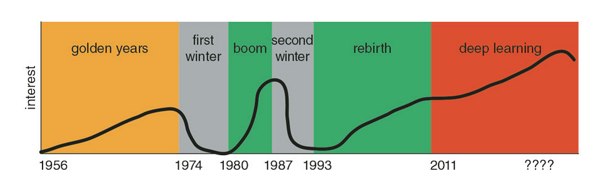

notes :
-there were 3 booms in artificial-intelligence history.
1950 :
we were able to build and code prototypes of speech recognizers, language interpreters, game players, math word-problem solvers, and simple robots.
1970 :
big investments in AI from japanese but no results.
-1990 :
development of Machine learning which predict surprising results.
(Machine learning refers to programs that develop their function from exposure to many examples, rather than from rules set by programmers.)
-Automation, Rule-Based Systems, Supervised Learning (backropagation), ANN, Unsupervised Learning (self set weight) are developed, which are very sharp implementations.

https://www.ted.com/talks/tim_urban_inside_the_mind_of_a_master_procrastinator#t-233223

« Inside a mind of a masterprocrastinator »
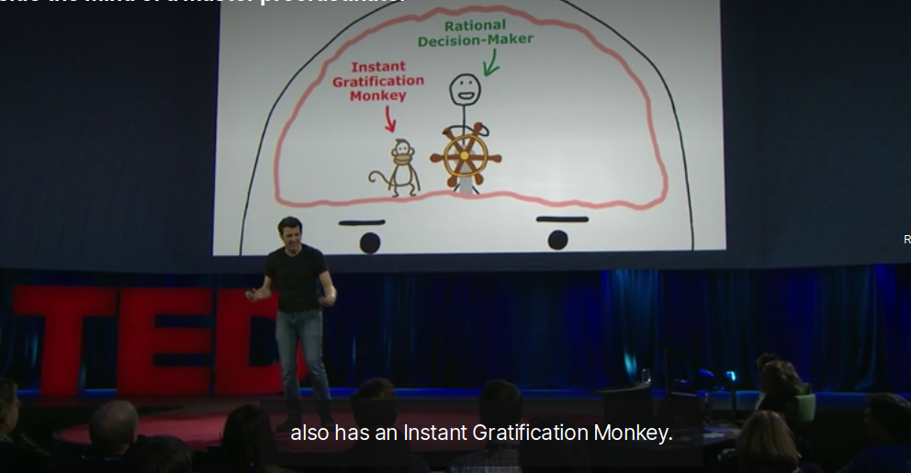
-everything is fine until it happens ⇒ we need deadline.
-our brain = mix of an instant gratification monkey to gratify our will and a rational decision maker : see the big picture, think about futur, what make sense.
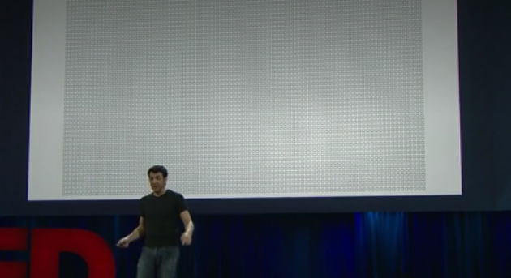
-time limited : the squares on the board represent the weeks before we die, use them.

-I chose theses articles because I’m keen on artificial intelligence and I’m just a procrastinator.
-I’ve watch the Ted video and read the article about AI, and writes notes.
-It might help me because I’ve learn vocabulary in english about things I’ve already knew (in french).

