Arizona Storm Wing Falcon
Conservation GIS Analysis Report

Southern New Hampshire University
Jacobb L. Foster II

- Introduction
Habitat conservation plays an essential role in ecological balance in sensitive biomes. This report uses GIS tools to analyze and address the spatial problem relevant to the wildlife management in Arizona. Specifically, reducing the human impact on areas nearby, or within, the Arizona Storm Winged Falcon breeding areas by closing down nonessential roads during breeding season. The purpose of this report is to exercise spatial data to isolate areas for seasonal closure through informed geoprocessing steps and best map design practices.
- Statement of Problem
A. Discipline
This report will detail the importance, and implementation of a conservation effort for the Arizona Storm Winged Falcon (ASWF) during the bird’s breeding season. The Arizona Storm Winged Falcon is an ecologically sensitive bird and requires special attention in the areas where it breeds. I picked this project over the other issues because it aligns with environmental science, and I aim to apply technology for real world outcomes in this field. The ASWF has particular breeding requirements like a sensitivity to man-made noise pollution or specific dietary, and habitat needs. However, it’s important to be mindful of private roads and Native American reservation land.
B. Question
How can GIS be used to identify non-essential roads within a half of a mile of bird breeding areas that can be seasonally closed for a reduction in man-made noise pollution during the ASWF breeding season?
- Data
- Spatial Data
Vector spatial data is used for analysis here, ideal for locating discrete geological features like roads, biomes, and land ownership. Key datasets involved in this report:
- Geology_a_az.shp: Polygon features for rock types in Arizona, used to find dacite areas.
- Brown_North_America.shp: Biome classifications, useful for locating the Rocky Mountain Montane Conifer Forest.
- a000rte_Unified.shp: Line shapefile with Arizona road data, with a subtype field labeling road importance.
- LandOwnership2012.shp: Polygon dataset useful for making the distinction between public, private and tribal land.
I found all these datasets within the SNHU FinalProjectData folder, in vector format.
- Organization
I imported the datasets into a single file geodatabase (.gdb) within ArcGIS. Organized the layers by theme, such as habitat or roads. I clipped and exported features as needed to reduce any unnecessary data.
- Data Quality
Attribute fields within the shapefiles were standardized. Metadata was reviewed to ensure scale and accuracy. No significant topological issues were detected. Vector data sourced from institutions, along with federal datasets containing good enough resolution for analysis.
- Methodology
- Step By Step
- Select biome from Brown_North_America.shp, select BIOME_NAME = “Rocky Mountain Montane Conifer Forest”. Export results to MontaneConiferForest.shp.
- Select Geology, Select by Attribute where ROCKTYPE2 = “Dacite”. Export results to Dacite.shp.
- Use Buffer tool to buffer Dacite.shp by 1 US mile to model bird nesting behavior nearby food sources.
- Intersect tool on MontaneConiferForest.shp and Dacite_Buffer1mi.shp to see the overlapping region, Falcon_BreedingAreas.
- Buffer Falcon_BreedingAreas by half a mile to define roads eligible for closure.
- Export AcceptableRoads.shp from a000rte_Unified selection where SUBTYPEFIE = 98. SUBTYPEFIE = 98 represents minor and non-essential roads eligible for closure.
- Clip AcceptableRoads.shp using ClosureArea_0_5mi to get RoadsToBeClosed.
- From LandOwnership2012.shp, select by attribute “WHERE Category is equal to Private Land” OR “WHERE Category is equal to Indian Res.”
- Using the Erase tool on RoadsToBeClosed.shp with RestrictedLands.shp I can get the Final_ClosureRoads.shp.
- Tools and Justification
Tool | Purpose
Select by Attribute | Filter features by biome, geology, or road subtype
Export Features | Create reusable layers
Buffer | Model spatial proximity of falcons to their food and habitats
Intersect | Combine biomes and geology
Erase | Remove features within restricted areas
Clip | Reduce data to closure zone

- Symbols and Map Elements
- Final closure roads: Bold red lines
- Closure buffer: Transparent shading with a bold black outline
- Breeding areas: Forest green fill
- Private/tribal land: Crosshatched grey
- Map elements: Title, legend, scale, north arrow, and data attribution

- Maps
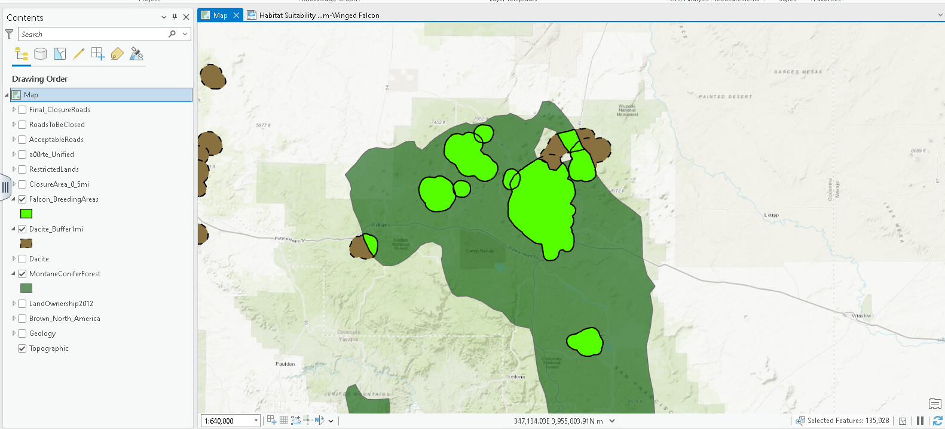
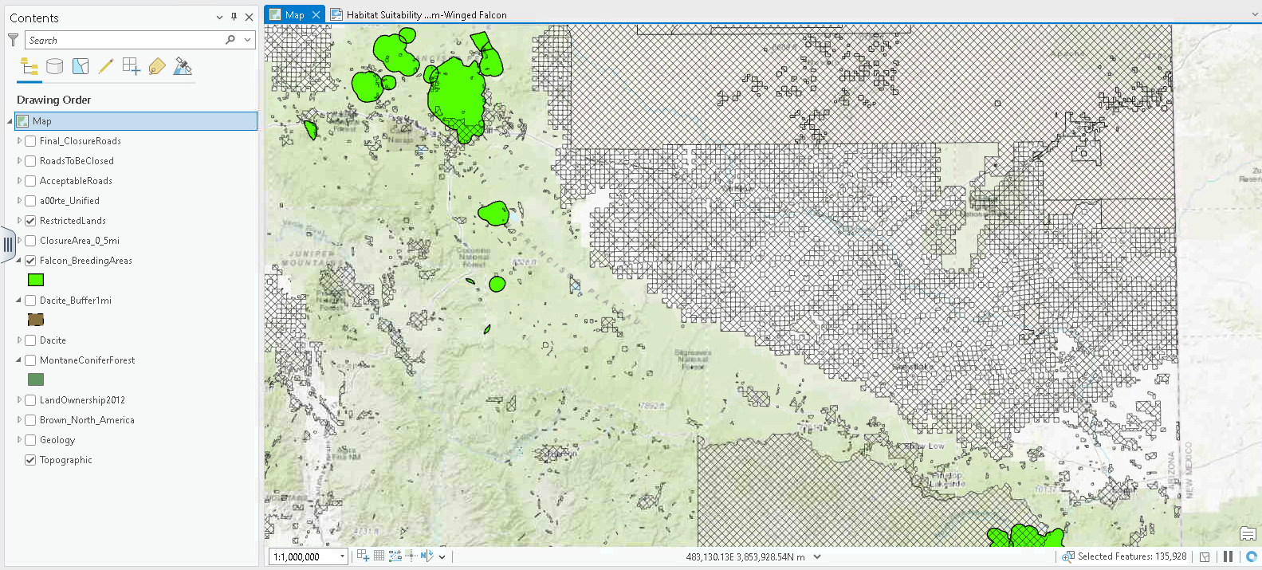
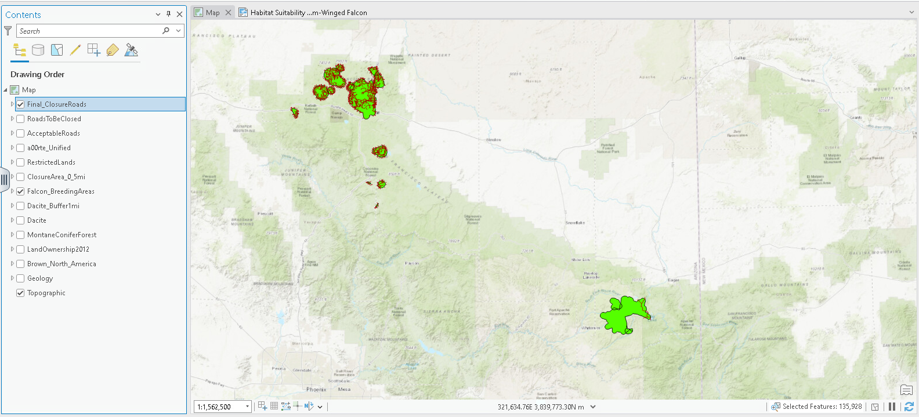
- Conclusion
- Observations
The final map is designed to highlight areas in Arizona where minor roads intersect falcon breeding zones and fall outside restricted lands. These roads are the most viable candidates for temporary closure. The analysis reveals that there are regions of concern where Dacite geology intersects the montane Conifer biome, indicating that a ASWF could take up nesting during the breeding season.
- Recommendations
State officials should make road closures a priority in the identified viable areas during the breeding season. A strategy implementing a phased closure processes using road signage and seasonal patrols could reduce human disturbance while keeping the roads available during the off seasons. Analysis in the future could consider elevation or the nest count data to refine this conservation approach.

References
Southern New Hampshire University. (n.d.). Geology_a_az [Data set]. FinalProjectData folder, IT 242 Virtual Desktop Environment.
Southern New Hampshire University. (n.d.). a000rte_Unified [Data set]. FinalProjectData folder, IT 242 Virtual Desktop Environment.
Southern New Hampshire University. (n.d.). Brown_North_America [Data set]. FinalProjectData folder, IT 242 Virtual Desktop Environment.
Southern New Hampshire University. (n.d.). LandOwnership2012 [Data set]. FinalProjectData folder, IT 242 Virtual Desktop Environment.

