Assignment-1

Date: 17-06-2025

By

Bharatoday Mishra

Steps.

1

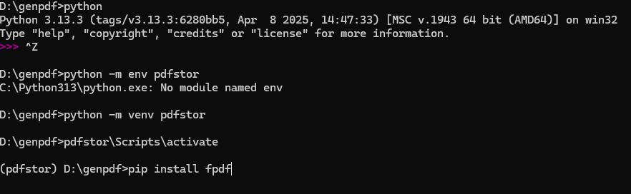

2

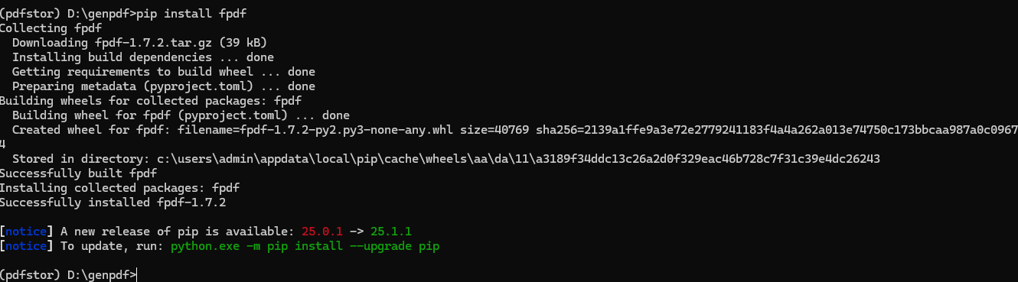

3

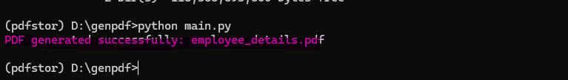

4.

