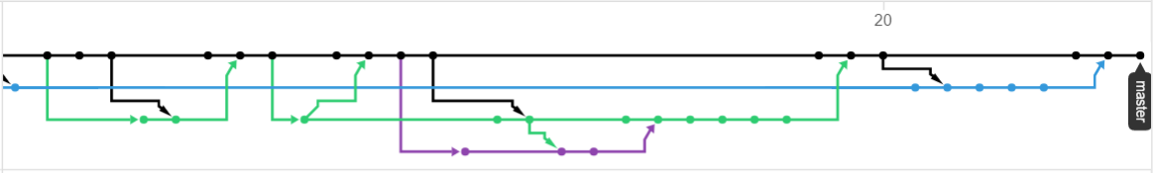

*Source:* [*https://github.com/Miss-Terra/Team34/network*](https://github.com/Miss-Terra/Team34/network)