About English Finish

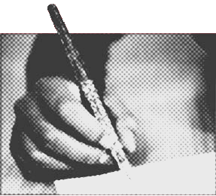

English Finish was set up by freelance copy editor Artemis Gause, who has worked in the bibliography and editorial teams of the Oxford Dictionary of National Biography (Oxford DNB, published by Oxford University Press, UK division), and as in-house copy editor at the American College of Greece (Athens). She has contributed twelve articles to the Oxford DNB and written pieces of literary criticism on modern novelists.
Artemis studied Human Sciences (BA Hons) at Oxford University, English Literature (MA) at the University of East Anglia and Publishing Studies (Buchwissenschaft) at Ludwig-Maximilians Universität in Munich, Germany.

Thanks to her broad academic and professional background she can handle subjects ranging from genetics to social anthropology to film and literary criticism. Many of her regular clients include film critics and business management experts. She also works as a freelance translator (from Greek into English).
Artemis specialises in copy-editing material written in English by non-native speakers and is experienced in bibliographic research and editing.

