Foil

Eva Reindl

24 4 2020

#PREPARE  
R.Version()#for referencing, shows you which R version you are using

## $platform  
## [1] "x86_64-w64-mingw32"  
##   
## $arch  
## [1] "x86_64"  
##   
## $os  
## [1] "mingw32"  
##   
## $system  
## [1] "x86_64, mingw32"  
##   
## $status  
## [1] ""  
##   
## $major  
## [1] "3"  
##   
## $minor  
## [1] "6.1"  
##   
## $year  
## [1] "2019"  
##   
## $month  
## [1] "07"  
##   
## $day  
## [1] "05"  
##   
## $`svn rev`  
## [1] "76782"  
##   
## $language  
## [1] "R"  
##   
## $version.string  
## [1] "R version 3.6.1 (2019-07-05)"  
##   
## $nickname  
## [1] "Action of the Toes"

rm(list=ls())#removes any other items in your workspace  
ls()#check whether workspace is empty

## character(0)

#LOAD DATA  
setwd("C:\\")#sets the working directory, this is where your datafile is  
Foil <-read.csv("Foil.csv",header=TRUE, sep = ";")

#OVERVIEW  
names(Foil)[1] <- "ID"  
str(Foil)

## 'data.frame': 655 obs. of 24 variables:  
## $ ID : int 1 1 1 1 1 1 1 1 2 3 ...  
## $ Gender : Factor w/ 2 levels "f","m": 2 2 2 2 2 2 2 2 2 2 ...  
## $ Age_months : int 61 61 61 61 61 61 61 61 42 43 ...  
## $ Age_group : int 5 5 5 5 5 5 5 5 3 3 ...  
## $ Midtesting_age_months : int 62 62 62 62 62 62 62 62 42 44 ...  
## $ Midtesting_age_group : int 5 5 5 5 5 5 5 5 3 3 ...  
## $ AdditionalSupportNeeds : Factor w/ 9 levels "global developmental delay",..: 3 3 3 3 3 3 3 3 4 4 ...  
## $ Mediansplit_midtesting_entiresample: Factor w/ 2 levels "old","young": 1 1 1 1 1 1 1 1 2 2 ...  
## $ Dropout : Factor w/ 2 levels "no","yes": 1 1 1 1 1 1 1 1 1 1 ...  
## $ Reason_Dropout : Factor w/ 7 levels "","Experimenter error (holes were not equally thick, child looked at size of holes)",..: 1 1 1 1 1 1 1 1 1 1 ...  
## $ StoppedEarly : Factor w/ 4 levels "no","yes","yes, after 4th test trial",..: 1 1 1 1 1 1 1 1 1 1 ...  
## $ Warm.up.Crit.reached : Factor w/ 6 levels "no","no (2 out of 5 correct)",..: 5 5 5 5 5 5 5 5 3 2 ...  
## $ Trial_Nr : int 1 2 3 4 5 6 7 8 1 1 ...  
## $ Success : Factor w/ 3 levels "","no","yes": 2 3 3 3 3 3 2 3 1 1 ...  
## $ Trial_correct : int 0 1 1 1 1 1 0 1 NA NA ...  
## $ CumulativeNrCorrectSearches : int 0 1 2 3 4 5 5 6 NA NA ...  
## $ CumulativeProportionCorrect : num 0 0.5 0.667 0.75 0.8 ...  
## $ Nr.AdministeredTestTrials : int 8 8 8 8 8 8 8 8 NA NA ...  
## $ Test.NrCorrectTrials : int 6 6 6 6 6 6 6 6 NA NA ...  
## $ Test.NrErrors : int 2 2 2 2 2 2 2 2 NA NA ...  
## $ Sanitycheck.NrTrials : int 8 8 8 8 8 8 8 8 NA NA ...  
## $ ProportionCorrect : num 0.75 0.75 0.75 0.75 0.75 0.75 0.75 0.75 NA NA ...  
## $ Video : Factor w/ 94 levels "ID1_AdditionalTask_Foil_m_5y",..: 1 1 1 1 1 1 1 1 29 38 ...  
## $ Comment : Factor w/ 26 levels "","\"I just noticed\"",..: 1 1 1 1 1 1 1 1 1 1 ...

There are 87 children in the dataset.

# Dropouts

Foil.dropout <-subset(Foil, Dropout =="yes")

Of the 87 children, there are **6 dropouts** (3 m, 3 f; 3 3-year-olds, 2 4-year-olds, 1 5-year-old):

* 1 child stopped in additional warm-up trials
* 1 child stopped after 4 trials
* 1 child stopped after 5 trials
* 1 child experimenter errors (holes were not of equal size)
* 1 child experimenter error (saw experimenter bait cups through camera)
* 1 child experimenter error (put sticker in wrong cup early)

**81 children are remaining**.

# Valid data

Foil.valid.T1 <-subset(Foil, Dropout =="no" & Trial_Nr =="1")  
table(Foil.valid.T1$StoppedEarly)

##   
## no yes   
## 80 1   
## yes, after 4th test trial yes, after 5 trials   
## 0 0

These 81 children include 1 child (ID 133) who only received 7 test trials (as tin foil ran out). We decide to include this child as this child completed 75% of test trials.

# Description of sample

## Gender distribution

table(Foil.valid.T1$Gender)

##   
## f m   
## 47 34

There were 47 girls and 34 boys.

## Age

### Age at the beginning of testing

mean(Foil.valid.T1$Age_months)

## [1] 48.37037

sd(Foil.valid.T1$Age_months)

## [1] 7.287737

min(Foil.valid.T1$Age_months)

## [1] 36

max(Foil.valid.T1$Age_months)

## [1] 70

table(Foil.valid.T1$Age_group)

##   
## 3 4 5   
## 39 36 6

table(Foil.valid.T1$Age_group, Foil.valid.T1$Gender)

##   
## f m  
## 3 24 15  
## 4 21 15  
## 5 2 4

At the beginning of testing, the children who had valid data on the Foil task were on average 48.37 months (SD = 7.29, range 36-70) old. There were 39 3-year-olds, 36 4-year-olds, and 6 5-year-olds.

* 3y: 24 f, 15 m
* 4y: 21 f, 15 m
* 5y: 2 f, 4 m

### Age in the middle of testing

mean(Foil.valid.T1$Midtesting_age_months)

## [1] 49.91358

sd(Foil.valid.T1$Midtesting_age_months)

## [1] 7.340296

min(Foil.valid.T1$Midtesting_age_months)

## [1] 38

max(Foil.valid.T1$Midtesting_age_months)

## [1] 72

table(Foil.valid.T1$Midtesting_age_group)

##   
## 3 4 5 6   
## 37 35 8 1

table(Foil.valid.T1$Midtesting_age_group, Foil.valid.T1$Gender)

##   
## f m  
## 3 24 13  
## 4 19 16  
## 5 4 4  
## 6 0 1

In the middle of testing, the children who had valid data on the Foil task were on average **49.91 months (SD = 7.34, range 38-72)** old. There were **37 3-year-olds, 35 4-year-olds, 8 5-year-olds, and 1 6-year-old**.

* 3y: 24 f, 13 m
* 4y: 19 f, 16 m
* 5y: 4 f, 4 m
* 6y: 1m

### Age mediansplit (based on entire sample)

table(Foil.valid.T1$Mediansplit_midtesting_entiresample)

##   
## old young   
## 42 39

table(Foil.valid.T1$Mediansplit_midtesting_entiresample, Foil.valid.T1$Gender)

##   
## f m  
## old 23 19  
## young 24 15

There were **39 young** and **42 old** children.

* young: 23 f, 19 m
* old: 24 f, 15 m

## Testing location

All children were from the Fife area.

# Criterion reached

table(Foil.valid.T1$Warm.up.Crit.reached)

##   
## no no (2 out of 5 correct) no (3 out of 5 correct)   
## 1 2 1   
## no, 3 out of 6 correct yes, within 2 trials yes, within 7 trials   
## 0 73 4

Of the 81 children, 4 children (all 3 years old) did not reach the warm-up criterion. 77 children (95%) reached the warm-up criterion.

# Number of administered test trials

Foil.valid.T1.critreached<-subset(Foil.valid.T1, Warm.up.Crit.reached =="yes, within 2 trials" | Warm.up.Crit.reached =="yes, within 7 trials")  
  
table(Foil.valid.T1.critreached$Nr.AdministeredTestTrials)

##   
## 7 8   
## 1 76

76 children were administered 8 trials, 1 child got 7 trials.

# Proportion of correct trials

mean(Foil.valid.T1.critreached$ProportionCorrect)

## [1] 0.5693414

sd(Foil.valid.T1.critreached$ProportionCorrect)

## [1] 0.2018845

min(Foil.valid.T1.critreached$ProportionCorrect)

## [1] 0.125

max(Foil.valid.T1.critreached$ProportionCorrect)

## [1] 1

hist(Foil.valid.T1.critreached$ProportionCorrect)

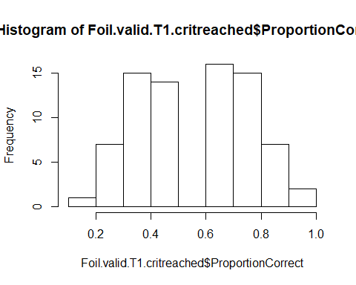

shapiro.test(Foil.valid.T1.critreached$ProportionCorrect)

##   
## Shapiro-Wilk normality test  
##   
## data: Foil.valid.T1.critreached$ProportionCorrect  
## W = 0.9567, p-value = 0.01035

wilcox.test(Foil.valid.T1.critreached$ProportionCorrect, mu = 0.5, alternative = "two.sided")

##   
## Wilcoxon signed rank test with continuity correction  
##   
## data: Foil.valid.T1.critreached$ProportionCorrect  
## V = 1417.5, p-value = 0.004294  
## alternative hypothesis: true location is not equal to 0.5

#by age groups  
table(Foil.valid.T1.critreached$Midtesting_age_group)

##   
## 3 4 5 6   
## 33 35 8 1

tapply(Foil.valid.T1.critreached$ProportionCorrect, Foil.valid.T1.critreached$Midtesting_age_group, mean)

## 3 4 5 6   
## 0.5303030 0.5500000 0.7924107 0.7500000

tapply(Foil.valid.T1.critreached$ProportionCorrect, Foil.valid.T1.critreached$Midtesting_age_group, sd)

## 3 4 5 6   
## 0.1875789 0.1969436 0.1505994 NA

tapply(Foil.valid.T1.critreached$ProportionCorrect, Foil.valid.T1.critreached$Midtesting_age_group, min)

## 3 4 5 6   
## 0.125 0.250 0.625 0.750

tapply(Foil.valid.T1.critreached$ProportionCorrect, Foil.valid.T1.critreached$Midtesting_age_group, max)

## 3 4 5 6   
## 0.875 0.875 1.000 0.750

three.years<- subset(Foil.valid.T1.critreached, Midtesting_age_group =="3")  
four.years<- subset(Foil.valid.T1.critreached, Midtesting_age_group =="4")  
five.years<- subset(Foil.valid.T1.critreached, Midtesting_age_group =="5")  
  
shapiro.test(three.years$ProportionCorrect)

##   
## Shapiro-Wilk normality test  
##   
## data: three.years$ProportionCorrect  
## W = 0.9544, p-value = 0.1786

shapiro.test(four.years$ProportionCorrect)

##   
## Shapiro-Wilk normality test  
##   
## data: four.years$ProportionCorrect  
## W = 0.91348, p-value = 0.009295

shapiro.test(five.years$ProportionCorrect)

##   
## Shapiro-Wilk normality test  
##   
## data: five.years$ProportionCorrect  
## W = 0.87942, p-value = 0.1859

wilcox.test(three.years$ProportionCorrect,mu = 0.5, alternative = "two.sided")

## Warning in wilcox.test.default(three.years$ProportionCorrect, mu = 0.5, :  
## cannot compute exact p-value with ties

## Warning in wilcox.test.default(three.years$ProportionCorrect, mu = 0.5, :  
## cannot compute exact p-value with zeroes

##   
## Wilcoxon signed rank test with continuity correction  
##   
## data: three.years$ProportionCorrect  
## V = 180, p-value = 0.3869  
## alternative hypothesis: true location is not equal to 0.5

t.test(four.years$ProportionCorrect, mu = 0.5, alternative = "two.sided")

##   
## One Sample t-test  
##   
## data: four.years$ProportionCorrect  
## t = 1.502, df = 34, p-value = 0.1423  
## alternative hypothesis: true mean is not equal to 0.5  
## 95 percent confidence interval:  
## 0.4823475 0.6176525  
## sample estimates:  
## mean of x   
## 0.55

wilcox.test(five.years$ProportionCorrect,mu = 0.5, alternative = "two.sided")

## Warning in wilcox.test.default(five.years$ProportionCorrect, mu = 0.5,  
## alternative = "two.sided"): cannot compute exact p-value with ties

##   
## Wilcoxon signed rank test with continuity correction  
##   
## data: five.years$ProportionCorrect  
## V = 36, p-value = 0.01391  
## alternative hypothesis: true location is not equal to 0.5

#by mediansplit  
table(Foil.valid.T1.critreached$Mediansplit_midtesting_entiresample)

##   
## old young   
## 42 35

tapply(Foil.valid.T1.critreached$ProportionCorrect, Foil.valid.T1.critreached$Mediansplit_midtesting_entiresample, mean)

## old young   
## 0.5914116 0.5428571

tapply(Foil.valid.T1.critreached$ProportionCorrect, Foil.valid.T1.critreached$Mediansplit_midtesting_entiresample, sd)

## old young   
## 0.2115903 0.1891906

tapply(Foil.valid.T1.critreached$ProportionCorrect, Foil.valid.T1.critreached$Mediansplit_midtesting_entiresample, min)

## old young   
## 0.250 0.125

tapply(Foil.valid.T1.critreached$ProportionCorrect, Foil.valid.T1.critreached$Mediansplit_midtesting_entiresample, max)

## old young   
## 1.000 0.875

young<- subset(Foil.valid.T1.critreached, Mediansplit_midtesting_entiresample =="young")  
old<- subset(Foil.valid.T1.critreached, Mediansplit_midtesting_entiresample =="old")  
  
shapiro.test(young$ProportionCorrect)

##   
## Shapiro-Wilk normality test  
##   
## data: young$ProportionCorrect  
## W = 0.95622, p-value = 0.1758

shapiro.test(old$ProportionCorrect)

##   
## Shapiro-Wilk normality test  
##   
## data: old$ProportionCorrect  
## W = 0.93917, p-value = 0.02672

t.test(young$ProportionCorrect,mu = 0.5, alternative = "two.sided")

##   
## One Sample t-test  
##   
## data: young$ProportionCorrect  
## t = 1.3402, df = 34, p-value = 0.1891  
## alternative hypothesis: true mean is not equal to 0.5  
## 95 percent confidence interval:  
## 0.4778679 0.6078464  
## sample estimates:  
## mean of x   
## 0.5428571

wilcox.test(old$ProportionCorrect, mu = 0.5, alternative = "two.sided")

## Warning in wilcox.test.default(old$ProportionCorrect, mu = 0.5, alternative  
## = "two.sided"): cannot compute exact p-value with ties

## Warning in wilcox.test.default(old$ProportionCorrect, mu = 0.5, alternative  
## = "two.sided"): cannot compute exact p-value with zeroes

##   
## Wilcoxon signed rank test with continuity correction  
##   
## data: old$ProportionCorrect  
## V = 522, p-value = 0.009074  
## alternative hypothesis: true location is not equal to 0.5

Of the 77 children who reached the warm-up criterion in the Foil task, children had on average a proportion of 0.57 (SD = 0.20, range .12-1) test trials correct. This variable is not normally distributed, W = 0.957, p = .010. Performance is significantly above chance, V = 1417.5, p = .004.

* 3y (n = 33): 0.53 (SD = 0.19, range 0.12-0.87), normally distributed, W = 0.954, p = .179, performance at chance, V = 180, p = .387
* 4y (n = 35): 0.55 (SD = 0.20, range 0.25-0.87), not normally distributed, W = 0.913, p = .009, performance at chance, t(34) = 1.502, p = .142
* 5y (n = 8): 0.79 (SD = 0.15, range 0.62-1), normally distributed, W = 0.879, p = .186, performance above chance, V = 36, p = .014
* 6y (n = 1): 0.75
* young (n = 35): 0.54 (SD = 0.19, range 0.12-0.87), normally distributed, W = 0.956, p = .176, performance at chance, t(34) = 1.340, p = .189
* old (n = 42): 0.59 (SD = 0.21, range 0.25-1), not normally distributed, W = 0.939, p = .027, performance above chance, V = 522, p = .009

Boxplot:

library(ggplot2)

## Warning: package 'ggplot2' was built under R version 3.6.3

p<- ggplot(  
 data=Foil.valid.T1.critreached, aes(x=rep(1, 77), y=ProportionCorrect)) +  
 geom_boxplot(outlier.colour = "black")+  
 ylim(0,1)+  
 xlim(0,2)+  
 labs(x="",y="Mean proportion of correct trials")+  
 theme(axis.text.x=element_blank(), axis.ticks.x=element_blank())+  
 ggtitle("Foil")  
  
p + theme_bw() + theme(panel.grid.major = element_blank(), panel.grid.minor = element_blank())+ theme(axis.text.x = element_blank()) + theme(axis.ticks.x = element_blank()) + geom_hline(yintercept=0.5, linetype="dashed", color = "red") + geom_count()

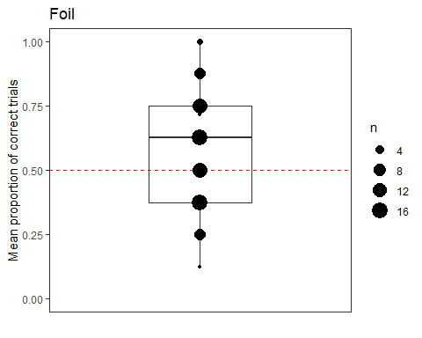

Boxplot:

p1<-ggplot(data=Foil.valid.T1.critreached, aes(x=Midtesting_age_group,y=ProportionCorrect)) +  
 geom_boxplot(aes(group=Midtesting_age_group, fill = as.factor(Midtesting_age_group)), outlier.colour = "black") +   
 ylim(0,1)+  
 xlim(2.5,6.5)+  
 geom_point(alpha=0.3) +  
 labs(x="",y="Mean proportion correct")+  
 theme(axis.text.x=element_blank(), axis.ticks.x=element_blank())+  
 ggtitle("Foil")  
  
p1 + geom_hline(yintercept=0.5, linetype="dashed", color = "red") +  
 theme_bw() + theme(panel.grid.major = element_blank(), panel.grid.minor = element_blank())+   
 geom_count(colour = "black", position = position_jitterdodge(0,0,1), alpha = 0.5)+  
 scale_fill_discrete(name = "Age group midtesting", labels = c("3 years, n = 33", "4 years, n = 35", "5 years, n = 8", "6 years, n = 1"))

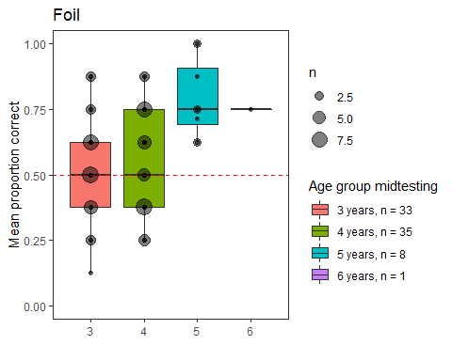

library(forcats)  
  
Foil.valid.T1.critreached$Mediansplit_midtesting_entiresample<-fct_relevel(Foil.valid.T1.critreached$Mediansplit_midtesting_entiresample, "young")  
#changes order of boxplots (young before old)  
  
p1<- ggplot(  
 data=Foil.valid.T1.critreached, aes(x=rep(1, 77), y=ProportionCorrect, fill = Mediansplit_midtesting_entiresample))+  
 geom_boxplot(outlier.colour = "black", position=position_dodge(1.5))+  
 ylim(0,1)+  
 xlim(0,2)+  
 labs(x="",y="Mean proportion of searches correct")+  
 theme(axis.text.x=element_blank(), axis.ticks.x=element_blank())+  
 ggtitle("Foil")  
  
  
p1 + geom_hline(yintercept=0.5, linetype="dashed", color = "red") +  
 theme_bw() + theme(panel.grid.major = element_blank(), panel.grid.minor = element_blank())+ theme(axis.text.x = element_blank()) + theme(axis.ticks.x = element_blank()) +  
 geom_point(pch = 21, position = position_jitterdodge(0,0,1.5)) +  
 scale_fill_discrete(name = "Age group midtesting (median split)", labels = c("young, n = 35", "old, n = 42"))

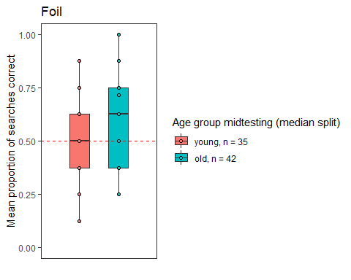

## Plot age as continuous variable against proportion correct

p1<- ggplot(Foil.valid.T1.critreached, aes(x=Midtesting_age_months , y=ProportionCorrect)) + geom_point()+  
 labs(x="Age in months",y="Proportion correct")  
  
p1 + geom_hline(yintercept=0.5, linetype="dashed", color = "red") +  
 theme_bw() + theme(panel.grid.major = element_blank(), panel.grid.minor = element_blank())

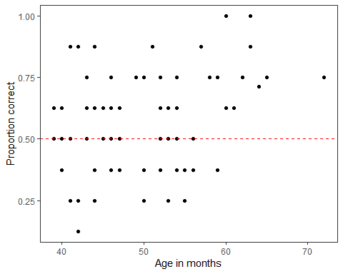

# Cumulative proportion correct

#Trial 1  
Foil.trial1<-subset(Foil.valid.T1.critreached, Trial_Nr == "1")  
  
#Trial 2  
Foil.trial2<-subset(Foil.valid.T1.critreached, Trial_Nr == "2")  
  
#Trial 3  
Foil.trial3<-subset(Foil.valid.T1.critreached, Trial_Nr == "3")  
  
#Trial 4  
Foil.trial4<-subset(Foil.valid.T1.critreached, Trial_Nr == "4")  
  
#Trial 5  
Foil.trial5<-subset(Foil.valid.T1.critreached, Trial_Nr == "5")  
  
#Trial 6  
Foil.trial6<-subset(Foil.valid.T1.critreached, Trial_Nr == "6")  
  
#Trial 7  
Foil.trial7<-subset(Foil.valid.T1.critreached, Trial_Nr == "7")  
  
#Trial 8  
Foil.trial8<-subset(Foil.valid.T1.critreached, Trial_Nr == "8")  
  
  
mean(Foil.trial1$CumulativeProportionCorrect)#.59

## [1] 0.5974026

sd(Foil.trial1$CumulativeProportionCorrect)#.49

## [1] 0.4936369

mean(Foil.trial2$CumulativeProportionCorrect)#.60

## [1] NaN

sd(Foil.trial2$CumulativeProportionCorrect)#.37

## [1] NA

mean(Foil.trial3$CumulativeProportionCorrect)#.59

## [1] NaN

sd(Foil.trial3$CumulativeProportionCorrect)#.30

## [1] NA

mean(Foil.trial4$CumulativeProportionCorrect)#.59

## [1] NaN

sd(Foil.trial4$CumulativeProportionCorrect)#.27

## [1] NA

mean(Foil.trial5$CumulativeProportionCorrect)#.60

## [1] NaN

sd(Foil.trial5$CumulativeProportionCorrect)#.24

## [1] NA

mean(Foil.trial6$CumulativeProportionCorrect)#.60

## [1] NaN

sd(Foil.trial6$CumulativeProportionCorrect)#.23

## [1] NA

mean(Foil.trial7$CumulativeProportionCorrect)#.59

## [1] NaN

sd(Foil.trial7$CumulativeProportionCorrect)#.20

## [1] NA

mean(Foil.trial8$CumulativeProportionCorrect)#.57

## [1] NaN

sd(Foil.trial8$CumulativeProportionCorrect)#.20

## [1] NA

#LOAD DATA  
setwd("C:\\")#sets the working directory, this is where your datafile is  
Graph <-read.csv("CumulPropCorrect.csv",header=TRUE, sep = ";")  
names(Graph)[1] <- "Trial_nr"

library(ggplot2)  
  
ggplot(Graph, aes(x=Trial_nr, y=Mean_proportionCorrect)) +   
 geom_errorbar(aes(ymin=Mean_proportionCorrect-SD_ProportionCorrect, ymax=Mean_proportionCorrect+SD_ProportionCorrect), width=.1) +  
 geom_line() +  
 geom_point()+  
 ylim(0,1.2)

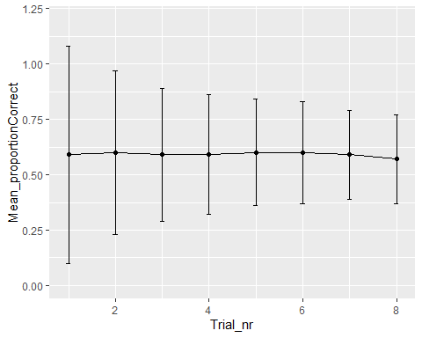

We use the arbitrary rule to decide that we want to include anyone who has done 75% of the trials, i.e., 6 trials and up. This means that we can include 1 child. We do that and re-run all the previous lines and find no change.

# Can age and trial number predict children’s success?

library(lme4)

## Loading required package: Matrix

Foil.valid <-subset(Foil, Dropout =="no" & Warm.up.Crit.reached =="yes, within 2 trials" | Warm.up.Crit.reached =="yes, within 7 trials")  
  
Foil.valid$z.age=as.vector(scale(Foil.valid$Midtesting_age_months))#transform age to mean of 0 and SD of 1  
mean(Foil.valid$z.age)#check whether it has worked

## [1] 4.289587e-17

sd(Foil.valid$z.age)

## [1] 1

Foil.valid$z.trial=as.vector(scale(Foil.valid$Trial_Nr))#transform trial to mean of 0 and SD of 1  
mean(Foil.valid$z.trial)#check whether it has worked

## [1] -1.481686e-16

sd(Foil.valid$z.trial)

## [1] 1

contr<-glmerControl(optimizer="bobyqa", optCtrl=list(maxfun=10000000))  
res<-glmer(Trial_correct ~ z.age + z.trial + z.age:z.trial + (1+z.trial|ID), data=Foil.valid, family=binomial, control=contr)  
  
null <- glmer(Trial_correct ~ 1 + (1+z.trial|ID), data=Foil.valid, family=binomial, control=contr)  
  
anova(null, res, test="Chisq")#significant

## Data: Foil.valid  
## Models:  
## null: Trial_correct ~ 1 + (1 + z.trial | ID)  
## res: Trial_correct ~ z.age + z.trial + z.age:z.trial + (1 + z.trial |   
## res: ID)  
## Df AIC BIC logLik deviance Chisq Chi Df Pr(>Chisq)   
## null 4 850.70 868.41 -421.35 842.70   
## res 7 845.29 876.28 -415.64 831.29 11.415 3 0.009682 **  
## ---  
## Signif. codes: 0 '***' 0.001 '**' 0.01 '*' 0.05 '.' 0.1 ' ' 1

Trial number, age, and the interaction between trial number and age explain the data significantly better than a null model only containing the intercept, X2(3) = 11.415, p = .010.

## Effect of interaction

contr<-glmerControl(optimizer="bobyqa", optCtrl=list(maxfun=10000000))  
res.nointer<-glmer(Trial_correct ~ z.age + z.trial + (1+z.trial|ID), data=Foil.valid, family=binomial, control=contr)  
  
anova(res.nointer, res, test="Chisq")

## Data: Foil.valid  
## Models:  
## res.nointer: Trial_correct ~ z.age + z.trial + (1 + z.trial | ID)  
## res: Trial_correct ~ z.age + z.trial + z.age:z.trial + (1 + z.trial |   
## res: ID)  
## Df AIC BIC logLik deviance Chisq Chi Df Pr(>Chisq)  
## res.nointer 6 843.30 869.87 -415.65 831.30   
## res 7 845.29 876.28 -415.64 831.29 0.0144 1 0.9045

The interaction term has no effect, so we remove it from the model.

contr<-glmerControl(optimizer="bobyqa", optCtrl=list(maxfun=10000000))  
res<-glmer(Trial_correct ~ z.age + z.trial + (1+z.trial|ID), data=Foil.valid, family=binomial, control=contr)  
  
anova(null, res, test="Chisq")

## Data: Foil.valid  
## Models:  
## null: Trial_correct ~ 1 + (1 + z.trial | ID)  
## res: Trial_correct ~ z.age + z.trial + (1 + z.trial | ID)  
## Df AIC BIC logLik deviance Chisq Chi Df Pr(>Chisq)   
## null 4 850.7 868.41 -421.35 842.7   
## res 6 843.3 869.87 -415.65 831.3 11.4 2 0.003345 **  
## ---  
## Signif. codes: 0 '***' 0.001 '**' 0.01 '*' 0.05 '.' 0.1 ' ' 1

summary(res)

## Generalized linear mixed model fit by maximum likelihood (Laplace  
## Approximation) [glmerMod]  
## Family: binomial ( logit )  
## Formula: Trial_correct ~ z.age + z.trial + (1 + z.trial | ID)  
## Data: Foil.valid  
## Control: contr  
##   
## AIC BIC logLik deviance df.resid   
## 843.3 869.9 -415.7 831.3 613   
##   
## Scaled residuals:   
## Min 1Q Median 3Q Max   
## -1.7316 -1.0352 0.6637 0.8560 1.2290   
##   
## Random effects:  
## Groups Name Variance Std.Dev. Corr  
## ID (Intercept) 0.13050 0.3612   
## z.trial 0.02412 0.1553 0.23  
## Number of obs: 619, groups: ID, 78  
##   
## Fixed effects:  
## Estimate Std. Error z value Pr(>|z|)   
## (Intercept) 0.29296 0.09393 3.119 0.00182 **  
## z.age 0.25028 0.09539 2.624 0.00870 **  
## z.trial -0.18548 0.08690 -2.134 0.03280 *   
## ---  
## Signif. codes: 0 '***' 0.001 '**' 0.01 '*' 0.05 '.' 0.1 ' ' 1  
##   
## Correlation of Fixed Effects:  
## (Intr) z.age   
## z.age 0.045   
## z.trial -0.012 -0.026

Trial number and age explain the data significantly better than a null model only containing the intercept, X2(2) = 11.4, p = .003

## Effect of terms

contr<-glmerControl(optimizer="bobyqa", optCtrl=list(maxfun=10000000))  
res.noage<-glmer(Trial_correct ~ z.trial + (1+z.trial|ID), data=Foil.valid, family=binomial, control=contr)  
  
anova(res.noage, res, test="Chisq")

## Data: Foil.valid  
## Models:  
## res.noage: Trial_correct ~ z.trial + (1 + z.trial | ID)  
## res: Trial_correct ~ z.age + z.trial + (1 + z.trial | ID)  
## Df AIC BIC logLik deviance Chisq Chi Df Pr(>Chisq)   
## res.noage 5 848.16 870.30 -419.08 838.16   
## res 6 843.30 869.87 -415.65 831.30 6.8584 1 0.008823 **  
## ---  
## Signif. codes: 0 '***' 0.001 '**' 0.01 '*' 0.05 '.' 0.1 ' ' 1

There is a significant positive effect of age, X2(1) = 6.858, p = .009.

contr<-glmerControl(optimizer="bobyqa", optCtrl=list(maxfun=10000000))  
res.notrial<-glmer(Trial_correct ~ z.age + (1+z.trial|ID), data=Foil.valid, family=binomial, control=contr)  
  
anova(res.notrial, res, test="Chisq")

## Data: Foil.valid  
## Models:  
## res.notrial: Trial_correct ~ z.age + (1 + z.trial | ID)  
## res: Trial_correct ~ z.age + z.trial + (1 + z.trial | ID)  
## Df AIC BIC logLik deviance Chisq Chi Df Pr(>Chisq)   
## res.notrial 5 845.83 867.97 -417.91 835.83   
## res 6 843.30 869.87 -415.65 831.30 4.5262 1 0.03338 *  
## ---  
## Signif. codes: 0 '***' 0.001 '**' 0.01 '*' 0.05 '.' 0.1 ' ' 1

There is a significant negative effect of trial, X2(1) = 4.526, p = .033.

## Model assumptions

source("diagnostic_fcns.r")  
ranef.diagn.plot(res)

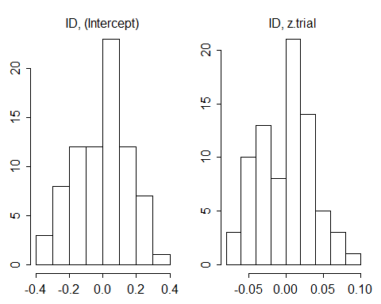

#collinearity  
xres=lm(Trial_correct ~ z.age + z.trial , data=Foil.valid)  
  
library(car)

## Loading required package: carData

## Registered S3 methods overwritten by 'car':  
## method from  
## influence.merMod lme4  
## cooks.distance.influence.merMod lme4  
## dfbeta.influence.merMod lme4  
## dfbetas.influence.merMod lme4

vif(xres)

## z.age z.trial   
## 1.000005 1.000005

source("glmm_stability.r")  
m.stab=glmm.model.stab(model.res=res)

## boundary (singular) fit: see ?isSingular

## boundary (singular) fit: see ?isSingular

m.stab$summary

## what orig min max  
## (Intercept) (Intercept) 0.2929593 0.2691623 0.3134919  
## z.age z.age 0.2502784 0.2120680 0.2770555  
## z.trial z.trial -0.1854788 -0.2119387 -0.1648626  
## ID@(Intercept) ID@(Intercept) 0.6010395 0.5623596 0.6137797  
## ID@z.trial ID@z.trial 0.3940687 0.1752647 0.4273565

source("boot_glmm.r")#requires centering of all predictors apart the ones one is interested in. We are interested in both.  
  
boot.res=boot.glmm.pred(model.res=res, excl.warnings=T,  
nboots=1000, para=F, resol=8, use="z.trial")  
  
boot.res$ci.estimates

## orig X2.5. X97.5.  
## (Intercept) 0.2929593 0.11116191 0.46591111  
## z.age 0.2502784 0.06495921 0.44735907  
## z.trial -0.1854788 -0.37172121 -0.02678618

boot.res$ci.predicted

## z.age z.trial fitted lower.cl upper.cl  
## 1 4.289587e-17 -1.5198770 0.6398848 0.5719687 0.7138415  
## 2 4.289587e-17 -1.0833091 0.6210224 0.5634950 0.6817629  
## 3 4.289587e-17 -0.6467412 0.6017869 0.5531959 0.6522645  
## 4 4.289587e-17 -0.2101732 0.5822318 0.5367270 0.6263077  
## 5 4.289587e-17 0.2263947 0.5624147 0.5154711 0.6058837  
## 6 4.289587e-17 0.6629626 0.5423964 0.4881977 0.5945964  
## 7 4.289587e-17 1.0995305 0.5222402 0.4538384 0.5865227  
## 8 4.289587e-17 1.5360984 0.5020114 0.4149971 0.5810090

par(mar=c(3, 3, 0.2, 0.2), mgp=c(1.7, 0.3, 0), las=1, tcl=-0.15)  
plot(x=Foil.valid$Trial_Nr, y=Foil.valid$Trial_correct, pch=19, las=2, ylim=c(0, 1),  
xlab="Trial number", ylab="Probability of success", cex=0.1*sqrt(Foil.valid$ID))  
  
plot.xvals=seq(from=min(Foil.valid$Trial_Nr), to=max(Foil.valid$Trial_Nr),  
length.out=8)  
  
lines(x=plot.xvals, y=boot.res$ci.predicted$fitted,  
lty=2)  
lines(x=plot.xvals, y=boot.res$ci.predicted$lower.cl,  
lty=3)  
lines(x=plot.xvals, y=boot.res$ci.predicted$upper.cl,  
lty=3)

