Foil

Eva Reindl

24 4 2020

## [1] "R version 3.6.1 (2019-07-05)"

There are 87 children in the dataset.

# Dropouts

Of the 87 children, there are **6 dropouts** (3 m, 3 f; 3 3-year-olds, 2 4-year-olds, 1 5-year-old):

* 1 child stopped in additional warm-up trials
* 1 child stopped after 4 trials
* 1 child stopped after 5 trials
* 1 child experimenter errors (holes were not of equal size)
* 1 child experimenter error (saw experimenter bait cups through camera)
* 1 child experimenter error (put sticker in wrong cup early)

**81 children are remaining**.

# Valid data

These 81 children include 1 child (ID 133) who only received 7 test trials (as tin foil ran out). We decide to include this child as this child completed 75% of test trials.

# Description of sample

## Gender distribution

There were 47 girls and 34 boys.

## Age

### Age at the beginning of testing

At the beginning of testing, the children who had valid data on the Foil task were on average 48.37 months (SD = 7.29, range 36-70) old. There were 39 3-year-olds, 36 4-year-olds, and 6 5-year-olds.

* 3y: 24 f, 15 m
* 4y: 21 f, 15 m
* 5y: 2 f, 4 m

### Age in the middle of testing

In the middle of testing, the children who had valid data on the Foil task were on average **49.91 months (SD = 7.34, range 38-72)** old. There were **37 3-year-olds, 35 4-year-olds, 8 5-year-olds, and 1 6-year-old**.

* 3y: 24 f, 13 m
* 4y: 19 f, 16 m
* 5y: 4 f, 4 m
* 6y: 1m

### Age mediansplit (based on entire sample)

There were **39 young** and **42 old** children.

* young: 23 f, 19 m
* old: 24 f, 15 m

## Testing location

All children were from the Fife area.

# Criterion reached

Of the 81 children, 4 children (all 3 years old) did not reach the warm-up criterion. 77 children (95%) reached the warm-up criterion.

# Number of administered test trials

76 children were administered 8 trials, 1 child got 7 trials.

# Proportion of correct trials

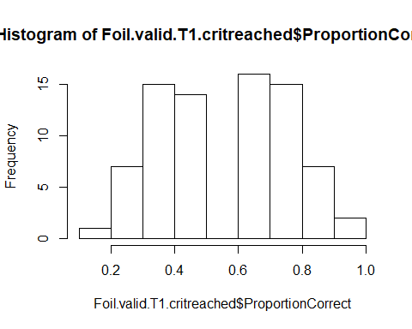

Of the 77 children who reached the warm-up criterion in the Foil task, children had on average a **proportion of 0.57 (SD = 0.20, range .12-1) test trials correct**. This variable is **not normally distributed**, W = 0.957, p = .010. Performance is **significantly above chance**, V = 1417.5, p = .004.

* 3y (n = 33): 0.53 (SD = 0.19, range 0.12-0.87), normally distributed, W = 0.954, p = .179, **performance at chance**, V = 180, p = .387
* 4y (n = 35): 0.55 (SD = 0.20, range 0.25-0.87), not normally distributed, W = 0.913, p = .009, **performance at chance**, t(34) = 1.502, p = .142
* 5y (n = 8): 0.79 (SD = 0.15, range 0.62-1), normally distributed, W = 0.879, p = .186, **performance above chance**, V = 36, p = .014
* 6y (n = 1): 0.75

4-year-olds did not outperform 3-year-olds, one-sided Wilcoxon test, W = 549, p = .363.

* young (n = 35): 0.54 (SD = 0.19, range 0.12-0.87), normally distributed, W = 0.956, p = .176, **performance at chance**, t(34) = 1.340, p = .189
* old (n = 42): 0.59 (SD = 0.21, range 0.25-1), not normally distributed, W = 0.939, p = .027, **performance above chance**, V = 522, p = .009

Older children did not outperform younger children, one-sided Wilcoxon test, W = 826, p = .174.

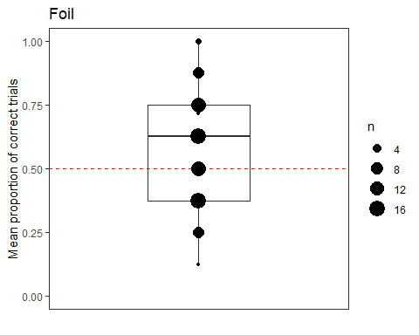

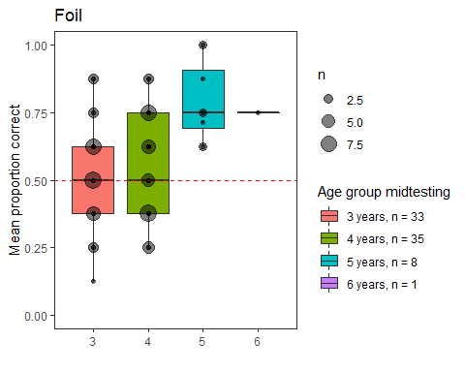

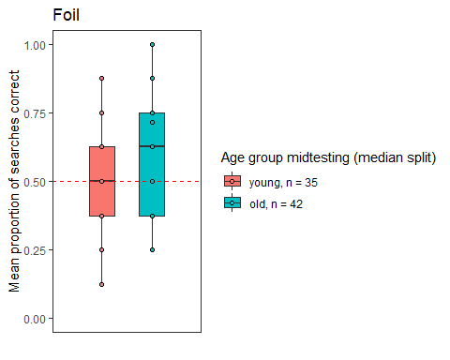

## Plot age as continuous variable against proportion correct

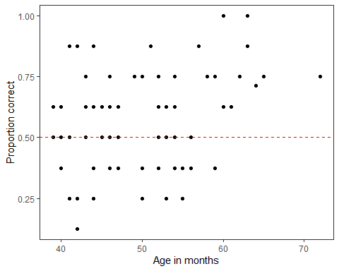

# Cumulative proportion correct

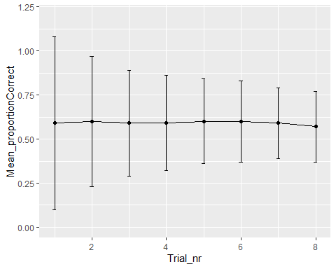

We use the arbitrary rule to decide that we want to include anyone who has done 75% of the trials, i.e., 6 trials and up. This means that we can include 1 child. We do that and re-run all the previous lines and find no change.

# Can age and trial number predict children’s success?

contr<-glmerControl(optimizer="bobyqa", optCtrl=list(maxfun=10000000))  
res<-glmer(Trial_correct ~ z.age + z.trial + z.age:z.trial + (1+z.trial|ID), data=Foil.valid, family=binomial, control=contr)

Trial number, age, and the interaction between trial number and age explain the data significantly better than a null model only containing the intercept, X2(3) = 11.415, p = .010.

The interaction term has no effect (X2(1) = 0.014, p = .904), so we remove it from the model.

contr<-glmerControl(optimizer="bobyqa", optCtrl=list(maxfun=10000000))  
res<-glmer(Trial_correct ~ z.age + z.trial + (1+z.trial|ID), data=Foil.valid, family=binomial, control=contr)

Trial number and age explain the data significantly better than a null model only containing the intercept, X2(2) = 11.4, p = .003

## Effect of terms

contr<-glmerControl(optimizer="bobyqa", optCtrl=list(maxfun=10000000))  
res.noage<-glmer(Trial_correct ~ z.trial + (1+z.trial|ID), data=Foil.valid, family=binomial, control=contr)

There is a **significant positive effect of age**, X2(1) = 6.858, p = .009.

There is a **significant negative effect of trial**, X2(1) = 4.526, p = .033.

## Model assumptions

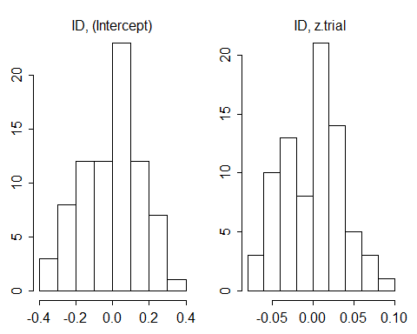

#collinearity  
xres=lm(Trial_correct ~ z.age + z.trial , data=Foil.valid)

## z.age z.trial   
## 1.000005 1.000005

source("glmm_stability.r")  
m.stab=glmm.model.stab(model.res=res)

## boundary (singular) fit: see ?isSingular

## boundary (singular) fit: see ?isSingular

m.stab$summary

## what orig min max  
## (Intercept) (Intercept) 0.2929593 0.2691623 0.3134919  
## z.age z.age 0.2502784 0.2120680 0.2770555  
## z.trial z.trial -0.1854788 -0.2119387 -0.1648626  
## ID@(Intercept) ID@(Intercept) 0.6010395 0.5623596 0.6137797  
## ID@z.trial ID@z.trial 0.3940687 0.1752647 0.4273565

boot.res$ci.estimates

## orig X2.5. X97.5.  
## (Intercept) 0.2929593 0.11116191 0.46591111  
## z.age 0.2502784 0.06495921 0.44735907  
## z.trial -0.1854788 -0.37172121 -0.02678618

