SallyAnn

Eva Reindl

5 7 2020

"R version 3.6.1 (2019-07-05)"

There are 104 children in the dataset.

# Dropouts

There are 2 dropouts (3y, m):

* 1 child had too poor language comprehension (bilingual) and the test did not work with them
* 1 child stopped paying attention and so the experimenter stopped the game (child chose at random)

# Valid data

There are **102 valid cases** in the Sally Ann task.

# Description of sample

## Gender

There are **63 females** and **39 males**.

## Age

### Age at the beginning of testing

At the beginning of testing, children included in the Sally Ann task were on average 49.10 months old (SD = 7.62, range 35-70). There were 1 2-year-old, 46 3-year-olds, 45 4-year-olds, and 10 5-year-olds.

### In the middle of testing

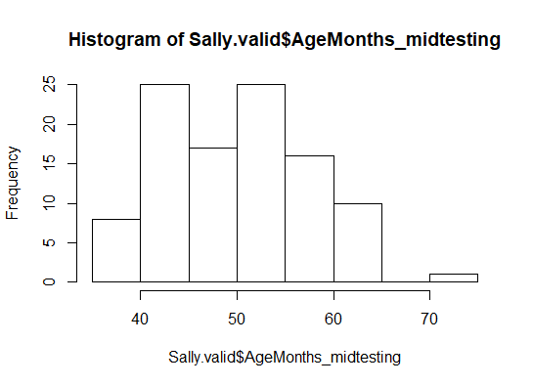

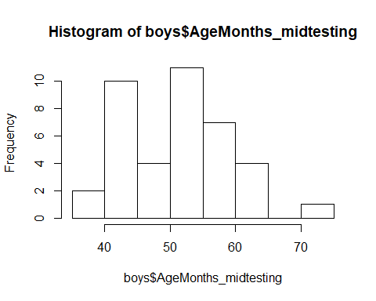 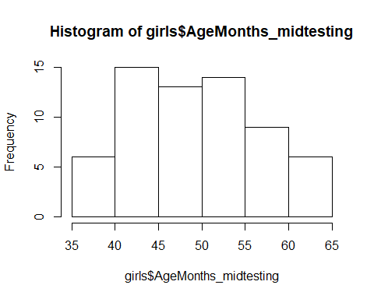

In the middle of testing, children included in the Sally Ann task were on average **50.47 months old (SD = 7.54, range 36-72)**. There were

* 45 3-year-olds (31 f, 14 m)
* 43 4-year-olds (24 f, 19 m)
* 13 5-year-olds (8 f, 5 m)
* 1 6-year-old (1 m)
* Boys: M = 51.56 (SD = 7.91, range 38-72)
* Girls: M = 49.79 (SD = 7.28, range 36-64)

There was no difference between males and females regarding the age distribution, two-sided Wilcoxon test, W = 1089, p = .338.

### Age mediansplit (based on entire sample)

There were **47 young** (31 f, 16 m) and **55 old** (32 f, 23 m) children.

## Testing Location

All children were from the Fife area.

# Control question 1

“Who is Sally? Who is Ann?”

Out of the 102 children, **100 children (98%) passed the first control question**. Note that the experimenter repeated the explanation and the questions up to 3 times, so not all of the children passed the question the first time.

# Test question

“Where will Sally look for her block?”

Out of the 102 children, **40 children (39%) passed the test question**.

* **3y (n = 45): 14 correct (31%)**
* **4y (n = 43): 17 correct (39%)**
* 5y (n = 13): 8 correct (61%)
* 6y (n = 1): 1 correct (100%)

**3- and 4-year-olds did not differ in their success rates**, Chi-squared test X2(1) = 0.364, p = .546.

* young (n = 47): 14 correct (30%)
* old (n = 55): 26 correct (47%)

**Old children did not perform differently than young children**, Chi-squared test X2(1) = 2.558, p = .110.

# Control question 2

“Where is the block really?”

Out of the 102 children, **90 children (88%) passed the second control question**.

* 3y (n = 45): 38 correct (84%)
* 4y (n = 43): 38 correct (88%)
* 5y (n = 13): 13 correct (100%)
* 6y (n = 1): 1 correct (100%)

# Control question 3

“Where was the block in the beginning?”

Out of the 102 children, **75 children (73%) passed the third control question**.

* 3y (n = 45): 25 correct (55%)
* 4y (n = 43): 36 correct (84%)
* 5y (n = 13): 13 correct (100%)
* 6y (n = 1): 1 correct (100%)

**4-year-olds were significantly better at this task than 3-year-olds**, Chi-squared test X2(1) = 6.931, p = .008.

* young (n = 47): 26 correct (55%)
* old (n = 55): 49 correct (89%)

**Old children were differently better than young children**, Chi-squared test X2(1) = 13.166, p < .001.

# Got at least one control question wrong

Out of the 102 children, 34 children **(33%) got at least one control question wrong** and thus were **excluded from calculating the final score**.

* 3y (n = 45): 25 at least one control question wrong (55%)
* 4y (n = 43): 9 at least one control question wrong (21%)
* 5y (n = 13): 0 at least one control question wrong (0%)
* 6y (n = 1): 0 at least one control question wrong (0%)

# Got test correct but at least one control question wrong

Out of the 102 children, 13 children (13%) got the test question correct but at least one control question wrong.

* 3y (n = 45): 10 got test correct but at least one control question wrong (22%)
* 4y (n = 43): 3 got test correct but at least one control question wrong (7%)
* 5y (n = 13): 0 got test correct but at least one control question wrong (0%)
* 6y (n = 1): 0 got test correct but at least one control question wrong (0%)

# DV: Test correct (yes/no) for those children who have all control questions correct

Out of the 102 children, **68 children (67%) passed the control question and are included** into the analysis.

Out of the 68 children, 27 children **(40%) passed the test question**.

* 3y (n = 20): 4 correct (20%)
* 4y (n = 34): 14 correct (41%)
* 5y (n = 13): 8 correct (61%)
* 6y (n = 1): 1 correct (100%)

**3- and 4-year-olds did not differ** in their success rates, Chi-squared test X2(1) = 1.678, p = .195.

* young (n = 21): 4 correct (19%)
* old (n = 47): 23 correct (49%)

**Old children performed significantly better than young children**, Chi-squared test X2(1) = 4.240, p = .039.

## Plot for age groups

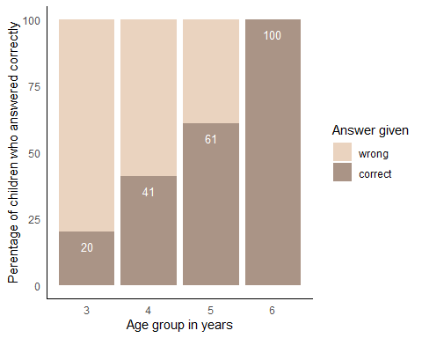

## Plot for age by mediansplit

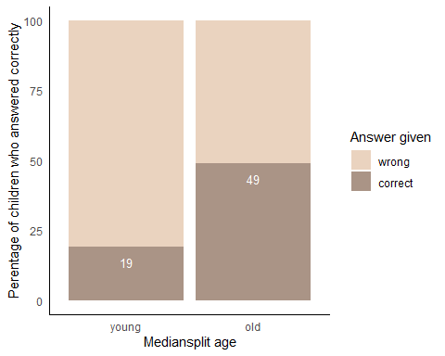

# Score that includes all children

0 = at least one control question wrong 1 = control questions correct but test question wrong 2 = control questions correct and test question correct

res <- polr(Score ~ AgeMonths_midtesting, data= Sally.valid)  
summary(res)

##   
## Re-fitting to get Hessian

## Call:  
## polr(formula = Score ~ AgeMonths_midtesting, data = Sally.valid)

## Value Std. Error t value p value  
## **AgeMonths_midtesting 0.1491406 0.02989761 4.988377 6.088868e-07**## 0|1 6.6443417 1.47237716 4.512663 6.401874e-06  
## 1|2 8.8765173 1.60559337 5.528497 3.229868e-08

#confidence intervals

## 2.5 % 97.5 %   
## 0.09264668 0.21031014

#getting odds ratios

## OR ci  
## 2.5 % 1.160836 1.097074  
## 97.5 % 1.160836 1.234061

* 0 points (at least 1 control question wrong): 34 children (33%)
* 1 point (control questions correct, test question wrong): 42 children (41%)
* 2 points (control questions correct, test question correct): 26 children (25%)

3y (n = 45):

* 0 points: 25 (55.5%)
* 1 point: 16 (35.5%)
* 2 points: 4 (9%)

4y (n = 43):

* 0 points: 9 (21%)
* 1 point: 21 (49%)
* 2 points: 13 (30%)

5y (n = 13):

* 0 points: 0
* 1 point: 5 (38.5%)
* 2 points: 8 (61.5%)

6y (n = 1):

* 2 points: 1 (100%)

young (n = 47):

* 0 points: 26 (55.5%)
* 1 point: 17 (36.5%) 2 points: 4 (8%)

old (n = 55):

* 0 points: 8 (14.5%)
* 1 point: 25 (45.5%) 2 points: 22 (40%)

Age has a significant effect on the test score.

