Scrambled_Boxes

Eva Reindl

18 9 2020

## [1] "R version 3.6.1 (2019-07-05)"

# How many children are in the dataset?

There are 198 children in the dataset.

# Dropouts

One child (D 172) stopped the game after 6 rounds in the first trial. This child will be excluded from further analyses.

# Valid data

**197 children have valid data** on the Scrambled box task.

# Sample description

## Gender distribution

There are 109 females and 88 males.

## Age

### Age at beginning of testing

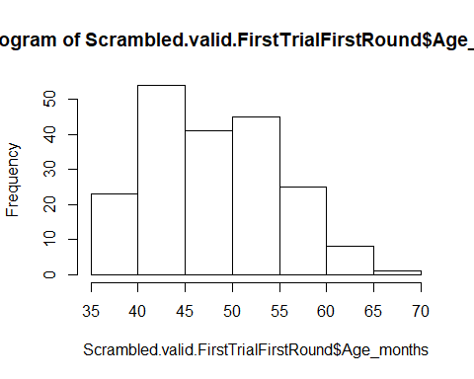

Children who contributed to this task were, at the beginning of testing, on average 48.60 months old (SD = 6.87, range 35-70). There were 1 2-year-old, 88 3-year-olds, 98 4-year-olds, and 10 5-year-olds.

## Age in the middle of testing

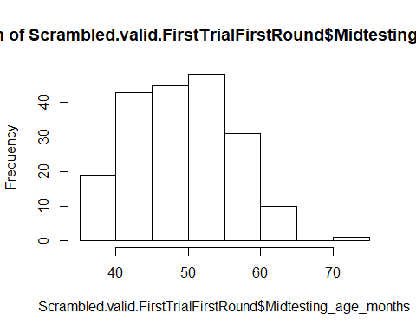

Children in this task were on average **49.63 months old (SD = 6.87, range 36-72)** when they were in the middle of the test battery. There were

* 86 3-year-olds
* 97 4-year-olds
* 13 5-year-olds
* 1 6-year-old

## Age mediansplit

There are **97 young** and **100 old** children.

# Testing location

120 children were from Fife, 77 children were from Edinburgh.

# Trial 1

## Total number of rounds administered

In trial 1, the total number of administered trials was 9.15 (SD = 1.22, range 8-11).

* 3y: 9.24 (SD = 1.21, range 8-11)
* 4y: 9.05 (SD = 1.25, range 8-11)
* 3y: 9.38 (SD = 1.12, range 8-11)
* 3y: 8
* Edinburgh: 9.09 (SD = 1.25, range 8-11)
* Fife: 9.19 (SD = 1.21, range 8-11)
* young: 9.23 (SD = 1.19, range 8-11)
* old: 9.08 (SD = 1.25, 8-11)

## Emptied all boxes

161 children (82%) emptied all boxes, 36 did not.

* 3y: 71 yes (93%), 15 no
* 4y: 79 yes (81%), 18 no
* 5y: 10 yes (77%), 3 no
* 6y: 1y
* Edinburgh: 64 yes (83%), 13 no
* Fife: 97 yes (80%), 23 no
* young: 81 yes (83%), 16 no
* old: 80 yes (80%), 20 no

## Number of boxes emptied

In trial 1, the total number of emptied boxes was 7.79 (SD = 0.48, range 5-8).

* 3y: 7.78 (SD = 0.54, range 5-8)
* 4y: 7.80 (SD = 0.42, range 6-8)
* 5y: 7.77 (SD = 0.44, range 7-8)
* 6y: 8
* Edinburgh: 7.82 (SD = 0.42, range 6-8)
* Fife: 7.77 (SD = 0.51, range 5-8)
* young: 7.79 (SD = 0.52, range 5-8)
* old: 7.79 (SD = 0.43, range 6-8)

## Effiency

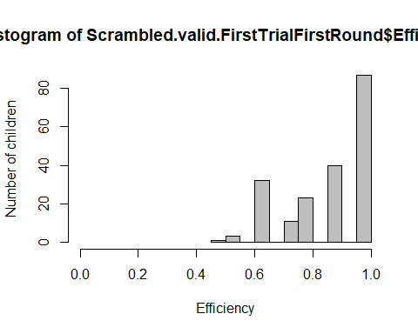

In trial 1, mean efficiency was 0.87 (SD = 0.14, range 0.45-1).

* 3y: 0.86 (SD = 0.14, range 0.45-1)
* 4y: 0.88 (SD = 0.14, range 0.54-1)
* 5y: 0.84 (SD = 0.13, range 0.64-1)
* 6y: 1
* Edinburgh: 0.88 (SD = 0.14, range 0.54-1)
* Fife: 0.86 (SD = 0.14, range 0.45-1)
* young: 0.86 (SD = 0.14, range 0.45-1)
* old: 0.88 (SD = 0.15, range 0.54-1)

## For those children wo did make an error, how many correct trials did they have before the first error occurred?

110 children made an error. Those children had an average of 5.35 (SD = 1.85, range 1-7) rounds correct before making the first error.

## Efficiency when disregarding the first trial

So that efficiency could also be 0

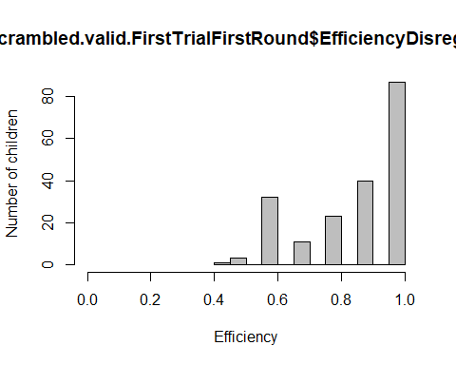

In trial 1, mean efficiency was 0.86 (SD = 0.16, range 0.40-1).

* 3y: 0.84 (SD = 0.16, range 0.4-1)
* 4y: 0.87 (SD = 0.16, range 0.5-1)
* 5y: 0.82 (SD = 0.15, range 0.6-1)
* 6y: 1
* Edinburgh: 0.87 (SD = 0.16, range 0.5-1)
* Fife: 0.85 (SD = 0.16, range 0.4-1)
* young: 0.85 (SD = 0.15, range 0.4-1)
* old: 0.86 (SD = 0.16, range 0.5-1)

## Can Success be predicted by age?

res<-glmer(Correct ~ z.age.midtesting + z.round + z.age.midtesting:z.round + (1|ID), data=Scrambled.valid.T1, family = binomial)#singular fit

## boundary (singular) fit: see ?isSingular

Together, trial number, age, and the interaction explain the data better than a null model, X2(3) = 307.37, p < .001.

res.nointer<-glmer(Correct ~ z.age.midtesting + z.round + (1|ID), data=Scrambled.valid.T1, family = binomial)#singular fit

The interaction term has a significant effect, X2(1) = 23.125, p < .001.

three <- subset(Scrambled.valid.T1, Midtesting_age_group == "3")  
#we z-transform age   
three$z.age.midtesting=as.vector(scale(three$Midtesting_age_months))#transfor

res<-glmer(Correct ~ z.round + (1|ID), data=three, family = binomial)#singular fit

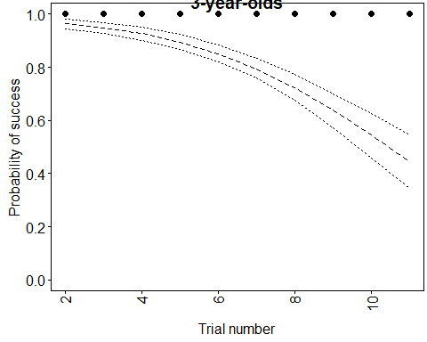

res1<-glmer(Correct ~ z.round + (1|ID), data=four, family =

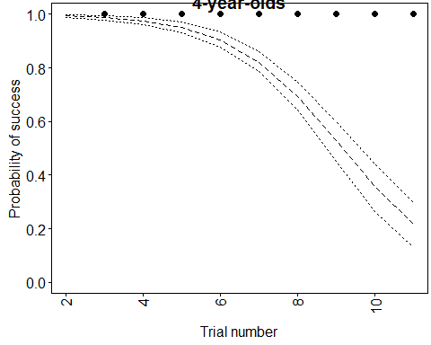

res2<-glmer(Correct ~ z.round + (1|ID), data=five, family =

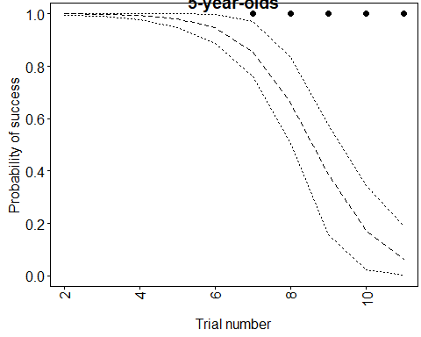

# Trial 2

## Total number of rounds administered

In trial 2, the total number of administered trials was 9.75 (SD = 1.27, range 8-11).

* 3y: 10.12 (SD = 1.16, range 8-11)
* 4y: 9.59 (SD = 1.24, range 8-11)
* 3y: 8.31 (SD = 0.85, range 8-11)
* 3y: 11
* Edinburgh: 9.86 (SD = 1.24, range 8-11)
* Fife: 9.68 (SD = 1.28, range 8-11)
* young: 10.09 (SD = 1.18, range 8-11)
* old: 9.41 (SD = 1.27, 8-11)

## Emptied all boxes

125 children (68%) emptied all boxes, 59 did not.

* 3y: 46 yes (55%), 38 no
* 4y: 66 yes (77%), 20 no
* 5y: 13 yes (100%)
* 6y: 0 yes
* Edinburgh: 47 yes (66%), 24 no
* Fife: 78 yes (69%), 35 no
* young: 53 yes (57%), 40 no
* old: 72 yes (79%), 19 no

## Number of boxes emptied

In trial 2, the total number of emptied boxes was 7.59 (SD = 0.65, range 5-8).

* 3y: 7.42 (SD = 0.70, range 6-8)
* 4y: 7.71 (SD = 0.61, range 5-8)
* 5y: 8.00 (SD = 0)
* 6y: 7
* Edinburgh: 7.60 (SD = 0.60, range 6-8)
* Fife: 7.58 (SD = 0.69, range 5-8)
* young: 7.45 (SD = 0.68, range 6-8)
* old: 7.74 (SD = 0.59, range 5-8)

## Effiency

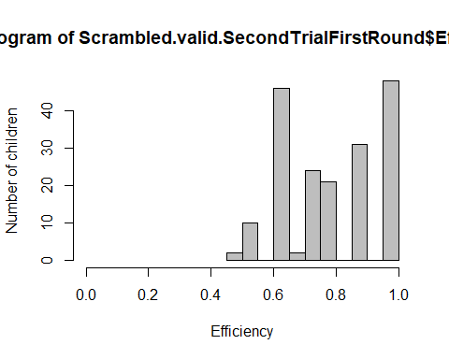

In trial 2, mean efficiency was 0.80 (SD = 0.15, range 0.45-1).

* 3y: 0.75 (SD = 0.15, range 0.54-1)
* 4y: 0.82 (SD = 0.15, range 0.45-1)
* 5y: 0.97 (SD = 0.08, range 0.73-1)
* 6y: 0.63
* Edinburgh: 0.79 (SD = 0.15, range 0.54-1)
* Fife: 0.80 (SD = 0.16, range 0.45-1)
* young: 0.75 (SD = 0.15, range 0.54-1)
* old: 0.84 (SD = 0.15, range 0.45-1)

## For those children wo did make an error, how many correct trials did they have before the first error occurred?

136 children made an error. Those children had an average of 5.16 (SD = 1.70, range 1-7) rounds correct before making the first error.

## Efficiency when disregarding the first trial

So that efficiency could also be 0

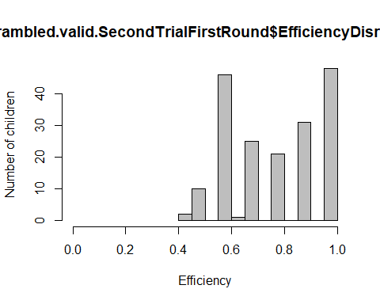

In trial 2, mean efficiency was 0.78 (SD = 0.17, range 0.40-1).

* 3y: 0.72 (SD = 0.16, range 0.5-1)
* 4y: 0.80 (SD = 0.16, range 0.4-1)
* 5y: 0.97 (SD = 0.09, range 0.7-1)
* 6y: 0.60
* Edinburgh: 0.77 (SD = 0.16, range 0.5-1)
* Fife: 0.78 (SD = 0.17, range 0.4-1)
* young: 0.73 (SD = 0.16, range 0.5-1)
* old: 0.82 (SD = 0.17, range 0.4-1)

## Can Success be predicted by age? res<-glmer(Correct ~ z.age.midtesting + z.round + z.age.midtesting:z.round + (1|ID), data=Scrambled.valid.T2, family = binomial)#singular fit

## boundary (singular) fit: see ?isSingular

Together, trial number, age, and the interaction explain the data better than a null model, X2(3) = 380.76, p < .001.

res.nointer<-glmer(Correct ~ z.age.midtesting + z.round + (1|ID), data=Scrambled.valid.T2, family = binomial)#singular fit

The interaction term has no effect, X2(1) = 0.134, p = .713.

Remove interaction term from model

Together, trial number and age explain the data better than a null model, X2(2) = 380.63, p < .001.

Effect of age

res.noage<-glmer(Correct ~ z.round + (1|ID), data=Scrambled.valid.T2, family = binomial)

Age has a significant effect, X2(1) = 17.639, p < .001.

Effect of round number

res.notrial<-glmer(Correct ~ z.age.midtesting + (1|ID), data=Scrambled.valid.T2, family = binomial)

Round number has a significant effect, X2(1) = 357.81, p < .001.

## Plot age as continuous variable against efficiency

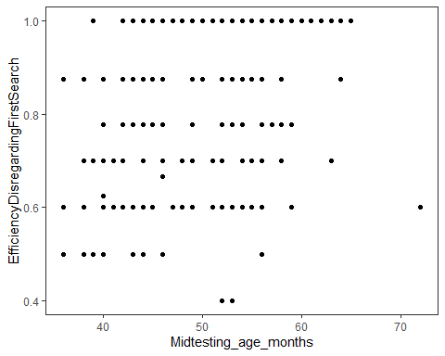

Effect of trial number

