Smarties

Eva Reindl

31 7 2020

There are **99 children** in the dataset.

# Dropouts

There are **5 dropouts** (4 3-year-olds, 1 4-year-olds; 3 m, 2 f):

* 1 child did not answer
* 1 child did not stay attentive
* 1 child too poor language skills
* 1 child: experimenter error (did not show child what was inside the box)
* 1 child: answers not understandable

# Valid data

There are **94 valid cases** in the Smarties task.

# Description of sample

## Gender

There are **59 females** and **35 males**.

## Age

### Age at the beginning of testing

At the beginning of testing, children included in the Smarties task were on average 48.98 months old (SD = 7.43, range 37-70). There were 44 3-year-olds, 42 4-year-olds, and 8 5-year-olds.

### In the middle of testing

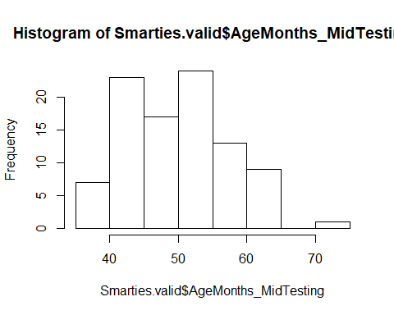

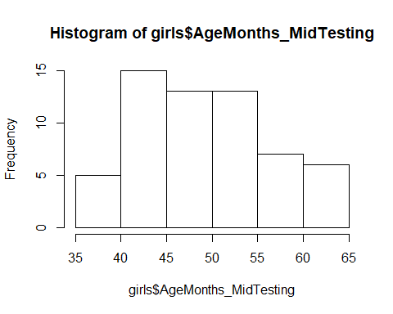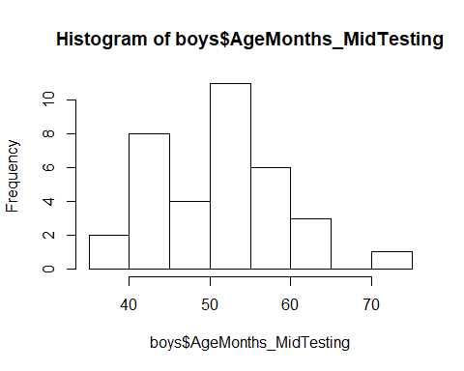

In the middle of testing, children included in the Smarties task were on average **50.44 months old (SD = 7.39, range 38-72)**. There were

* 42 3-year-olds (30f, 12m)
* 40 4-year-olds (22f, 18m)
* 11 5-year-olds (7f, 4m)
* 1 6-year-old (1m)
* Boys: M = 51.68 (SD = 7.76, range 38-72)
* Girls: M = 49.69 (SD = 7.13, range 39-64)

There was no difference between males and females regarding the age distribution, two-sided Wilcoxon test, W = 886.5, p = .254.

### Age mediansplit (based on entire sample)

There were **44 young** (30 f, 14 m) and **50 old** (29 f, 21 m) children.

## Testing Location

All children were from the Fife area.

# Control question 1 (What is inside the box?)

All 94 children answered the question correctly.

# Test question 1 (What did you think was inside?)

29 children (31%) answered the question correctly, 65 answered wrongly.

* 3y: 9 correct (21%), 33 wrong
* 4y: 15 correct (37.5%), 25 wrong
* 5y: 4 correct (36%), 7 wrong
* 6y: 1 correct (100%)

There is no difference in performance between 3- and 4-year-olds, X2(1) = 1.839, p = .175.

* young: 9 correct (20%), 35 wrong
* old: 20 correct (40%), 30 wrong

There is no difference in performance between young and old children, X(1) = 3.325, p = .068.

# Test question 2 (What would x think is inside the box?)

50 children (53%) answered the question correctly, 44 answered wrongly.

* 3y: 19 correct (59%), 23 wrong
* 4y: 21 correct (51%), 19 wrong
* 5y: 9 correct (82%), 2 wrong
* 6y: 1 correct (100%)

There is no difference in performance between 3- and 4-year-olds, X2(1) = 1.191, p = .662.

* young: 19 correct (43%), 25 wrong
* old: 31 correct (61%), 19 wrong

There is no difference in performance between young and old children, X(1) = 2.616, p = .106.

# Control question 2 (What does box look like?)

40 children (42%) answered the question correctly, 54 answered wrongly.

* 3y: 14 correct (33%), 28 wrong
* 4y: 20 correct (50%), 20 wrong
* 5y: 6 correct (54%), 5 wrong
* 6y: 1 wrong (0%)

There is no difference in performance between 3- and 4-year-olds, X2(1) = 1.708, p = .191.

* young: 14 correct (32%), 30 wrong
* old: 26 correct (52%), 24 wrong

There is no difference in performance between young and old children, X(1) = 3.118, p = .077.

# Control question 3 (What is really inside?)

86 children (91%) answered the question correctly, 8 answered wrongly.

* 3y: 38 correct (90%), 4 wrong
* 4y: 36 correct (90%), 4 wrong
* 5y: 11 correct (100%)
* 6y: 1 correct (100%)

There is no difference in performance between 3- and 4-year-olds.

* young: 40 correct (91%), 4 wrong
* old: 46 correct (92%), 4 wrong

There is no difference in performance between young and old children.

# Score: Own false belief

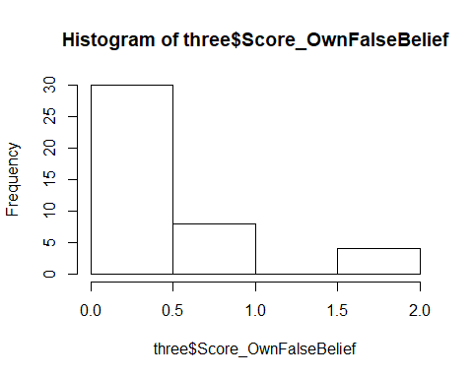 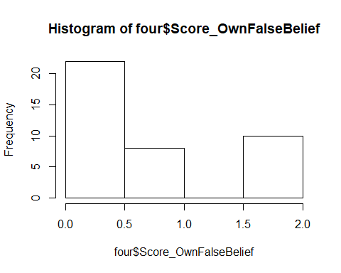

0 = at least one control question wrong 1 = control questions correct, test question wrong 2 = control and test questions correct

The average score is **0.57 (SD = 0.80, range 0-2).**

* Score 0: 58 children (62%)
* Score 1: 18 children (19%)
* Score 2: 18 children (19%)
* 3y (n = 42): 0.38 (SD = 0.66, range 0-2)
  + Score 0: 30
  + Score 1: 8
  + Score 2: 4
* 4y (n = 40): 0.70 (SD = 0.85, range 0-2)
  + Score 0: 22
  + Score 1: 8
  + Score 2: 10
* 5y (n = 11): 0.91 (SD = 0.94, range 0-2)
  + Score 0: 5
  + Score 1: 2
  + Score 2: 4
* 6y (n = 1): 0
  + Score 0: 1

**Three-year-olds have a lower score than 4-year-olds**, W = 678, p = .040.

* young (n = 44): 0.36 (SD = 0.65, range 0-2)
* old (n = 50): 0.76 (SD = 0.87, range 0-2)

**Young children have a lower score than older children**, W = 836, p = .011.

# Score: Other false belief

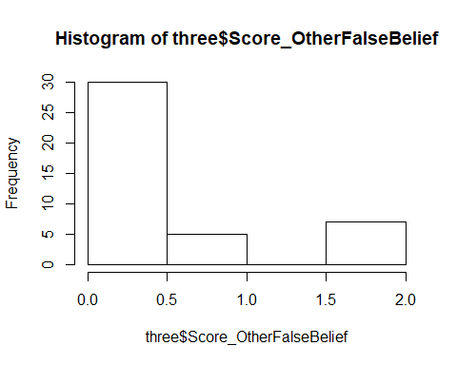 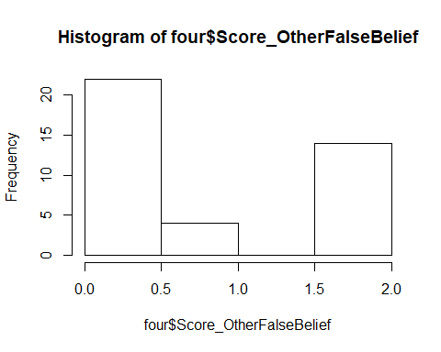

0 = at least one control question wrong 1 = control questions correct, test question wrong 2 = control and test questions correct

The average score is **0.66 (SD = 0.89, range 0-2)**.

* Score 0: 58 children (62%)
* Score 1: 10 children (11%)
* Score 2: 26 children (28%)
* 3y (n = 42): 0.45 (SD = 0.77, range 0-2)
  + Score 0: 30
  + Score 1: 5
  + Score 2: 7
* 4y (n = 40): 0.80 (SD = 0.94, range 0-2)
  + Score 0: 22
  + Score 1: 4
  + Score 2: 14
* 5y (n = 11): 1.00 (SD = 1.00, range 0-2)
  + Score 0: 5
  + Score 1: 1
  + Score 2: 5
* 6y (n = 1): 0
  + Score 0: 1

**Three-year-olds have a lower score than 4-year-olds**, W = 681, p = .042.

* young (n = 44): 0.43 (SD = 0.76, range 0-2)
* old (n = 50): 0.86 (SD = 0.95, range 0-2)

**Young children have a lower score than older children**, W = 842, p = .012.

# Total score

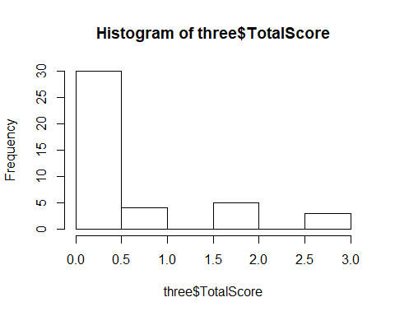 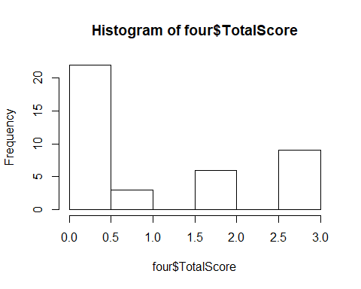

0: at least 1 control question wrong

1: control questions correct, test questions wrong

2: only 1 test question correct

3: both test questions correct

The average score is 0.85 (SD = 1.18, range 0-3).

* 3y (n = 42): 0.55 (SD = 0.97, range 0-3)
* 4y (n = 40): 1.05 (SD = 1.28, range 0-3)
* 5y (n = 11): 1.36 (SD = 1.36, range 0-3)
* 6y (n = 1): 0

Three-year-olds have a lower score than 4-year-olds, W = 670.5, p = .034.

* young (n = 44): 0.52 (SD = 0.95, range 0-3)
* old (n = 50): 1.14 (SD = 1.29, range 0-3)

Young children have a lower score than older children, W = 825.5, p = .008.

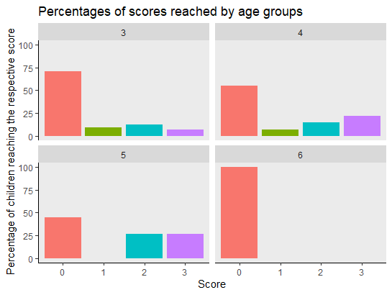

# Analysis of only those children who answered all questions correctly

Out of the 94 children, **37 children (39%) passed the control question and are included** into the analysis.

Out of the 37 children, **19 children (51%) passed the own false belief test question.**

- 3y (n = 13): 5 correct (38%)

- 4y (n = 18): 10 correct (55%)

- 5y (n = 6): 4 correct (67%)

3- and 4-year-olds did not differ in performance, X2(1) = 0.331, p = .565.

- young (n = 13): 5 correct (38%)

- old (n = 24): 14 correct (58%)

No difference between young and old children, X2(1) = 0.656, p = .418.

Out of the 37 children, **27 children (73%) passed the other false belief test question.**

- 3y (n = 13): 8 correct (61%)

- 4y (n = 18): 14 correct (78%)

- 5y (n = 6): 5 correct (83%)

3- and 4-year-olds did not differ in performance, X2(1) = 0.339, p = .561.

- young (n = 13): 8 correct (61%)

- old (n = 24): 19 correct (79%)

No difference between young and old children, X2(1) = 0.585, p = .444.