Worlds

Eva Reindl

31 7 2020

There are 85 children in the dataset.

# Dropouts

There are 5 dropouts (2 3-year-olds, 2 4-year-olds, 1 5-year-old; 1 m, 4 f):

* 2 children opened two cups simultaneously on the test boards
* 3 times experimenter error (cup was knocked off or a block showed in the test)

# Valid data

There are **80 valid cases** in the Worlds task.

# Description of sample

## Gender

There are **48 females** and **32 males**.

## Age

### Age at the beginning of testing

At the beginning of testing, children included in the Worlds task were on average 48.19 months old (SD = 7.61, range 35-70). There were 1 2-year-old, 39 3-year-olds, 33 4-year-olds, and 7 5-year-olds.

### In the middle of testing

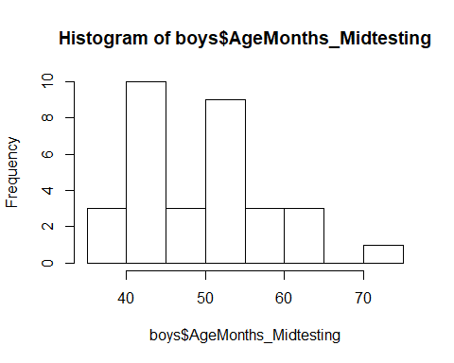 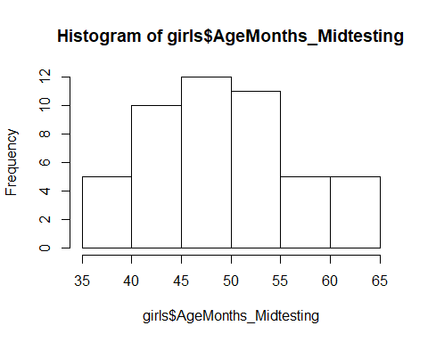

In the middle of testing, children included in the Worlds task were on average **49.75 months old (SD = 7.62, range 36-72)**. There were

* 38 3-year-olds (24f, 14m)
* 31 4-year-olds (18f, 13m)
* 10 5-year-olds (6f, 4m)
* 1 6-year-old (1m)
* Boys: M = 50.00 (SD = 8.28, range 38-72)
* Girls: M = 49.58 (SD = 7.23, range 36-64)

There was no difference between males and females regarding the age distribution.

### Age mediansplit (based on entire sample)

There were **40 young** (24 f, 16 m) and **40 old** (24 f, 16 m) children.

## Testing Location

All children were from the Fife area.

# How many children switched by themselves?

**78 children switched, 2 did not**. These two were 4 years old.

# Number of cups flipped before switch

Children switched after an average of **6.46 lifted cups** (SD = 4.10, range 1-10).

* 22 children (**27.5%** out of all children, including the ones who did not switch), **switched after 1 cup**
* 6 after 2 cups
* 2 after 3 cups
* 1 after 5 cups
* 3 after 7 cups
* 2 after 8 cups
* 5 after 9 cups
* **39 (49%) after 10 cups**
* 3y: 5.53 (SD = 4.08, range 1-10)
* 4y: 7.52 (SD = 3.82, range 1-10)
* 5y: 7.30 (SD = 4.35, range 1-10)
* 6y: 1

**3-year-olds switched after fewer cups than 4-year-olds**, W = 427, p = .038.

* young: 5.75 (SD = 4.09, range 1-10)
* old: 7.17 (SD = 4.03, range 1-10)

**Young and old children did not differ** in the number of cups lifted before they switched, W = 643.5, p = .106.

# Time before switch

Children switched after an average of 46.35 seconds (SD = 38.32, range 2-153).

* 3y: 45.66 (SD = 39.83, range 2-137)
* 4y: 54.62 (SD = 38.94, range 3-153)
* 5y: 29.40 (SD = 23.76, range 4-84)
* 6y: 2

3-year-olds did not switch sooner than 4-year-olds, W = 474, p = .333.

* young: 46.57 (SD = 39.33, range 2-137)
* old: 46.10 (SD = 37.77, range 2-153)

Young and old children do not differ in the time after which they switched.