Chimps and Children compared

Eva Reindl

27 8 2020

#PREPARE  
R.Version()#for referencing, shows you which R version you are using

## $platform  
## [1] "x86_64-w64-mingw32"  
##   
## $arch  
## [1] "x86_64"  
##   
## $os  
## [1] "mingw32"  
##   
## $system  
## [1] "x86_64, mingw32"  
##   
## $status  
## [1] ""  
##   
## $major  
## [1] "3"  
##   
## $minor  
## [1] "6.1"  
##   
## $year  
## [1] "2019"  
##   
## $month  
## [1] "07"  
##   
## $day  
## [1] "05"  
##   
## $`svn rev`  
## [1] "76782"  
##   
## $language  
## [1] "R"  
##   
## $version.string  
## [1] "R version 3.6.1 (2019-07-05)"  
##   
## $nickname  
## [1] "Action of the Toes"

rm(list=ls())#removes any other items in your workspace  
ls()#check whether workspace is empty

## character(0)

#LOAD DATA  
setwd("C:\\")#sets the working directory, this is where your datafile is  
BothSpecies <-read.csv("ChimpsAndChildren.csv",header=TRUE, sep = ";")  
library(ggplot2)

## Warning: package 'ggplot2' was built under R version 3.6.3

library(cowplot)

## Warning: package 'cowplot' was built under R version 3.6.3

##   
## ********************************************************

## Note: As of version 1.0.0, cowplot does not change the

## default ggplot2 theme anymore. To recover the previous

## behavior, execute:  
## theme_set(theme_cowplot())

## ********************************************************

names(BothSpecies)[1] <- "ID"  
str(BothSpecies)

## 'data.frame': 238 obs. of 14 variables:  
## $ ID : Factor w/ 238 levels "1","10","100",..: 1 102 113 124 135 145 154 165 176 2 ...  
## $ Species : Factor w/ 2 levels "Children","Chimpanzees": 1 1 1 1 1 1 1 1 1 1 ...  
## $ WMUpdating : num 0.833 0.667 0.833 0.667 0.5 ...  
## $ WMBoxes : num 0.375 0.5 0.625 0.5 0.375 NA 0.5 0.75 0.375 0.375 ...  
## $ WMGrid : num 0.879 0.767 0.731 0.623 0.624 ...  
## $ SD : num 0.86 0.57 0.78 0.54 0.9 NA 0.78 0.78 0.78 0.74 ...  
## $ Reversal : num 0.86 0.29 0.75 NA 1 NA 0.73 0.86 0.6 NA ...  
## $ CD_all : num 0.857 0.583 0.625 0.857 0.846 NA 0.615 0.458 0.417 NA ...  
## $ EDS : num 0.94 NA NA NA 0.92 NA 0.83 NA NA NA ...  
## $ Tray : num 1 0.75 0.78 0.88 0.82 0.67 0.7 0.86 0.52 0.73 ...  
## $ Shelf : num 1 0.36 0.91 0.91 0.36 0.91 0.64 0.45 0.36 NA ...  
## $ GlassCeiling: num 0 0.75 0.917 0.833 0.833 ...  
## $ Cylinder : num 0.917 0.167 0.75 1 1 ...  
## $ InhibGrid : num 0.333 0.167 0.333 0.333 0.5 0 0.167 0.5 0.167 0.5 ...

# WM Updating

sum(is.na(BothSpecies$WMUpdating))

## [1] 1

1 missing value, so N = 237

Boxplot:

p1<- ggplot(  
 data=BothSpecies, aes(x=rep(1, 238), y=WMUpdating, fill = Species))+  
 geom_boxplot(outlier.colour = "black", position=position_dodge(1.5))+  
 ylim(0,1)+  
 xlim(0,2)+  
 labs(x="",y="Mean prop correct")+  
 theme(axis.text.x=element_blank(), axis.ticks.x=element_blank())+  
 ggtitle("WM Updating")+  
 geom_hline(yintercept=0.57965, linetype="dashed", color = "red") +  
 theme_bw() + theme(panel.grid.major = element_blank(), panel.grid.minor = element_blank())+ theme(axis.text.x = element_blank()) + theme(axis.ticks.x = element_blank()) +  
 geom_count(colour = "black", position = position_jitterdodge(0,0,1.5), alpha = 0.5)+  
 theme(legend.position = "none")  
p1

## Warning: Removed 1 rows containing non-finite values (stat_boxplot).

## Warning: Removed 1 rows containing non-finite values (stat_sum).

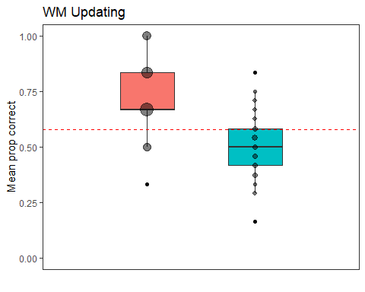

# WM Grid

sum(is.na(BothSpecies$WMGrid))

## [1] 58

58 missing values, so N = 180

Boxplot:

p2<- ggplot(  
 data=BothSpecies, aes(x=rep(1, 238), y=WMGrid, fill = Species))+  
 geom_boxplot(outlier.colour = "black", position=position_dodge(1.5))+  
 ylim(0,1)+  
 xlim(0,2)+  
 labs(x="",y="Mean distance")+  
 theme(axis.text.x=element_blank(), axis.ticks.x=element_blank())+  
 ggtitle("WM Grid")+  
 geom_hline(yintercept=0.5376574, linetype="dashed", color = "red") +  
 theme_bw() + theme(panel.grid.major = element_blank(), panel.grid.minor = element_blank())+ theme(axis.text.x = element_blank()) + theme(axis.ticks.x = element_blank()) +  
 geom_count(colour = "black", position = position_jitterdodge(0,0,1.5), alpha = 0.5)+  
 theme(legend.position = "none")  
p2

## Warning: Removed 58 rows containing non-finite values (stat_boxplot).

## Warning: Removed 58 rows containing non-finite values (stat_sum).

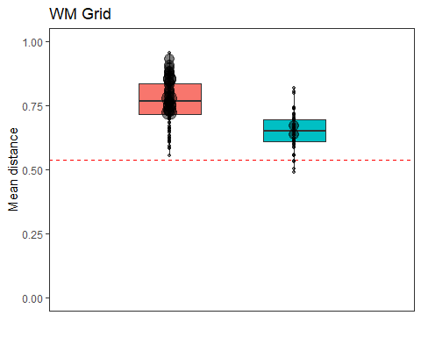

# WM Boxes

sum(is.na(BothSpecies$WMBoxes))

## [1] 36

36 missing values, so N = 202

Boxplot:

p3<- ggplot(  
 data=BothSpecies, aes(x=rep(1, 238), y=WMBoxes, fill = Species))+  
 geom_boxplot(outlier.colour = "black", position=position_dodge(1.5))+  
 ylim(0,1)+  
 xlim(0,2)+  
 labs(x="",y="Mean prop correct")+  
 theme(axis.text.x=element_blank(), axis.ticks.x=element_blank())+  
 ggtitle("WM Boxes")+  
geom_hline(yintercept=0.5, linetype="dashed", color = "red") +  
 theme_bw() + theme(panel.grid.major = element_blank(), panel.grid.minor = element_blank())+ theme(axis.text.x = element_blank()) + theme(axis.ticks.x = element_blank()) +  
 geom_count(colour = "black", position = position_jitterdodge(0,0,1.5), alpha = 0.5)+  
 theme(legend.position = "none")  
p3

## Warning: Removed 36 rows containing non-finite values (stat_boxplot).

## Warning: Removed 36 rows containing non-finite values (stat_sum).

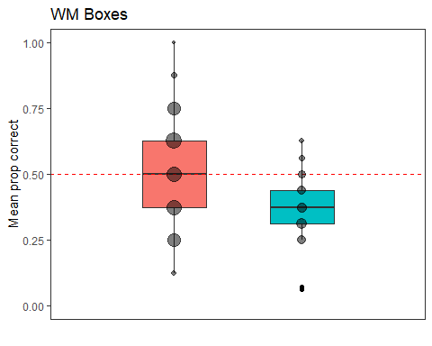

# Inhibition Boxes

sum(is.na(BothSpecies$GlassCeiling))

## [1] 59

59 missing values, so N = 179

Boxplot:

p4<- ggplot(  
 data=BothSpecies, aes(x=rep(1, 238), y=GlassCeiling, fill = Species))+  
 geom_boxplot(outlier.colour = "black", position=position_dodge(1.5))+  
 ylim(0,1)+  
 xlim(0,2)+  
 labs(x="",y="Mean prop correct")+  
 theme(axis.text.x=element_blank(), axis.ticks.x=element_blank())+  
 ggtitle("Inhibition Boxes")+  
geom_hline(yintercept=0.5, linetype="dashed", color = "red") +  
 theme_bw() + theme(panel.grid.major = element_blank(), panel.grid.minor = element_blank())+ theme(axis.text.x = element_blank()) + theme(axis.ticks.x = element_blank()) +  
 geom_count(colour = "black", position = position_jitterdodge(0,0,1.5), alpha = 0.5)+  
 theme(legend.position = "none")  
p4

## Warning: Removed 59 rows containing non-finite values (stat_boxplot).

## Warning: Removed 59 rows containing non-finite values (stat_sum).

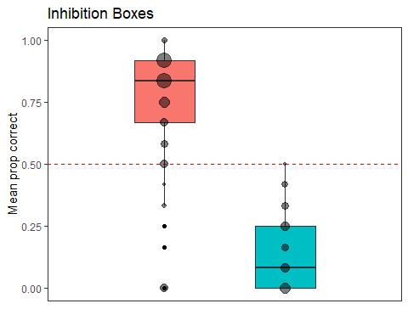

# Inhibition Cylinder

sum(is.na(BothSpecies$Cylinder))

## [1] 43

43 missing values, so N = 195

Boxplot:

p5<- ggplot(  
 data=BothSpecies, aes(x=rep(1, 238), y=Cylinder, fill = Species))+  
 geom_boxplot(outlier.colour = "black", position=position_dodge(1.5))+  
 ylim(0,1)+  
 xlim(0,2)+  
 labs(x="",y="Mean prop correct")+  
 theme(axis.text.x=element_blank(), axis.ticks.x=element_blank())+  
 ggtitle("Inhibition Cylinder")+  
geom_hline(yintercept=0.5, linetype="dashed", color = "red") +  
 theme_bw() + theme(panel.grid.major = element_blank(), panel.grid.minor = element_blank())+ theme(axis.text.x = element_blank()) + theme(axis.ticks.x = element_blank()) +  
 geom_count(colour = "black", position = position_jitterdodge(0,0,1.5), alpha = 0.5)+  
 theme(legend.position = "none")  
p5

## Warning: Removed 43 rows containing non-finite values (stat_boxplot).

## Warning: Removed 43 rows containing non-finite values (stat_sum).

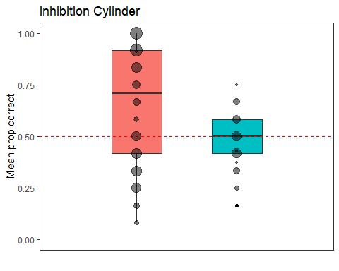

# Inhibition Grid

sum(is.na(BothSpecies$InhibGrid))

## [1] 27

43 missing values, so N = 211

Boxplot:

p6<- ggplot(  
 data=BothSpecies, aes(x=rep(1, 238), y=InhibGrid, fill = Species))+  
 geom_boxplot(outlier.colour = "black", position=position_dodge(1.5))+  
 ylim(0,1)+  
 xlim(0,2)+  
 labs(x="",y="Mean prop correct")+  
 theme(axis.text.x=element_blank(), axis.ticks.x=element_blank())+  
 ggtitle("Inhibition Grid")+  
geom_hline(yintercept=0.5, linetype="dashed", color = "red") +  
 theme_bw() + theme(panel.grid.major = element_blank(), panel.grid.minor = element_blank())+ theme(axis.text.x = element_blank()) + theme(axis.ticks.x = element_blank()) +  
 geom_count(colour = "black", position = position_jitterdodge(0,0,1.5), alpha = 0.5)+  
 theme(legend.position = "none")  
p6

## Warning: Removed 27 rows containing non-finite values (stat_boxplot).

## Warning: Removed 27 rows containing non-finite values (stat_sum).

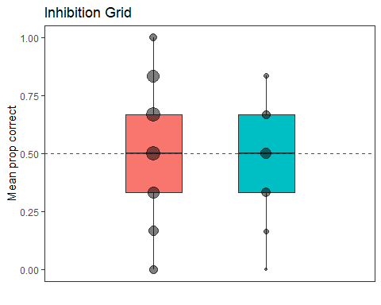

# Shifting Tray

sum(is.na(BothSpecies$Tray))

## [1] 38

38 missing values, so N = 200

Boxplot:

p7<- ggplot(  
 data=BothSpecies, aes(x=rep(1, 238), y=Tray, fill = Species))+  
 geom_boxplot(outlier.colour = "black", position=position_dodge(1.5))+  
 ylim(0,1)+  
 xlim(0,2)+  
 labs(x="",y="Mean prop correct")+  
 theme(axis.text.x=element_blank(), axis.ticks.x=element_blank())+  
 ggtitle("Shifting Tray")+  
geom_hline(yintercept=0.5, linetype="dashed", color = "red") +  
 theme_bw() + theme(panel.grid.major = element_blank(), panel.grid.minor = element_blank())+ theme(axis.text.x = element_blank()) + theme(axis.ticks.x = element_blank()) +  
 geom_count(colour = "black", position = position_jitterdodge(0,0,1.5), alpha = 0.5)+  
 theme(legend.position = "none")  
p7

## Warning: Removed 38 rows containing non-finite values (stat_boxplot).

## Warning: Removed 38 rows containing non-finite values (stat_sum).

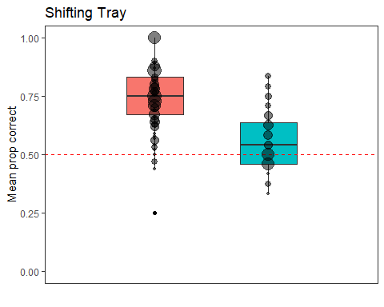

# Shifting Shelf

sum(is.na(BothSpecies$Shelf))

## [1] 36

36 missing values, so N = 202

Boxplot:

p8<- ggplot(  
 data=BothSpecies, aes(x=rep(1, 238), y=Shelf, fill = Species))+  
 geom_boxplot(outlier.colour = "black", position=position_dodge(1.5))+  
 ylim(0,1)+  
 xlim(0,2)+  
 labs(x="",y="Mean prop of switches")+  
 theme(axis.text.x=element_blank(), axis.ticks.x=element_blank())+  
 ggtitle("Shifting Shelf")+  
geom_hline(yintercept=0.2242245, linetype="dashed", color = "red") +  
 theme_bw() + theme(panel.grid.major = element_blank(), panel.grid.minor = element_blank())+ theme(axis.text.x = element_blank()) + theme(axis.ticks.x = element_blank()) +  
 geom_count(colour = "black", position = position_jitterdodge(0,0,1.5), alpha = 0.5)+  
 theme(legend.position = "none")  
p8

## Warning: Removed 36 rows containing non-finite values (stat_boxplot).

## Warning: Removed 36 rows containing non-finite values (stat_sum).

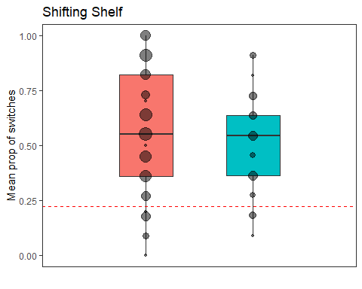

# Shifting Boxes

sum(is.na(BothSpecies$CD_all))

## [1] 53

53 missing values, so N = 185

Boxplot:

p9<- ggplot(  
 data=BothSpecies, aes(x=rep(1, 238), y=CD_all, fill = Species))+  
 geom_boxplot(outlier.colour = "black", position=position_dodge(1.5))+  
 ylim(0,1)+  
 xlim(0,2)+  
 labs(x="",y="Mean prop correct")+  
 theme(axis.text.x=element_blank(), axis.ticks.x=element_blank())+  
 ggtitle("CD")+  
geom_hline(yintercept=0.5, linetype="dashed", color = "red") +  
 theme_bw() + theme(panel.grid.major = element_blank(), panel.grid.minor = element_blank())+ theme(axis.text.x = element_blank()) + theme(axis.ticks.x = element_blank()) +  
 geom_count(colour = "black", position = position_jitterdodge(0,0,1.5), alpha = 0.5)+  
 theme(legend.position = "none")  
p9

## Warning: Removed 53 rows containing non-finite values (stat_boxplot).

## Warning: Removed 53 rows containing non-finite values (stat_sum).

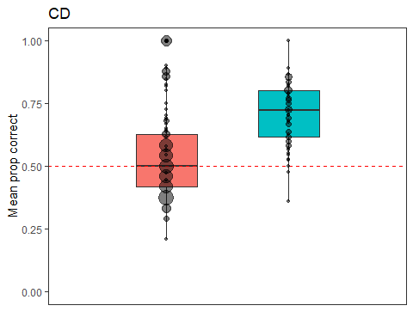

# Reversal

sum(is.na(BothSpecies$Reversal))

## [1] 83

83 missing values, so N = 155

Boxplot:

p10<- ggplot(  
 data=BothSpecies, aes(x=rep(1, 238), y=Reversal, fill = Species))+  
 geom_boxplot(outlier.colour = "black", position=position_dodge(1.5))+  
 ylim(0,1)+  
 xlim(0,2)+  
 labs(x="",y="Mean prop correct")+  
 theme(axis.text.x=element_blank(), axis.ticks.x=element_blank())+  
 ggtitle("Reversal")+  
geom_hline(yintercept=0.5, linetype="dashed", color = "red") +  
 theme_bw() + theme(panel.grid.major = element_blank(), panel.grid.minor = element_blank())+ theme(axis.text.x = element_blank()) + theme(axis.ticks.x = element_blank()) +  
 geom_count(colour = "black", position = position_jitterdodge(0,0,1.5), alpha = 0.5)+  
 theme(legend.position = "none")  
p10

## Warning: Removed 83 rows containing non-finite values (stat_boxplot).

## Warning: Removed 83 rows containing non-finite values (stat_sum).

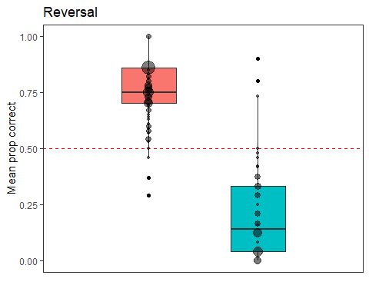

# EDS

sum(is.na(BothSpecies$EDS))

## [1] 160

160 missing values, so N = 78

Boxplot:

p11<- ggplot(  
 data=BothSpecies, aes(x=rep(1, 238), y=EDS, fill = Species))+  
 geom_boxplot(outlier.colour = "black", position=position_dodge(1.5))+  
 ylim(0,1)+  
 xlim(0,2)+  
 labs(x="",y="Mean prop correct")+  
 theme(axis.text.x=element_blank(), axis.ticks.x=element_blank())+  
 ggtitle("EDS")+  
 geom_hline(yintercept=0.5, linetype="dashed", color = "red") +  
 theme_bw() + theme(panel.grid.major = element_blank(), panel.grid.minor = element_blank())+ theme(axis.text.x = element_blank()) + theme(axis.ticks.x = element_blank()) +  
 geom_count(colour = "black", position = position_jitterdodge(0,0,1.5), alpha = 0.5)+  
 theme(legend.position = "none")  
p11

## Warning: Removed 160 rows containing non-finite values (stat_boxplot).

## Warning: Removed 160 rows containing non-finite values (stat_sum).

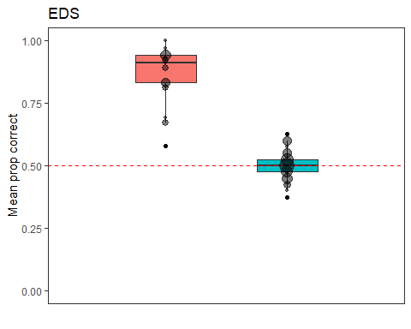

# SD

sum(is.na(BothSpecies$SD))

## [1] 43

43 missing values, so N = 195

Boxplot:

p12<- ggplot(  
 data=BothSpecies, aes(x=rep(1, 238), y=SD, fill = Species))+  
 geom_boxplot(outlier.colour = "black", position=position_dodge(1.5))+  
 ylim(0,1)+  
 xlim(0,2)+  
 labs(x="",y="Mean prop correct")+  
 theme(axis.text.x=element_blank(), axis.ticks.x=element_blank())+  
 ggtitle("SD")+  
geom_hline(yintercept=0.5, linetype="dashed", color = "red") +  
 theme_bw() + theme(panel.grid.major = element_blank(), panel.grid.minor = element_blank())+ theme(axis.text.x = element_blank()) + theme(axis.ticks.x = element_blank()) +  
 geom_count(colour = "black", position = position_jitterdodge(0,0,1.5), alpha = 0.5)+  
 theme(legend.position = "none")  
p12

## Warning: Removed 43 rows containing non-finite values (stat_boxplot).

## Warning: Removed 43 rows containing non-finite values (stat_sum).

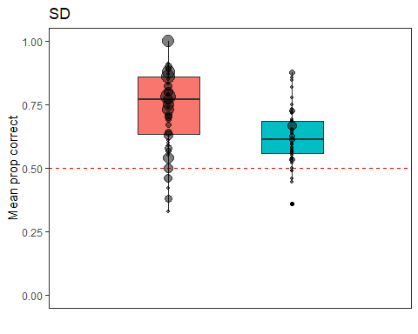

plot_grid(p1, p2, p3, p4, p5, p6, p7, p8, p9, p10, p11, p12, rel_widths = c(1, 1,1), rel_heights = c(4,4,4,4), ncol = 3, nrow = 4)

## Warning: Removed 1 rows containing non-finite values (stat_boxplot).

## Warning: Removed 1 rows containing non-finite values (stat_sum).

## Warning: Removed 58 rows containing non-finite values (stat_boxplot).

## Warning: Removed 58 rows containing non-finite values (stat_sum).

## Warning: Removed 36 rows containing non-finite values (stat_boxplot).

## Warning: Removed 36 rows containing non-finite values (stat_sum).

## Warning: Removed 59 rows containing non-finite values (stat_boxplot).

## Warning: Removed 59 rows containing non-finite values (stat_sum).

## Warning: Removed 43 rows containing non-finite values (stat_boxplot).

## Warning: Removed 43 rows containing non-finite values (stat_sum).

## Warning: Removed 27 rows containing non-finite values (stat_boxplot).

## Warning: Removed 27 rows containing non-finite values (stat_sum).

## Warning: Removed 38 rows containing non-finite values (stat_boxplot).

## Warning: Removed 38 rows containing non-finite values (stat_sum).

## Warning: Removed 36 rows containing non-finite values (stat_boxplot).

## Warning: Removed 36 rows containing non-finite values (stat_sum).

## Warning: Removed 53 rows containing non-finite values (stat_boxplot).

## Warning: Removed 53 rows containing non-finite values (stat_sum).

## Warning: Removed 83 rows containing non-finite values (stat_boxplot).

## Warning: Removed 83 rows containing non-finite values (stat_sum).

## Warning: Removed 160 rows containing non-finite values (stat_boxplot).

## Warning: Removed 160 rows containing non-finite values (stat_sum).

## Warning: Removed 43 rows containing non-finite values (stat_boxplot).

## Warning: Removed 43 rows containing non-finite values (stat_sum).

