All_Correlations

Eva Reindl

3 8 2020

Correlation coefficients

|  |  |  |  |  |  |  |  |  |  |
| --- | --- | --- | --- | --- | --- | --- | --- | --- | --- |
|  | WMUpdating | WMBoxes | WMGrid | CD_all | Tray | Shelf | GlassCeiling | Cylinder | InhibGrid |
| WMUpdating | 1.00 | -0.13 (n = 148) | **0.18* (n = 126)** | 0.14 (n = 131) | -0.02 (n = 147) | 0.05 (n = 152) | 0.04 (n = 125) | 0.04 (n = 143) | -0.02 (n = 158) |
| WMBoxes |  | 1.00 | **0.16† (n = 127)** | 0.08 (n = 132) | 0.11 (n = 146) | 0.12 (n = 129) | 0.11 (n = 126) | 0.10 (n = 144) | 0.07 (n = 142) |
| WMGrid |  |  | 1.00 | 0.07 (n = 123) | 0.15† (n = 124) | 0.26** (n = 112) | 0.08 (n = 121) | 0.24** (n = 125) | 0.16† (n = 120) |
| CD_all |  |  |  | 1.00 | **0.17† (n = 129)** | **0.23* (n = 117)** | 0.04 (n = 120) | 0.22* (n = 130) | -0.09 (n = 126) |
| Tray |  |  |  |  | 1.00 | 0.30*** (n = 128) | 0.07 (n = 123) | 0.15† (n = 141) | -0.13 (n = 142) |
| Shelf |  |  |  |  |  | 1.00 | 0.17† (n = 108) | 0.26** (n = 125) | -0.19* (n = 139) |
| GlassCeiling |  |  |  |  |  |  | 1.00 | 0.12 (n = 124) | 0.11 (n = 120) |
| Cylinder |  |  |  |  |  |  |  | 1.00 | 0.11 (n = 137) |
| InhibGrid |  |  |  |  |  |  |  |  | 1.00 |

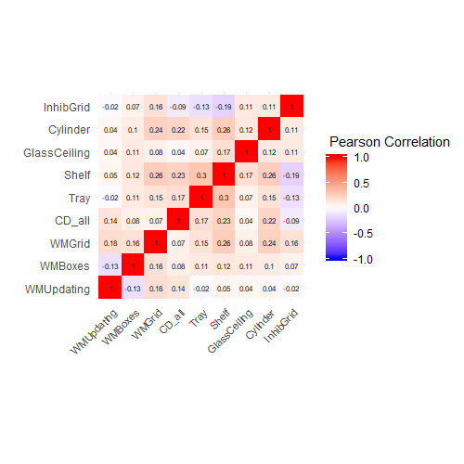

|  |  |  |  |  |  |  |  |  |  |
| --- | --- | --- | --- | --- | --- | --- | --- | --- | --- |
|  | WMUpdating | WMBoxes | WMGrid | CD_all | Tray | Shelf | GlassCeiling | Cylinder | InhibGrid |
| BRIEF-P WM scale | -0.07 (n = 114) | **-0.20* (n = 107)** | -0.10 (n = 94) | 0.02 (n = 97) | -0.10 (n = 105) | -0.01 (n = 96) | 0.01 (n = 92) | -0.09 (n = 106) | -0.11 (n = 106) |
| BRIEF-P Inhibit scale | 0.03 (n = 114) | **-0.23* (n = 107)** | -0.01 (n = 94) | 0.09 (n = 97) | -0.05 (n = 105) | 0.06 (n = 96) | -0.06 (n = 92) | -0.11 (n = 106) | -0.10 (n = 106) |
| BRIEF-P Shifting scale | -0.06 (n = 114) | -0.08 (n = 107) | 0.02 (n = 94) | **-0.17† (n = 97)** | -0.10† (n = 105) | -0.12 (n = 96) | -0.04 (n = 92) | -0.14 (n = 106) | **-0.18† (n = 106)** |

Negative correlation means: The more efficient children were in the test battery, the less difficulty did their parents report in the questionnaire.