WM_Correlations

Eva Reindl

19 5 2020

|  |  |  |  |
| --- | --- | --- | --- |
|  | **WM Updating** | **WM Boxes** | **WM Grid** |
| **WM Updating** | 1.00 | -0.13 (n = 148) | 0.18* (n = 126) |
| **WM Boxes** |  | 1.00 | 0.16† (n = 127) |
| **WM Grid** |  |  | 1.00 |

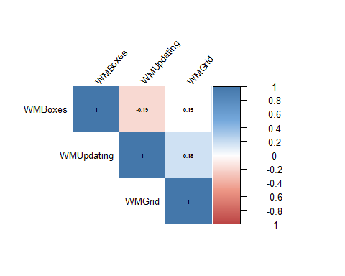

rcorr(as.matrix(keep))

## WMUpdating WMBoxes WMGrid  
## WMUpdating 1.00 -0.13 0.18  
## WMBoxes -0.13 1.00 0.16  
## WMGrid 0.18 0.16 1.00  
##   
## n  
## WMUpdating WMBoxes WMGrid  
## WMUpdating 184 148 126  
## WMBoxes 148 149 127  
## WMGrid 126 127 127  
##   
## P  
## WMUpdating WMBoxes WMGrid  
## WMUpdating 0.1102 0.0466  
## WMBoxes 0.1102 0.0714  
## WMGrid 0.0466 0.0714

