Cylinder

Eva Reindl

6 4 2020

Key findings:

* 144 valid datapoints
* DV: Proportion of correct searches out of the first 10, 11 or 12 searches
  + Not normally distributed
  + Performance of all children (all age groups, mediansplit) above chance
  + 4-year-olds better than 3-year-olds, older children better than younger children
  + Significant effect of age on performance (no effect of trial number or location)

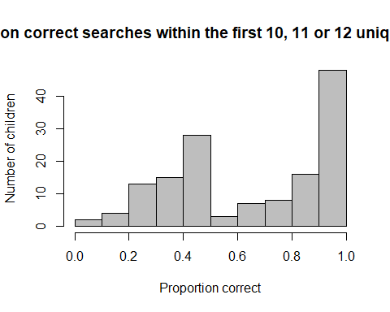 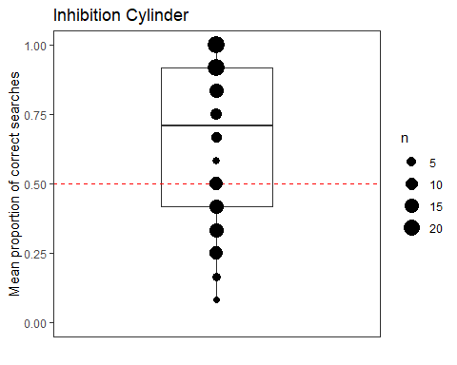

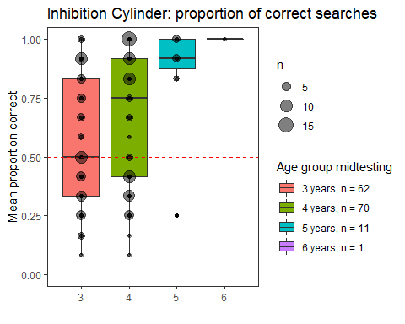 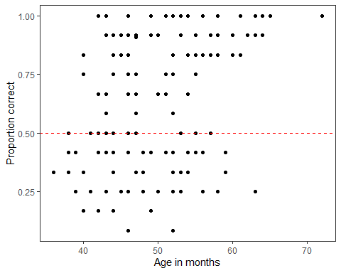

Children Chimps

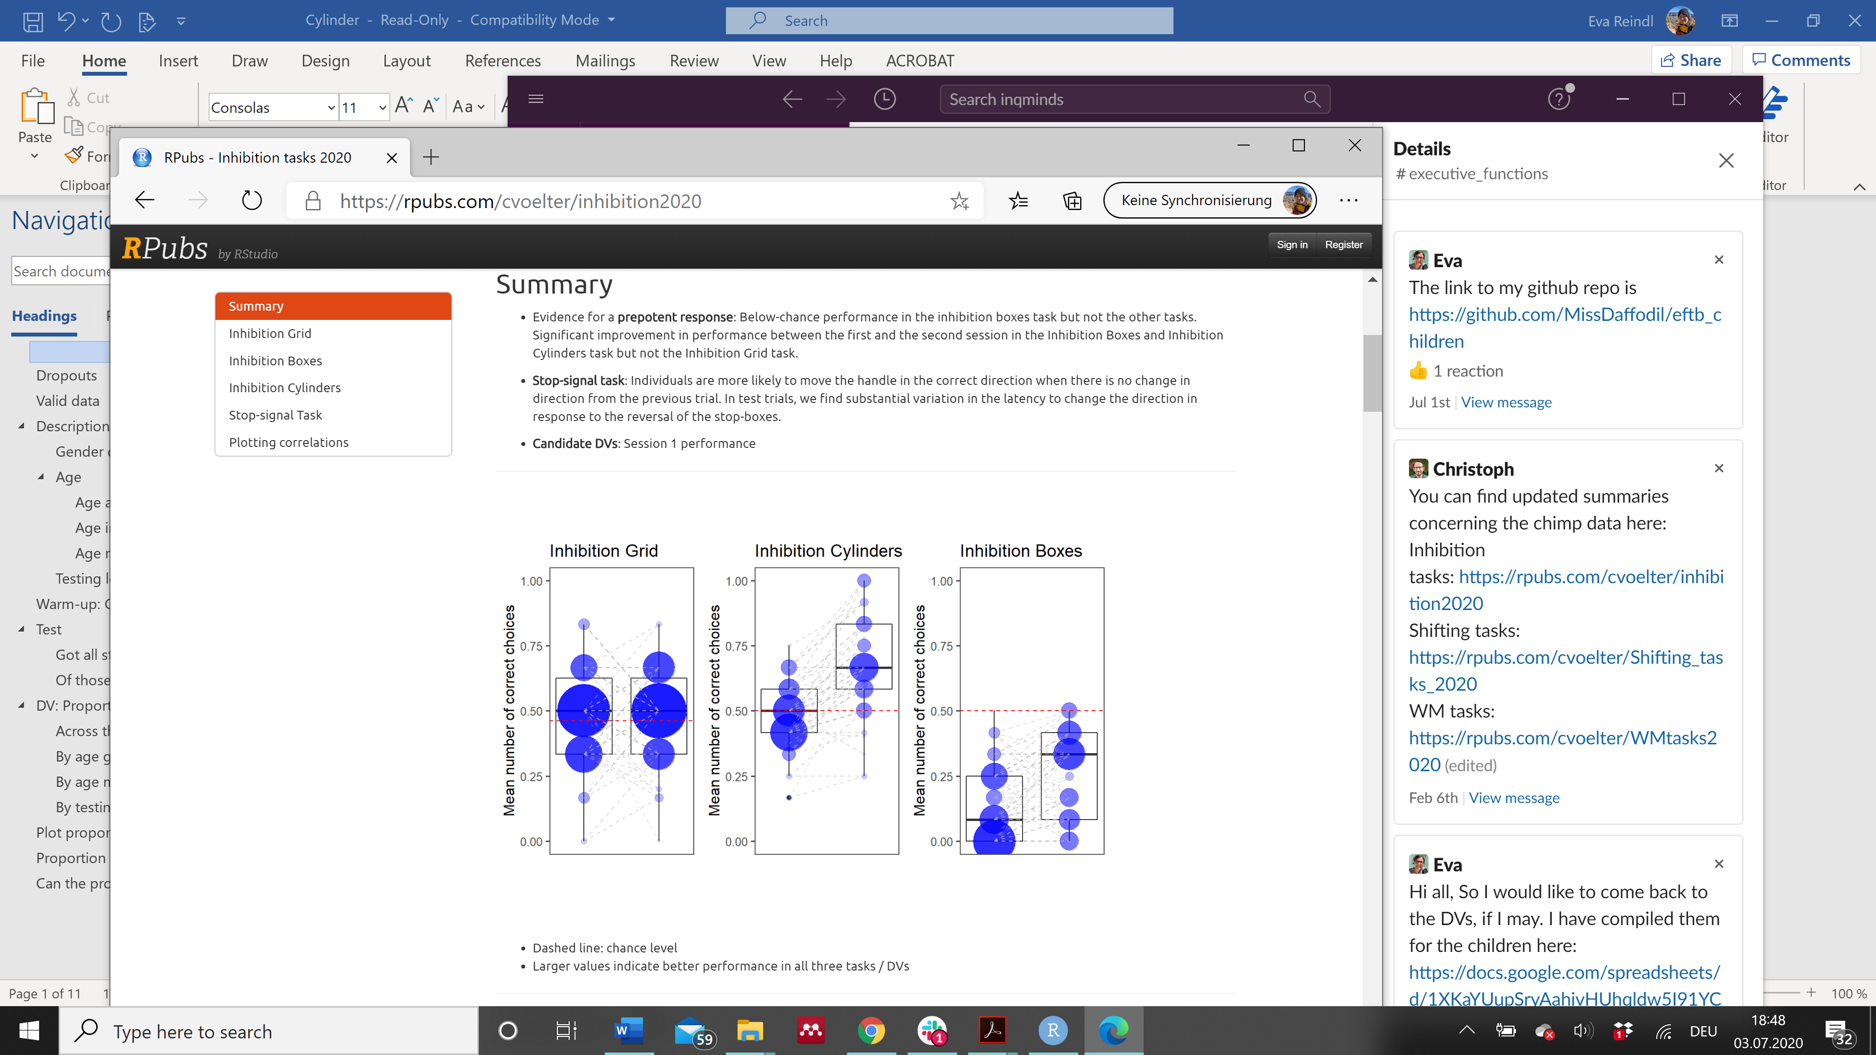 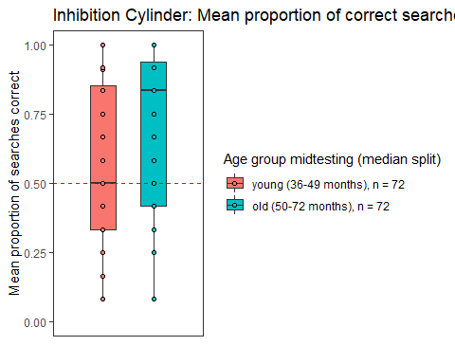

"R version 3.6.1 (2019-07-05)"

# Dropouts

There are 3 dropouts:

* for 2 children there was an experimenter error (forgot to label counterevidence in warm-up; 4y m, 3y f)
* 1 child (3y m) stopped after 3 searches (was on medication and very usually drowsy)

# Valid data

There are 144 valid cases in the cylinder task. These include:

* 3 children with 10 unique searches (child stopped and said she had found all stickers - 4y f, one child got frustrated and refused to pick any more - 3y f, one child there was an experimenter error (E gestured toward one side of the board) so the trial was cut after 10 unique searches - 4y f)
* 2 children with 11 unique searches (E accidentally stopped earlier - 4y f, child stopped and saif he had found all stickers - 3y m)

# Description of sample

## Gender distribution

There were 78 girls and 66 boys.

## Age

### Age at the beginning of testing

At the beginning of testing, the children who had valid data on the Cylinder task were on average 48.83 months (SD = 6.88, range 36-70) old. There were 64 3-year-olds, 72 4-year-olds, and 8 5-year-olds.

* 3y: 37 f, 27 m
* 4y: 37 f, 35 m
* 5y: 4 f, 4 m

### Age in the middle of testing

In the middle of testing, the children who had valid data on the Cylinder task were on average **49.94 months (SD = 6.81, range 36-72)** old. There were **62 3-year-olds, 70 4-year-olds, 11 5-year-olds, and 1 6-year-old**.

* 3y: 36 f, 26 m
* 4y: 35 f, 35 m
* 5y: 7 f, 4 m
* 6y: 1m

### Age mediansplit (based on entire sample)

There were **72 young** and **72 old** children.

* young: 39 f, 33 m
* old: 39 f, 33 m

## Testing location

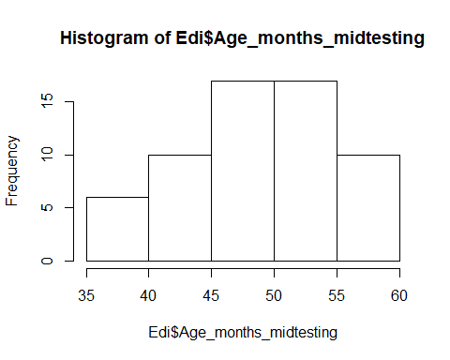 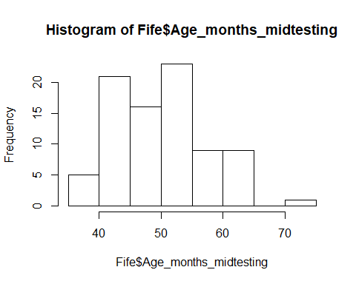

84 children were from Fife, 60 from Edinburgh. Edinburgh: M = 49.22 (SD = 5.80, range 36-58)

* 3y: 25
* 4y: 35

Fife: M = 50.46 (SD = 7.45, range 38-72)

* 3y: 37
* 4y: 35
* 5y: 11
* 6y: 1

There is no difference in the age distribution between the two testing locations, two-sided Wilcoxon test, W = 2391.5, p = .603.

# Warm-up: Cup chosen

From the 144 children, the choice of cup in the warm-up was known for 130 (90%) children. For the rest of the children, the experimenter missed to take a note of the cup chosen and the video also did not show it. From the 130 children of which we know which cup was chosen, 122 (94%) chose the sticker cup (i.e., the wrong cup). This shows that there was indeed a strong pull to reach to the nice sticker cup.

# Test

## Got all stickers?

Of the 144 children, 101 (70%) found all the stickers. 43 children stopped the game before finding all the stickers (either they announced they had found all the stickers and did not want to search anymore or the experimenter stopped the game as the child had already searched a lot and has been unable to find the remaining stickers).

## Of those children who did not find 12 stickers, how many stickers did they find?

Of the children who had 12 unique searches (n = 139), 101 children (73%) did get all the stickers, i.e., 38 (27%) children did not get all 12 stickers:

* 21 children got 11 stickers
* 7 children got 10 stickers
* 2 children got 9 stickers
* 3 children got 8 stickers
* 1 chid got 7 stickers
* 3 children got 3 stickers
* 1 child got 5 stickers

Of the children who did not have 12 unique searches (n = 5):

* had 11 searches (n = 2): 1 child got all 11 stickers, 1 child got 10 stickers
* had 10 searches (n = 3): all 3 children got all 10 stickers

Thus, from the 5 children with fewer than 12 searches, 4 (80%) got all stickers.

Altogether:

* children who got 12 unique searches (n = 139): 101 got all stickers (73%), 38 did not find all stickers
* children who had fewer than 12 unique searches (n = 5): 4 got all stickers (80%), 1 did not find all stickers.

Taken together: **Out of 144 children, 105 children (73%) got all stickers**, 39 children did not get all stickers.

# DV: Proportion of correct searches out of the first 10, 11 or 12 unique trials

## Across the sample



The mean proportion of correct searches within the first 10, 11 or 12 searches was 0.65 (SD = 0.28, range 0.08-1). The variable is bimodal and not normally distributed, W = 0.891, p < .001. Children’s performance is significantly above chance value (0.5), two-sided Wilcoxon test, V = 7001.5, p < .001.



## By age groups

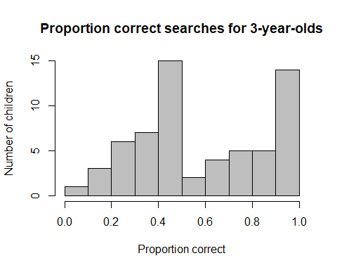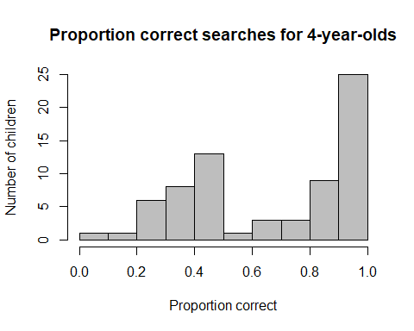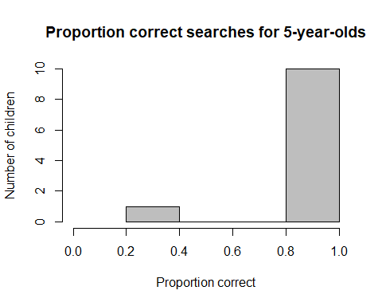

* 3y (n = 62): M = 0.58 (SD = 0.27, range 0.08-1), significantly above chance (V = 1007.5, p = .009)
* 4y (n = 70): M = 0.66 (SD = 0.29, range 0.08-1), significantly above chance (V = 1836.5, p < .001)
* 5y (n = 11): M = 0.87 (SD = 0.21, range 0.25-1), significantly above chance (V = 65, p = .004)
* 6y (n = 1): M = 1

4-year-olds perform better than 3-year-olds, one-sided Wilcoxon test, W = 1785, p = .039.



## By age mediansplit

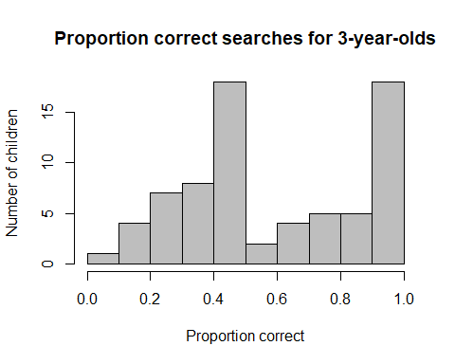 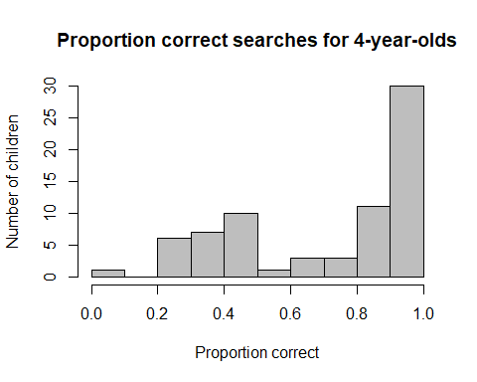

* young (n = 72): M = 0.58 (SD = 0.27, range 0.08-1), significantly above chance (V = 1403.5, p = .007)
* old (n = 72): M = 0.71 (SD = 0.28, range 0.08-1), significantly above chance (V = 2106, p < .001)

Older children are better than younger children, one-sided Wilcoxon test, W = 3289.5, p = .002.



## By testing location

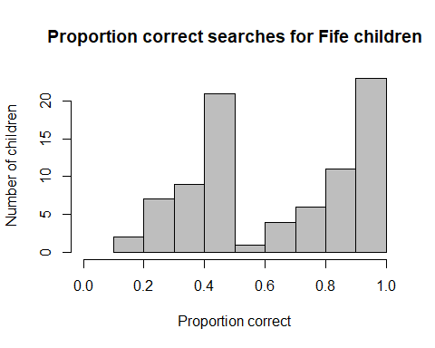 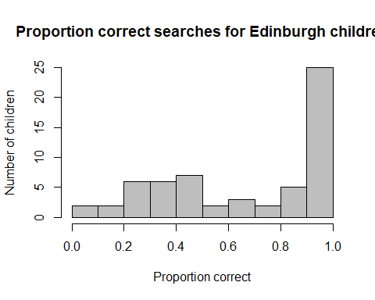

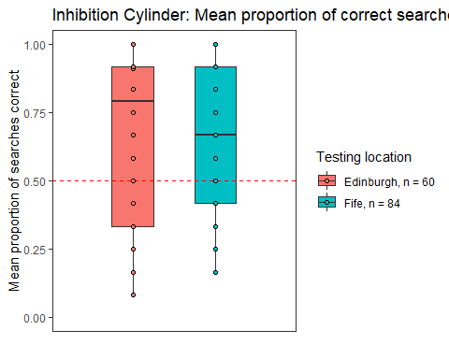

* Edinburgh: M = 0.66 (SD = 0.30, range 0.08-1), significantly above chance (V = 1287, p < .001)
* Fife: M = 0.64 (SD = 0.27, range 0.17-1), significantly above chance (V = 2307.5, p < .001)

There is no difference in performance between testing locations, W = 2666, p = .553.

# Plot proportion correct against age as continuous variable



# Proportion of correct searches as calculated for each cumulative number of trials

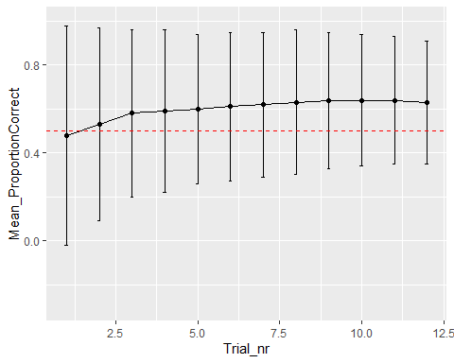

# Can the proportion of correct searches be predicted by age and trial number?

We are not testing for an effect of testing location here, as the above results indicate that there is no difference in performance.

res<-glmer(GotSticker ~ z.age + z.trial + z.age:z.trial + (1+z.trial|ID), data=Cyl.validtrials, family=binomial)

Together, age, trial number, and the interaction between age and trial number can explain the data significantly better than a null model only consisting of the intercept, X2(3) = 21.387, p < .001.

**Effect of interaction term**

There is no effect of the interaction term (X2(1) = 0.912, p = .339), so we remove it from the model. We also tried to enter the non-transformed version of trial number, but then the model did not converge.

res<-glmer(GotSticker ~ z.age + z.trial + (1+z.trial|ID), data=Cyl.validtrials, family=binomial)

Together, age, and trial number can explain the data significantly better than a null model only consisting of the intercept, X2(2) = 20.457, p < .001.

**Effect of trial number**

There is no effect of trial number, X2(1) = 1.283, p = .257.

**Effect of age**

There is a significant effect of age, X2(1) = 19.642, p < .001.

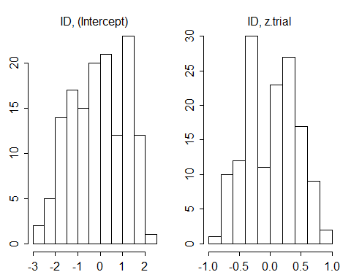

#collinearity

## z.age z.trial   
## 1.000002 1.000002