Inhibition Grid

Eva Reindl

18 7 2020

Key highlights:

* **155 valid datapoints**
* DV: proportion of correct searches within the first 6 unique searches (not counting repeated searches)
  + **not normally distributed**, W = 0.946, p < .001
  + performance above chance for across ages and 4-year-olds, at chance for 3-year- and 5-year-olds
  + no difference between young and old children, no difference between testing locations
  + age cannot predict DV

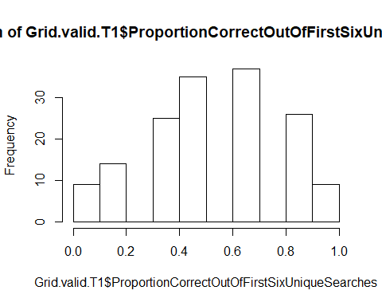 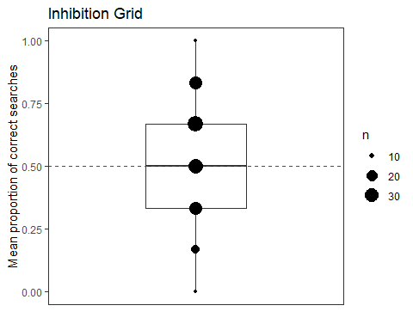

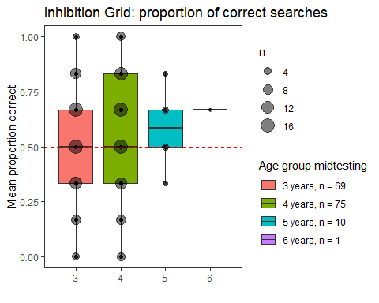 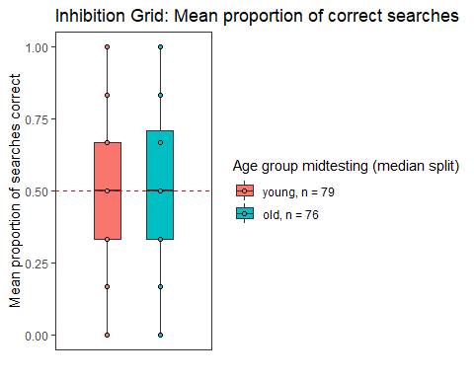

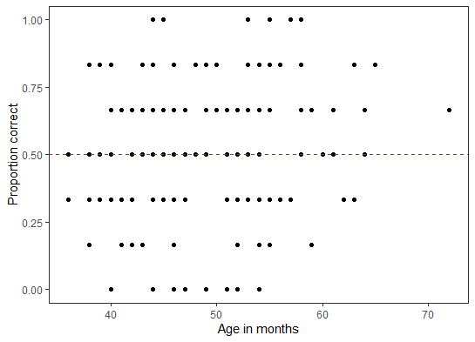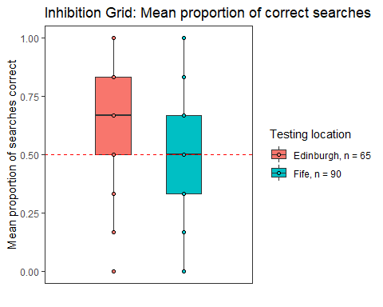

## [1] "R version 3.6.1 (2019-07-05)"

# Dropouts

There were **11 clear dropouts** (all female, 7 3-year-olds, 3 4-year-olds, 1 5-year-old):

* 1 child stopped reacting (ID 13)
* 1 child experimenter error (camera was positioned badly so that coding was impossible; ID 33)
* 1 child experimenter error (E forgot to bait the box, ID 47)
* 2 child experimenter error (heavy intervention and prompting by E, IDs 145, 17)
* 2 children experimenter error (opaque door was open from the start, IDs 21, 31)
* 2 children experimenter error (only put 6 trasnparent boxes, IDs 11, 45)
* 1 child did not react at all (ID 99)
* 1 child picked box up and flipped it towards her so that animals fell out (ID 18)

There are 155 remaining children in the dataset.

# Description of dataset

## Gender

There are 79 girls and 76 boys.

## Age

### Age at the beginning of testing

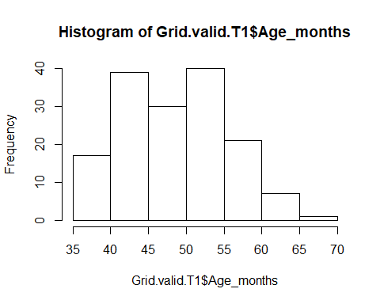

At the beginning of testing, the 156 children were 49.21 (SD = 6.94, range 36-70) months old. There were 68 3-year-olds, 76 4-year-olds, 10 5-year-olds, and 1 6-year-old.

### Age in the middle of testing

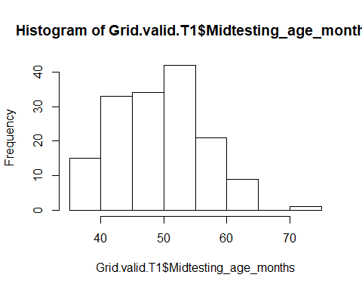

In the middle of testing, the 155 children were 49.67 (SD = 6.94, range 36-72) months old. There were 69 3-year-olds, 75 4-year-olds, 10 5-year-olds, and 1 6-year-old.

### Mediansplit age (based on entire sample)

There were 79 young and 76 old children.

## Testing location

65 children were from Edinburgh, 90 children from Fife.

Edinburgh: 49.37 (SD = 5.70, range 36-58) - 3y: 27 - 4y: 38

Fife: 49.89 (SD = 7.74, range 36-72) - 3y: 42 - 4y: 37 - 5y: 10 - 6y: 1

There is no difference in mean age between the two testing locations.

# Clean data

62 children have clean data, 93 children have some kind of issue.

* Edinburgh: 3 children (5%) have clean data, 62 don’t
* Fife: 59 children (65%) have clean data, 31 don’t

# Type of issues

* Door bent inwards/outwards: 10
* Door bent inwards/outwards and experimenter intervention at start: 1
* Door bent inwards/outwards and experimenter intervention during trial, possibly intervention at start: 1
* door wobble: 8
* Door wobble and experimenter intervention at start: 7
* door wobble and experimenter intervention during trial: 8
* door wobble, experimenter intervention at start and during trial: 5
* door wobble, possibly experimenter intervention at start: 2
* Experimenter intervention at start: 13
* Experimenter intervention at start and during trial: 8
* Experimenter intervention during trial: 8
* Experimenter intervention during trial, possibly also at start : 5
* no video, latencies cannot be coded: 1
* received help: 11
* suspicious, probably door wobble: 2
* very inattentive: 1

# Trial 1

## 6 searches after the first toy was found

### How many transparent doors were touched in the 6 searches after the first toy was found (here, these 6 searches are counted by ignoring repeated visits to opaque doors, but punishing for repeated visits to transparent doors)

#### If we take all data

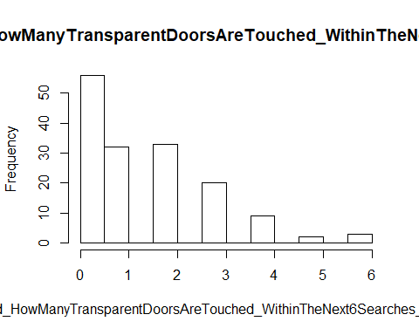

With data from all 155 children, children reached on average 1.43 (SD = 1.46, range 0-6) times to transparent doors in the first 6 unique searches after the first toy was found (not counting repeated visits to opaque doors). This variable is rather left-skewed.

* 3y (n = 69): 1.58 (SD = 1.49, range 0-6)
* 4y (n = 75): 1.33 (SD = 1.48, range 0-6)
* 5y (n = 10): 1.30 (SD = 1.06, range 0-3)
* 6y (n = 1): 0

3- and 4-year-olds don’t differ in how often they touch transparent doors after finding the first toy, W = 2868.5, p = .123.

* young (n = 79): 1.57 (SD = 1.46, range 0-6)
* Old (n = 76): 1.29 (SD = 1.45, range 0-6)

Young children did not go back to transparent doors more often than older children, W = 3373, p = .085.

* Edinburgh (n = 65): 1.48 (SD = 1.29, range 0-4)
* Fife (n = 90): 1.40 (SD = 1.58, range 0-6)

Children from Edinburgh and Fife do not differ in how often they touch transparent doors after finding the first toy.

#### If we take only clean data

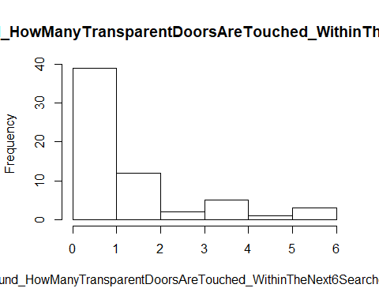

With data from the 62 children with clean data, children reached on average 1.39 (SD = 1.68, range 0-6) times to transparent doors in the first 6 unique searches after the first toy was found (not counting repeated visits to opaque doors). This variable is very left-skewed.

* 3y (n = 32): 1.47 (SD = 1.66, range 0-6)
* 4y (n = 22): 1.50 (SD = 1.92, range 0-6)
* 5y (n = 7): 0.86 (SD = 0.90, range 0-2)
* 6y (n = 1): 0

3- and4-year-olds do not differ in how often they touch transparent doors after finding the first toy.

* young (n = 34): 1.41 (SD = 1.63, range 0-6)
* Old (n = 28): 1.36 (SD = 1.77, range 0-6)

Young and old children did not differ, W = 507.5, p = .323.

### How many transparent doors were touched in the 6 immediate searches after the first toy was found

#### If we take all data

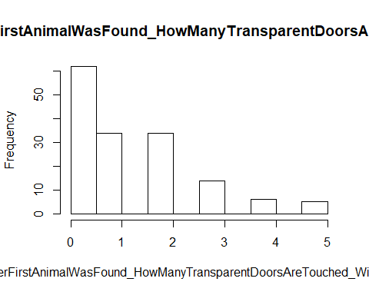

With data from all 155 children, children reached on average 1.24 (SD = 1.34, range 0-5) times to transparent doors in the first 6 searches after the first toy was found. This variable is rather left-skewed.

* 3y (n = 69): 1.36 (SD = 1.36, range 0-5)
* 4y (n = 75): 1.21 (SD = 1.38, range 0-5)
* 5y (n = 10): 0.80 (SD = 0.79, range 0-2)
* 6y (n = 1): 0

3- and 4-year-olds do not differ in how often they go back to transparent doors after finding the first animal, W = 2785, p = .205.

* young (n = 79): 1.38 (SD = 1.35, range 0-5)
* Old (n = 76): 1.10 (SD = 1.32, range 0-5)

Young and old children do not differ in how often they go back to transparent doors after finding the first animal, W = 3393, p = .072.

* Edinburgh (n = 65): 1.37 (SD = 1.26, range 0-4)
* Fife (n = 90): 1.15 (SD = 1.40, range 0-5)

There was no difference between the two testing locations in how often children touched trasnparent doors after finding the first animal, W = 2549.5, p = .155.

#### If we take only clean data

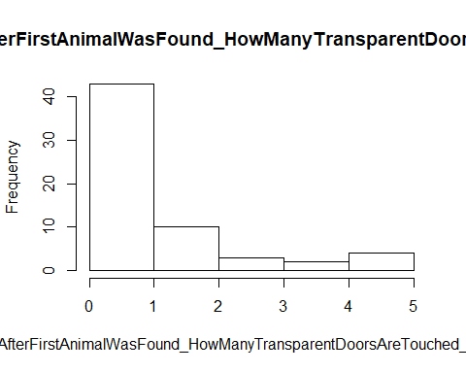

With data from the 62 children with clean data, children reached on average 1.11 (SD = 1.48, range 0-5) times to transparent doors in the first 6 searches after the first toy was found. This variable is very left-skewed.

* 3y (n = 32): 1.25 (SD = 1.48, range 0-5)
* 4y (n = 22): 1.14 (SD = 1.67, range 0-5)
* 5y (n = 7): 0.57 (SD = 0.79, range 0-2)
* 6y (n = 1): 0
* young (n = 34): 1.20 (SD = 1.45, range 0-5)
* Old (n = 28): 1.00 (SD = 1.54, range 0-5)

## Preferred DV: Proportion correct (not punishing for repeated visits to transparent doors)

### all data



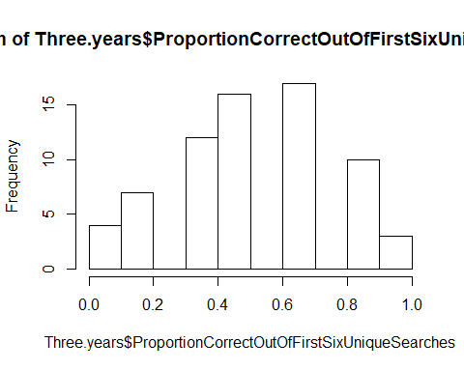 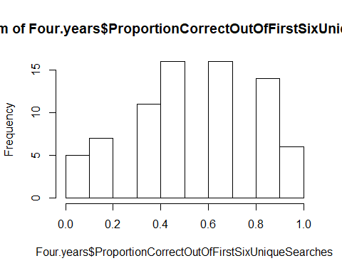

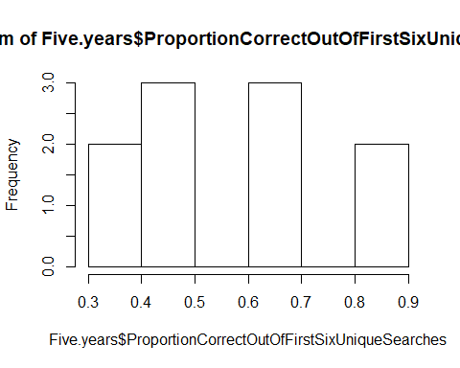

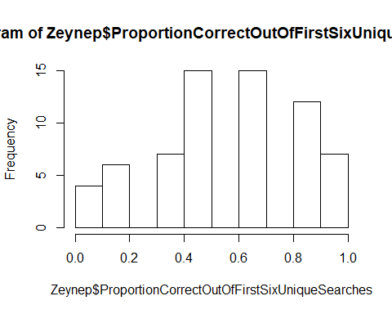

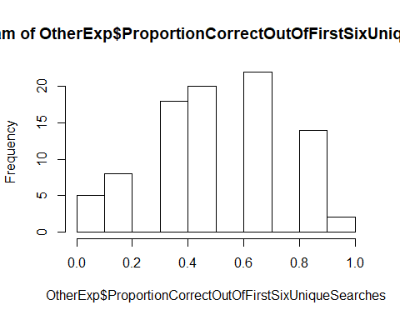

With data from all 155 children, children had on average 0.54 (SD = 0.26, range 0-1) searches out of the first 6 searches (not counting any repeated visits) correct. The distribution of this variable ok, but not normally distributed, W = 0.946, p < .001. Performance above chance, V = 4776.5, p = .002.

* 3y (n = 69): 0.52 (SD = 0.25, range 0-1), not normally distributed, W = 0.949, p = .007, performance at chance, V = 887, p = .126
* 4y (n = 75): 0.55 (SD = 0.28, range 0-1), not normally distributed, W = 0.943, p = .002, performance above chance, V = 1168, p = .031
* 5y (n = 10): 0.58 (SD = 0.18, range 0.33-0.83), normally distributed, W = 0.906, p = .258, performance at chance, t(9) = 1.463, p = .177
* 6y (n = 1): 0.67

No difference between 3- and 4-year-olds, W = 2410.5, p = .236.

* young (n = 79): 0.53 (SD = 0.25, range 0-1)
* Old (n = 76): 0.55 (SD = 0.27, range 0-1)
* Edinburgh (n = 65): 0.58 (SD = 0.27, range 0-1)
* Fife (n = 90): 0.51 (SD = 0.25, range 0-1)

There is no difference between Edinburgh children and Fife children in the proportion correct, W = 3388.5, p = .087.

* Zeynep: 0.57 (SD = 0.28, 0-1)
* Other experimenters: 0.51 (SD = 0.24, 0-1)

There is no difference between children tested by Zeynep and children tested by other experimenters in the proportion correct, W = 3339, p = .139.











#### Can age predict children's success?

*res<-lm(ProportionCorrectOutOfFirstSixUniqueSearches ~ z.age, data=Grid.valid.T1)*

*null<-lm(ProportionCorrectOutOfFirstSixUniqueSearches ~ 1, data=Grid.valid.T1)*

Age cannot predict the proportion corect ouf of the first 6 searches, X2(1) = 0.138, p = .153.

## only clean data

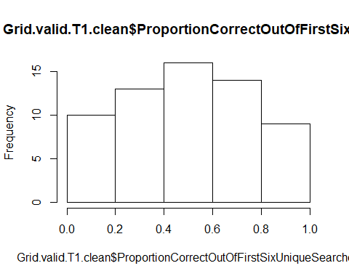

With data from the 60 children with clean data, children reached on average 0.49 (SD = 0.24, range 0-1) times to transparent doors in the first 6 searches after the first toy was found.

* 3y (n = 32): 0.50 (SD = 0.25, range 0-1)
* 4y (n = 22): 0.45 (SD = 0.27, range 0-1)
* 5y (n = 7): 0.55 (SD = 0.18, range 0.33-0.83)
* 6y (n = 1): 0.67
* young (n = 34): 0.51 (SD = 0.25, range 0-1)
* Old (n = 28): 0.46 (SD = 0.24, range 0-1)

# Proportion correct (punishing for repeated visits to transparent doors)

## all data

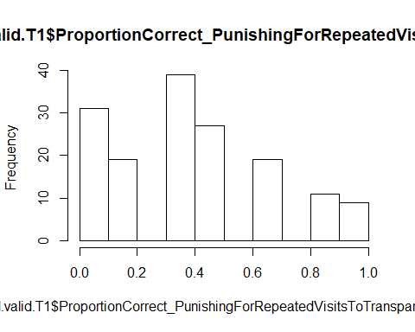

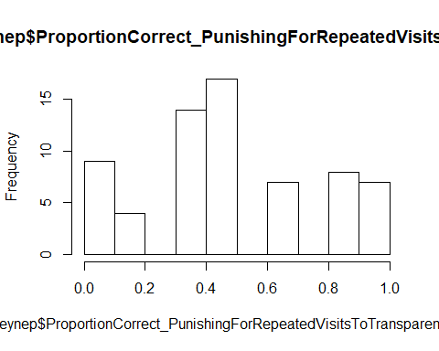 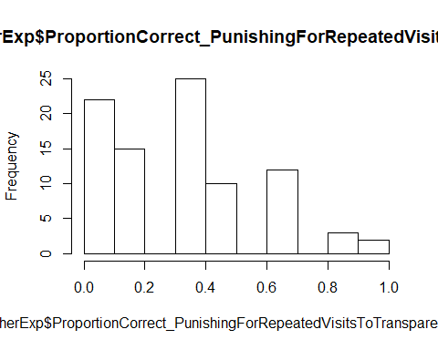

With data from all 155 children, children had on average 0.39 (SD = 0.29, range 0-1) searches out of the first 6 searches (punishing repeated visits to transparent doors) correct.

* 3y (n = 69): 0.38 (SD = 0.28, range 0-1)
* 4y (n = 75): 0.41 (SD = 0.30, range 0-1)
* 5y (n = 10): 0.32 (SD = 0.33, range 0-0.83)
* 6y (n = 1): 0.67

3-year-olds did not perform worse than 4-year-olds, W = 2419, p = .247.

* young (n = 79): 0.39 (SD = 0.29, range 0-1)
* Old (n = 76): 0.39 (SD = 0.30, range 0-1)

There was no difference between young and old children.

* Edinburgh (n = 65): 0.49 (SD = 0.30, range 0-1)
* Fife (n = 90): 0.31 (SD = 0.26, range 0-1)

Children in Edinburgh perform better than children in Fife, W = 3945, p < .001.

* Zeynep: 0.49 (SD = 0.30, 0-1)
* Other experimenters: 0.32 (SD = 0.26, 0-1)

Children tested by Zeynep perform better than children tested by other experimenters, W = 3895, p < .001.

## only clean data

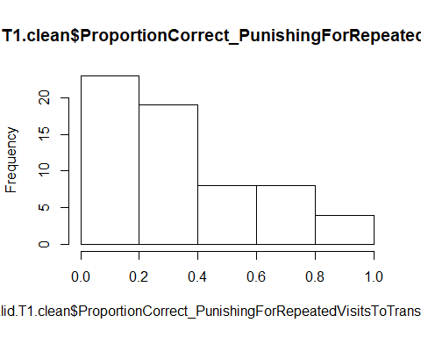

With data from the 62 children with clean data, children reached on average 0.34 (SD = 0.26, range 0-1) times to transparent doors in the first 6 searches after the first toy was found (punishing for repeated visits to transparent doors).

* 3y (n = 32): 0.36 (SD = 0.25, range 0-1)
* 4y (n = 22): 0.30 (SD = 0.25, range 0-1)
* 5y (n = 7): 0.36 (SD = 0.32, range 0-0.83)
* 6y (n = 1): 0.67
* young (n = 34): 0.34 (SD = 0.26, range 0-1)
* Old (n = 28): 0.35 (SD = 0.26, range 0-1)

# New DV: no redundant searches punished: 2 phases combined, proportion of transparent boxes touched

## all data

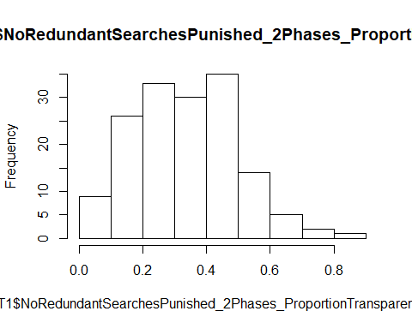

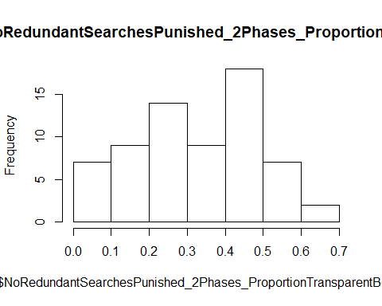 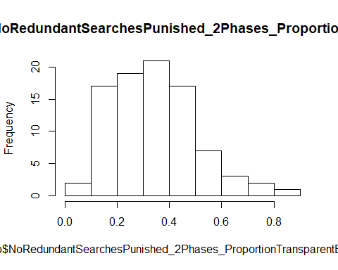

With data from all 155 children, the proportion of transparent doors touched was on average 0.35 (SD = 0.17, range 0-0.87).

* 3y (n = 69): 0.36 (SD = 0.16, range 0-0.70)
* 4y (n = 75): 0.33 (SD = 0.19, range 0-0.87)
* 5y (n = 10): 0.33 (SD = 0.09, range 0.12-0.45)
* 6y (n = 1): 0.22

3-year-olds did not perform worse than 4-year-olds, t(140.62) = 1.120, p = .132.

* young (n = 79): 0.36 (SD = 0.16, range 0-0.70)
* Old (n = 76): 0.33 (SD = 0.18, range 0-0.87)

Young children did not perform worse than old children, t(147.91) = 1.203, p = .115.

* Edinburgh (n = 65): 0.34 (SD = 0.18, range 0-0.67)
* Fife (n = 90): 0.35 (SD = 0.17, range 0-0.87)

There was no difference in performance between testing locations.

* Zeynep: 0.34 (SD = 0.18, 0-0.67)
* Other experimenters: 0.35 (SD = 0.17, 0-0.87)

There was no difference in performance between children tested by Zeynep and children tested by other researchers.

## only clean data

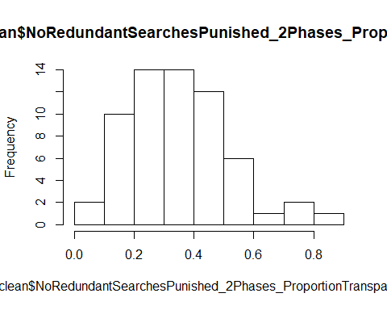

With data from the 62 children with clean data, the proportion of transparent doors touched was on average 0.36 (SD = 0.18, range 0-0.87).

* 3y (n = 32): 0.36 (SD = 0.16, range 0-0.70)
* 4y (n = 22): 0.38 (SD = 0.22, range 0-0.87)
* 5y (n = 7): 0.30 (SD = 0.09, range 0.12-0.42)
* 6y (n = 1): 0.22
* young (n = 34): 0.35 (SD = 0.17, range 0-0.70)
* Old (n = 28): 0.37 (SD = 0.19, range 0-0.87)
* Edinburgh (n = 3): 0.28 (SD = 0.26, 0.12-0.58)
* Fife (n = 59): 0.36 (SD = 0.17, 0-0.87)

# New DV: Redundant searches to transparent doors punished: 2 phases combined, proportion of transparent boxes touched

## all data

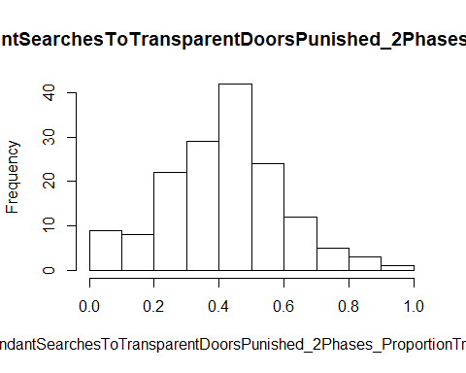

 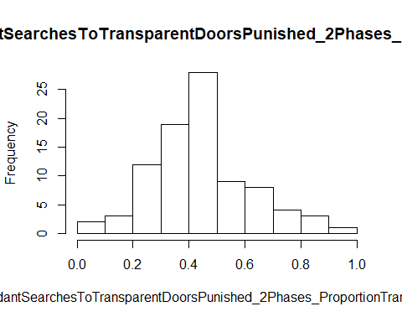

With data from all 155 children, the proportion of transparent doors touched was on average 0.42 (SD = 0.19, range 0-0.92).

* 3y (n = 69): 0.44 (SD = 0.18, range 0-0.92)
* 4y (n = 75): 0.41 (SD = 0.19, range 0-0.87)
* 5y (n = 10): 0.47 (SD = 0.21, range 0.12-0.75)
* 6y (n = 1): 0.22

3-year-olds did not perform worse than 4-year-olds, W = 2857.5, p = .140.

* young (n = 79): 0.44 (SD = 0.18, range 0-0.92)
* Old (n = 76): 0.41 (SD = 0.20, range 0-0.87)

Young children did not perform worse than old children, t(148.49) = 0.831, p = .203.

* Edinburgh (n = 65): 0.38 (SD = 0.19, range 0-0.75)
* Fife (n = 90): 0.45 (SD = 0.18, range 0-0.92)

There was no difference in performance between testing locations, W = 2515, p = .134.

* Zeynep: 0.39 (SD = 0.19, 0-0.75)
* Other experimenters: 0.45 (SD = 0.18, 0-0.92)

There was no difference in performance between children tested by Zeynep and children tested by other researchers, W = 2975.5, p = .890.

## only clean data

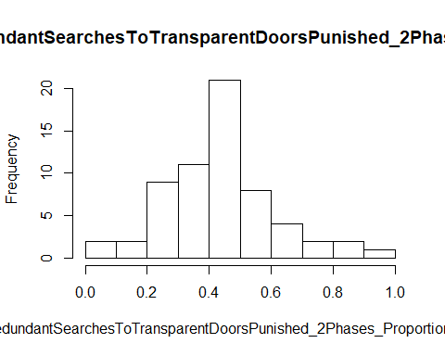

With data from the 62 children with clean data, the proportion of transparent doors touched was on average 0.44 (SD = 0.19, range 0-0.92).

* 3y (n = 32): 0.44 (SD = 0.19, range 0-0.92)
* 4y (n = 22): 0.46 (SD = 0.19, range 0-0.87)
* 5y (n = 7): 0.41 (SD = 0.20, range 0.12-0.67)
* 6y (n = 1): 0.22
* young (n = 34): 0.44 (SD = 0.18, range 0-0.92)
* Old (n = 28): 0.43 (SD = 0.20, range 0-0.87)

## First box touched

123 children touched a transparent box first, 32 children touched an opaque box first.

* Edinburgh: 45 transparent, 20 opaque
* Fife: 78 transparent, 12 opaque

Children in Edinburgh touched an opaque door more often than children in Fife, X2(1) = 5.980, p = .014.

# Trial 2

154 children have a second trial.

## Preferred DV: Proportion correct (not punishing for repeated visits to transparent doors)

### all data

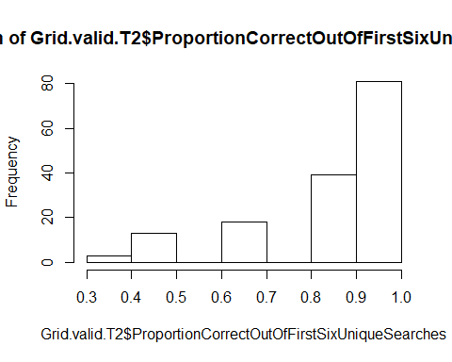

With data from all 154 children, children had on average 0.86 (SD = 0.18, range 0.33-1) searches out of the first 6 searches (not counting any repeated visits) correct. The variable is right-skewed and not normally distributed, W = 0.758, p < .001.

* 3y (n = 68): 0.84 (SD = 0.17, range 0.33-1)
* 4y (n = 75): 0.87 (SD = 0.19, range 0.33-1)
* 5y (n = 10): 0.93 (SD = 0.12, range 0.67-1)
* 6y (n = 1): 1
* young (n = 78): 0.85 (SD = 0.17, range 0.33-1)
* Old (n = 76): 0.88 (SD = 0.19, range 0.33-1)
* Edinburgh (n = 65): 0.87 (SD = 0.17, range 0.33-1)
* Fife (n = 89): 0.85 (SD = 0.18, range 0.33-1)

There is no difference between testing locations, W = 2704.5.5, p = .453.

* Zeynep: 0.85 (SD = 0.18, 0.33-1)
* Other experimenters: 0.87 (SD = 0.17, 0.33-1)

There is no difference between children tested by Zeynep and children tested by other experimenters in the proportion correct, W = 2664, p = .339.

