ToolUse

Eva Reindl

10 8 2020

## [1] "R version 3.6.1 (2019-07-05)"

There were 84 children in the dataset.

# Dropouts

There were **9 dropouts** (6 3-year-olds, 1 4-year-olds, 2 5-year-olds; 5 m, 4 f).

* 3 children dropped out because of a change in protocol
* 3 children dropped out because of experimenter error (tube/boxes was not firmly fixed on table)
* 1 child dropped out because of experimenter error (table was not standing on a flat surface)
* 1 child dropped out because of experimenter error (testing outside, wind blew into tube and removed reward)
* 1 child was dropped because they did not understand the instructions (bilingual, too poor language skills)

**75 valid datapoints** are remaining.

# Description of dataset

## Gender

There are 49 girls and 26 boys.

## Age

### Age at the beginning of testing

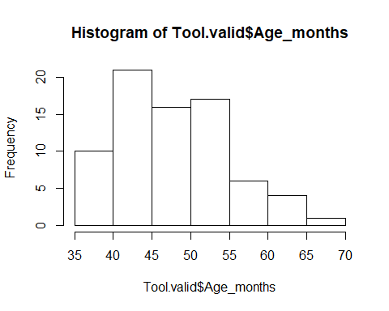

At the beginning of testing, the 75 children were 48.23 (SD = 7.32, range 35-70) months old. There were 1 2-year-old, 35 3-year-olds, 34 4-year-olds, and 5 5-year-olds.

### Age in the middle of testing

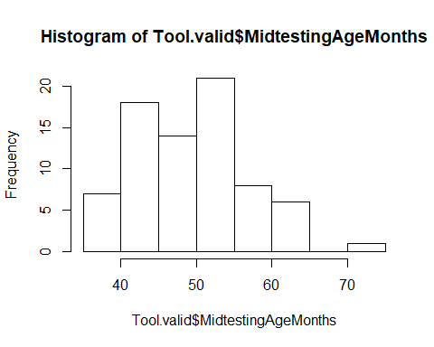

In the middle of testing, the 75 children were 49.84 (SD = 7.34, range 36-72) months old. There were 34 3-year-olds, 33 4-year-olds, 7 5-year-olds, and 1 6-year-old.

### Mediansplit age (based on entire sample)

There were 36 young and 39 old children.

## Testing location

All children were from the Fife area.

# Score

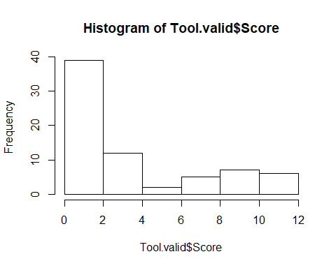

We created scores for all children, including the children with incorrect success, but without those who had incorrect success by blowing out the reward of the tube (as this was difficult to classify). **71 children had a score**: The mean score was 3.98 (SD = 3.48, range 0-12). The variable was highly left-skewed.

## Ordered logistic regression

res <- polr(Score ~ z.age, data = Tool.valid)  
null <- polr(Score ~ 1, data = Tool.valid)

Age does not significantly contribute to model fit, X2(1) = 2.89, p = .089.

# Plot age as continuous variable against score

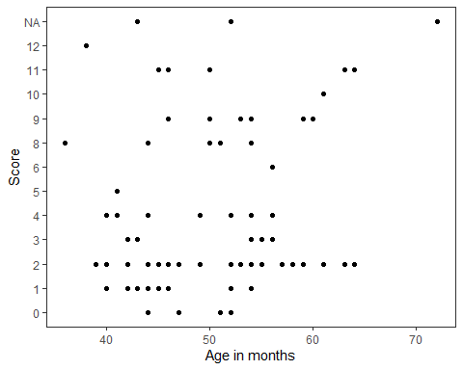

# Success

12 children had incorrect success, 57 children no success and 6 children were successful.

* 3y:
  + No success: 29
  + Success: 3
  + Incorrect success: 2
* 4y:
  + No success: 25
  + Success: 1
  + Incorrect success: 7
* 5y:
  + No success: 3
  + Success: 2
  + Incorrect success: 2
* 6y:
  + Incorrect success: 1

## Sankey Plot:

file:///C:/Users/evare/Dropbox/St%20Andrews%20Postdoc/Analysis%20Testbattery/AdditionalTask_ToolUse/SankeyPlotToolUse.html

**42 children only paid attention to the tube** and never interacted with the tool boxes (but some children pointed to them or explicitly looked at them). Of these 42 children, **39 children remained unsuccessful** (as expected) and **3 children had incorrect success** by blowing the reward out of the tube.

The remaining **33 children paid attention to the tool boxes**.

* **18** of those eventually had **no success**
* **6 children had success**
* **9 children** had **incorrect** success
  + 8 children eventually got the hose with the hand
  + 1 child got the hose with a distractor tool (which was retrieved by hand)

Of these 33 children, 18 children used their hand on the tool boxes; of those, 14 children tried to get a distractor tool first while 4 children immediately tried to reach the hose. The remaining 15 children used the stick on the tool boxes (as intended). 6 of the 15 children had success eventually (see below), while 9 children failed. Of these 9 children, 5 used the stick to get the hose, while 4 children used the stick to get a distractor tool. Of these latter 4 children, 1 child then also tried to get the hose with the stick.

Solution procedures for the children with success:

ID 4:

* **Retrieves rope** with short stick
* Inserts rope in tube
* Tries to get hose with stick but struggles
* **Retrieves long stick** with short stick
* Inserts long stick in tube
* **Gets hose** with short stick and succeeds

ID 93:

* Inserts stick in tube
* Tries to get long stick with hand
* Inserts stick in tube
* **Gets rope** with stick
* Inserts rope in tube
* **Gets long stick** with stick
* Inserts long stick in tube
* **Gets hose** with long stick

ID 89:

* Tries to get hose with hand and stick
* Tries to get long stick with hand
* Tries to get hose with hand
* Tries to reach rope with hand
* **Gets rope** with stick
* Inserts rope in tube
* **Gets long** stick with stick
* Inserts long stick in tube
* **Gets hose** with stick

ID 46:

* Inserts stick in tube
* **Gets long stick** with stick
* Inserts long stick in tube
* **Gets hose** with long stick

ID 35:

* Inserts stick into tube
* Inserts stick in hose box
* Inserts stick into tube
* **Gets hose** with stick

ID 133:

* Inserts stick in tube
* **Gets rope** with stick
* Inserts rope in tube
* **Gets hose** with stick