A: Reproduction and Meiosis
- a) Outline the stages involved in making pollen in the anthers of a strawberry plant. (4)
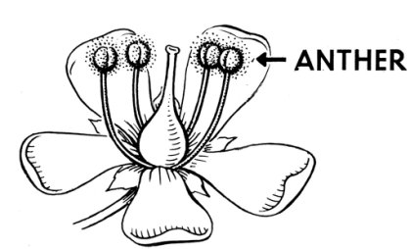
The anther cells divide by meiosis
Copies of the genetic information is made
The cell divides twice
To form four gametes (pollen)
b) The mass of DNA in the nucleus of a pollen cell is 0.25micrograms (µg). (4)
i) What will the mass of DNA be inside the nucleus of an unfertilised egg cell? 0.25 µg
ii) What will the mass of DNA be inside a fertilised cell nucleus? 0.5µg
iii) What will the mass of DNA be inside the nucleus of an anther cell in grams?
0.5 µg = 0.5 x10⁻⁶g
iv) What will the mass of DNA be in an anther cell nucleus prior to cell division? 1 µg or 0.000001g
- a) Why do most organisms have even numbers of chromosomes in their body cells? (2)
Chromosomes are in pairs
Inherited one from each parent
One chromosome of each pair is found in each gamete
Gametes have an odd number of chromosomes so after fertilisation the fertilised cell has an even number.
b) What happens to the chromosomes in the nucleus of an ovary cell when it forms egg cells? (3)
Chromosomes duplicate/double/copied
And separate into four sets/ divide twice
Number halved in the egg cell compared to the ovary cell

- After the sperm and the egg nuclei fuse, the fertilised egg is known as a zygote. The single cell of the zygote divides every 15 hours to form two cells. These cells continue to divide every 15 hours to formm a ball of cells known as the embryo.
Calculate how long it will take in hours from fertilisation to the formation of a ball of 32 cells. (1)
5 x 15 hours = 75 hours in total.
1 cell to 2 cells = 15 hours
2 cells to 4 cells = 30 hours
4 cells to 8 cells = 45 hours
8 cells to 16 cells = 60 hours
16 cells to 32 cells = 75 hours 2 marks for correct final answer
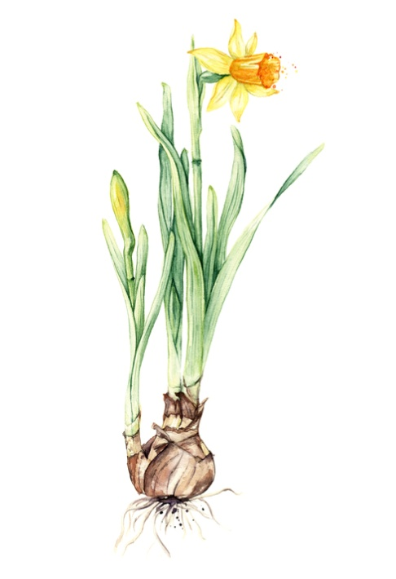
Biology only question

Extended response question:

- Daffodils can reproduce both sexually and asexually.
Flowers produce gametes (pollen and eggs) which create seeds if fertilisation is successful.
A daughter bulb grows from a bud at the base of a parent bulb. This will generate a new plant.
Explain the advantages and disadvantages of sexual and asexual reproduction for the daffodil. (6)
- Level 3 (5-6 marks)
A detailed and coherent explanation is provided that considers a range of relevant points for both the advantages and disadvantages of both types of reproduction.
- Level 2 (3-4 marks)
Most relevant points made which cover both types of reproduction and most advantages and disadvantages written in a logical way.
- Level 1 (1-2 marks)
Some relevant points made with no logical structure.
Indicative content
Advantages of sexual reproduction
- Introduces variation into the population
- The species can adapt to new environments
- A disease is less likely to affect all individuals in a population
Disadvantages of sexual reproduction
- Not possible for a single isolated plant
- Relies on insects to transfer the pollen from one plant to another via insects
Advantages of asexual reproduction
  - Population increases rapidly
  - Can exploit a habitat quickly
  - Only one plant is needed
  - All new plants have same characteristics as parent plant
Disadvantages of asexual reproduction
- No variation
- Species may only be adapted to survive in one habitat
- Disease may affect all the plants in a population as they are all genetically identical

B: Genetic inheritance, inherited disorders and sex determination
- Hitch hiker’s thumb is a genetically inherited condition caused by a dominant allele, T. 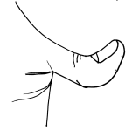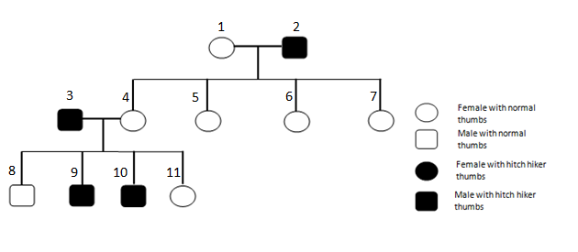
.

- What is the genotype of person 1? tt or homozygous recessive
- What is the phenotype of person 4 in relation to gender and thumb type? (1) Female and normal thumbs
- Describe the genotype of parents 3 and 4. (1)
Genotype of parent 3 is heterozygous;
because if 3 was homozygous dominant for hitch hikers thumb;
all the offspring would inherit a dominant allele and possess hitch hikers thumb.
Person 4 is homozygous recessive;
because we are told they do not possess a dominant allele and do not have hitch hikers thumb.

- Explain how their offspring 9 and 10 have inherited hitch hiker thumbs, yet 8 and 11 have not. Complete the Punnett square diagram to show the possible offspring if 3 and 4 mated. (6)

Person 4
 | t | t
T  Person 3 | Tt | Tt
t | tt | tt

The Punnett square shows there is a 1 in 2 (50:50 or 50%) possibility of parents 3 and 4 having a child with hitch hikers thumb or having normal thumbs.
In the family tree this is what occurred.

- Mary has a genetic condition called cystic fibrosis which is a disorder of cell membranes. Mary is homozygous recessive for the condition. Her sister is heterozygous and is healthy.
She and her husband John want to have children in the future. John is healthy but he does not want to know his genotype. Explain why it would be helpful for John’s genotype to be known. (3)

Cystic fibrosis is caused by inheritance of a recessive allele from both parents. (1)
If John is a carrier: (1)
then there is a 1 in 4 chance (25%) of a child inheriting two recessive alleles/ cystic fibrosis.
Embryo screening could be carried out in the womb to see if the embryo had cystic fibrosis and a decision could be made to terminate the pregnancy at that point.
If John is not a carrier: (1)
there is 0% chance of their child having cystic fibrosis.
There is a 100% chance of their children becoming carriers and by knowing this the offspring can be warned later in life that they are carriers.

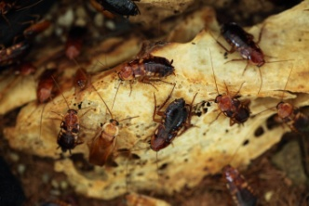
- Male cockroaches only have one sex chromosome.
Their genotype is XO where O means there is no chromosome present.
Female cockroaches have the genotype XX

Complete the genetic diagram to show the possible genotypes and phenotypes of the offspring from two cockroaches. One has been done for you. (5)

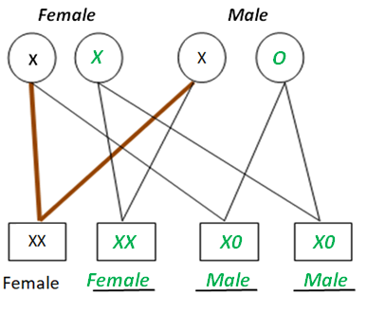
C: DNA and protein synthesis
1 a) Complete the diagram of a DNA molecule by adding in the correct complementary bases. (3)
3 marks for all correct
2 marks for 1 error only
1 mark for 2 errors
0 marks for more than 2 errors.

G | A | A | G | C | T | A | C | G | T
C | T | T | C | G | A | T | G | C | A
b) Annotate the diagram of the DNA polymer below with the following 4 labels: (4)
base common sugar phosphate group nucleotide
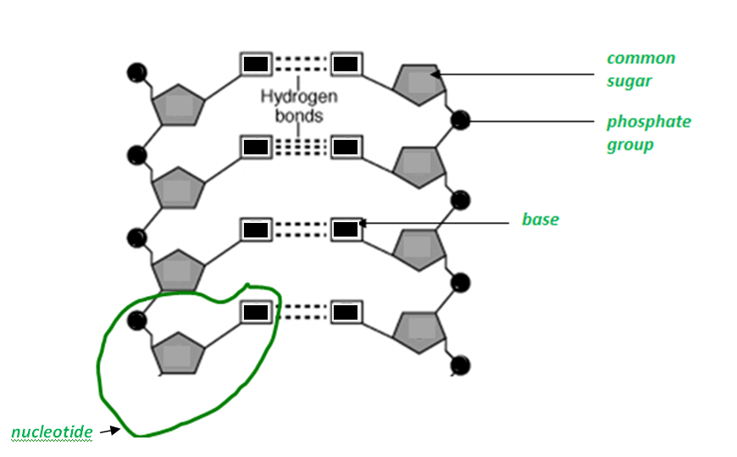

c) Explain why DNA is described as a polymer. (2)
Two of:
Made up or repeating units/monomers
called nucleotides
which consist of phosphate, sugar and a base
Biology Only Question
Extended response question
- Mutations occur continuously and on rare occasions some mutations result in an altered protein with a different shape being produced.
The mutation which results in cystic fibrosis results in bases being deleted.

Normal sequence of nucleotides:
A T C A T C T T T G G T G T T
Mutated sequence of nucleotides:
A T C A T T G G T G T T

In people without cystic fibrosis, the protein made functions as a channel across the membranes of cells which produce mucus. Chloride ions pass in and out of cells through this channel and aid the movement of water which is required to produce thin freely flowing mucus. This protein channel does not function in cystic fibrosis due to the changed shape of the protein produced.
- Explain how this mutation would result in an altered protein being made which does not fold properly and so does not function. (6)
- Level 3 (5-6 marks)
A detailed and coherent explanation of how the missing bases affect the protein made and its function.
- Level 2 (3-4 marks)
Most relevant points made and written in a logical way.
- Level 1 (1-2 marks)
Some relevant points made with no logical structure.
Indicative content
Three bases have been deleted (CTT)
A sequence of three bases codes for a particular amino acid
The order of the bases controls the order in which amino acids are assembled to produce a particular protein
An amino acid is missing from the protein chain
changing its shape so it will not fold properly
A differently shaped protein will not form the channel needed to make thin mucus

- If there was genetic variation in the non coding part of a gene, how could this affect the phenotype? (3)
Mutation in the non coding part of the DNA may affect the ability of the RNA polymerase to bind to it.
This can affect how much mRNA is transcribed
and this can affect how much protein is made.
The phenotype may be affected by how much protein is produced.
D: Variation, mutation and the human genome project
- Sweet potato plants produce tubers.
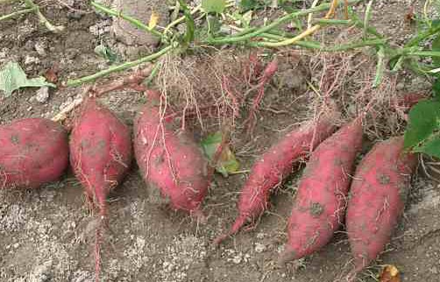
Tuber of sweet potato
A gardener uses some of the tubers for food and some to produce sweet potato plants.
The tubers are produced by asexual reproduction.
The gardener plants the tubers in different parts of the garden. She noticed that the plants did not all grow to become the same height despite having the same genome. Suggest two reasons why this has happened. (2)
Not all tubers are getting the same amount of water
Or the same amount of minerals
Or the same amount of light
They may be competing with other plants for space
Environmental variation

- These trees are all the same species.
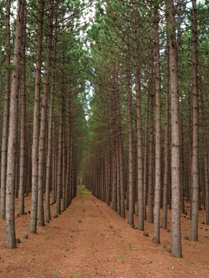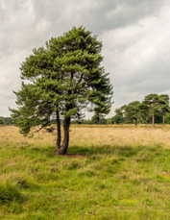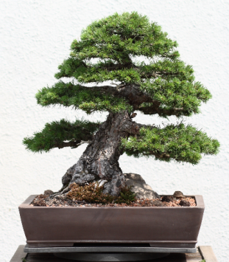
Scots Pine bonsai tree
Scots Pine plantation
Scots Pine in a field
25m
300mm
35m

- Convert the height of the bonsai tree into metres. (1)
300mm = 0.3m
- What is the simplest ratio of height between the plantation tree and the field tree? (2)
35:25 simplified
35/5 = 7
25/5 = 5
Ratio is 7:5
- What is the major cause of variation between these trees? (1)
Environmental
Competition for a named factor
- If the Bonsai tree was planted outside in a field would it grow larger? Explain your answer. (2)
Yes
The environmental factor restricting growth would be removed
The Bonsai tree has the genotype to be able to grow large

- The lake in the picture was home to a large population of fish of the same species. Over a long period of time, the lake reduced in size and formed two smaller lakes.
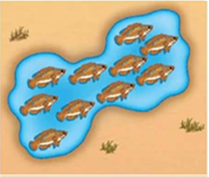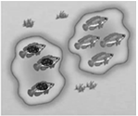
In the winter of 2013 there was a lot of rainfall and the two lakes merged back into one.
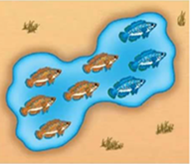
Fishermen noticed that there seemed to be two different phenotypes of fish in the lake. Scientists found that two new species had been formed.
Explain how this has occurred. (5)
Isolation has occurred and formed two populations of fish
Mutations occur continuously
Because the two populations were not interbreeding the new alleles resulting from mutations were not being mixed.
There would be environmental differences in the two lakes over time which can cause variation
When the two lakes formed one lake again, the two fish were so genetically different they could not breed and produce fertile offspring
Two new species have formed

- a) Suggest two ways in which the Human Genome Project (HGP) may improve the medical care for the future. (2)

It will allow increased/improved use of gene therapy
Target drug treatment to reduce symptoms or delay onset of disorders
Enable people to be more informed and make lifestyle choices

- Suggest two ways in which the HGP may have a negative effect on people. (2)
It could be used to refuse insurance cover for individuals who possess certain genotypes
It could make it more difficult to find employment if a potential employer is aware of an employee’s genotype
Knowing that something may occur may increase peoples stress
May feel under pressure not to have children or terminate pregnancies
Ethical concerns regarding ownership of data and right to access it
Lead to more people wanting gene therapy and increased cost to NHS

