A. Genetics – Part 1
- What is a gamete?
- Name the male and female gametes in a) a human b) a daisy plant
- For each row, tick one box to show which method of cell division is correct.
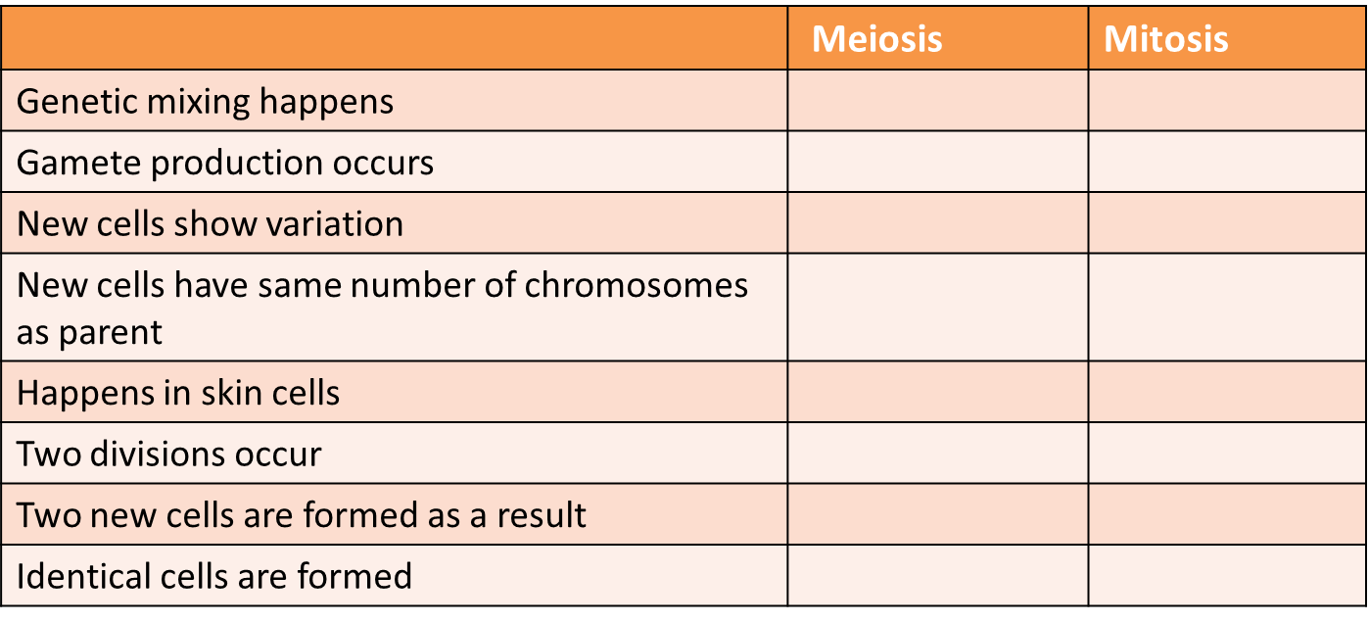
- What occurs at the point of fertilisation in humans?
- How many chromosomes are found in the nucleus of a human:
  - ovary cell ?
  - egg cell ?
  - embryo cell ?
  - a cell just after fertilisation has occurred?
  - a testes cell ?
- What happens to the DNA just before the first meiotic division?
- What does the term ‘haploid’ mean?
Biology only
- What are three advantages of sexual reproduction?
- What are three advantages of asexual reproduction?
- List three organisms which use both sexual and asexual reproduction methods.
- Describe a disadvantage to an organism of i) using sexual reproduction and ii) asexual reproduction. List three organisms which reproduce using both sexual and asexual reproduction methods.
B. Genetics – Part 2 BIOLOGY ONLY
- What is the definition of a polymer?
- Name the shape which best describes the DNA polymer.
- How is DNA organised inside the cell nucleus?
- Which is larger, a chromosome or a gene?
- What does a gene code for?
- Where would you find a nucleotide?
- What does a nucleotide consist of?
- What are the symbols of the 4 bases found in DNA?
- What does the code for an amino acid consist of?

- Fill in the missing terms:
The long strands of DNA are made of alternating _____ and ______ sections. Attached to each ______ is one of the four bases.
The DNA polymer is made up of repeating ____________ units. The strands of DNA are held together by _____________ _________.
- What is the purpose of adding detergent to fruit when trying to extract its DNA?
Higher Tier biology only
- In the complementary strands of DNA – which base is T always linked to?
- What type of molecule is RNA polymerase?
- What is the role of RNA polymerase?
- Which organelle in the cytoplasm carries out protein synthesis?
- What do carrier molecules bring to this organelle from the cytoplasm?
- What is this carrier molecule called?
- Describe a codon.
- What happens in protein synthesis once the protein chain is complete?
- What happens if a mutation codes for a slightly altered enzyme protein with a different shape?
- What can the non-coding parts of DNA do?

C. Genetics – Part 3
- Complete the sentences below using one of the following words:
genotype phenotype homozygous gamete chromosome
The same alleles for a particular characteristic are described as ..........................
Mice fur can be described by its colour. This is known as the ...............................
The alleles for a particular characteristic determine its ........................................
The pollen of a rose plant can also be described as a male ..................................
- What are the different forms of a gene called?
- Why is it easy to describe an organisms phenotype for a particular characteristic but very difficult to state the genotype?
- List the alternative ways of describing the following outcome of a genetic cross:
3 in every 4 crosses will have black fur.
- If two heterozygous tall plants were crossed 75 times, what proportion of the offspring would you expect to be short?
- What is polydactyly and is it caused by inheriting a recessive or dominant allele?
- Look at the following picture of a person’s chromosomes.
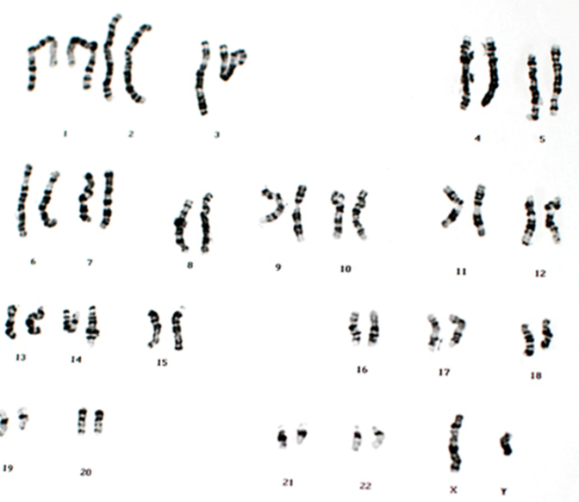
- How many chromosomes does this person have in a normal body cell?
- What sex is the person and how do you know?

- Black fur is dominant to brown fur in mice. Use B to represent black fur and b to represent brown fur.
  - Complete the Punnett square diagram to show the outcome of a genetic cross between two heterozygous mice.

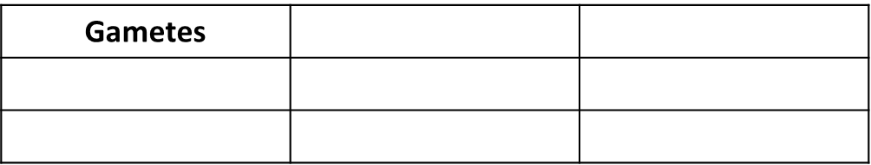

  - What is the phenotype of the parent mice?
  - What are the chances of a homozygous recessive mouse being born to two heterozygous mice?

- What is meant by the term zygote?
- The family tree shows the inheritance of cystic fibrosis (CF). Cystic fibrosis is a condition caused by a recessive allele. Let F = healthy allele and f = CF allele

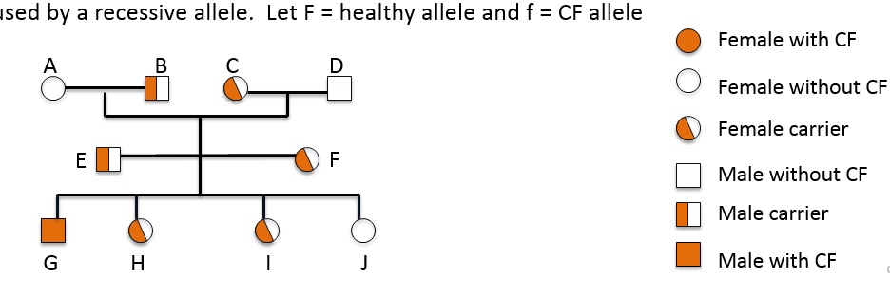

  - What is the genotype of a female carrier?
  - Explain why person G inherited cystic fibrosis.
  - Explain why person J did not inherit cystic fibrosis.
  - What is the probability of a fifth child having cystic fibrosis?
  - Many people feel opposed to the screening of embryos to identify the CF allele. Suggest two reasons why they may feel this way.

D. Genetics – Part 4
- Write down the definition of the genome of a horse.
- List two reasons why it is important to understand more about the human genome.
- What can bring about genetic variation in a species?
- What is meant by ‘an acquired characteristic’?
- What is the chance of most genetic mutations having an effect on the phenotype? High, Medium or Low
- What is meant by discontinuous variation?

