**The Set Game**

**How to open the game:**

Double click on “SetGame.exe”.

**Game Rule:**

***Successfully forming a set will earn 20 score. A missing check will lose 5 score. Negative score is allowed.***

***A 'Set' consists of three cards in which each feature is EITHER the same on each card OR is different on each card. That is to say, any feature in the 'Set' of three cards is either common to all three cards or is different on each card.***

A card has four features:

*(A) COLOR:*

Each card is red, blue, green.

*(B) SHAPE*

Each card contains circle, triangle, square.

*(C) NUMBER:*

Each card has one, two, or three symbols.

*(D) FILLING*

Each card is solid, shaded, clear.

**Examples:**

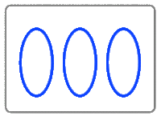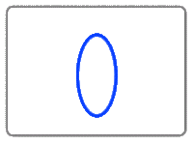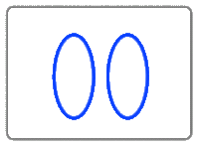

**Set:** They are all circle, all clear, all blue, different number.

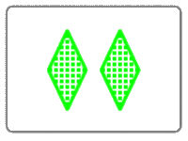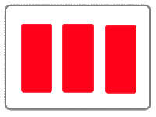

**Set:** They are different colors, different shape, different filling, different number.

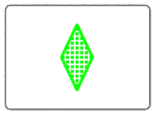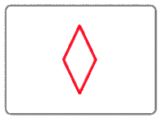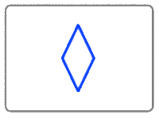

**Not A Set:** They are different colors, all one, all triangle, but 2 clear and one shaded.

-------------------------**Buttons and Messages**----------------------------------

**“hint”** button can only be clicked on 3 times to get a hint each game.

**“Home**” button returns to Home without showing score.

**“Click to Restart the Game”** button directly refreshes the display board and clear the record without showing the final score.

**“Give Up”** button returns to Home and shows final score.

“Yellow” Message indicates the display board is refreshed because no set can be formed currently

“Green” Message indicates the submitted cards are a set.

“Red” Message indicates the submitted cards are not a set.

**How to close the game:**

Click on the “X” on the top right corner