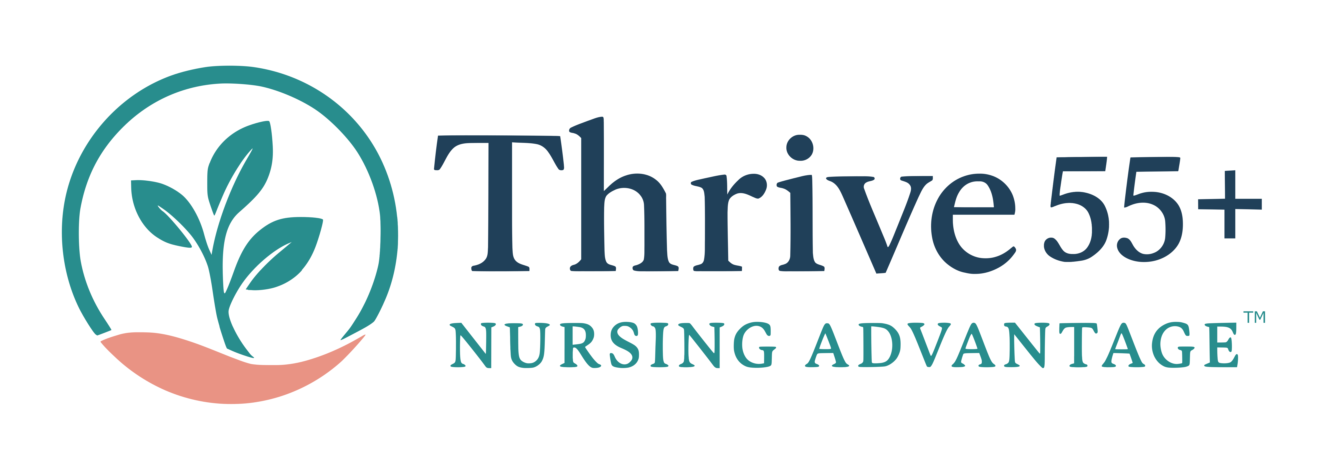
Topic Video Curriculum Map
Titles · Big Ideas · Learning Objectives
The Thrive 55+ Career Direction Program — 15 short lessons across 6 weeks
Prepared for Melissa Tully · July 2026

How to read this map
Each weekly lesson is broken into a few short topic videos (micro-lessons) so they’re easier to record, easier to re-shoot, and easier for learners to watch in one sitting. Fifteen videos total. For every video you get three things, in the vocabulary of backward design:
Title — the hook a learner sees in the player. Written to be plain, warm, and specific.
Big idea — the enduring understanding you want the learner to still hold months later (Wiggins & McTighe’s “understanding by design”). One sentence, one video.
Learning objectives — observable, measurable outcomes stated as “learners will be able to…” with action verbs (identify, distinguish, score, compare, select). These are what a learner does — and what a mission or workbook page can check.

Objectives intentionally map to the weekly mission and workbook page, so the Learn → Do → Share loop stays tight: the video sets the objective, the mission is where the learner demonstrates it, the cohort is where they share it.
Note on granularity: if you’d rather shoot one longer video per week, each week’s topic videos combine cleanly in order — the objectives and big ideas still hold. Week 5 (Financial) is drafted from the handoff and marked where it needs Alyson’s content.

Week 0 · Orientation
Meet the cohort, see the whole map, set an intention.
V0.1 You’re Not Done — Start Here ~5 min
Big idea Career direction is not one decision made in a panic; it is a method you can learn, repeat, and walk with a cohort beside you.
Learners will be able to:
- Describe the three parts of the Career Direction Method™ — name the strain, capture your value, investigate your options — and how the six weeks map to them.
- Locate the workbook, the cohort space, and the weekly Learn → Do → Share loop.
- Write one intention for what they want to leave the program with.
Connects to: Workbook p.1–2 · Orientation post in the cohort feed.

Week 1 · Name the Strain
Phase 1 — read the work before you read the job board.
V1.1 Read the Work Before You Read the Job Board ~5 min
Big idea A career change does not start with a job title; it starts with understanding what the current work is asking of your body, attention, and capacity to adapt.
Learners will be able to:
- Explain why career direction begins with strain rather than with job titles.
- Distinguish “I still love nursing” from “this version of the work is sustainable for me.”
Connects to: Workbook p.2 (The Starting Point).
V1.2 The Three Loads — Body, Interruption, Change ~7 min
Big idea Strain is not weakness or lost competence — it is information, and it arrives in three distinct forms you can name.
Learners will be able to:
- Define body load, interruption load, and change load, and give one example of each from their own shifts.
- Sort their current stressors into the three loads.
Connects to: Workbook p.4–5 (Body / Interruption / Change load).
V1.3 Score It, Don’t Panic ~6 min
Big idea Your highest strain score does not tell you to quit — it tells you where to look first.
Learners will be able to:
- Rate each of the three loads on the 1–10 scale using the scoring guide.
- Interpret their highest score to name what the next role most needs to reduce.
- Reframe one strain from a fear into a piece of information.
Connects to: Workbook p.3–6 · Week 1 mission (score your three areas).

Week 2 · Capture Your Value
Phase 2 — name what you bring, without shame.
V2.1 Tell the Truth Without the Shame ~5 min
Big idea Naming what is getting harder is honest data, not a personal failing — and it must be kept separate from self-judgment.
Learners will be able to:
- Name what is getting harder in their current role using non-punishing language.
- Differentiate an honest limitation from shame-based self-talk.
Connects to: Workbook p.6 (What is getting harder).
V2.2 Your Ordinary Isn’t Ordinary ~8 min
Big idea The skills experienced nurses dismiss as “just the job” are hard-won, human, and exactly the ones automation cannot replace.
Learners will be able to:
- Identify at least five professional strengths built through years of nursing experience.
- Explain why judgment-and-relationship skills keep their value across different roles.
- Select one strength to carry into the next role.
Connects to: Workbook p.7 (What do I still do well) · Week 2 mission (five strengths).

Weeks 3–4 · Investigate Your Options
Phase 3 — reconnaissance: study, ask, compare. Spread across two weeks.
V3.1 Reconnaissance Turns Fear Into Information ~5 min
Big idea Investigating options is not choosing a job today — it is gathering information so that fear stops making the decision for you.
Learners will be able to:
- Explain the purpose of reconnaissance versus applying for jobs.
- Reframe two personal career fears as questions that can be investigated.
Connects to: Workbook p.7–8 (Options intro).
V3.2 Study the Work — Read Postings Like a Detective ~7 min
Big idea A job posting hides its real demands in one small paragraph; learning to read for it turns browsing into intelligence-gathering.
Learners will be able to:
- Set up job alerts and collect postings without applying.
- Extract the required skills, software, schedule, and physical demands from a posting.
- Locate the paragraph that describes what the person actually does all day.
Connects to: Workbook p.8–9 (Study the Work).
V3.3 Ask Three People This Week ~6 min
Big idea Three short conversations reveal what no posting can — and most people are glad to be asked.
Learners will be able to:
- Identify three approachable people who know a role or setting of interest.
- Use the five reconnaissance questions to learn what a role is really like day to day.
- Ask “who else would be useful for me to talk to?” to open the next door.
Connects to: Workbook p.9 (Talk to Three People).
V3.4 Compare and Re-Score ~5 min
Big idea Better information changes the picture — a role you feared may open up, and a role that sounded easy may reveal red flags.
Learners will be able to:
- Compare a researched role against their strain, value, income, and time needs.
- Re-score one strain area using new information and explain what changed.
Connects to: Workbook p.10 (Compare What You Learn).
V3.5 Role Categories, Red Flags, and Skill Gaps ~8 min
Big idea Categories are starting points, not answers; a red flag means look closer, and “I haven’t done this lately” is not “I can’t learn this.”
Learners will be able to:
- Name several nursing and nursing-adjacent role categories worth exploring.
- Evaluate a role’s tradeoffs against their highest strain.
- Distinguish a genuine stop sign from a skill gap that can be rebuilt with time and practice.
Connects to: Workbook p.10–13 · Weeks 3–4 missions (alerts, five postings, three conversations, tracker).

Week 5 · Financial Readiness
Phase 4 — with Alyson. Draft objectives — to be finalized from Alyson’s script/workbook.
V5.1 Why Career and Money Belong Together ~5 min
Big idea A career decision is also a financial decision; readiness on both sides is what makes a change feel safe rather than reckless.
Learners will be able to:
- Explain why income, benefits, savings, and retirement timing belong in the same conversation as career direction.
- Identify the financial information to gather before making a change.
Connects to: Workbook p.15 (Career-to-Financial Handoff).
V5.2 What to Gather — Income, Benefits, and Timing ~7 min (draft)
Big idea You cannot weigh a new role honestly until you know your real number and how quickly a new role must produce income.
Learners will be able to:
- Determine current income and the minimum income the next role must support.
- Inventory the core and additional benefits a change would affect.
- Estimate how quickly a new role needs to produce dependable income.
Connects to: Workbook p.15 · NEEDS Alyson’s content to finalize wording and scope.

Week 6 · Your Direction
Phase 5 — commit to one step and close with the cohort.
V6.1 Choose One Informed Step ~5 min
Big idea You do not have to solve your whole career today; direction begins with a single, specific, informed step.
Learners will be able to:
- Select one concrete next step from the method (score, alert, five postings, one conversation, five strengths, start a tracker).
- Commit to when they will take it and what they expect to learn.
Connects to: Workbook p.16 (Your Next Informed Step).
V6.2 Name the Strain. Capture Your Value. Investigate Your Options. ~6 min
Big idea The method is repeatable — you now own a way to turn dread into information and information into your next step, for this decision and the next one.
Learners will be able to:
- Summarize their personal method: highest strain, value to carry forward, direction to investigate, and next step.
- Share their committed step with the cohort and name their ongoing support.
Connects to: Workbook p.16–17 · Week 6 mission (commit + share).

At a glance — all 15 videos
Code | Title | Week | Length
V0.1 | You’re Not Done — Start Here | Week 0 | ~5 min
V1.1 | Read the Work Before You Read the Job Board | Week 1 | ~5 min
V1.2 | The Three Loads — Body, Interruption, Change | Week 1 | ~7 min
V1.3 | Score It, Don’t Panic | Week 1 | ~6 min
V2.1 | Tell the Truth Without the Shame | Week 2 | ~5 min
V2.2 | Your Ordinary Isn’t Ordinary | Week 2 | ~8 min
V3.1 | Reconnaissance Turns Fear Into Information | Weeks 3–4 | ~5 min
V3.2 | Study the Work — Read Postings Like a Detective | Weeks 3–4 | ~7 min
V3.3 | Ask Three People This Week | Weeks 3–4 | ~6 min
V3.4 | Compare and Re-Score | Weeks 3–4 | ~5 min
V3.5 | Role Categories, Red Flags, and Skill Gaps | Weeks 3–4 | ~8 min
V5.1 | Why Career and Money Belong Together | Week 5 | ~5 min
V5.2 | What to Gather — Income, Benefits, and Timing | Week 5 | ~7 min (draft)
V6.1 | Choose One Informed Step | Week 6 | ~5 min
V6.2 | Name the Strain. Capture Your Value. Investigate Your Options. | Week 6 | ~6 min

Total run time is roughly 90 minutes of video across the six weeks — delivered as 15 short lessons, never more than about eight minutes each.

