PE01 Amazon Rekognition Custom Labels Demo

AI620 Fall 2024 by Verónica Elze

# 1. Task 1 Complete Amazon Rekognition Custom Labels Demo

4. Specify Stack Details

9. Launch CloudFormation

10. Output URL

# Task 2 Try Pictures for Classification

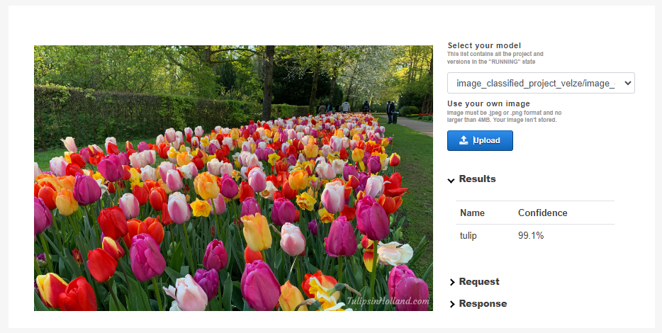

My experience using Amazon Rekognition was mostly positive, though there were a few challenges. The setup of Rekognition itself was smooth and well-documented, making it easy to deploy the model. However, the CloudFormation setup presented some confusion, particularly towards the end, where the instructions and interface buttons didn’t always align with what was expected. This mismatch slowed the process slightly and required some troubleshooting.

Regarding the model's performance, I found it difficult to interpret how it classified images. The results were inconsistent when testing various pictures, and it wasn’t clear why certain classifications were made. A more detailed explanation of how the model arrives at its conclusions would have helped me understand its decision-making process better. Overall, while getting started with Amazon Rekognition was straightforward, clearer guidance on CloudFormation and model interpretation would improve the user experience.