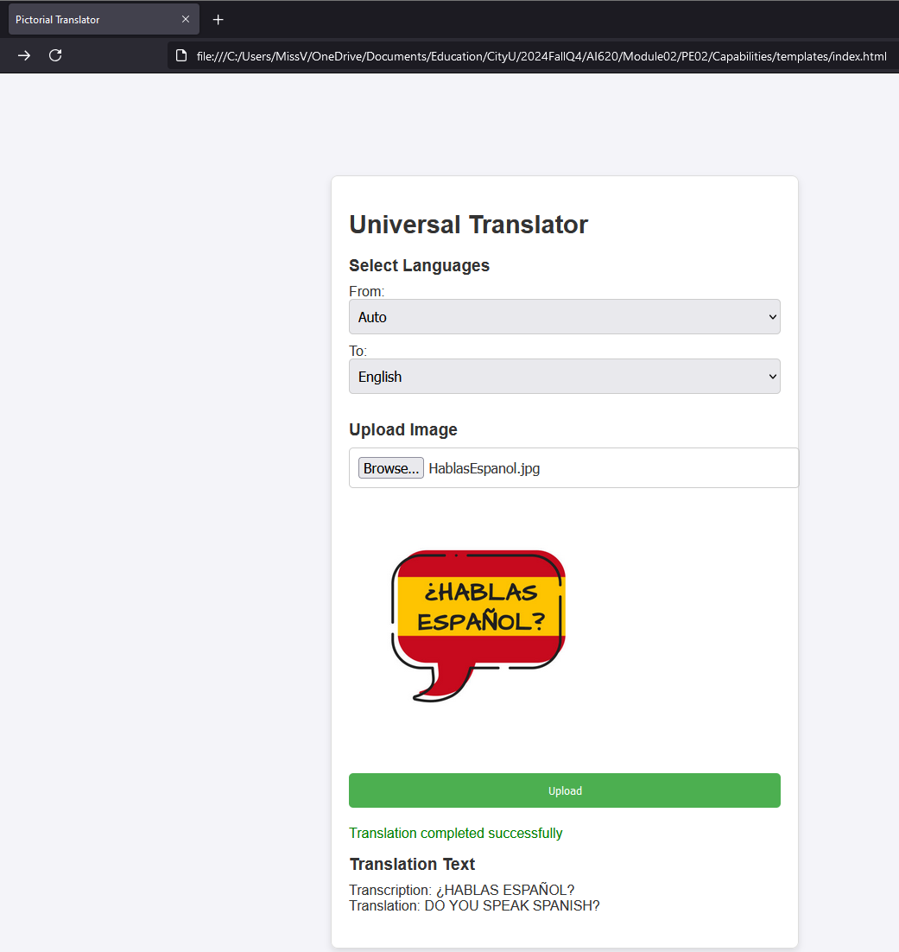PE02 Pictorial Translator Application

AI620 Fall 2024 by Verónica Elze

## Step PE02-01 Setting up the project structure

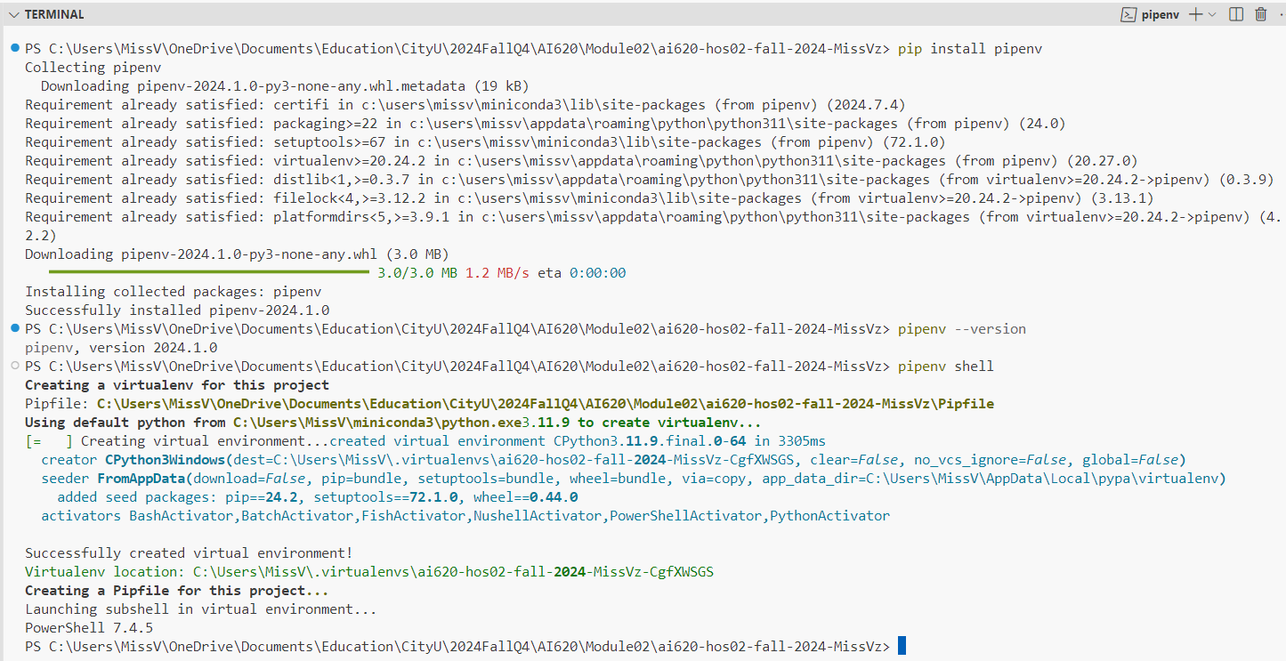

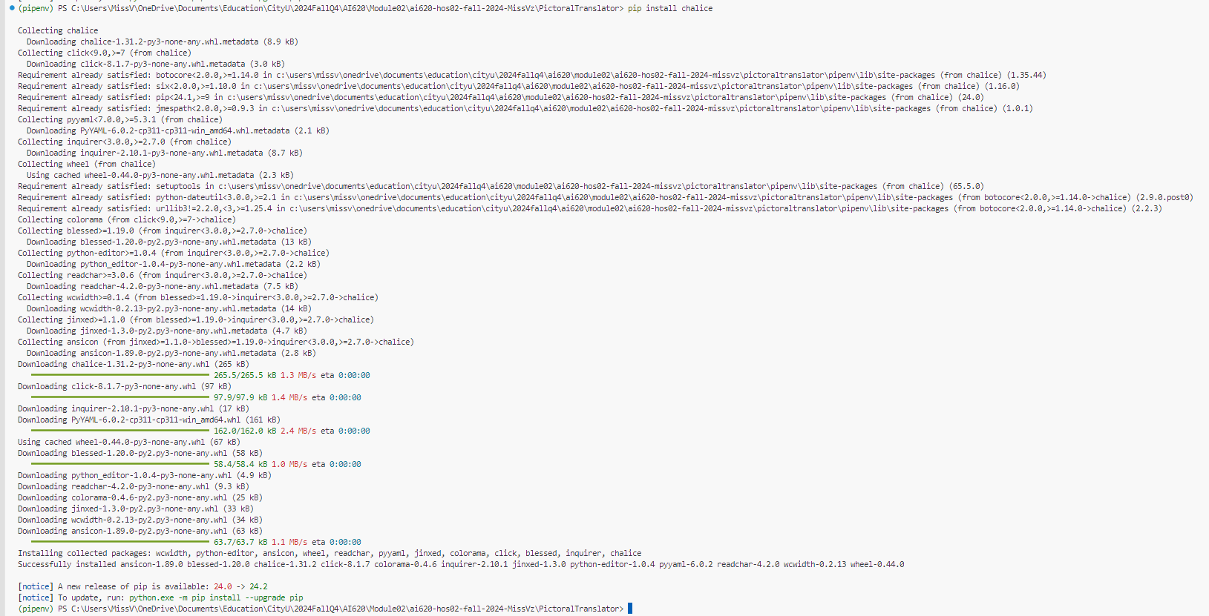

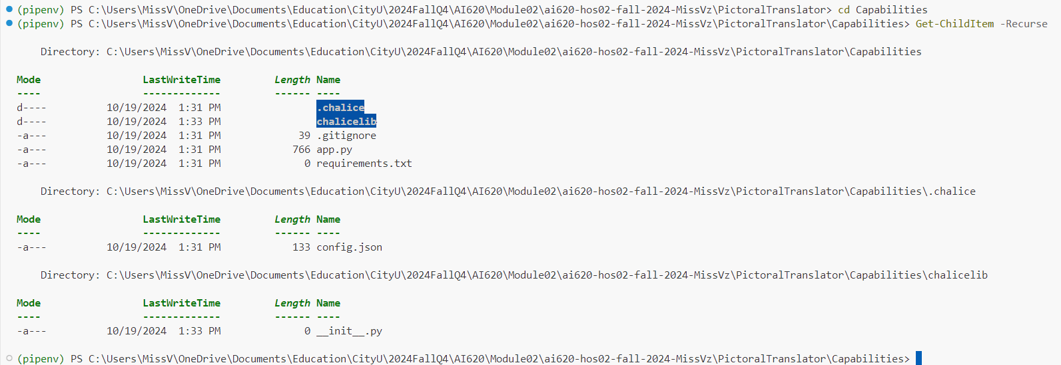

Good thing I checked each folder structure, because I found a file I missed—kind of like discovering you forgot your wallet, but way less embarrassing!

I also noticed that the last two files are missing in the HOS instructions' illustrated file structure. Here is what ChatGPT has to say about their relation. According to ChatGPT, they’re responsible for managing project dependencies—kind of like the people who actually show up to group meetings and keep everything from falling apart!

## Steps PE02-2 Implement services

### PE02-2.1 Recoknition service – text detection

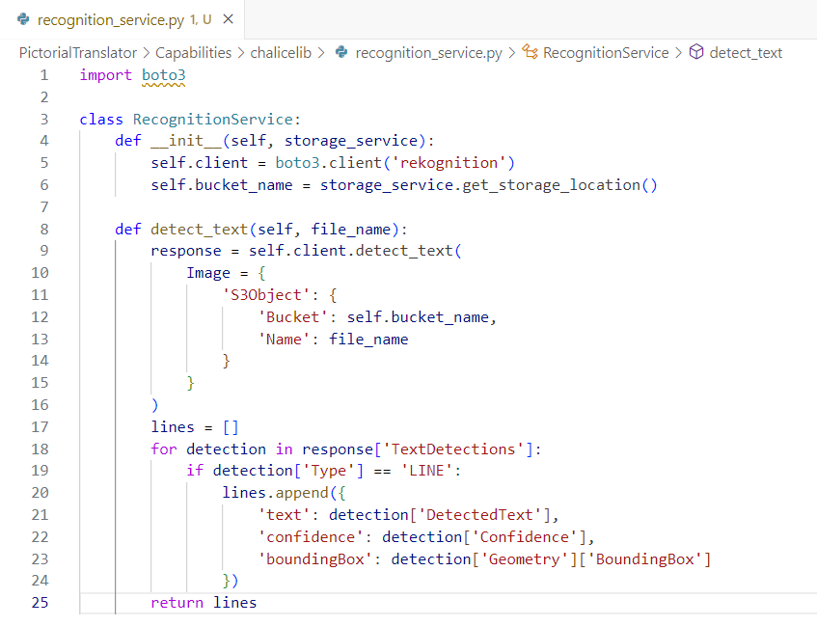

### PE02-2.2 Translation service – translating text

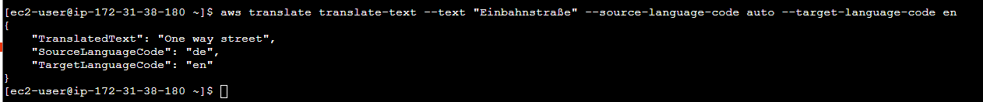

### PE02-2.3 Storage service – uploading files

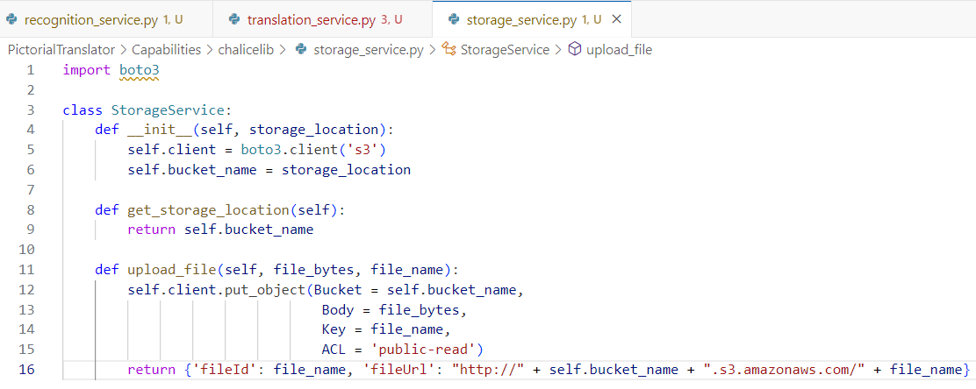

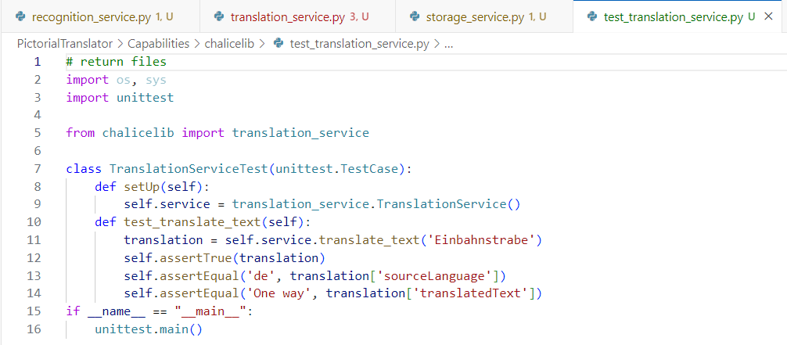

## PE02-3 Implement RESTful endpoints

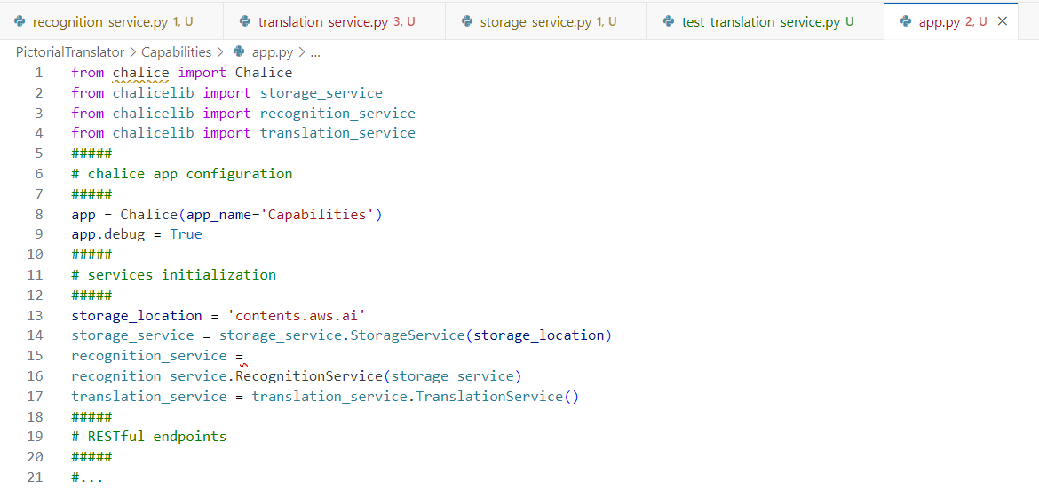

### PE02-3.1 Translate the image text endpoint

### PE02-3.2 Upload the image endpoint

#### Early attempt

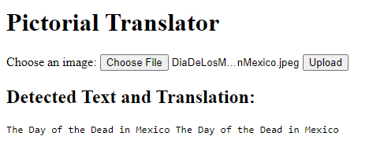

#### Later attempt

 

## PE02-5 Deploying the Pictorial Translator to AWS

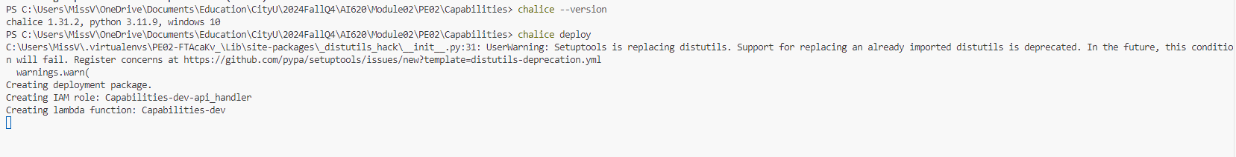

Resources deployed:

- Lambda ARN: arn:aws:lambda:us-west-2:850995577816:function:Capabilities-dev

- Rest API URL: <https://f37dcreay4.execute-api.us-west-2.amazonaws.com/api/>



