HOS02A Pictorial Translator Application

AI620 Fall 2024 by Verónica Elze

## Steps 7 & 8

## Steps 9, 10 & 11

Step 12 for OSX is Not Applicable

## Step 13a

## Step 13b

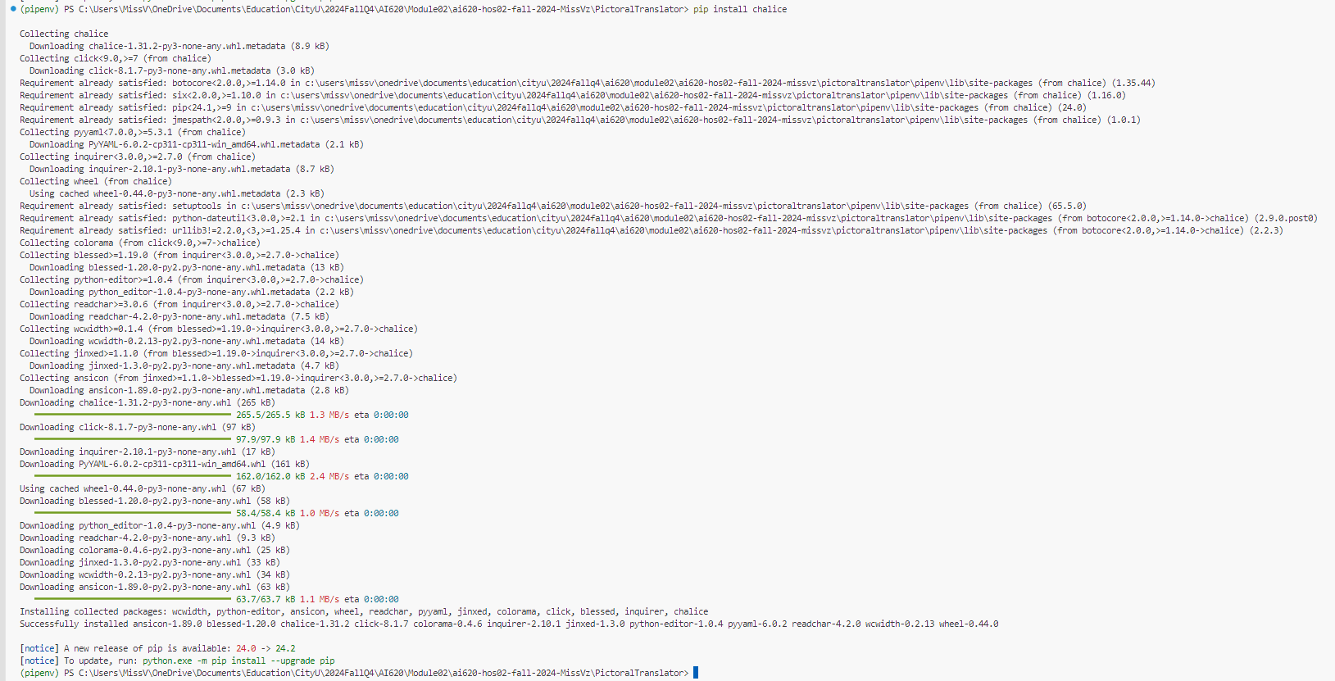

## Steps 14 & 15

After those two steps, I attempted to show the directory structure, but it was so long that my Chalice command lines got lost in the abyss. Pretty sure they’re still scrolling through the matrix somewhere!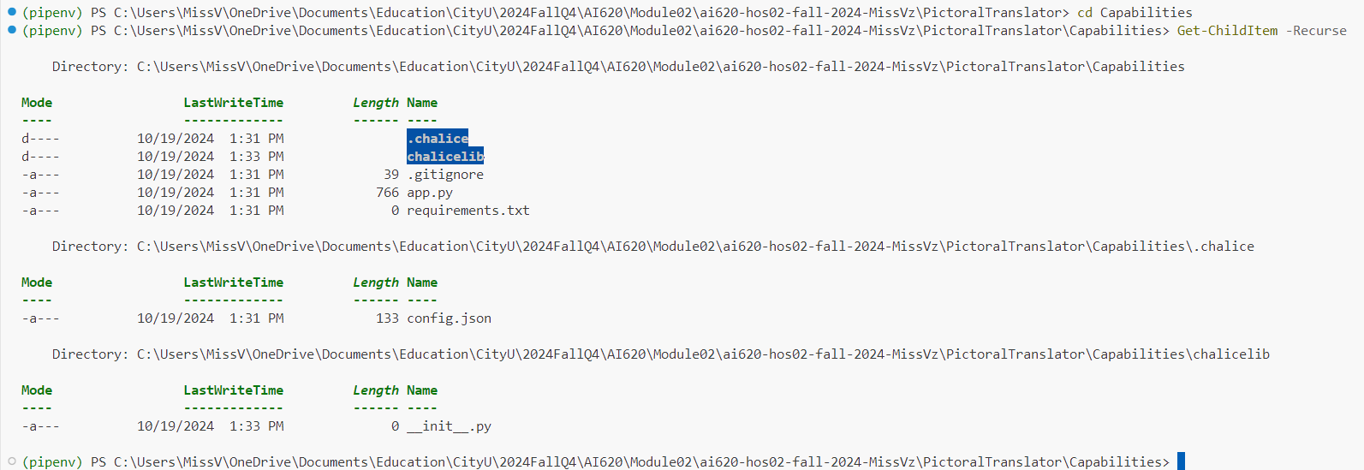

Good thing I checked each folder structure, because I found a file I missed—kind of like discovering you forgot your wallet, but way less embarrassing!

I also noticed that the last two files are missing in the HOS instructions' illustrated file structure. Here is what ChatGPT has to say about their relation. According to ChatGPT, they’re responsible for managing project dependencies—kind of like the people who actually show up to group meetings and keep everything from falling apart!

## Steps 16, 17 & 18



## Step 30

## Steps 31-40

## Steps 41-46

## Step 47

