**PE03: Programming Exercise**

**Instruction**

**Universal Translator Application**

Closely follow the textbook chapter 4 and Lecture 03.pptx to implement Universal Translator application:

* PE03-1
  + Setting up the project structure
    - Follow textbook page127 step 1 to 6
* 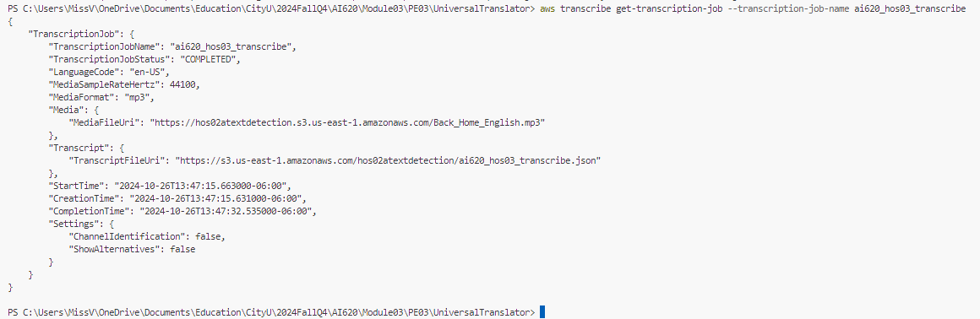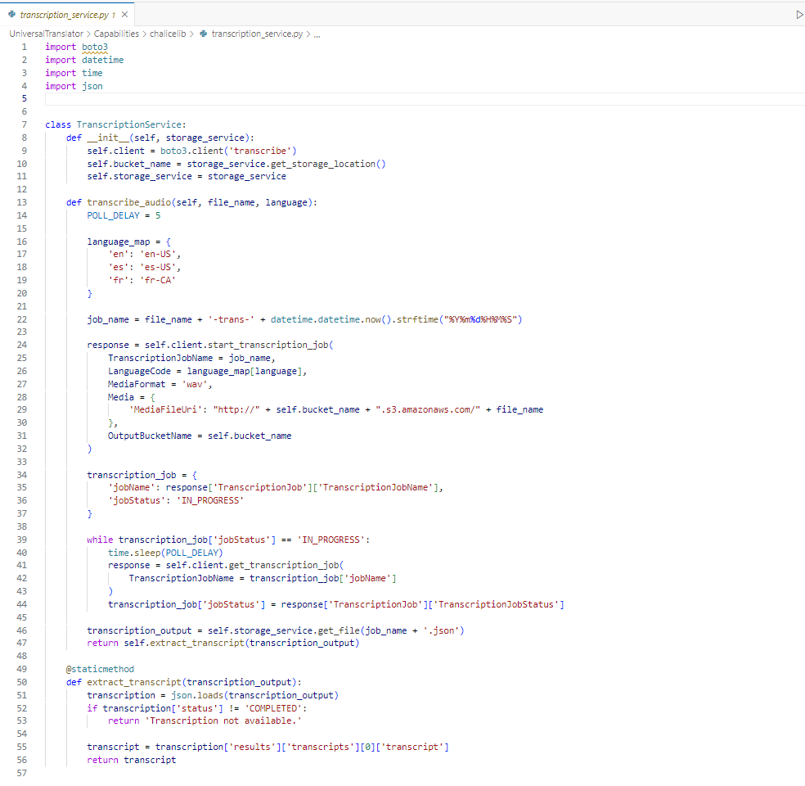PE03-2 Implement services
  + 2.1 Transcription service – speech-to-text
  + 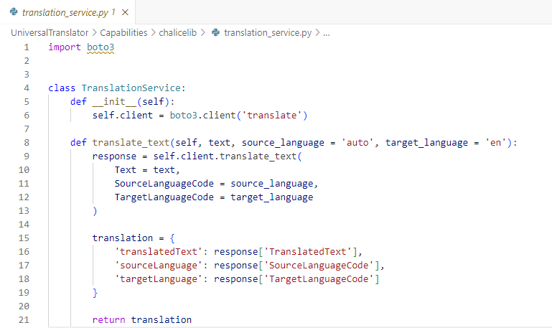2.2 Translation service – translating text (Same as PE02)
  + 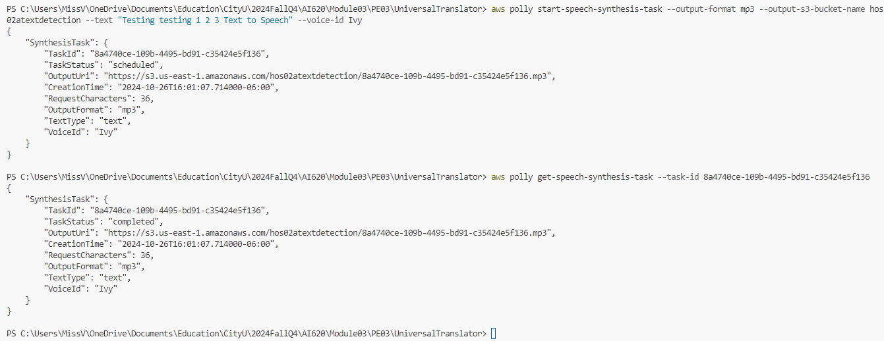2.3 [**Optional**] Speech service – text-to-speech
  + 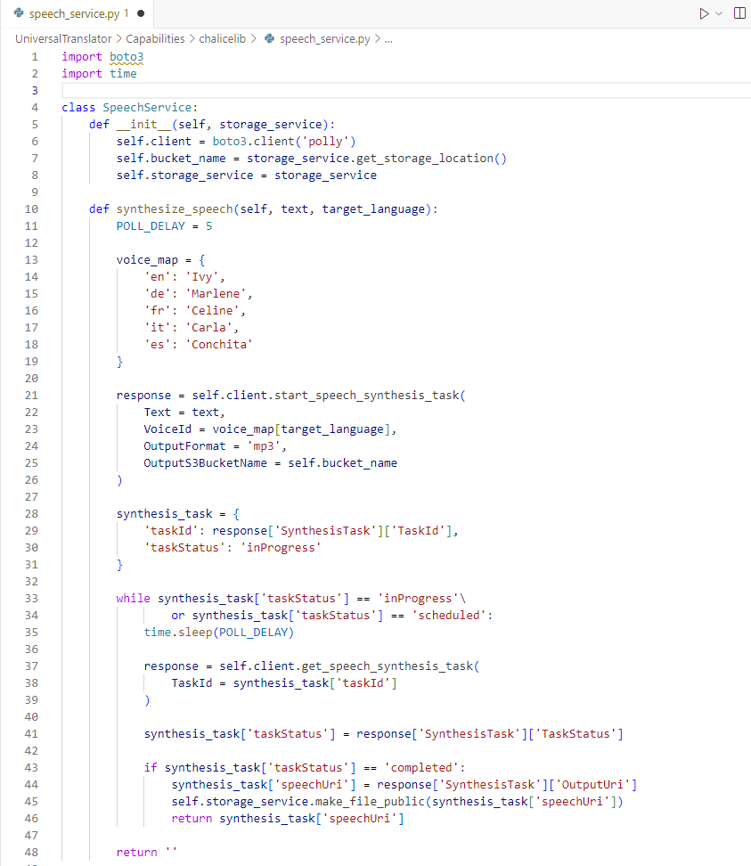2.4 Storage service – uploading and retrieving a file (Similar to PE02)

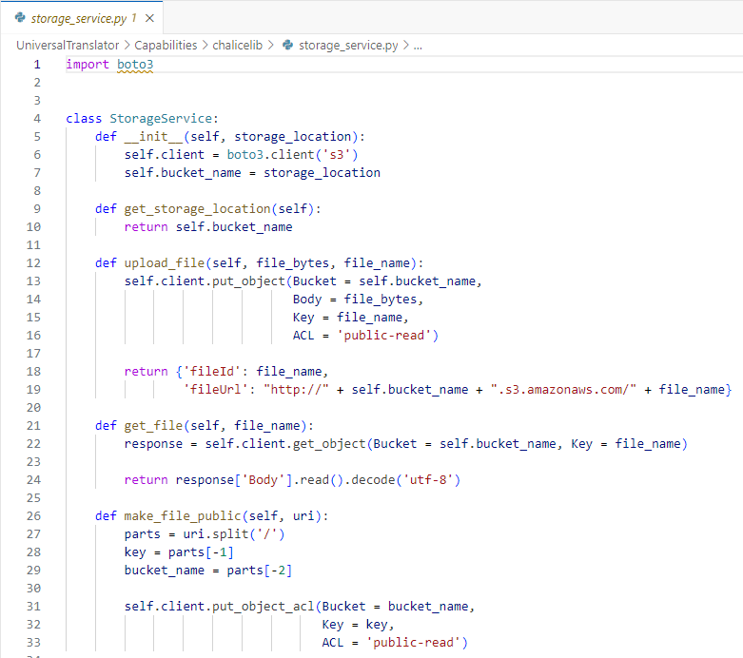

* PE03-3 Implement RESTful endpoints
  + 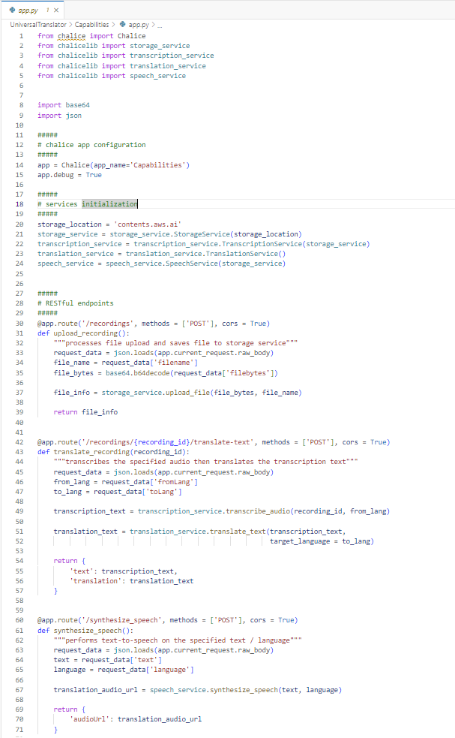3.1 Translate recording endpoint
  + A screenshot of a computer program

    Description automatically generated3.2 [**Optional**] Synthesize speech endpoint
  + 3.3 Upload recording endpoint (Similar to PE02)

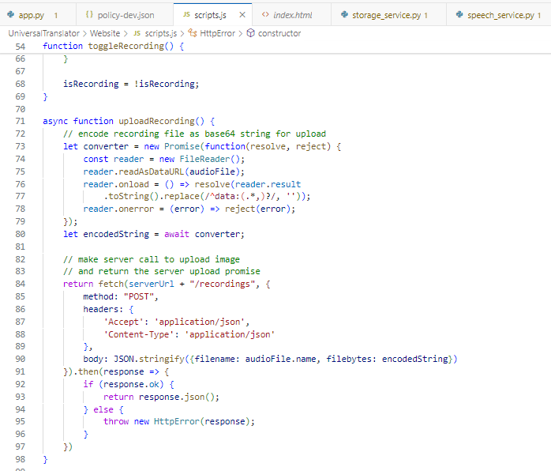

* PE03-4 Implement the web user interface
  + A screenshot of a computer program

    Description automatically generatedIndex.html + scripts.js

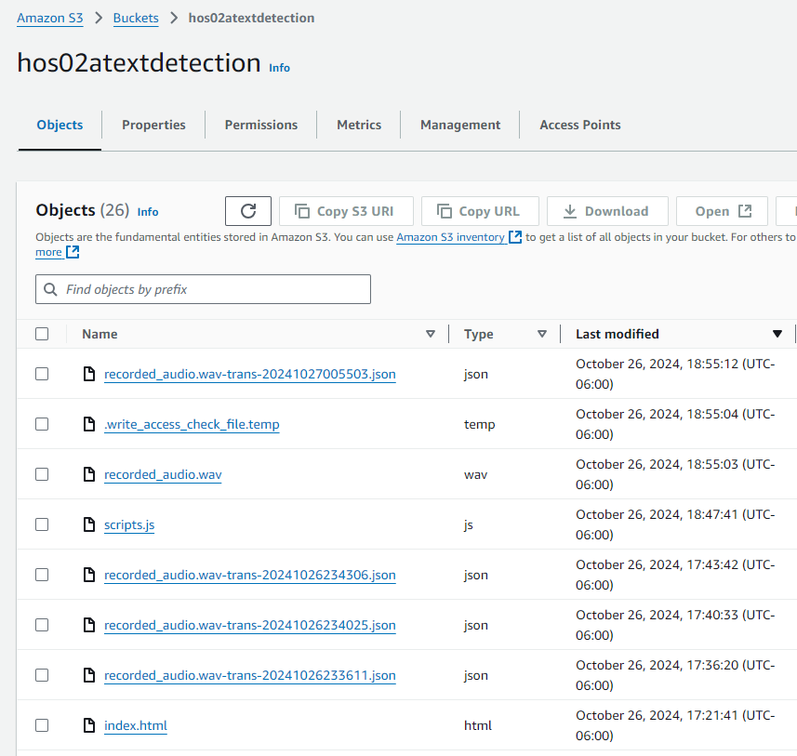

* A screenshot of a computer

  Description automatically generatedPE03-5 Deploy Pictorial Translator to AWS (Similar to PE02)

**Your task for PE03 is to:**

1. Complete above task
2. Please randomly try a couple of short videos in your computer to see how it works

**Please make sure you remove all the running resources after finishing the task.**

**HINT**:

* Try to complete this PE as much as you can as this is the fundamental for the following course PEs
* Feel free to follow the textbook’s GitHub codes if needed: <https://github.com/PacktPublishing/Hands-On-Artificial-Intelligence-on-Amazon-Web-Services/tree/master/Chapter04>
* Make sure completing task 2 to receive full credits

**Submit the items below to the PE submission page:**

* Please provide screenshots after completing task1 PE03-2.1, PE03-2.3 [**Optional**], PE03-3.1, PE03-3.2 [**Optional**], and PE03-4.
* Please complete task2, and screenshots of the results, and around 100 words of overall feelings completing this whole PE.
  + Make sure the PE module number and your name are written on the file name, e.g., "*PE03_Name.docx").*

Completing this Universal Translator exercise was like putting together a high-tech jigsaw puzzle, except every piece came with its own set of AWS permissions! Between the elusive API errors and a few “Why isn’t this working?” moments, it felt like an emotional rollercoaster worthy of a support group. But watching the app finally translate audio was strangely exhilarating, like seeing your code actually listen and respond—almost like it had a soul (or at least a sense of humor). Now, I’m one step closer to building my dream AI assistant. Just need it to remind me to sleep occasionally!