AI620 PE04: Programming Exercise

Fall 2024 by Verónica Elze

# Contact Organizer Application

Closely follow the textbook chapter 5 and Lecture 04.pptx to implement Contact Organizer application.

## PE04-1

## PE04-2 Implement services

### 2.1 Recognition Service – text detection (Same as PE02)

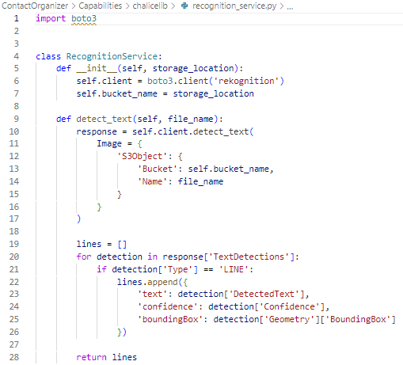

### **2.2 Extraction Service – contact information extraction**

### **2.3 Contact Store – save and retrieve contacts**

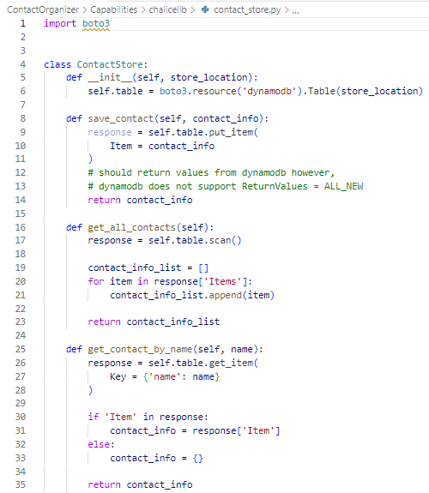

### 2.4 Storage Service – uploading and retrieving a file (Same as PE02)

## PE04-3 Implement RESTful endpoints

### **3.1 Translate [Extract] Image Information endpoint**

### **3.2 Save contact and get all contacts endpoint**

### 3.3 Upload image endpoint (Similar to PE02)

## **PE04-4 Implement the web user interface (Index.html + scripts.js)**

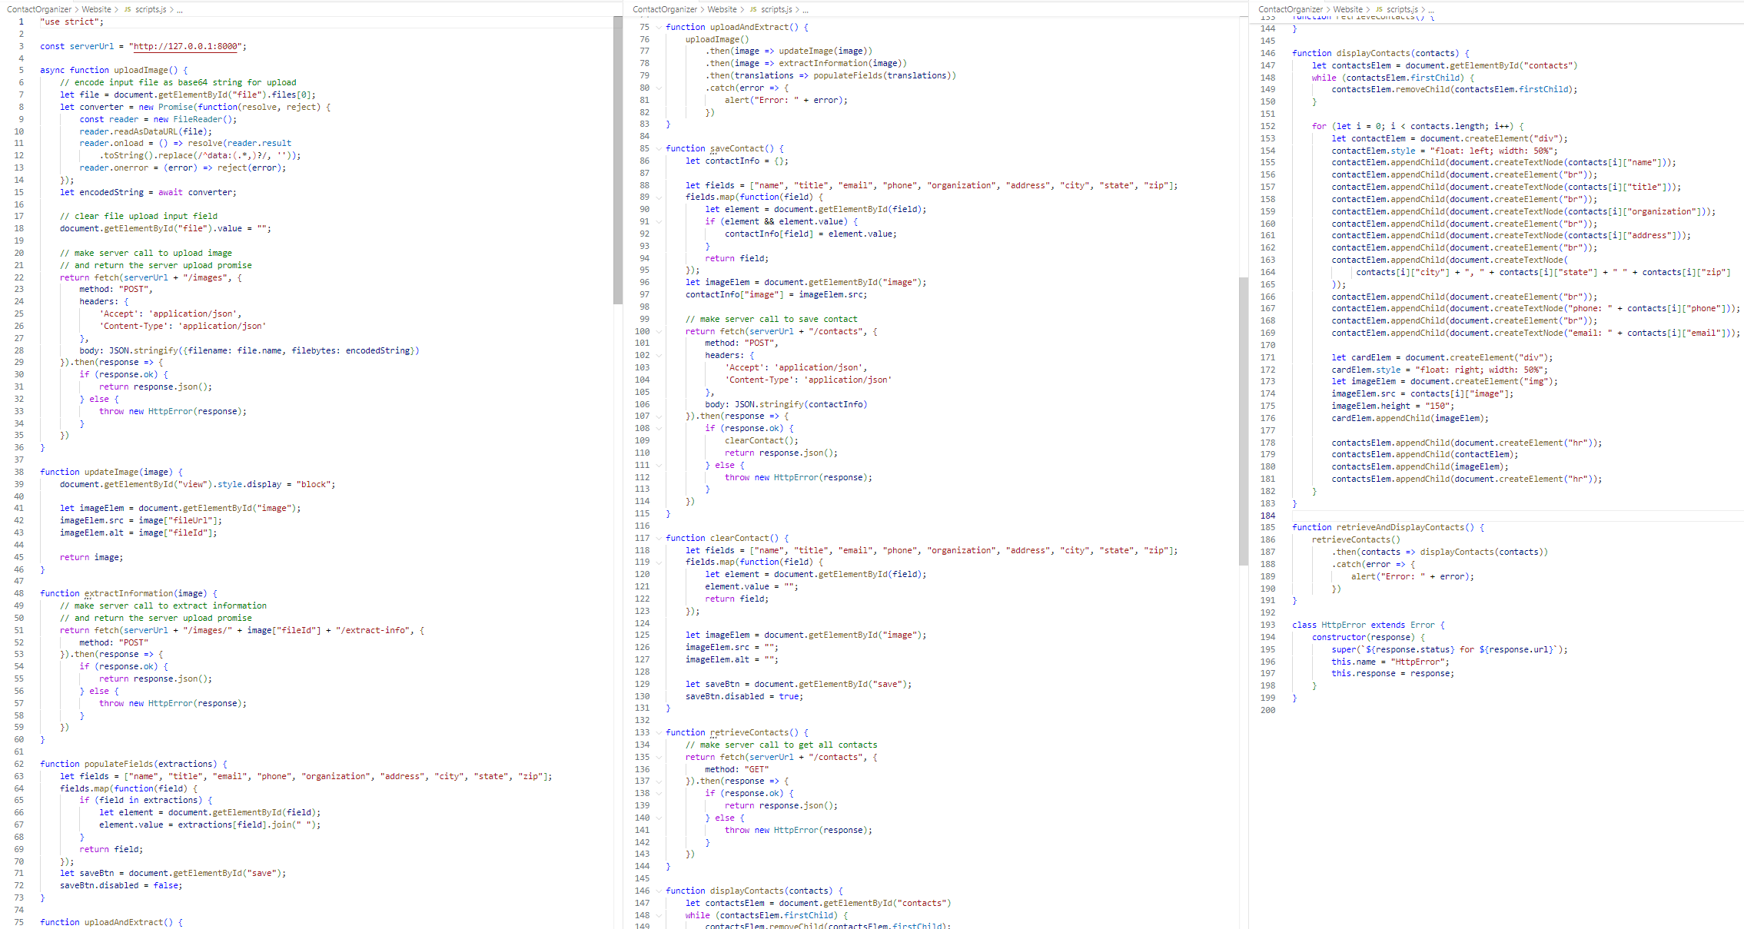

## **PE04-5 Deploy the Contact Organizer to AWS (Similar to PE02)**

# Please randomly try a couple of examples to see how it works

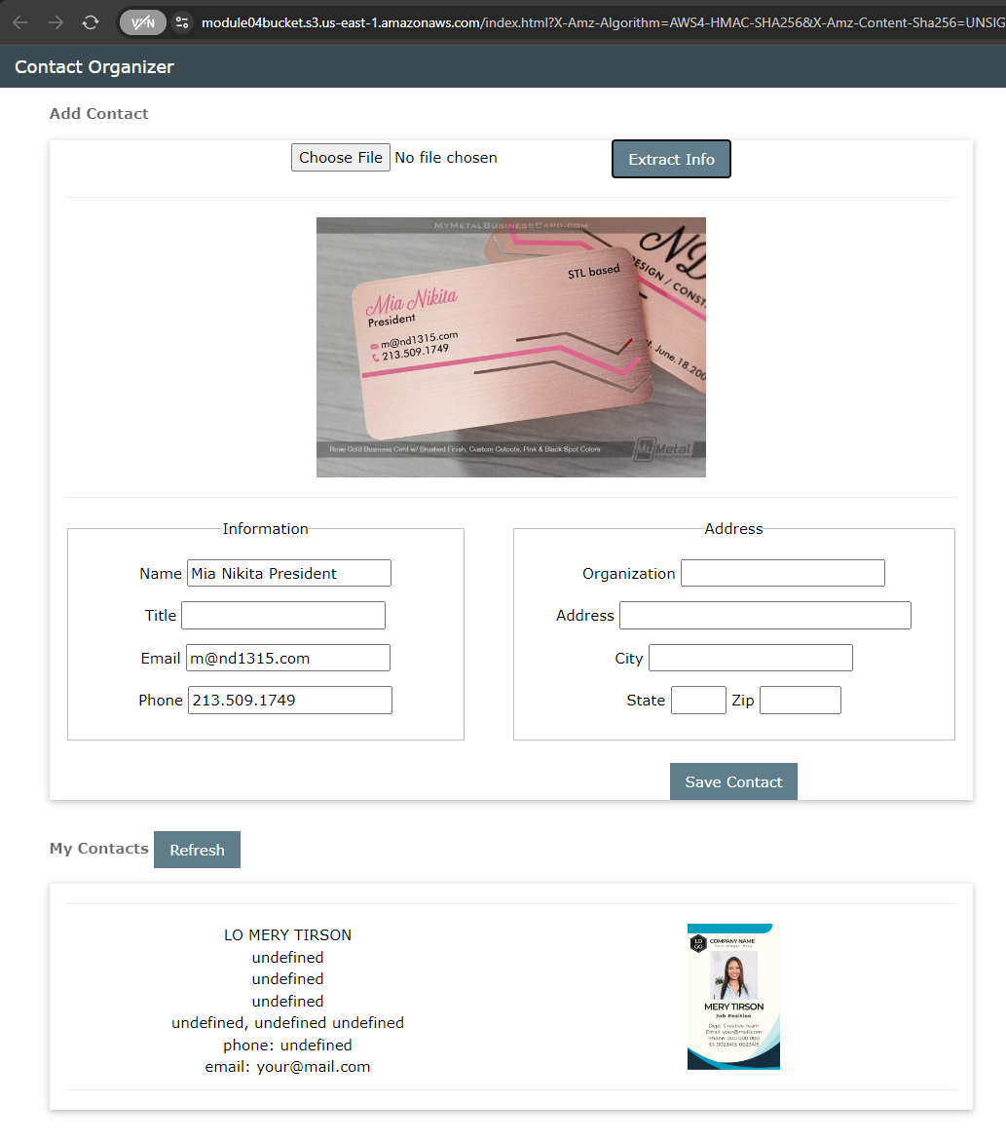

Around 100 words of overall feelings completing this whole PE.

Wrapping up this exercise felt like surviving a digital jungle! Between wrestling with CORS like it was a rogue tiger, and battling mixed content warnings that just wouldn’t quit, it was a nauseating rollercoaster. Every 500 error was like a jolt from AWS reminding me who's boss. But nothing beats the triumph of finally getting that green light! I’ve never felt prouder of persuading an API to play nice. In the end, I learned a lot—and might even have earned a few extra gray hairs. Now I’m basically ready to add “Cloud Wrangler” to my resume!