HOS05A Amazon Lex

Fall 2024 by Verónica Elze

# Setting up the contact assistant bot

## Step 1

## Step 2

## Step 3

## Step 4

# LookupPhoneNumberByName intent

## Step 1

## Step 2

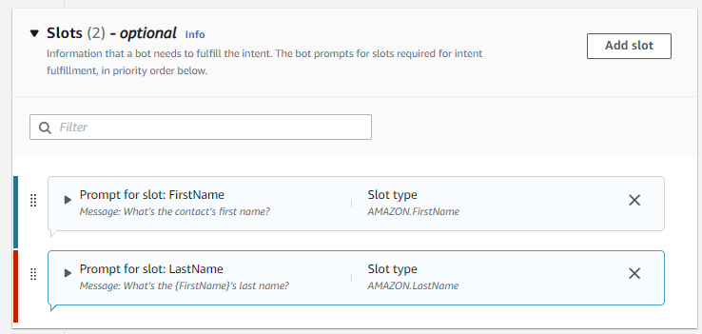

## Step 3

## Step 4

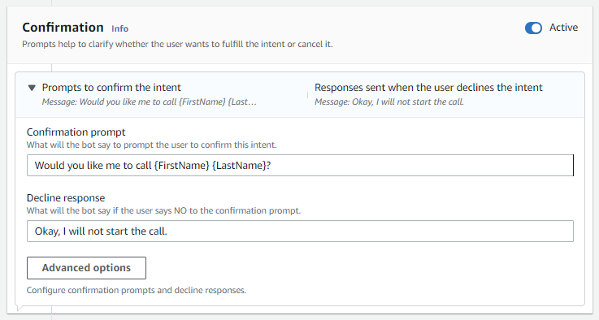

Step 5

## Step 3.1 TEST

