PE06 Inference Pipeline in SageMaker

Fall 2024 by Verónica Elze

Closely follow the textbook chapter 8 and Lecture 06.pptx to implement Inference Pipeline in SageMaker:

* PE06-1 The prerequisites
  + Follow textbook page286 step 1 to 4
  + 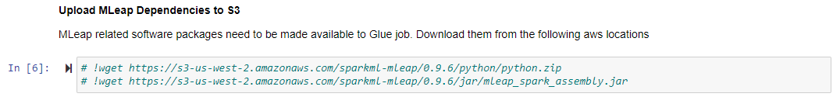A screenshot of a computer

    Description automatically generated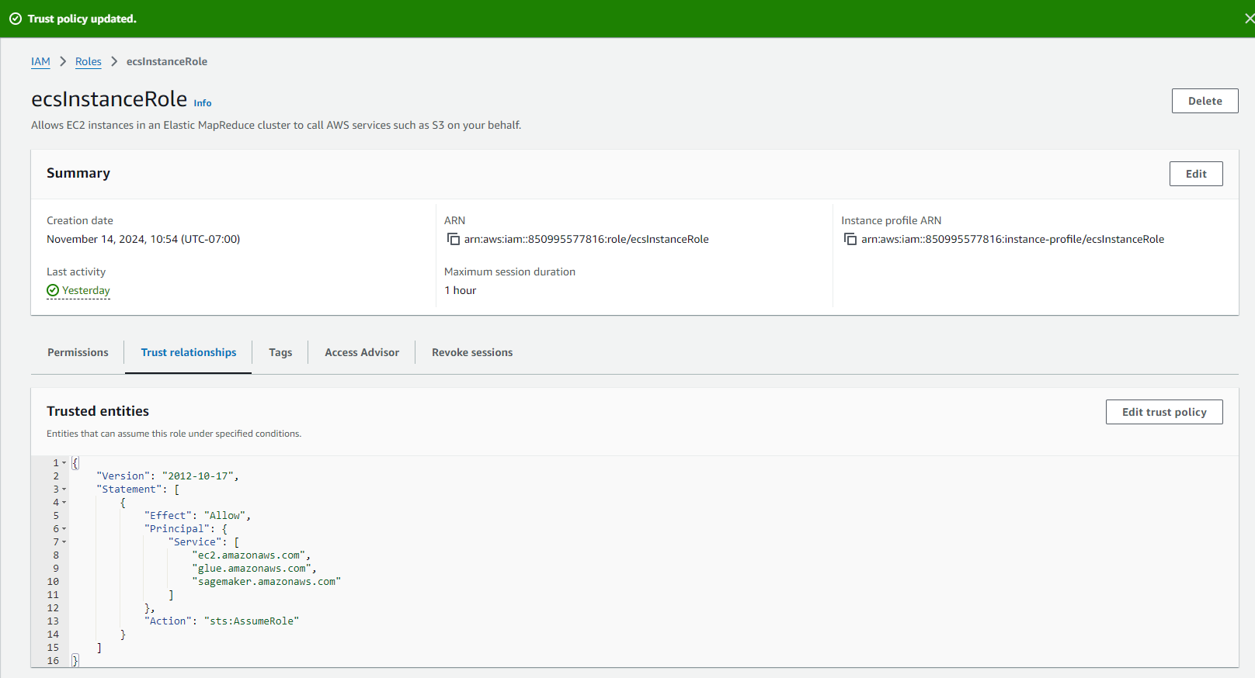If you are suing PDF version of textbook, it should be page280

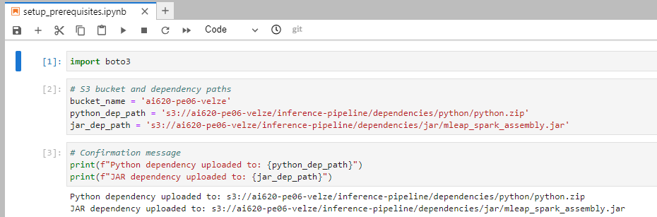

* PE06-2 Preprocessing data using PySpark
  + A screenshot of a computer program

    Description automatically generated2.1 Gather arguments sent by the SageMaker Notebook instance
  + 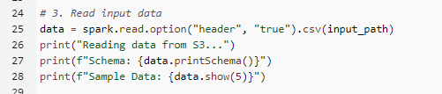2.2 Read the news headlines
  + 2.3 Retrieve 10% of the headlines and define the data transformations
  + 2.4 Stitch all the transformer and estimator stages together into a pipeline and transform the headlines into feature vectors
  + 2.5 Save the resulting feature vectors in .csv format
  + 2.6 Similarly, we will also save the vocabulary into a separate text file
  + 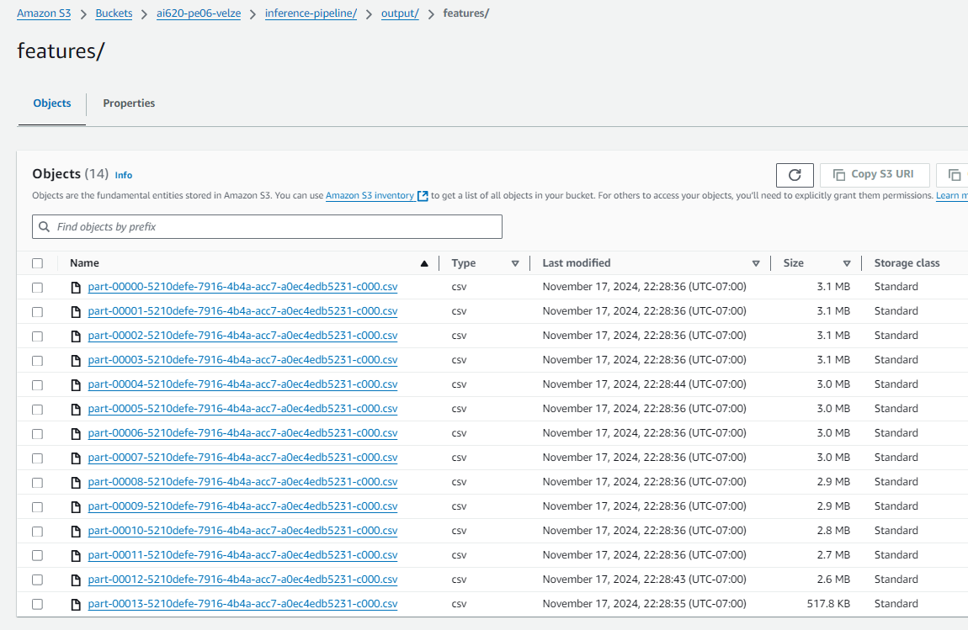2.7 Serialize news_pl_fit and push it to an S3 bucket

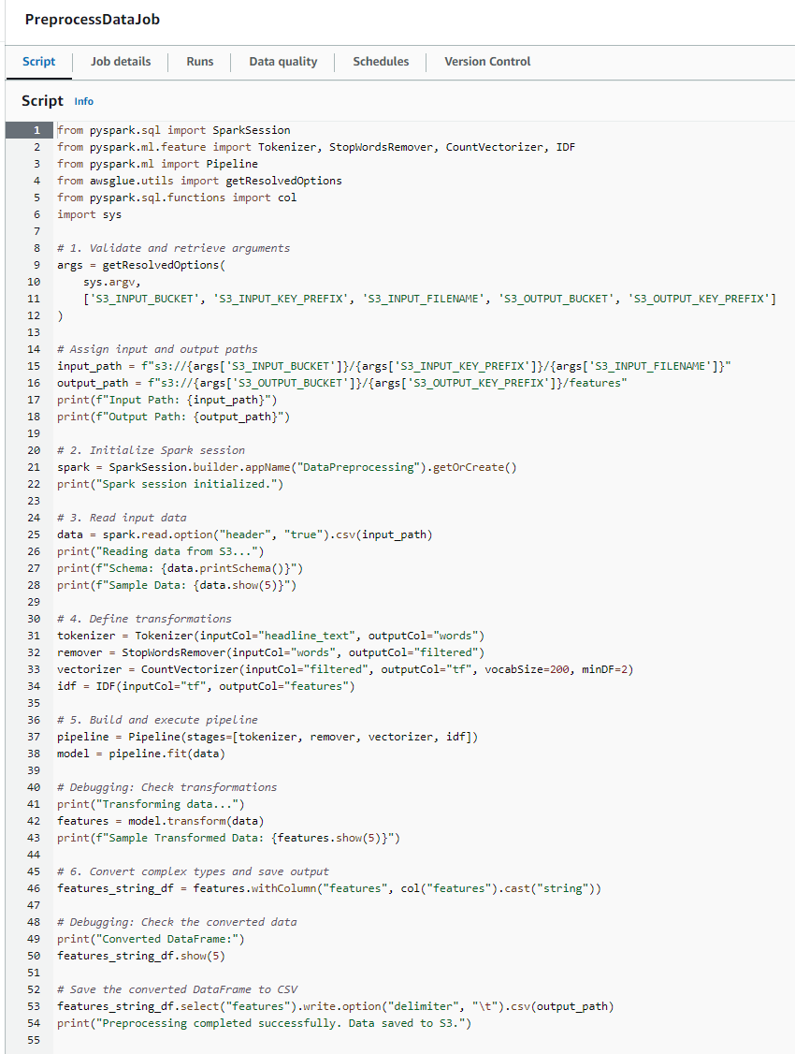

* 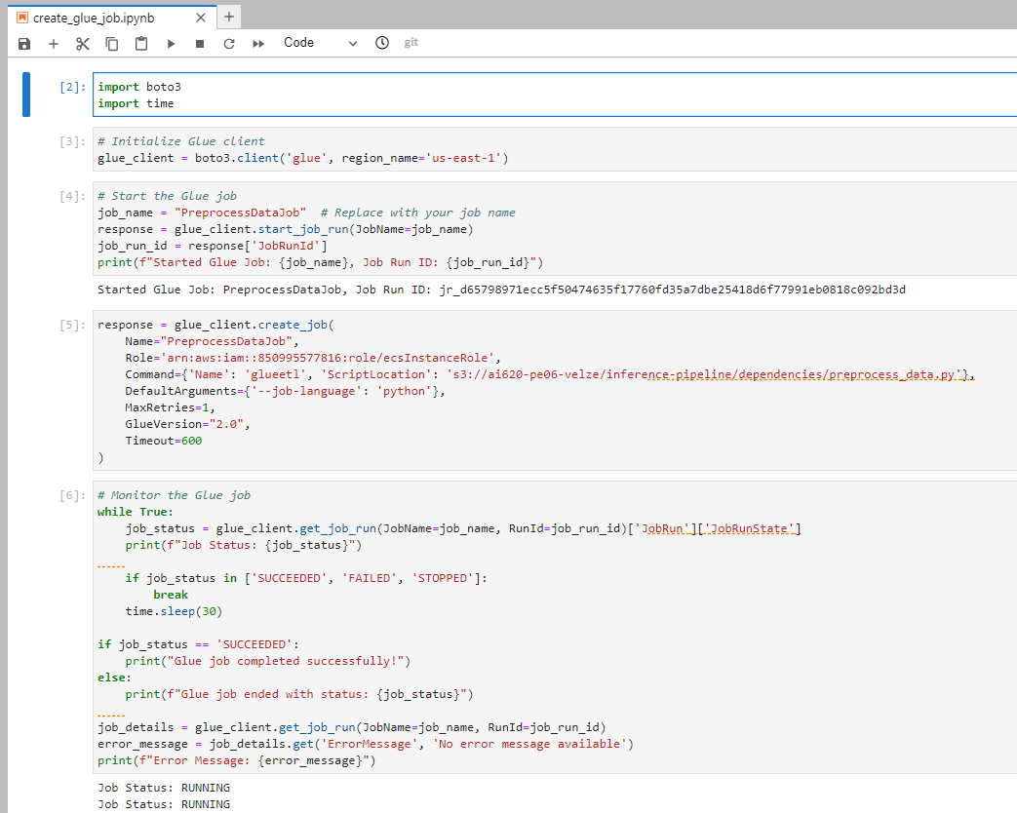PE06-3 Create an AWS Glue job

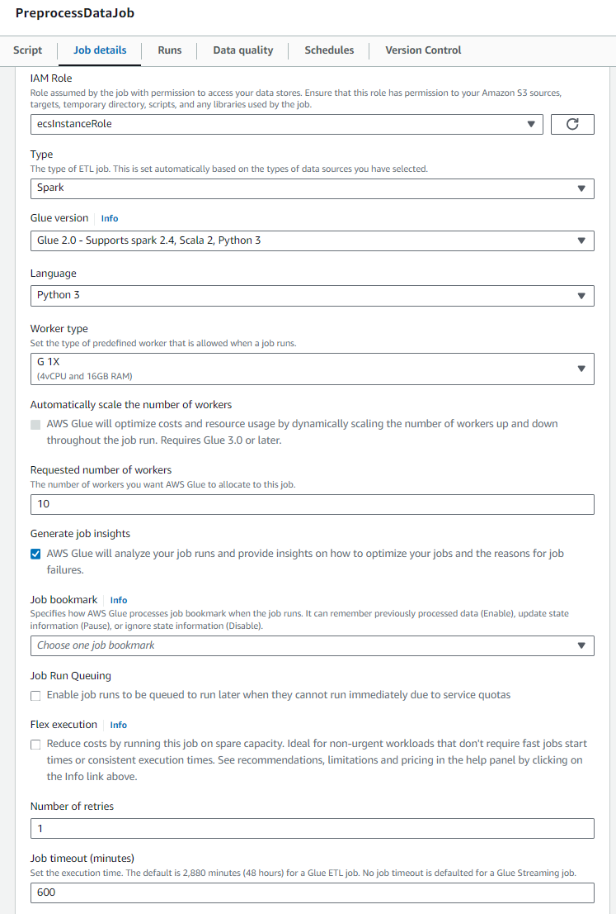

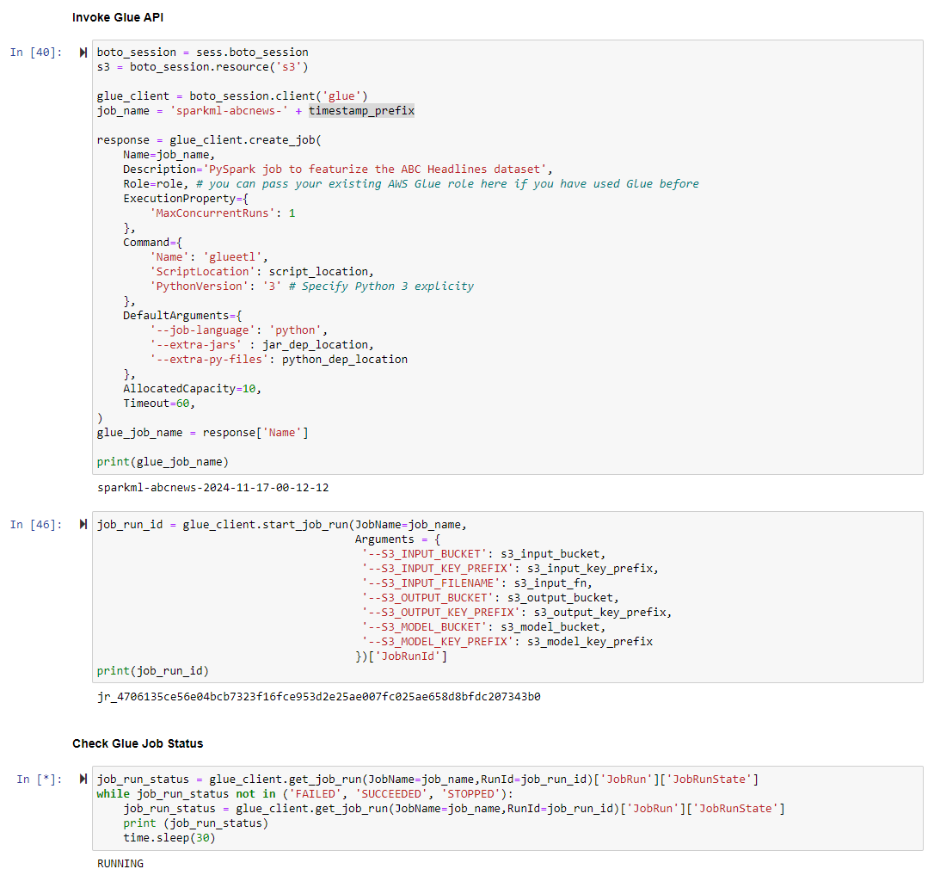

* PE06-4 Train NTM in SageMaker
  + Follow textbook 292 (286 if PDF version) step 1 to 5

* *[****Optional****] PE06-5 Prediction*
  + *5.1 Create real-time predictions through inference pipeline*
  + *5.2 Create batch predictions through an inference pipeline*

**Your task for PE06 is to:**

1. Complete above task

**Please make sure you remove all the running resources after finishing the task.**

**HINT**:

* Try to complete this PE as much as you can
* Feel free to follow the textbook’s GitHub codes if needed: <https://github.com/PacktPublishing/Hands-On-Artificial-Intelligence-on-Amazon-Web-Services/tree/master/Chapter08>
* Feel free to refer the [step-by-step video walkthrough](https://cityuseattle.sharepoint.com/teams/AI620ONEmergicTopicsinArtificialIntelligence-Fall2024/_layouts/15/stream.aspx?id=%2Fteams%2FAI620ONEmergicTopicsinArtificialIntelligence%2DFall2024%2FShared%20Documents%2FModule%2006%2FRecordings%2FMeeting%20in%20%5FModule%2006%5F%2D20241111%5F102817%2DMeeting%20Recording%2Emp4&referrer=StreamWebApp%2EWeb&referrerScenario=AddressBarCopied%2Eview%2E3599de18%2D756f%2D4c3b%2D87b2%2Da6355370caff) to complete this PE

**Submit the items below to the PE submission page:**

* Please provide screenshots after completing task1 PE06-2, PE06-3, PE06-4,
* Please provide around 100 words of overall feelings completing this whole PE.

Completing this Programming Exercise felt more like stumbling through a maze than crossing a finish line. PySpark and S3 kept me on my toes, and while I made it through the steps, I couldn’t shake the feeling that something might’ve been missed. Debugging was like playing detective with a blindfold on—chasing errors and second-guessing every move. By the end, I wasn’t sure if I had completed everything correctly or if I just got lucky. It was a humbling experience, reminding me there’s still a lot to learn. Hopefully, the results reflect more success than confusion!

Make sure the PE module number and your name are written on the file name, e.g., "*PE06_Name.docx").*